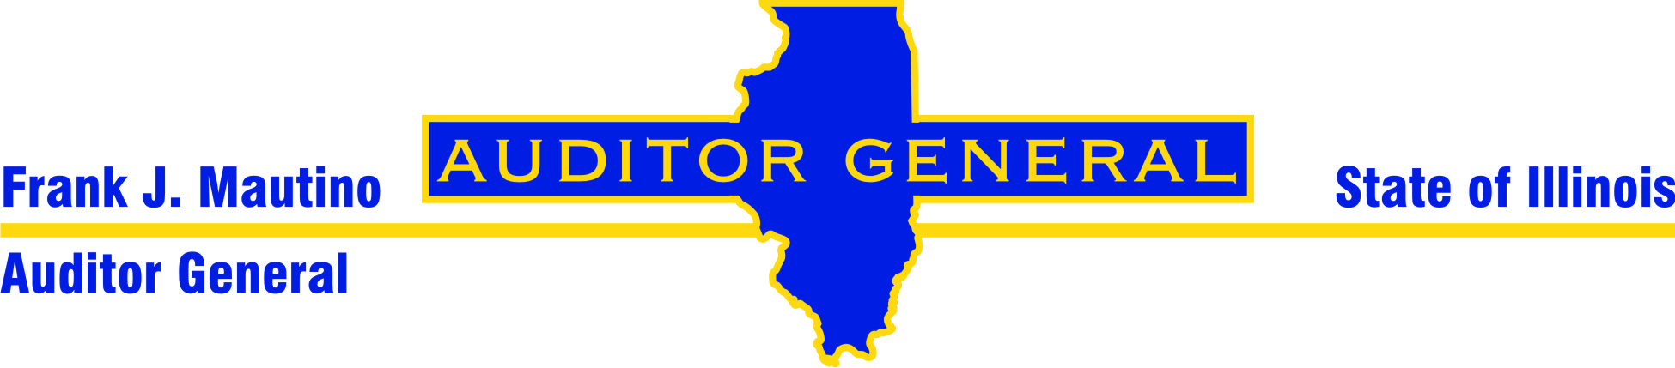

Internship Opportunities at the
Illinois Office of the Auditor General

The Illinois OAG is seeking college juniors and seniors for paid internships in our Springfield location. An internship in auditing provides an excellent opportunity to put your education to use in a professional environment and gain a vast understanding of how the State of Illinois conducts its affairs. In this field of auditing, your creativity and insight are encouraged. The work is challenging and important. Your contributions help to improve the efficiency and effectiveness of the State. As an OAG Audit Intern, you'll learn the operations of government firsthand, broadening your professional abilities.

Benefits
OAG Audit Interns enjoy benefits such as:
- a competitive hourly salary
- flexible working hours to accommodate course schedules
- the opportunity to intern during any semester
- an excellent training program
- academic credit (if offered by your college or university)
- travelling to State agencies in the Springfield area
- the potential for full-time employment and benefits upon completion of your bachelor’s degree.

Overview of the Illinois OAG

The Illinois Office of the Auditor General is a constitutional office charged with the responsibility of auditing over 150 State agencies annually. As part of our constitutional mission, we review State financial records, monitor agency program performance, and test for agency compliance with State and federal regulations.

Our audit findings and recommendations are reported directly to the General Assembly and to the Governor. OAG audit reports commonly identify methods to save tax dollars and improve services in Illinois government agencies. Audit findings have made recommendations to correct issues such as inventory lapses, misappropriation of funds, and personnel deficiencies.

Establishment of the OAG within the legislative branch of government grants us independence as auditors. Thus, our audit reports provide the General Assembly with valuable information for monitoring the efficiency and effectiveness of State government.

Application Process

Simply visit our website at www.auditor.illinois.gov for application instructions or to learn more about career opportunities with the Illinois Office of the Auditor General.

Questions may be directed to Jim Dahlquist at (217) 782-6046 or by e-mail at jdahlquist@auditor.illinois.gov
OFFICE OF THE AUDITOR GENERAL
OAG AUDIT INTERN POSITION DESCRIPTION

AUTHORITIES AND RESPONSIBILITIES
Responsible for acquiring basic skills pertinent to governmental auditing in Illinois and applying general audit skills. Exercises major responsibility for gathering data pertinent to the audit, reviewing and comprehending data, documenting pertinent information, and working with the Audit Supervisor(s) or Manager on the printed report, the product of the Office of the Auditor General.

RELATIONSHIPS OF THE POSITION TO OTHER POSITIONS
Under the general supervision of a Director; when appropriate under the direct supervision of an Auditor V, Auditor IV and/or Auditor III. Reporting relationships may vary depending upon the nature of the assignment.

PRINCIPAL REQUIREMENTS STATED IN PERFORMANCE TERMS
The Audit Intern:
- Develops working knowledge of auditing techniques, Illinois State government, professional auditing standards, and State fiscal practices.
- Serves as a contributing member of an audit team, completing assigned duties of limited scope and communicating with the team leader concerning proper methods to be applied in the audit context.
- Receives controlled assignments of increasing difficulty and responsibility.
- Conducts background research of agencies being audited, including examination of relevant statutes, rules and regulations.
- Travels to audit site locations and obtains audit evidence. Performs audit fieldwork which includes visual examination of records and other items and preparation and organization of workpapers showing the results of audit examinations.
- Learns to gather, interpret, compile, and analyze data pertinent to audits performed by the office. Reviews data and other information pertinent to the audit.
- Participates in interviews of agency staff to elicit factual information.
- Prepares preliminary drafts of audit findings and helps draft audit reports.
- Responsible for gaining professional experience and ability primarily through on-the-job training.
- Performs other assigned or required duties.

CAPABILITY REQUIREMENTS

Education
Requires current enrollment as a junior or senior in good academic standing at an accredited college or university with coursework in accounting, auditing, economics, finance, business administration, political science, public administration, information systems or another area with a significant relationship to the above tasks. (Some internships may require credentials which are more limited than, or are different from, those listed above and preference will be given to individuals with the desired education or equivalent experience suitable for those positions.) Staffing plans may dictate the preferred fields of study to help the office achieve a desired mix of academic backgrounds and areas of expertise.

Experience
None required, although preference may be given to those with relevant experience.

Required Characteristics
- Strong conceptual, reading, communication, comprehension, interpersonal and analytical skills.
- Must be able to contribute substantively to audit reports.
- Must be able to work as part of a team, take initiative, and meet deadlines.

Desired Characteristics
Preference may be given to those with desired characteristics pertinent to the position. Desired characteristics may include but are not necessarily limited to:
  - knowledge of the management structures and operations of Illinois government;
  - working knowledge of computer software packages such as Access, Excel, SQL, ACL;
  - available to work 20 hours a week during a semester and 35 hours a week during semester breaks;
  - experience in a public agency, particularly in Illinois;
  - experience in auditing or with a Public Accounting firm when appropriate to the position; and
  - high grades in coursework relevant to the duties of an Audit Intern.

