Instructions for SCAG Subregional Model Dashboard

4/4/2018

1. Need to add the field "CC" in the input and output highway network. It is 1 for all links connected to centroids, and null for all others.

(1) In the node layer, select all centroids using this condition: [Zone Centroid] = "Y"

(2) In the line layer, select all links that connects to the centroids

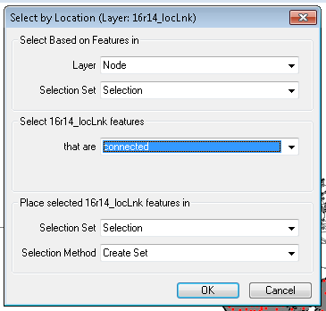

2. Need to make sure “AB_FT_Group” in the input and output highway network.

AB_FT_Group

floor(AB_Facility_Type/10)

and for CC=1, AB_FT_Group = 10

Use the following formula:

if CC = 1 then 10 else (if AB_Facility_Type<100 then floor(AB_Facility_Type/10) else 99)

if CC = 1 then 10 else (if BA_Facility_Type<100 then floor(BA_Facility_Type/10) else 99)