Shopping List Mobile Application Design
Module 3 Critical Thinking
This prototype supports personal shopping lists on one device. The first version creates lists, adds and edits items, marks purchases, and changes sorting preferences. Local persistence keeps the core workflow available without a network connection; shared lists and cloud synchronization are later extensions.

Architecture and data responsibilities
The user interface sends actions to a list controller, which validates input and updates the list repository. The repository owns loading and saving local records. Separating the UI and data responsibilities follows the Android architecture guidance and keeps storage decisions from spreading through every screen (Google, n.d.).
A List has list_id and name. An Item has item_id, list_id, name, quantity, and purchased. IDs remain stable when labels change. The controller requires a nonempty item name and a positive quantity, checks that an item belongs to the selected list, and saves a change before reporting success.

Interaction decisions
Five screens cover the main workflow. Home selects a list; View List is its working screen; Add Item and Edit/Delete Items return to the same list after saving or cancelling. Settings/About returns to Home. Delete requires confirmation, and Cancel preserves the previously saved value.
Visible saved-state feedback and clear Cancel controls apply Nielsen’s principles of system-status visibility and user control (Nielsen, 1994). An empty list explains how to add the first item. Validation preserves the typed name and identifies the field to correct.

Prototype script
shopping_list_prototype.py defines the five screens in a dictionary and eight navigation links in a list. Its execution prints the screen count, responsibilities, and flow. It describes the proposed app; it does not implement mobile screens, persistence, or synchronization.

Component architecture
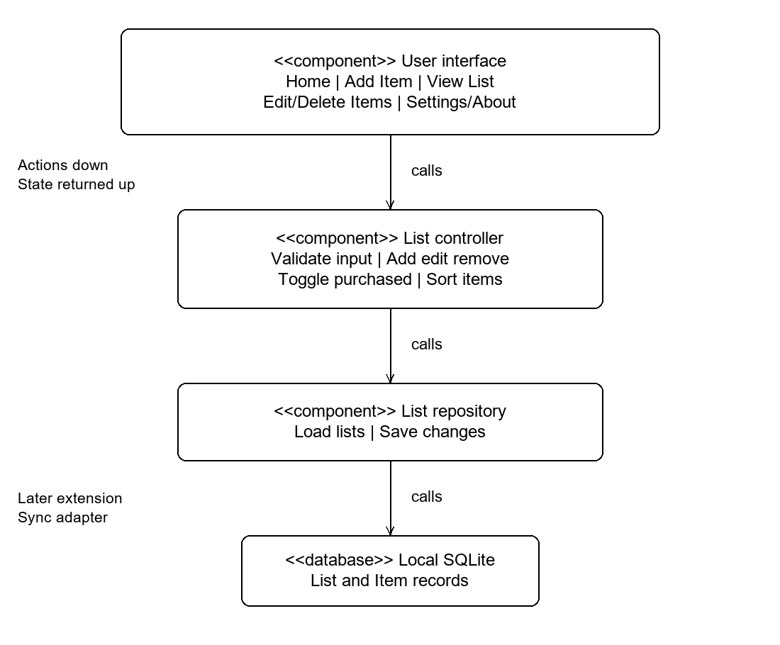
Calls move from the UI toward storage; saved data and operation results return to the caller. A future synchronization adapter would sit behind the repository. Conflict resolution, accounts, and sharing permissions must be designed before enabling shared lists.

Five screen paper prototype
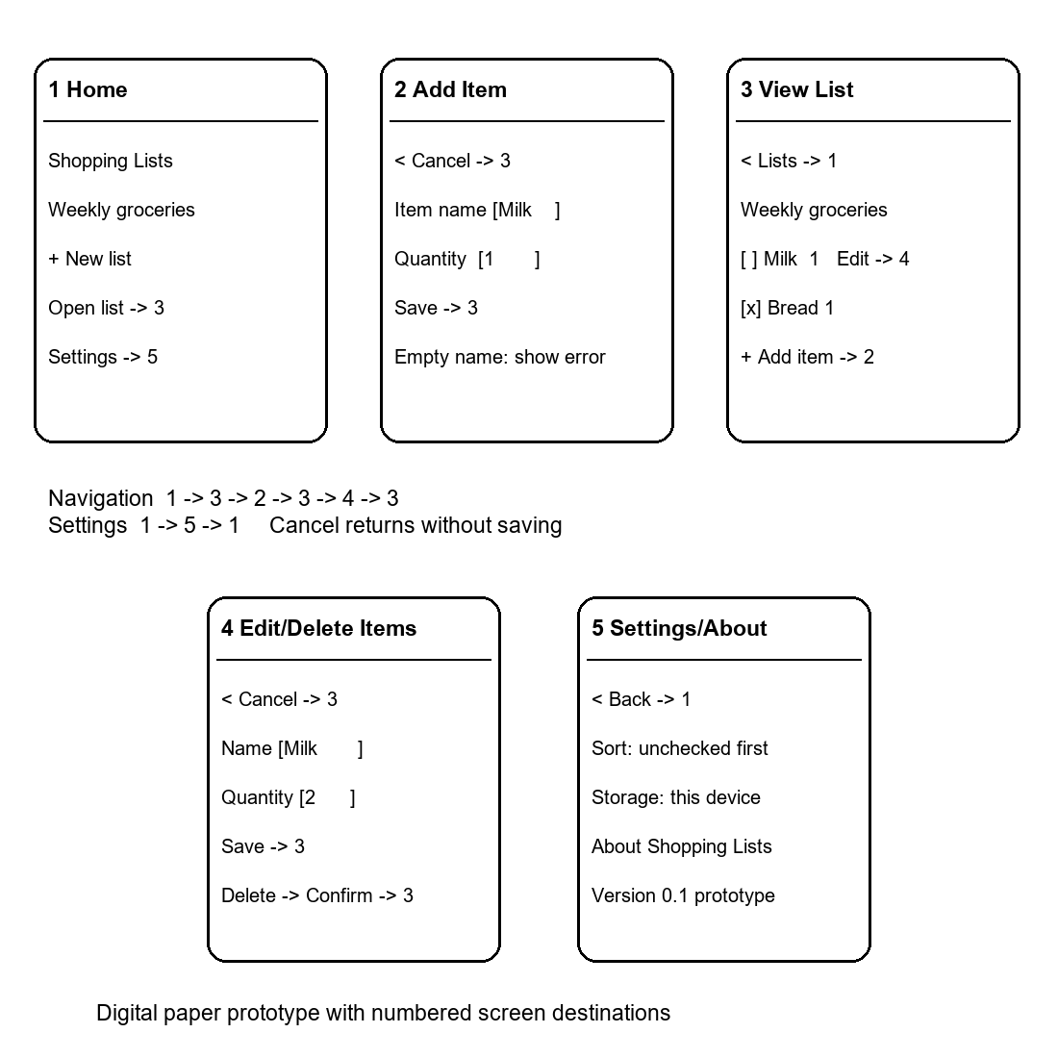
Numbers in the sketches identify destinations. In a usability walkthrough, ask a participant to create a list, add milk, change its quantity, cancel an edit, and delete it. Observe wrong turns and whether the participant can tell when a change has been saved.

Validation and implementation boundaries
The script ran successfully and reported five screens. A structural check confirmed that every navigation origin and destination names an existing screen. The architecture and sketch labels use the same names as the program.
Before implementing the mobile application, validate persistence across a restart, error recovery after a failed save, keyboard and screen-reader access, and preservation of the selected list during navigation. These are proposed acceptance checks, not results from a working mobile app.

References
Google. (n.d.). Guide to app architecture. Android Developers. https://developer.android.com/topic/architecture
Nielsen, J. (1994, April 24). 10 usability heuristics for user interface design. Nielsen Norman Group. https://www.nngroup.com/articles/ten-usability-heuristics/
Pressman, R. S., & Maxim, B. R. (2020). Software engineering: A practitioner’s approach (9th ed.). McGraw-Hill Education.

