Chanceller waters
Assignment 5.2: sql

Script run results

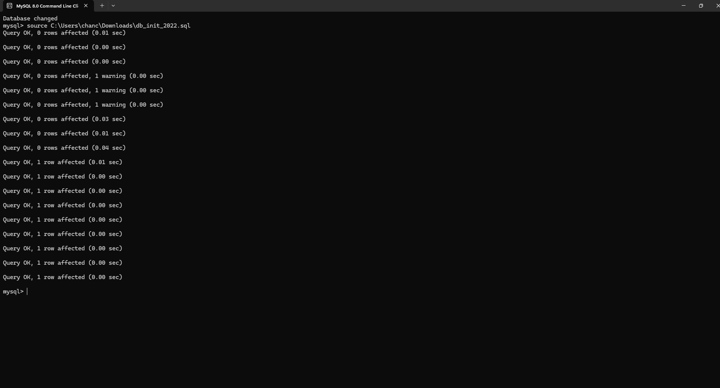

Show table results

