Chanceller waters
02/01/2026

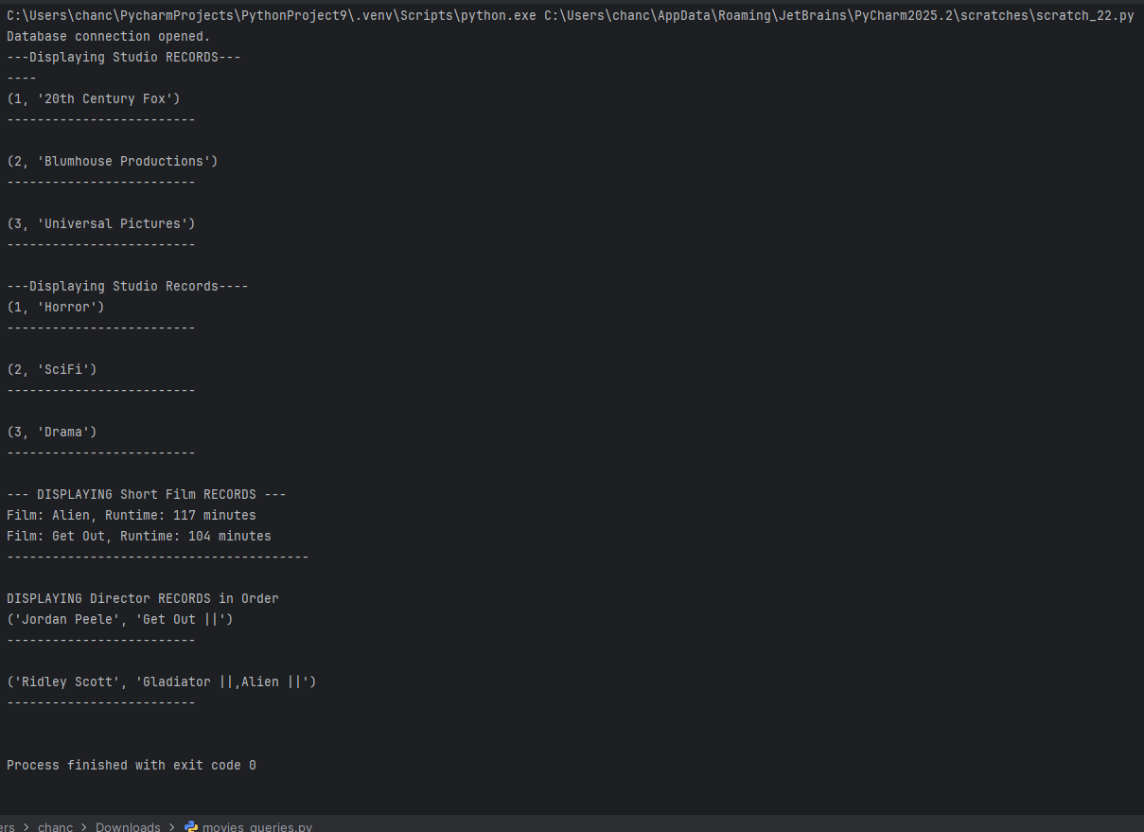

https://github.com/cwaters-00/csd-310.git

