Chanceller waters
Assignment 2.3

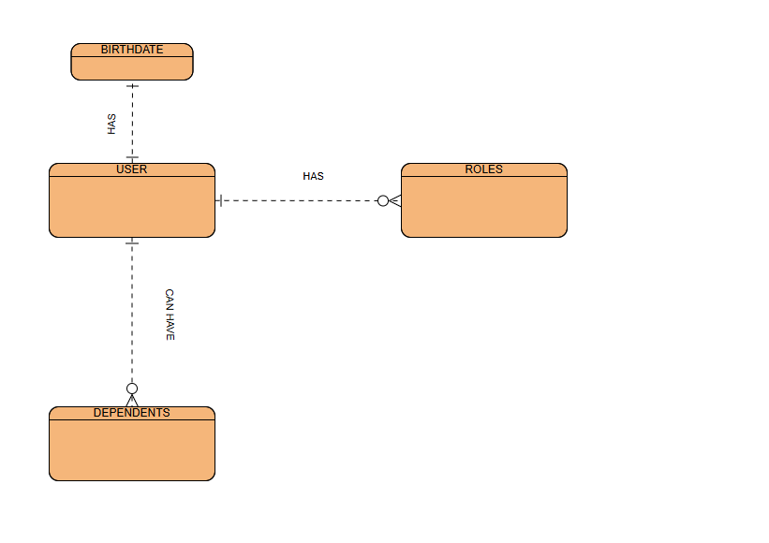

Nosql:

nosqql data structure
{
"user": "user_id_0925",
"name": "Tatsuro Yamashita",
"email": "yama.tatsu@magicways.com",
"birthdate":"1986-01-16"
"Roles":["musician"
"songwriter"],
"dependents":

[["name"":|"Mariya Takeuchi","
"birthdate:1986-06-02"},
[
"name":"Taeko Ohnuki",
"birthdate:1986-04-02
]
]
}

