CHANCELLER WATERS

ASSIGNMENT:4.2

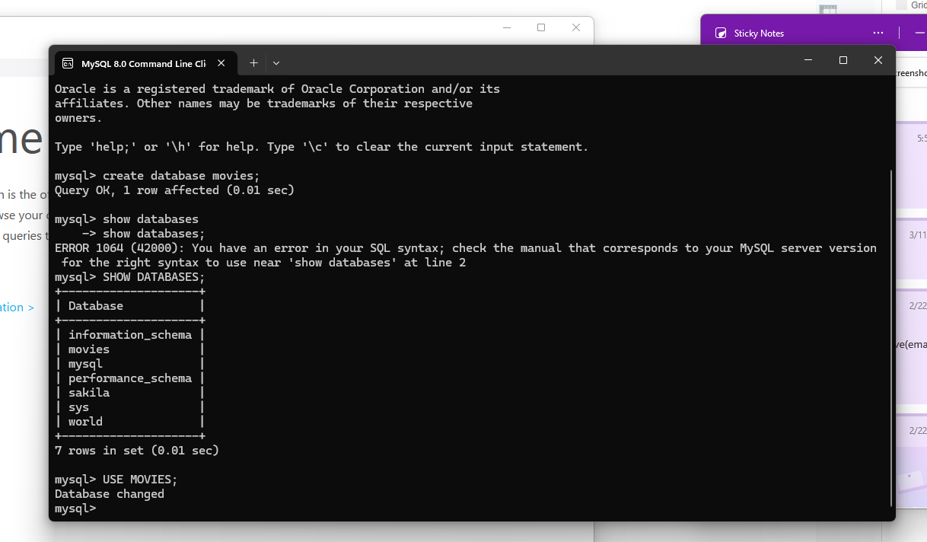

Mysql FUNCTIONS AND THEIR USES.

ABS(absolute values)
This function applies the absolute value of a given integer

This function could be used when a non-negative number is needed and essential, such as in;

Distance calculation
When attempting to calculate the distance between two points, the resulting integer must be a non-negative number, making the use of abs a non-negotiable

Data normalization
When cleaning or preparing data, it can be used to ensure that all values in a specific column are positive, which may be a prerequisite for further processing.

LCASE Lowercase

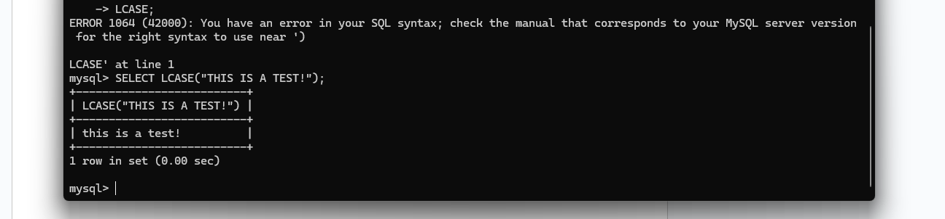

This function can be used to convert a string to all lowercase

This function would be used when;
When formatting user inputs
When processing user-provided information, such as email addresses or search queries, using lcase can reduce potential variations and improve overall search accuracy.

ROUND() Function

It would be used to round numerical data( like prices or averages) to a set number of decimal places; this allows for clearer reporting

