Chanceller Waters
3-21-2026
Assignment 1.3

Github link:
https://github.com/cwaters-00/csd-340.git

Sample code validator results

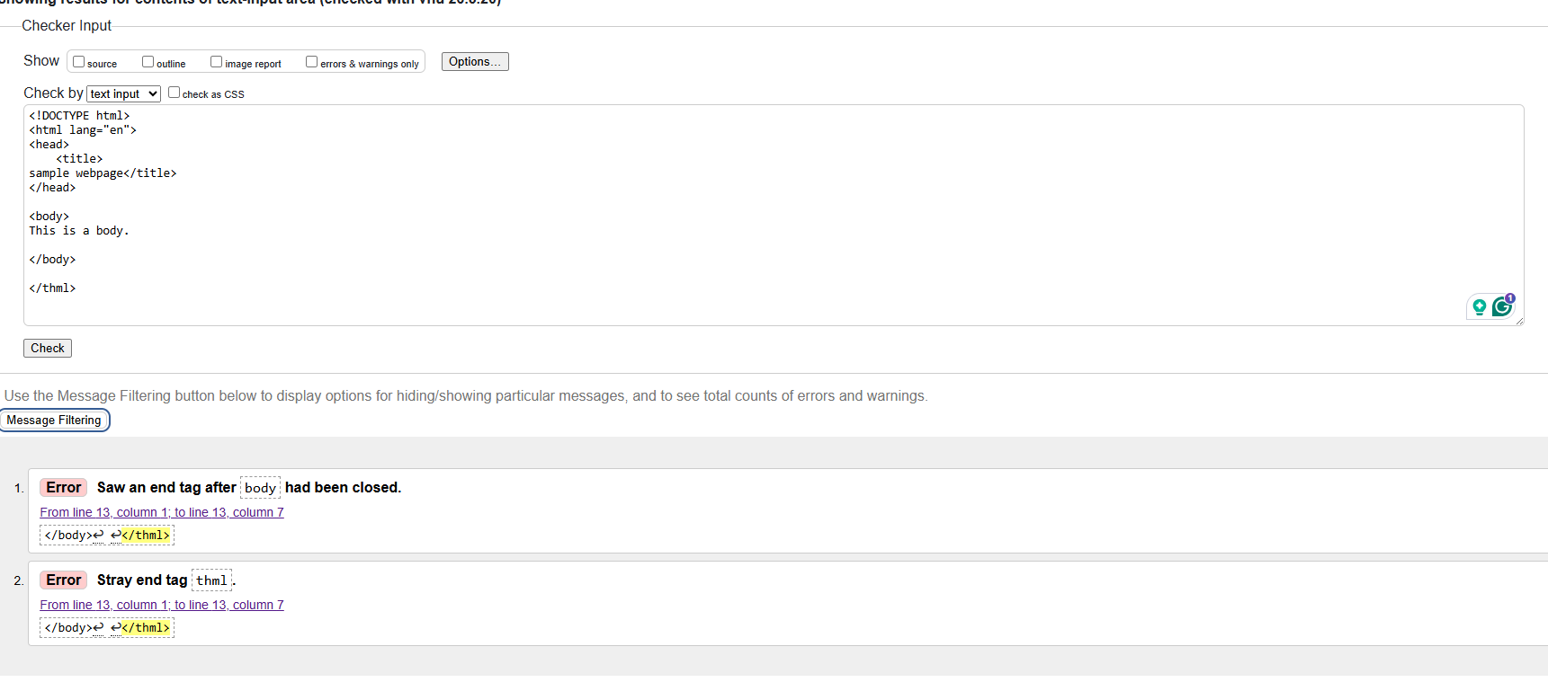
Corrected results
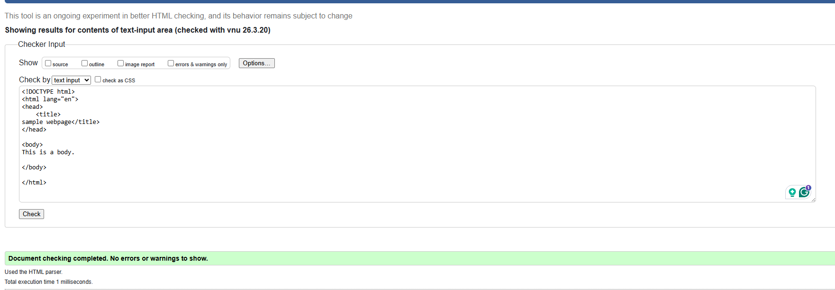
Updated results
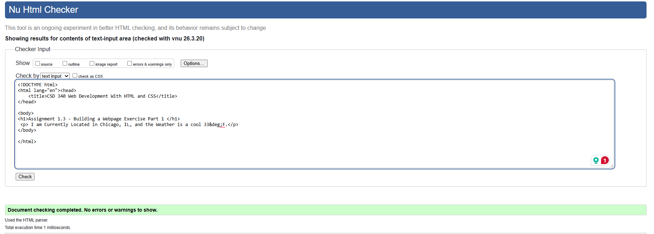
Default browser output
