Chanceller waters
3-16-26

Repo link

https://github.com/cwaters-00/csd-340.git

Local directory:
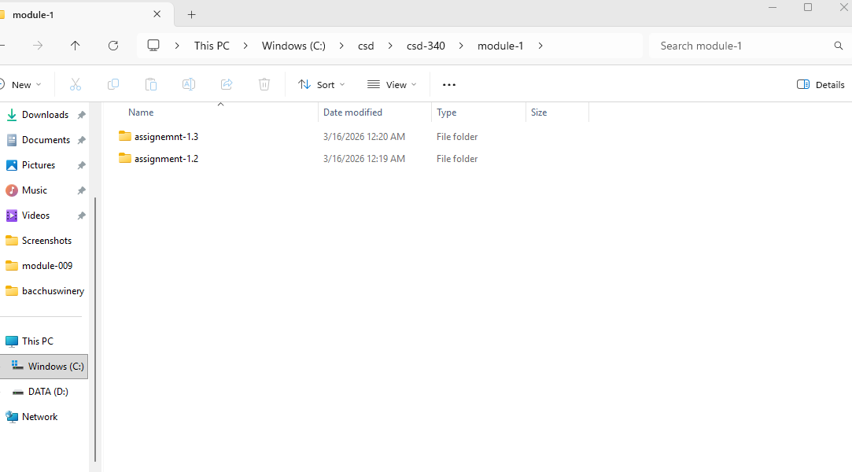

Repo homepage:
