Chanceller Waters Assignment 1.2: 325 repository set up

Link to GitHub repository

https://github.com/cwaters-00/csd-325.git

Screenshot of csd-325 repository:
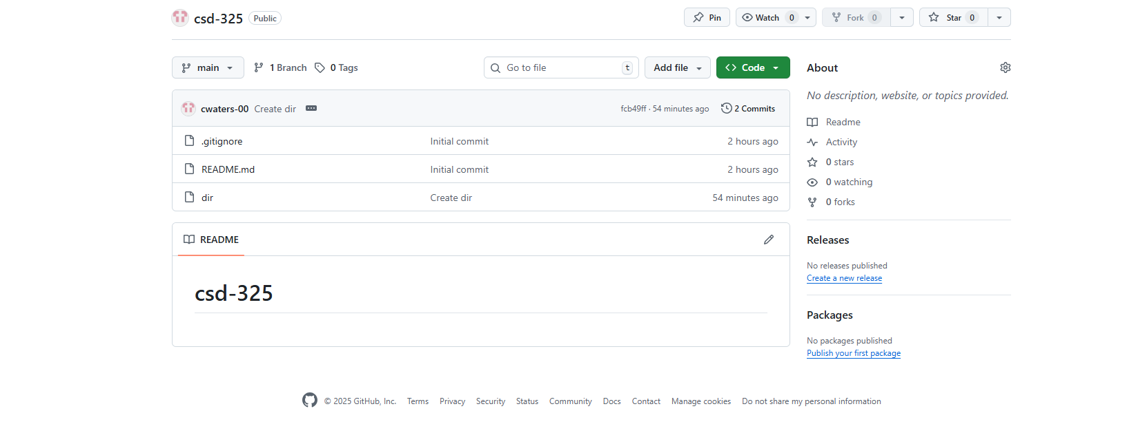

Screenshot of the 325 directory :

