Chanceller Waters

Terminal run

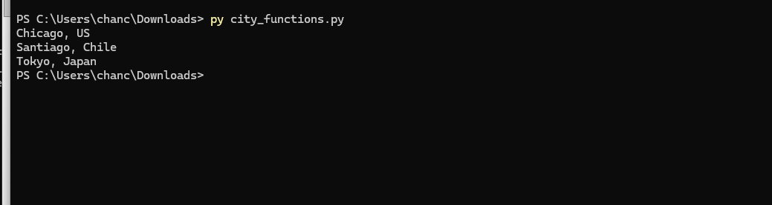

Unittest
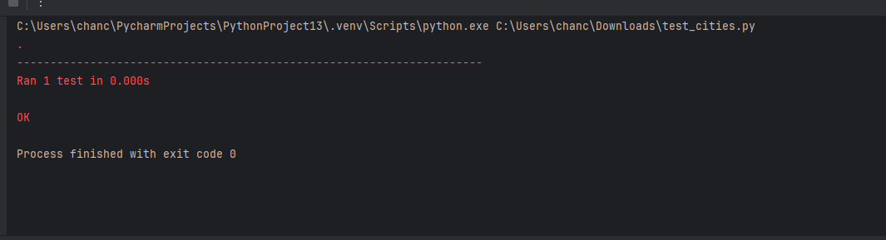

Test failed
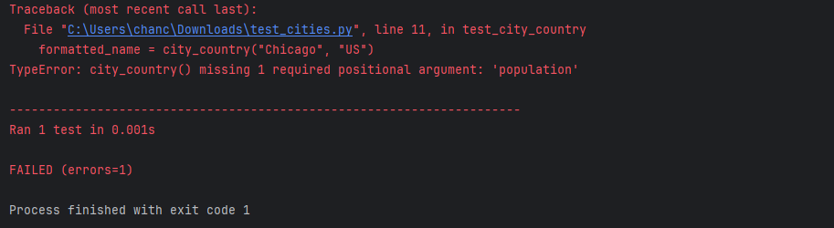

Test pass
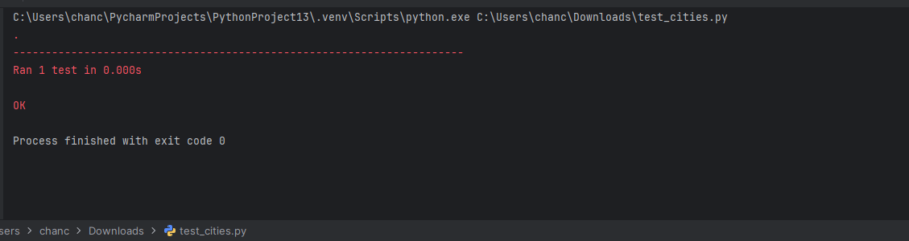

Language test fail
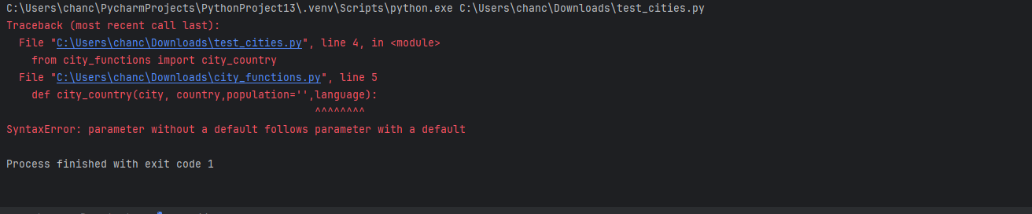

Final results + pass
