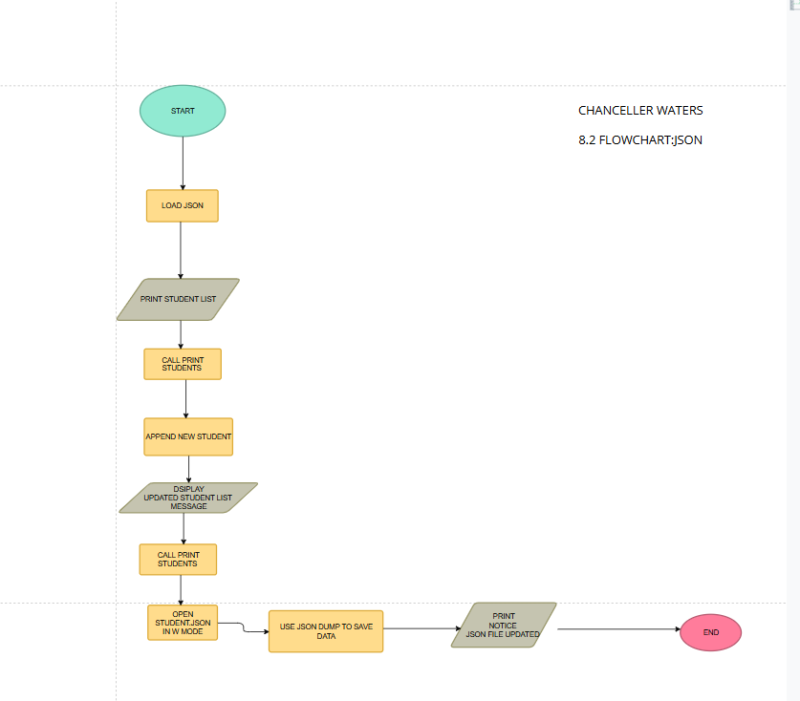

CHANCELLER WATERS
jSON FLOWCHART

