Configure AWS API Gateway - Lambda - Opensearch for Geoportal Catalog UI

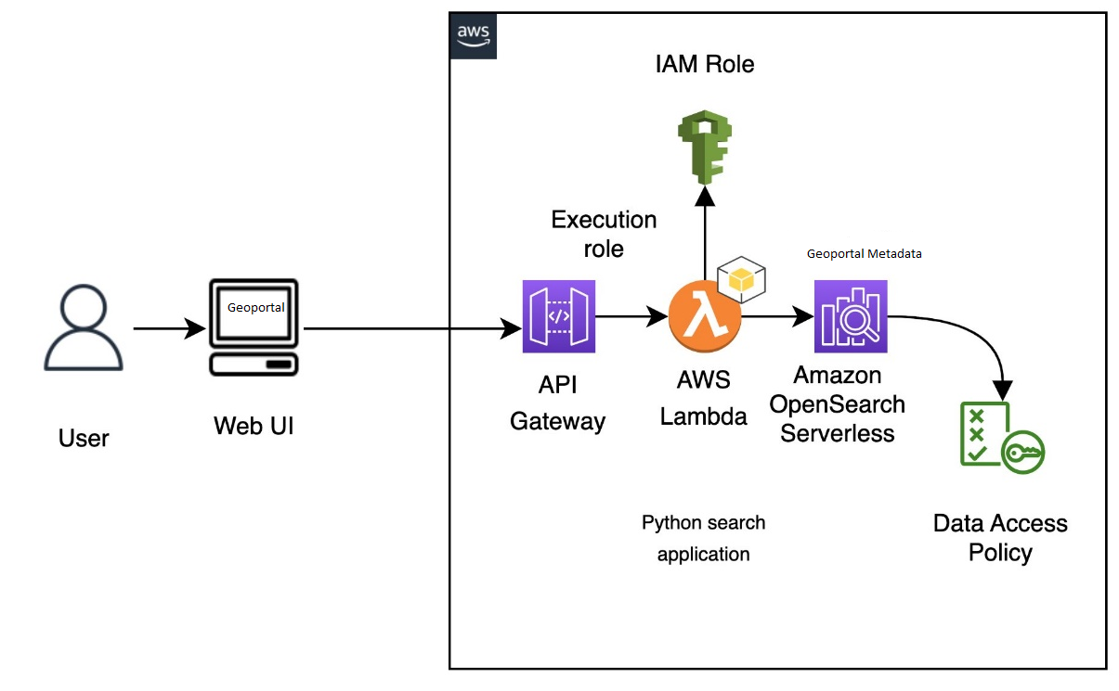

1. Create and deploy the Lambda function
To create your function using the Lambda console
- Navigate to the Lambda console at https://console.aws.amazon.com/lambda/home. On the left navigation pane, choose Functions.
- Select Create function.
- Configure the following fields:
  - Function name: opensearch-function
  - Runtime: Python 3.9
  - Architecture: x86_64
Keep all other default options and choose Create function.
- In the Code source section of the function summary page, choose the Upload from dropdown and select .zip file. And select geoportal/doc/aws-serverless/deployment-package.zip and Save.
- The handler is the method in your function code that processes events. Under Runtime settings, choose Edit and change the handler name according to the name of the file in your deployment package where the Lambda function is located. Since your file is named opensearch-lambda.py, rename the handler to opensearch-lambda.lambda_handler. For more information, see Lambda function handler in Python.

Next, you need to configure the permissions in OpenSearch Serverless’s data access policy to let the Lambda function access the collection.
- On the Lambda console, navigate to your function.
- On the Configuration tab, in the Permissions section, under Execution role, copy the value for Role name.
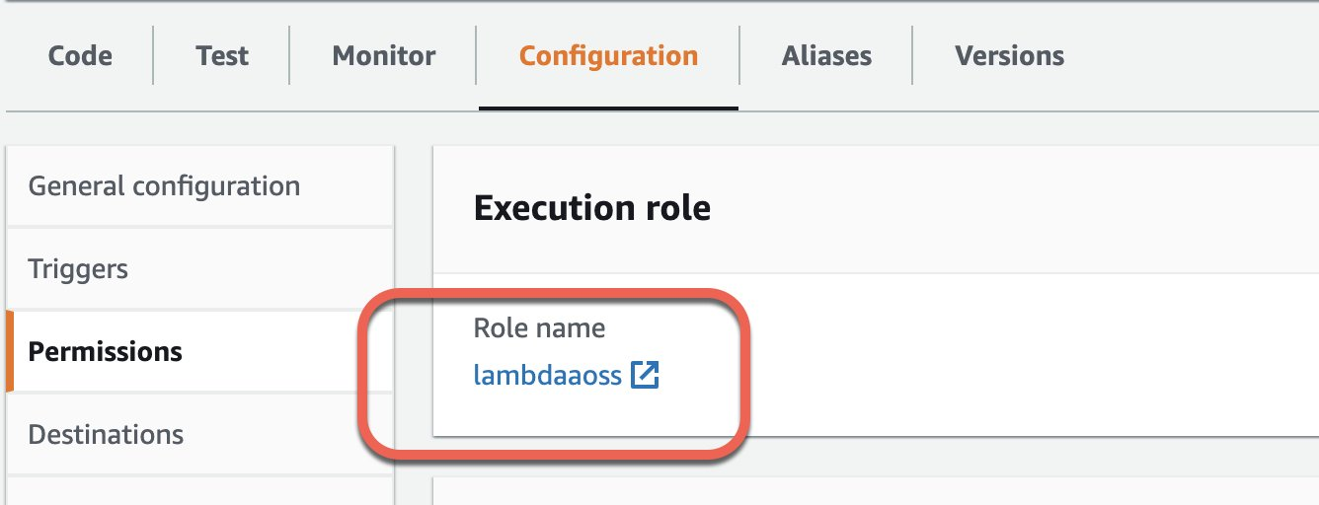
- Add this role name as one of the principals of your movie-search collection’s data access policy.
Principals can be AWS Identity and Access Management (IAM) users, role ARNs, or SAML identities. These principals must be within the current AWS account.
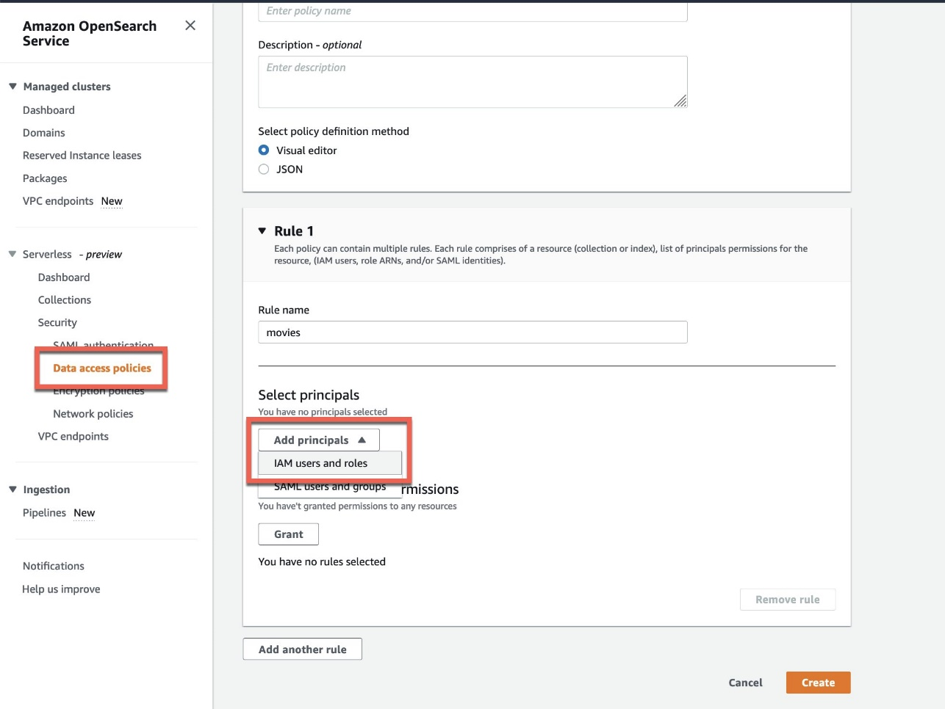
After you add the role name as a principal, you can see the role ARN updated in your rule, as show in the following screenshot.
Now you can grant collection and index permissions to this principal.
For more details about data access policies, refer to Data access control for Amazon OpenSearch Serverless. Skipping this step or not running it correctly will result in permission errors, and your Lambda code won’t be able to query the Geoportal catalog.
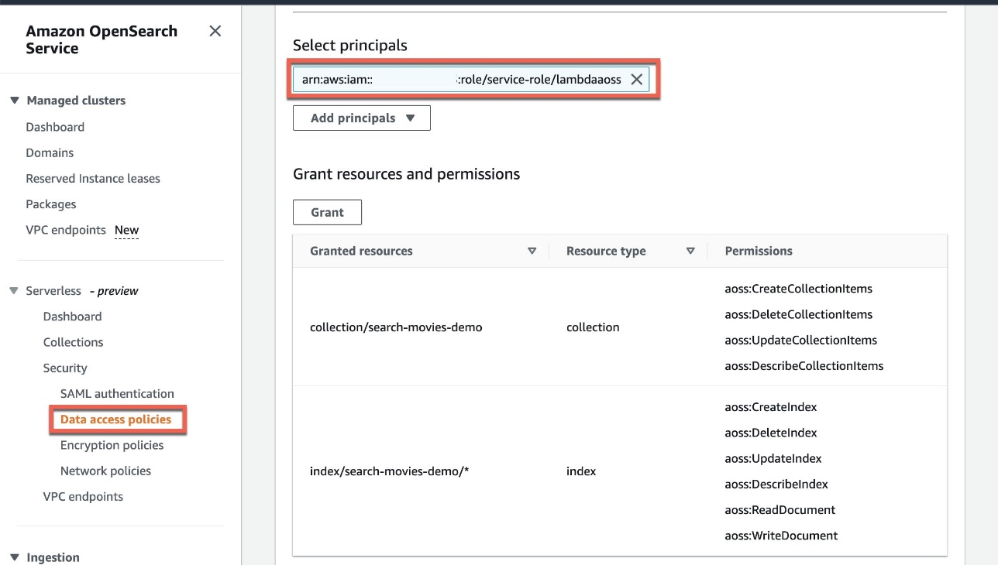

Edit Role of lambda function
- On the Lambda console, navigate to your function.
- On the Configuration tab, in the Permissions section, Click on Execution role
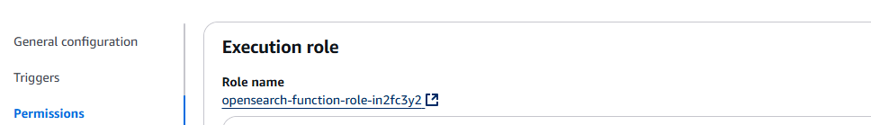

- Open Permission Policies
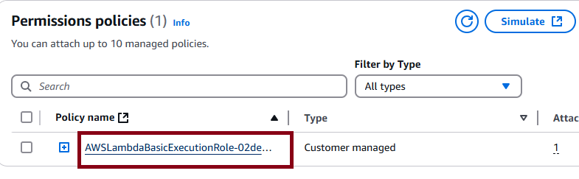
Add below permission
{
"Sid": "VisualEditor0",
"Effect": "Allow",
"Action": [
"aoss:DashboardsAccessAll",
"aoss:APIAccessAll"
],
"Resource": "*"
}

Create the API in API Gateway
To create your API using the API Gateway console
- Navigate to the API Gateway console at https://console.aws.amazon.com/apigateway/home. On the left navigation pane, choose APIs.
- Locate REST API (not private) and choose Build.
- On the following page, locate the Create new API section and make sure New API is selected.
- Configure the following fields:
  - API name: opensearch-api
  - Description: Public API for searching an Amazon OpenSearch Service domain
  - Endpoint Type: Regional
- Choose Create API.
- Choose Actions and Create Method.
- Select POST in the dropdown and click the checkmark to confirm.
- Configure the following settings, then choose Save:
Setting | Value
Integration type | Lambda function
Use Lambda proxy integration | Yes
Lambda region | us-east-1
Lambda function | opensearch-lambda
Use default timeout | Yes
- Configure the method request
Choose Method Request and configure the following settings:
Setting | Value
Authorization | NONE
Request Validator | None
API Key Required | false
Under URL Query String Parameters, choose Add query string and configure the following two parameters:
Setting | Value
Name | from  size
Required | Yes

Enable CORS on the POST resource. Under Advanced, set Access-Control-Allow-Credentials to 'true'.

Deploy the API and configure a stage
The API Gateway console lets you deploy an API by creating a deployment and associating it with a new or existing stage.
- Choose Actions and Deploy API.
- For Deployment stage choose New Stage and name the stage opensearch-api-test.
- Choose Deploy.
- Configure the following settings in the stage editor, then choose Save Changes:
Setting | Value
Enable throttling | Yes
Rate | 1000
Burst | 500

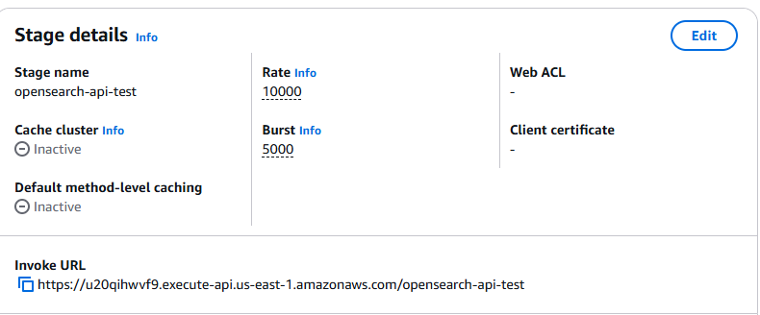

Note down the invoke URL and configure this in app-context.xml
<beans:property name="awsAPIGatewayEndpoint" value=" "/> <!-- API gateway endpoint -->

