DIRECTORATE OF LABORATORY MEDICINE

Generic Procedure

AS Procedure for Reviewing and Monitoring Referral Laboratories

Owner & Update Responsibility | Validator: | Document Control Authoriser:
Joanne Duffy | Louise Fallon | Louise Fallon
Title: Principal Clinical Scientist | Title: Quality Manager | Title: Quality Manager
 | Signature: | Signature:

This Document is Valid for these Sites:  (Delete any that do not apply) | - Good Hope Hospital  - Heartlands Hospital  - Solihull Hospital
Document Type:  (Procedure/Policy/Report/etc) | - Procedure
Personnel & Training Requirements: | - To be used by all staff

CONTENTS
1. INTRODUCTION 3
1.1. Scope and purpose 3
1.2. Responsibility 3
1.3. Related Documents 3
1.4. References 3
2. METHODOLOGY 3

INTRODUCTION

Scope and purpose
In order to comply with ISO 15189 Standard 4.5 it is necessary on a regular basis to be assured that the selected referral laboratory is maintaining the quality of the service they provide. This can be achieved by obtaining information about, for example, Accreditation Status, EQA performance, Uncertainty of Measurement and Turnaround Times from these laboratories.
Turnaround times for referred samples are monitored along with all turnaround times. Confirmation of EQA participation and performance for referral laboratories should be periodically reviewed to ensure compliance. All referral laboratories are instructed by letter to inform us of any changes to CPA/UKAS accreditation status, turnaround times, EQA performance etc.

This document describes the procedures to follow to obtain this information.

Responsibility
The Laboratory Management Committee is responsible for ensuring the implementation and maintenance of this procedure. The Quality Lead in each section is responsible for ensuring all information is collected and reviewed.

Related Documents
- AssayXchange website (http://heft-send-away.herokuapp.com)
- GM.P019 Referral Policy
- GM.F995 Referral Laboratory Selection form

References
- ISO 15189 Standard: 4.5
- A Practical Guide to ISO 15189 in Laboratory Medicine

METHODOLOGY
Selection Criteria for Referral laboratories.
The selection criteria for referral laboratories are set out in GM.P019. The referral laboratory is assessed using this criteria and the form GM.F995 is completed and signed off by the Clinical Lead for that particular speciality. All selection forms are stored in a folder with the referral laboratory lead.
The only time this form needs to be completed again for the same referral laboratory is if there has been a change in the service provided by the laboratory, either by communication from the referral laboratory to ourselves or when we have contacted them as part of our annual check.

Sending out first letter

- There is a link to the AssayXchange website in Q-pulse that is set to be reviewed annually. The website is accessible to all staff and usernames and passwords can be obtained from the webmaster.
- Laboratories where an initial letter needs to be sent – or information is 12 months out of date are indicated in the first link in the current status of send away investigations panel on the laboratory home page (figure 1) or on the menu item indicated on the left hand side of the web page

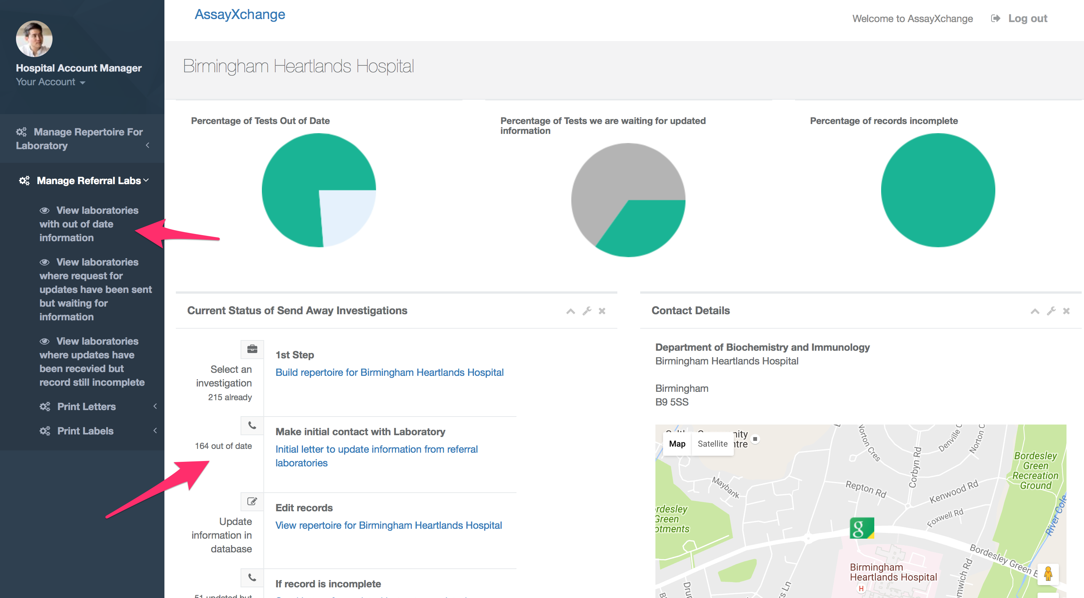
Figure 1: Initial Letter Send
- Clicking on the menu item brings up a display of the of laboratories and tests which have out of date information or have not yet been approached by the laboratory.

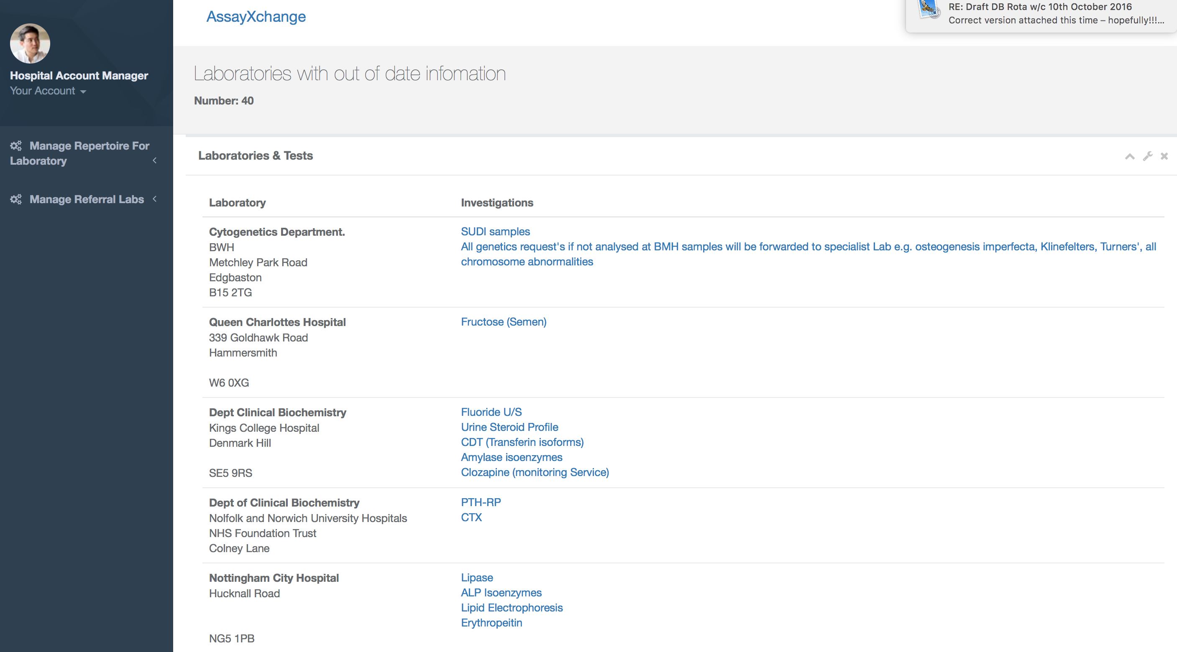
- Clicking the link in the panel brings up the letters ready for printing, to a printer or PDF for printing later (these letters can also be accessed under the manage referral labs | Print Letters menu option on the left hand side menu

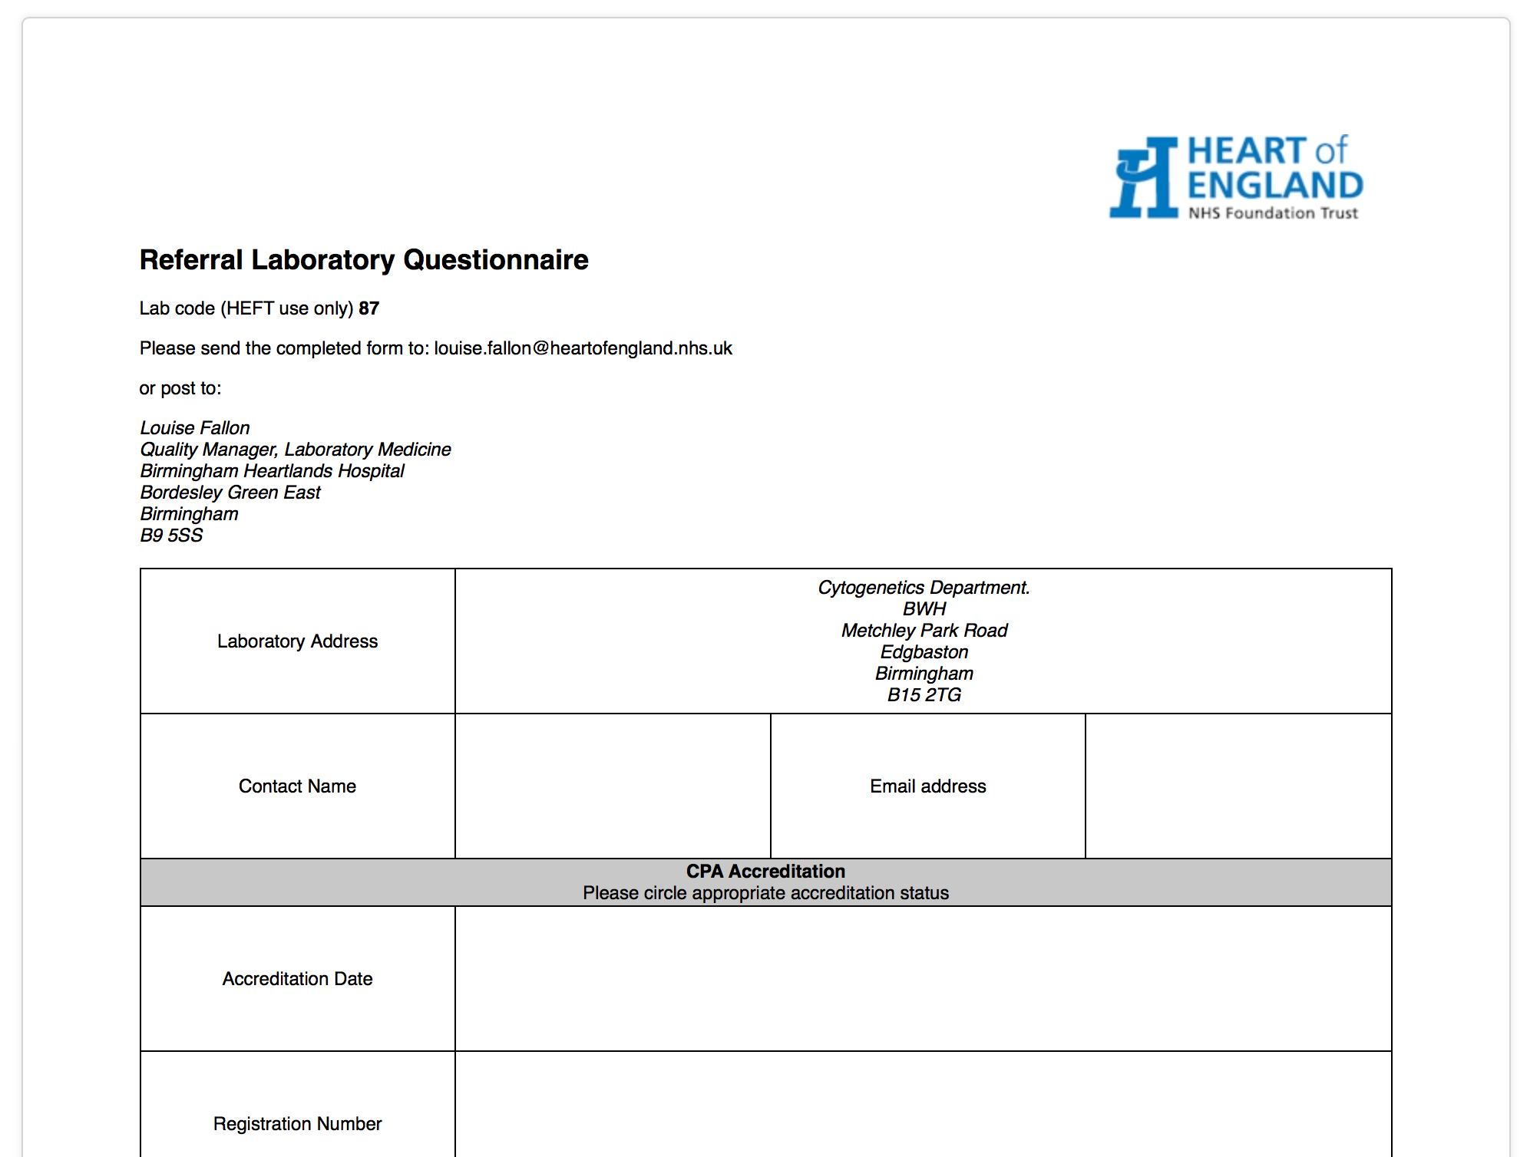

- These letters can then be posted to the required laboratories.
- Labels can be printed for these laboratories by accessing the print labels menu option and selecting the correct label type
- After successfully printing the letters, click the printed at link in the displayed web page to set flags to allow reminders to be sent and request for updates for information to be sent in 12 months.
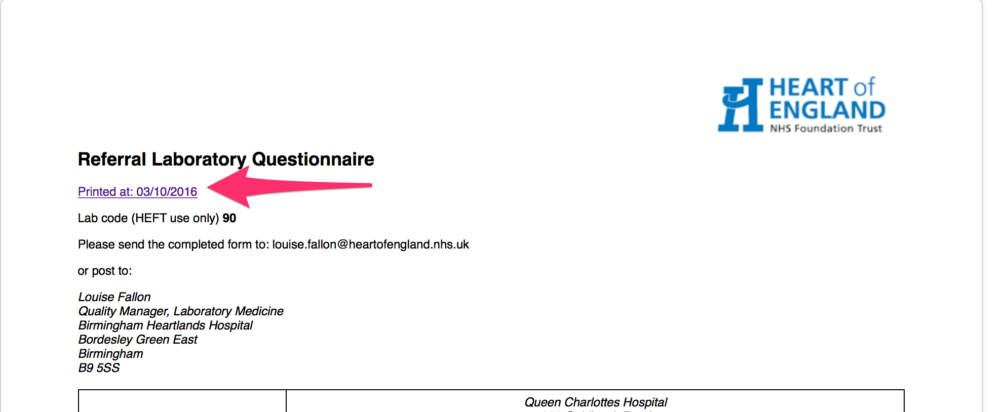

Checking responses to letters
- Receipt of responses to questionnaires should be entered into the AssayXchange website and any changeds also recorded onto the directorate website www.heftpathology.com. Details of assays received on the questionnaire need to be cross checked with details held on the laboratory web site test database. Any changes which may be required should be checked with an appropriate senior manager in the department first.
- Data can be updated in the web site by clicking on the manage repertoire for laboratory menu option and then the view repertoire for laboratory menu item. This displays a table for the current investigations in the laboratories repertoire

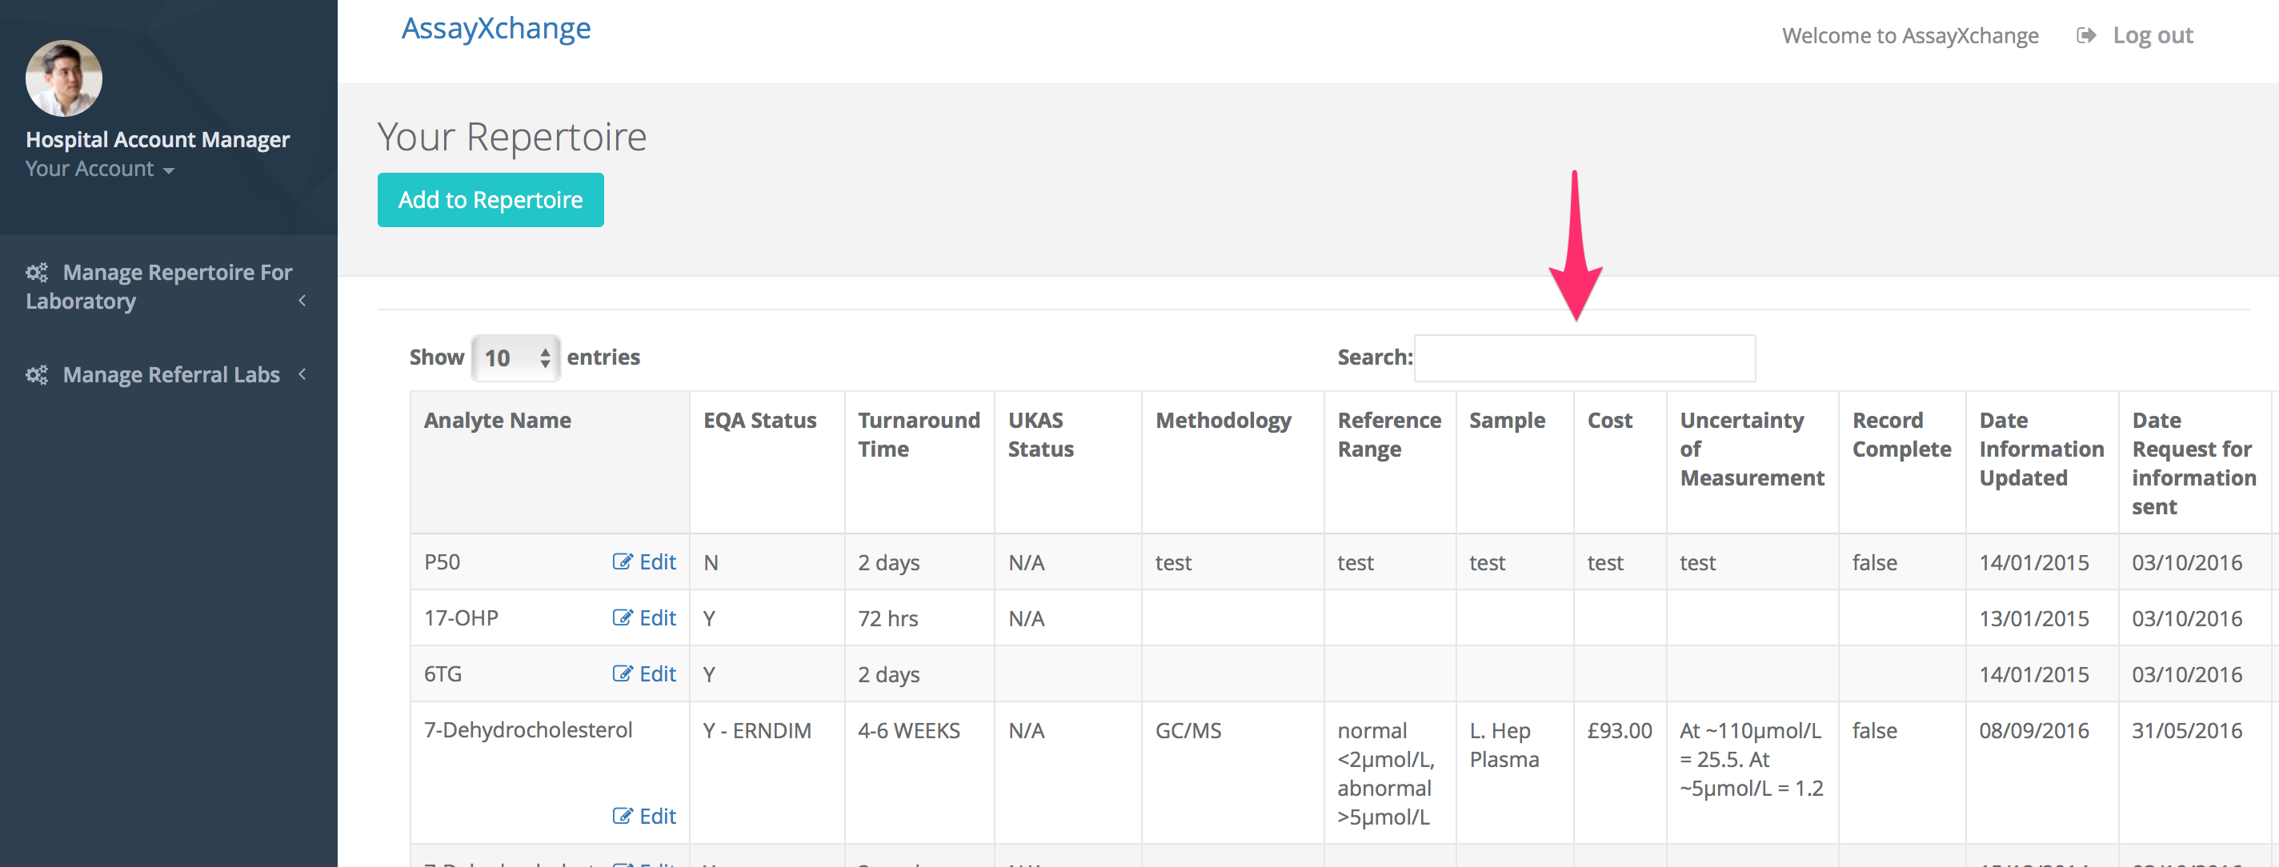

- Search for the analyte name using the search box. The table will automatically narrow down the tests matching your criteria.
- Once test has been found click the edit button next to the test name.

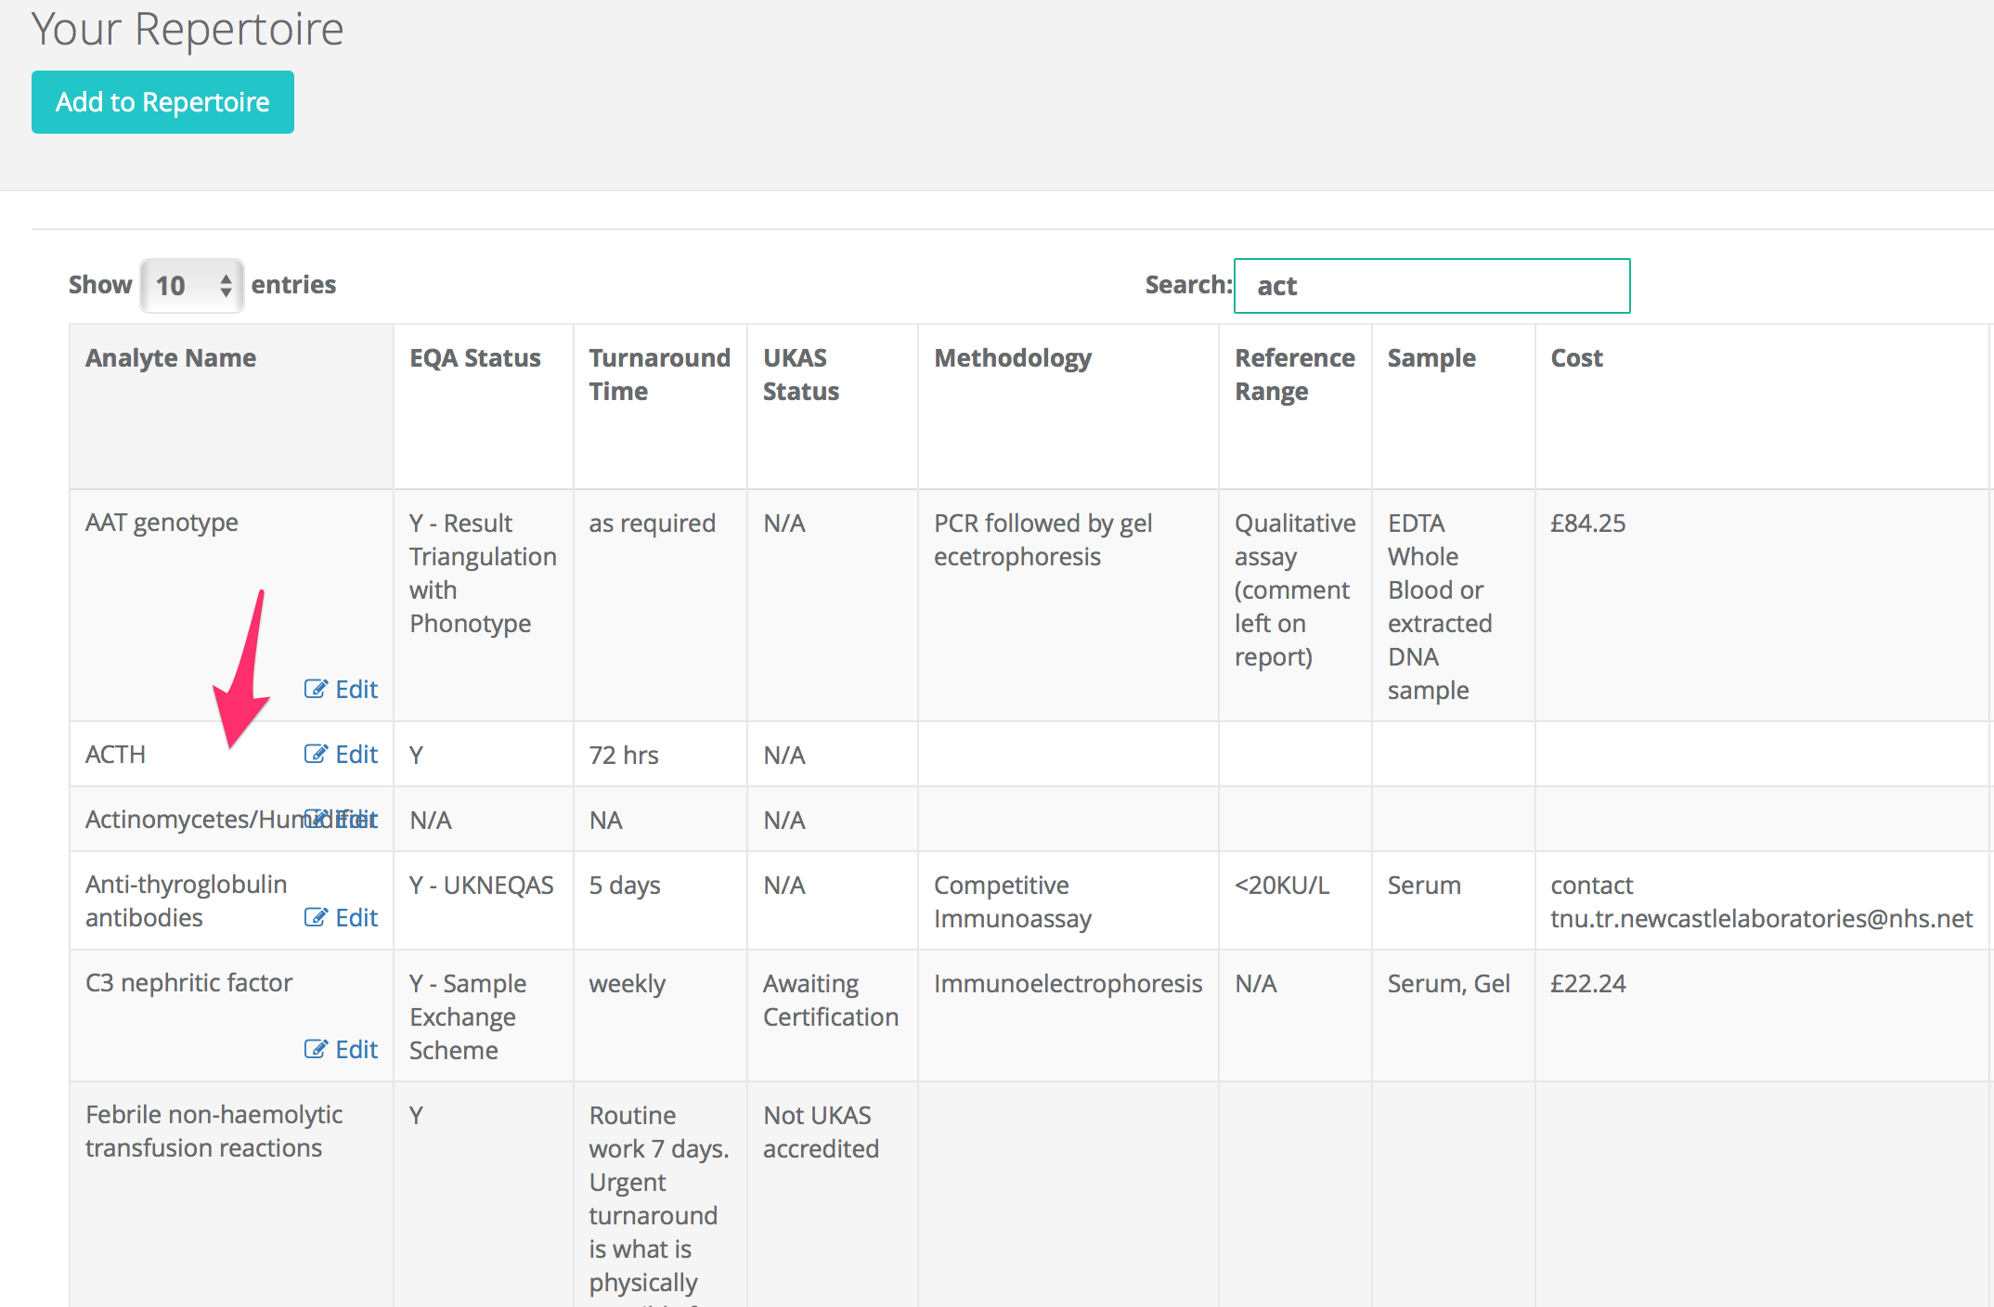
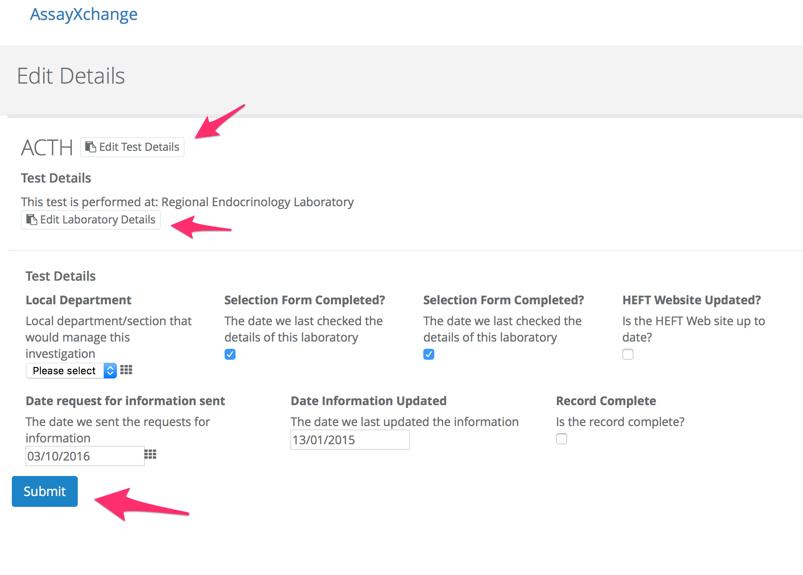
- Editing the laboratory details will update the details for all investigations sent to that laboratory. This only needs to be done once on each information update
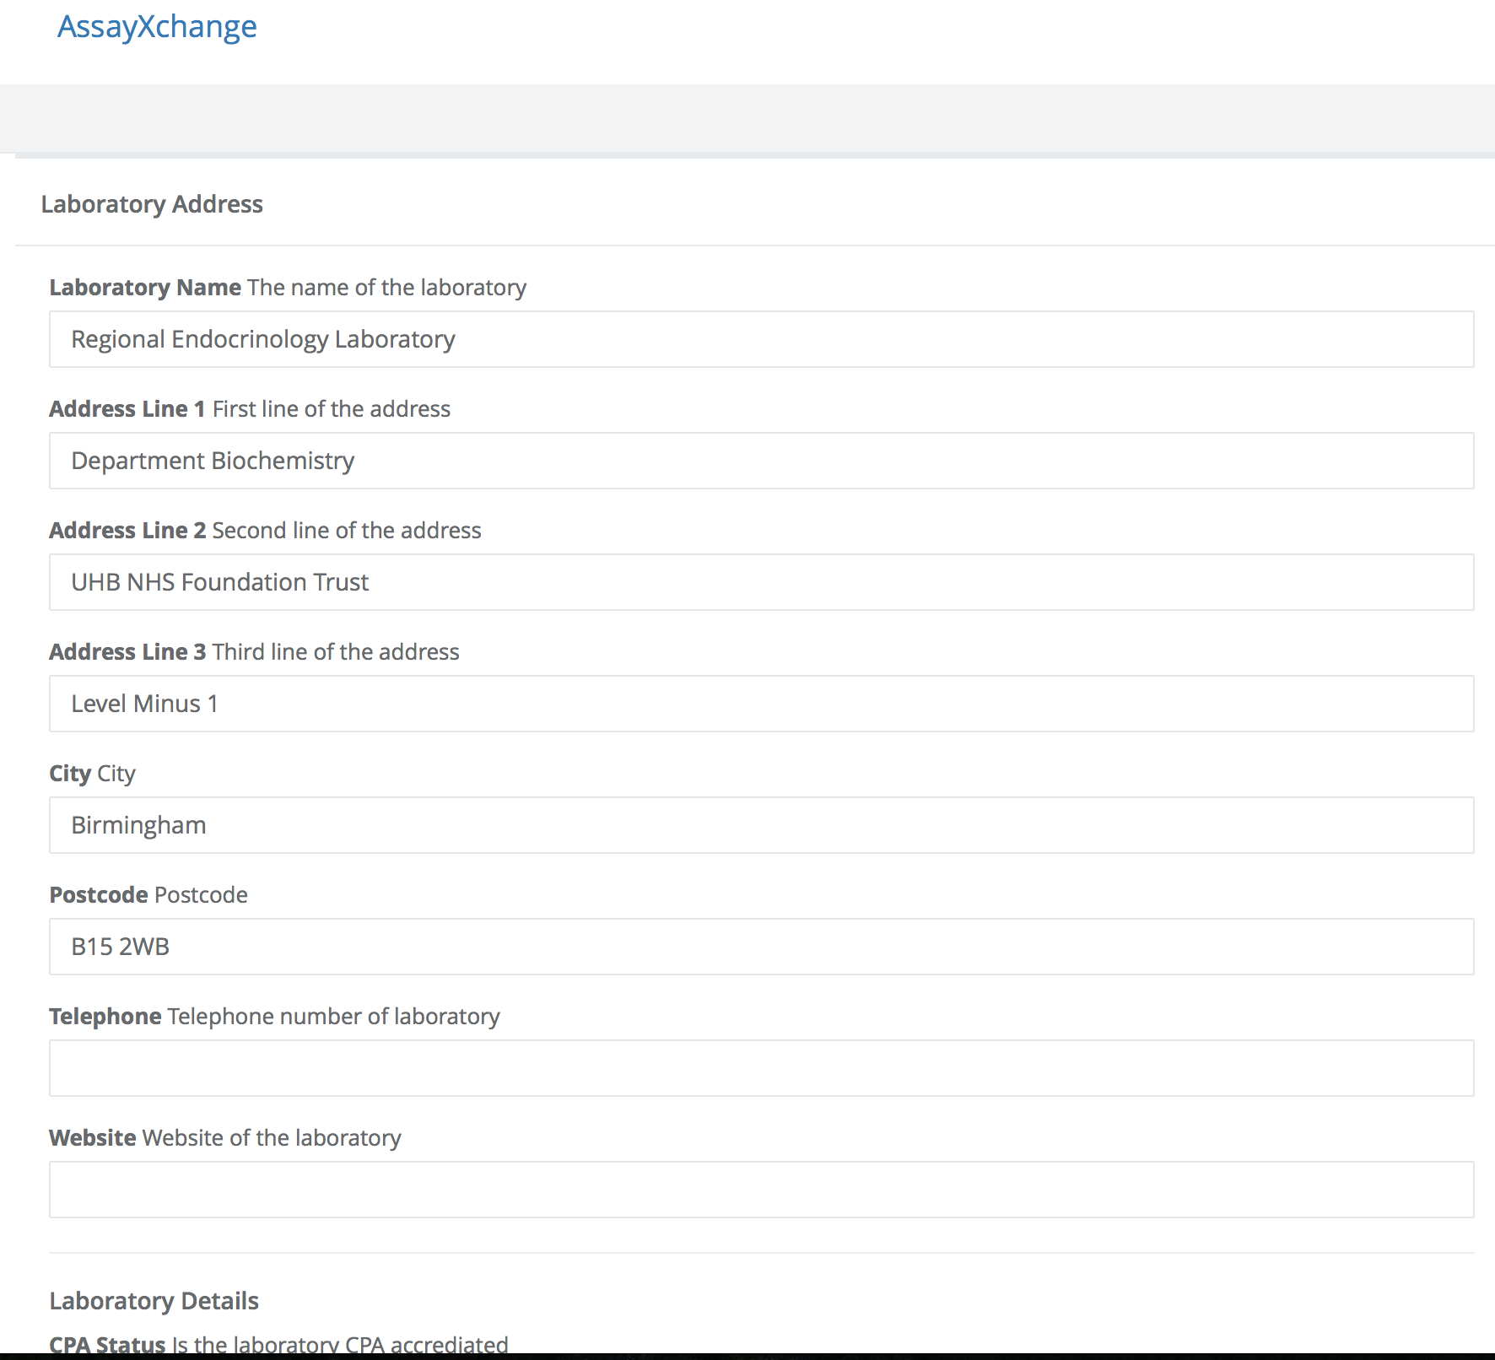

- Edit the test details to update information about the test
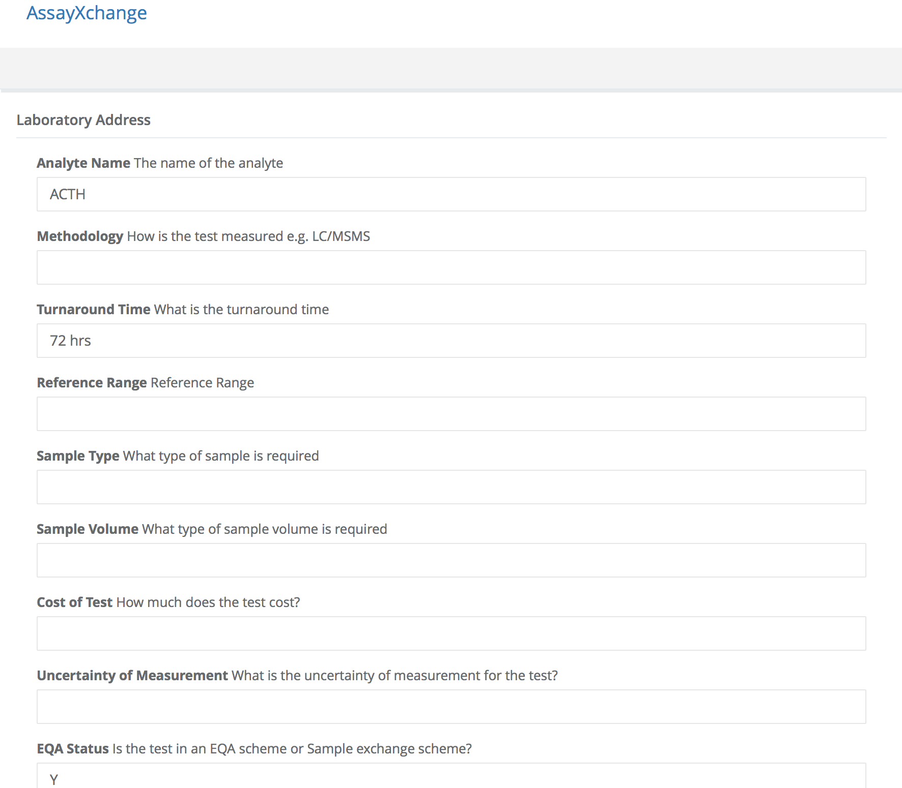

- Laboratories that fail to respond to the letter and questionnaire should be pursued by a further letter and questionnaire and or verbal communication. The AssayXchange web site lists these laboratories under the menu items listed in the screen capture below.
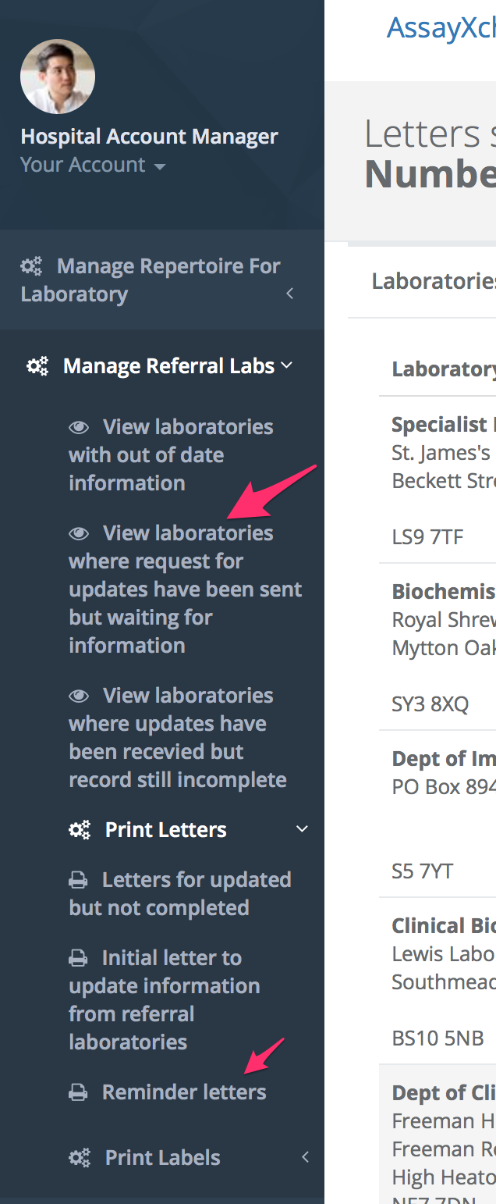
- Data can be continually entered into the website as data arrives. The website will keep track of dates for reminders for updates
- If data supplied is complete and meets all requirements mark the record as complete. This will set a flag to remind the supplier to supply updated information in 12 months.
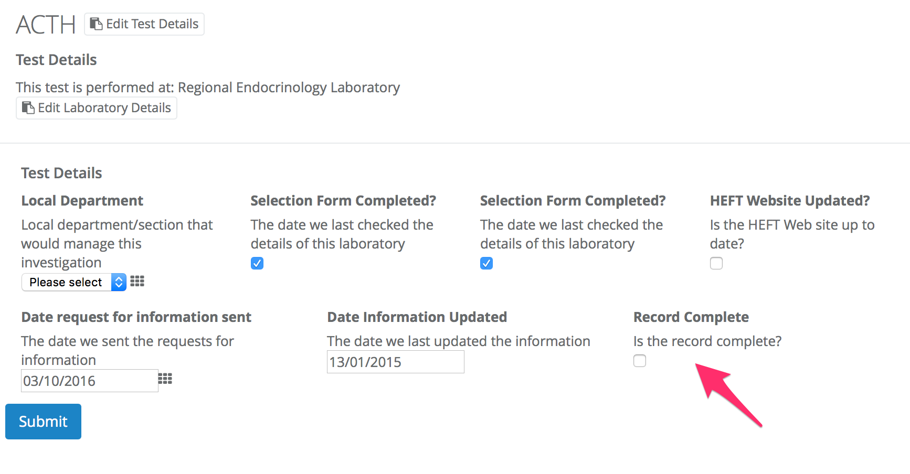
- Only laboratories that have meet the selection criteria stated in GM.P019 and have a completed selection form GM.F995 will be used for referred tests. However, as part of the periodic checks of referral laboratories, if they fail to respond to the letters, that assure us of the quality of their service, then a non-conformance against this supplier will be raised. The details of the non-conformance will be taken to senior laboratory management for consideration of any suitable further action. I.e. consider referring tests to another suitable accredited laboratory.

- If data has been supplied but it is not complete or does not meet selection criteria the record is incomplete. These laboratories can be accessed by clicking the relevant menu options on the left hand side menu.

- Reminder letters for this information can be sent. The web site will automatically track when information was requested or out of date.

Adding a new Investigation or Laboratory
New information can be passed to the web master at craig.webster@heartofengland.nhs.uk for adding to the web site.

