

FurEver FurBabies AMS

Overview

The project I have chosen to implement will be a Management System for any pet adoption agency. This web application will allow the agency to post pets for adoption, Potential adopters can create a login, profile and preferences. They can also search on what kind of pet they are looking to adopt. Users can also request a meet and greet for the pet adoption. This system will help homeless animals that are needing their forever home all around the community. It will help the agency staff to better manage all the animals they have in their facility and find the best forever family match for that pet. Faster pet adoptions mean more saved lives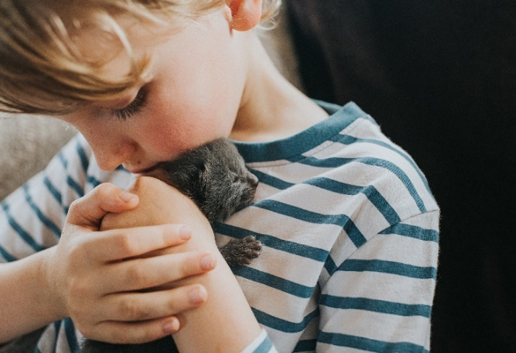.

Problem/Solution

The overwhelming pet population

and homeless pets in America has

1.5 million pets euthanized every

year in United States. The has shelters overrun with family less animals in need of their forever home. One of the biggest reasons pets go up for adoption, is the pet is just not a good fit for that family based on its personality traits. The AMS system will allow faster and easier adoptions and a better fit for the right family with the meet and greet option.

Value

The value of this application to the community would be allowing homeless animals find their forever family. The adoption agencies would have a better way of managing their adoptions for pets and enables them to better assist with the potential pet owner in finding the best fit for the sheltered pets. This in turn will eliminate return of pets back to the shelter. It allows adopters to ask any questions needed about the animal for adoption to be sure it is the right pet for their home and family.

Goals

A goal of this application would be to allow faster and smoother adoption processes of homeless pets. Faster adoptions mean more pets being able to be taken into the agency and more pet lives saved every year.

A second goal of this application would allow the agency staff to better manage meet and greets and find the best fit for that particular pet and their needs.

Personas

The application will be set to target three main audiences.

The first audience being the agency volunteer/foster. A middle-aged adult with a few pets of their own and a love for animals and volunteering or working to save animals lives.

The second main audience would be young adults looking to start a family of their own and a family pet for everyone to love.

The third audience would be a retired adult looking for the companion for the everyday retired life. One that likes to possibly foster to adopt or volunteer their time to the shelter.

Minimal Viable Product (MVP)

**Overview/Features**

The Languages I plan to use in the application is python, SQL and some JavaScript along with the webpage design of HTML, CSS and styling will incorporate Bootstrap. I plan to implement an AWS API Gateway along with a Postgres database for record storage.

Adopter UI

1. Can create a login account.
2. Can create a profile and set preferences on what kind of pet they are looking for.
3. Search for a dog/cat based on input characteristics
4. Can send a request for that particular pet for a meet and greet.

**Architecture**

