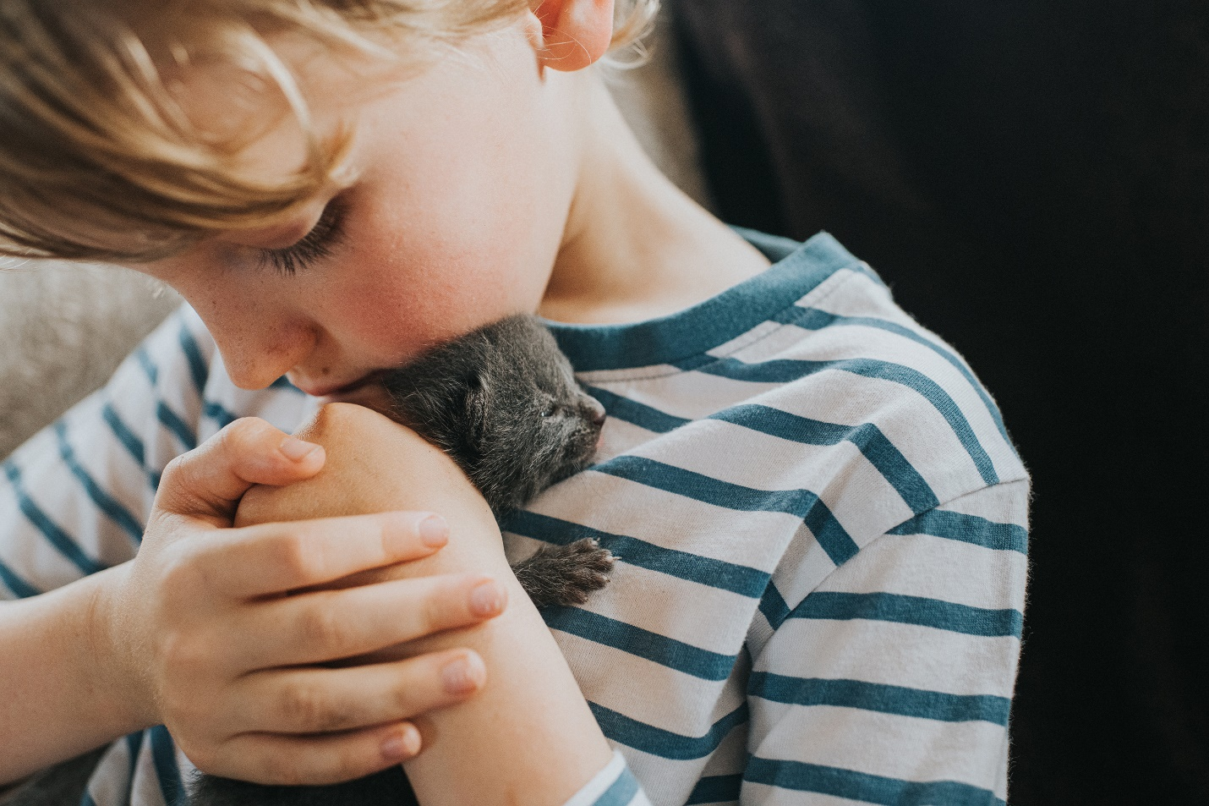

Furever

FurBabies AMS :

Database Design

Introduction

The database framework I will be using for my database requirement will be PostgreSQL. I am using this relational database framework because my data has many relationships that can be demonstrated for my application. Animals have a lot of the same characteristics, this shows many-to-many relationships. Potential Adopters have a lot in common with what they are searching for in a pet. This would be another many-to-many relationships. Therefore, I chose a relational database, such as PostgreSQL for my project.

I plan to host this RDS through AWS RDS on the free tier that they offer. This will provide an easy management for the data that is collected as well as a security feature for the logins created by the potential pet adopter.

To integrate a RESTful API, I plan to use AWS REST API gateway for the endpoints required. This will be the simplest to integrate with the database for the application when the User is making a request from the relational database.

Tables/Data Structures

*Dogs and Cats*

The tables for Dogs and Cats will contain many-to-many relationships. I will connect the two tables with the primary key of Age. The potential adopter will be able to search for an animal by the age they are looking for, in example a puppy, kitten or adult pet.

*Login/Adopter Profile/Preferences*

The tables for Login, Adopter Profile and Preferences will contain many-to-many relationships along with the Dogs and Cats tables. The primary key I will connect the preferences table to dogs and cats will be current pets and if the adopter has any children. The preferences table will be connected to the Adopter profile table with a primary key of the email address. The login table will also use the same primary key of the email address to connect to the Adopter profile and the preferences.

Entity-Relationship Diagram

C:\Program Files\PostgreSQL\15\data