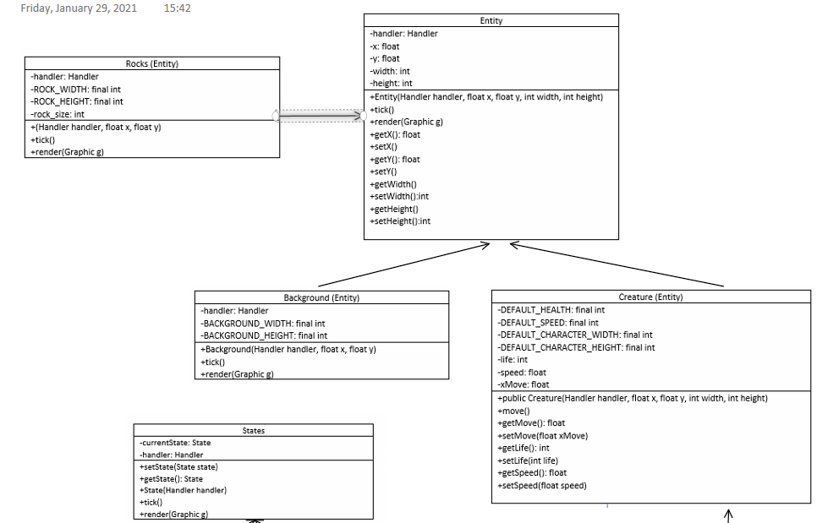

**Polymorphism**

Our Entity class contains two abstract methods tick() and render() which is the parent class for our polymorphism method. In child classes such as background, big rock, boot rock, fire rock, heart rock, ice rock, medium rock, player and smoll rocks allows over riding to take place. This is because similar operations have different ways for different object types.

Parent class example

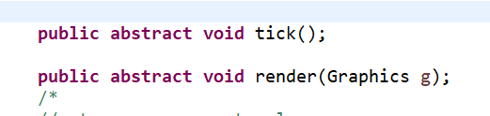

Child class example

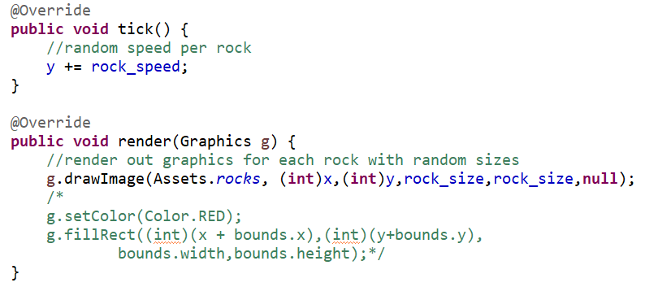

**Abstract class**

Entity class is the abstract class, there are two method are abstract, tick() and render(). Each entity appear in GUI, thus they should have these 2 method implement.

Tick() method is use for movement and animation, as the movement for different entity will have different tick.

Render() method use for drawing different images, each will have different image.