FIT3179 Data Visualization Week 9 Homework

Name: Chenlongjie Weng

Student ID: 29334152

Studio: 4

Tutor: Joe Liu

<https://cwen0008.github.io/FIT3179/>

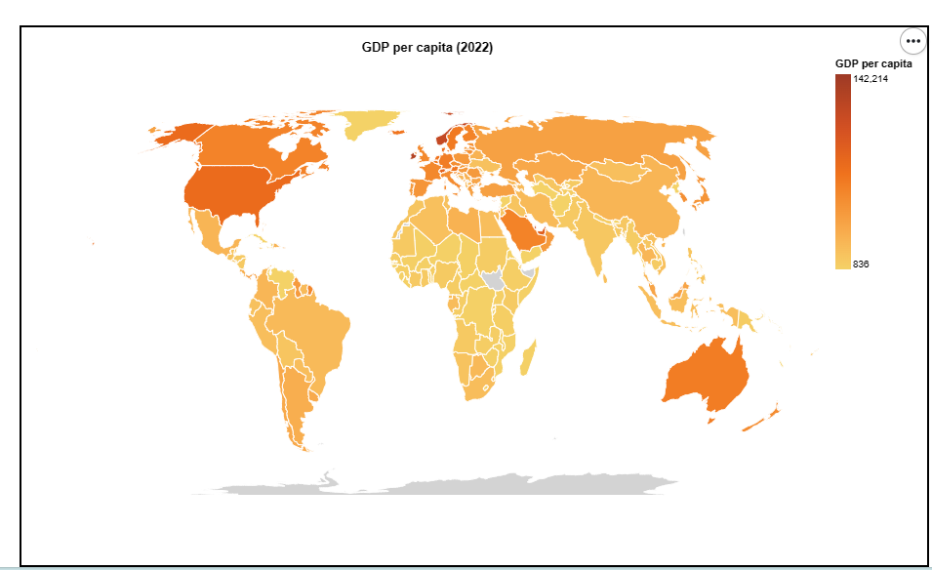

Domain: The GDP per capita in 2022

Source: <https://data.worldbank.org/indicator/NY.GDP.PCAP.PP.CD>

Data Type: table

Data attribute : country code(categorical), GDP per capita(ordered, quantitative)

Data transformation: delete some not useful columns and focus on data in 2022

Map Idiom : A Choropleth map is the preferred choice for comparing GDP per capita among countries, as it is better suited for displaying quantitative data at the country level, unlike proportional symbol maps, which are more appropriate for representing quantitative values at specific geographic locations such as cities or states.