FIT3179 Data Visualization Week 10 Homework

Name: Chenlongjie Weng

Student ID: 29334152

Studio: 4

Tutor: Joe Liu

<https://cwen0008.github.io/FIT3179/>

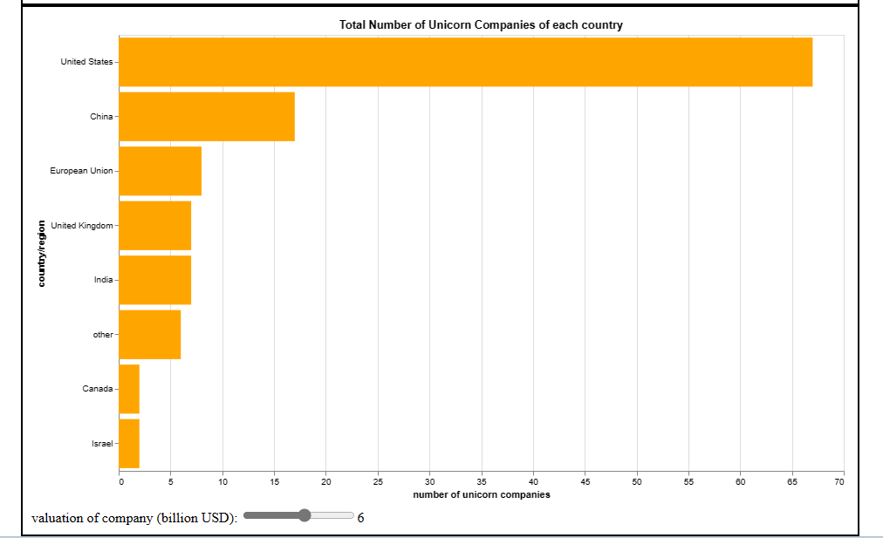

Domain: Number of Unicorn company of each country

Source: <https://data.worldbank.org/indicator/NY.GDP.PCAP.PP.CD>

Data Type: table

Data attribute : country (categorical), number of company (ordered, quantitative)

Map Idiom : This bar chart is designed to facilitate a comparative analysis of the number of unicorn companies across various countries. It includes a user-friendly filtering mechanism in the form of a slider, allowing users to dynamically explore the distribution of companies based on their valuations within the range of 1 to 10 billion USD in different countries.