Active Directory Help Desk Lab Documentation
Windows Server 2019 | UTM/QEMU | Active Directory | DNS | DHCP | GPO | Help Desk Ticketing
Prepared as an IT Support / Help Desk portfolio artifact.

1. Objective
Built a Windows Server 2019 Active Directory environment to gain hands-on experience with user account management, Group Policy, domain administration, DNS, DHCP, and common Help Desk troubleshooting tasks.
The lab simulates Tier 1 Help Desk and junior systems administration workflows, including creating domain users, joining a client workstation to the domain, managing security groups, resetting passwords, unlocking accounts, mapping network drives, validating file share permissions, applying Group Policy, and documenting mock support tickets.

2. Environment
Category | Configuration
Hardware | Apple Mac with Apple M1 Pro processor.
Virtualization Platform | UTM / QEMU running on macOS. Windows Server 2019 was built as an x86_64 VM; Windows 11 client was built as an ARM/Apple Silicon compatible VM.
Server | AD-Server-01 / DC01 running Windows Server 2019 Standard Evaluation Desktop Experience. Static IP: 192.168.64.2.
Client | CLIENT-01 running Windows 11, joined to homeitlab.local. Client used for authentication, file share, GPO, ticketing, and network validation.
Domain | homeitlab.local.
Core Services | Active Directory Domain Services, DNS Server, DHCP Server, Group Policy Management, File and Storage Services, and optional Active Directory Certificate Services exposure.
Network | 192.168.64.0/24 UTM virtual network. Gateway: 192.168.64.1. Domain DNS: 192.168.64.2.

3. Implementation Steps

Phase 1: Virtual Machine Setup
1. Created a Windows Server virtual machine in UTM and named it AD-Server-01.
2. Configured the server VM with x86_64 architecture, Q35 machine type, 8 GB RAM, 4 CPU cores, and an 80 GB virtual disk.
3. Mounted the Windows Server 2019 Evaluation ISO for installation.
4. Created a separate Windows 11 client VM named CLIENT-01 using the Apple Silicon compatible Windows 11 ARM image.

Phase 2: Windows Server Installation
1. Installed Windows Server 2019 Standard Evaluation with Desktop Experience.
2. Selected Custom installation and installed Windows to the primary virtual disk.
3. Removed the Windows installation ISO after setup so the VM booted from the installed disk.
4. Installed UTM Guest Tools after the operating system installation to improve display and VM usability.

Phase 3: Active Directory Configuration
1. Renamed the server to DC01.
2. Configured a static IPv4 address of 192.168.64.2 with the gateway set to 192.168.64.1.
3. Configured DC01 to use itself for DNS.
4. Installed Active Directory Domain Services and DNS Server roles.
5. Promoted DC01 to a domain controller and created the homeitlab.local forest.
6. Logged into the domain as HOMEITLAB\Administrator.

Phase 4: User, OU, and Group Management
1. Created Organizational Units for IT, Help Desk, HR, Finance, Workstations, and Disabled Users.
2. Created sample user accounts including James Smith, Alex Johnson, Eric Williams, Mike Brown, Brianna Rowe, Jared Hikes, and Lou Gibbs.
3. Created the Technicians security group to represent Help Desk team access.
4. Practiced password reset, account unlock, and new user onboarding workflows.
5. Added users to appropriate departmental OUs and security groups.

4. Updated Progress
Area | Status | Summary
Client Domain Join | Completed | CLIENT-01 was joined to homeitlab.local and verified in Active Directory Users and Computers.
Help Desk File Share | Completed | TechniciansShare was created on DC01 and tested from CLIENT-01.
Access Control | Completed | Help Desk group members could access the share; a non-group user was denied.
Group Policy | Completed | Created and tested desktop wallpaper GPOs, including a Finance Department wallpaper policy.
Ticketing System Documentation | Completed | Created mock tickets for password reset, account lockout, onboarding, and group access.
DHCP Server | Completed / Documented | Installed DHCP Server, authorized it in AD, created an IPv4 scope, configured options, and validated client connectivity.

5. CLIENT-01 Domain Join and Validation
1. Installed Windows 11 on CLIENT-01 and renamed the computer.
2. Validated connectivity to DC01 using ping and DNS lookup commands.
3. Joined CLIENT-01 to homeitlab.local using domain administrator credentials.
4. Verified CLIENT-01 appeared as a computer object in Active Directory.
5. Logged in as domain users to test authentication and domain profile creation.
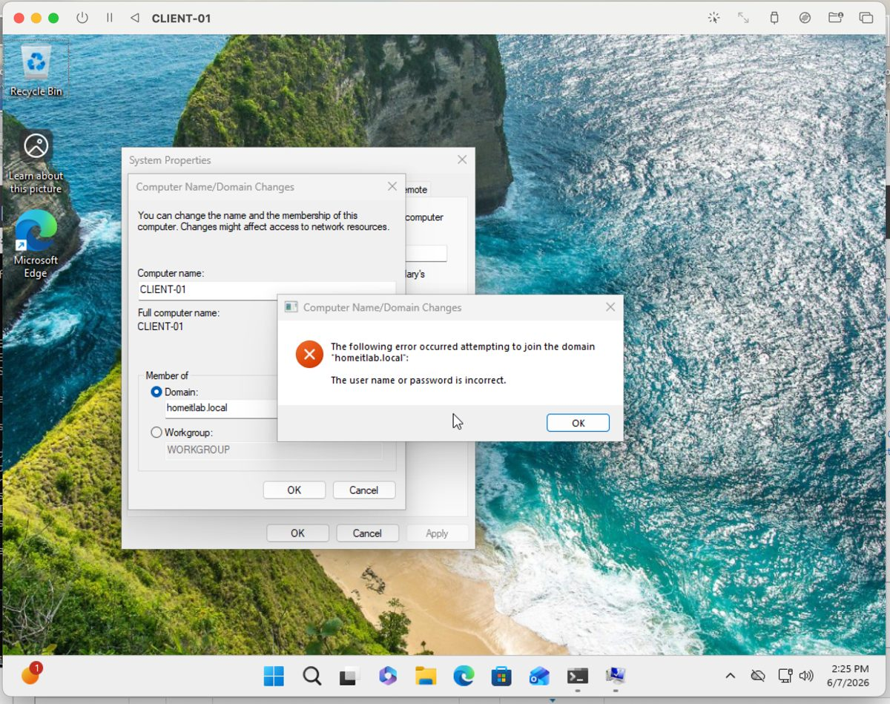
Figure 1. CLIENT-01 successfully joined to homeitlab.local.
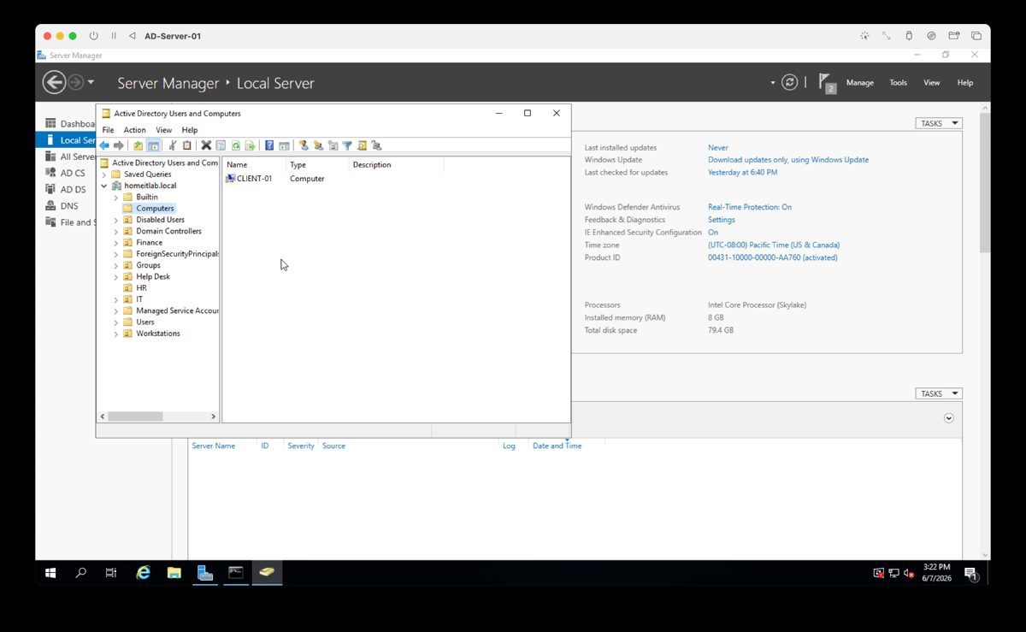
Figure 2. CLIENT-01 computer object visible in Active Directory Users and Computers.

6. File Share, Permissions, and Network Drive Mapping
Item | Configuration
Share Name | TechniciansShare
UNC Path | \\DC01\TechniciansShare
Purpose | Help Desk / Technicians file share access testing.
Authorized Access | Technicians security group / Help Desk members.
Validation | Help Desk group member could access and write. Non-member was denied access.
Mapping | Mapped the share as a network drive on CLIENT-01.
1. Created TechniciansShare on DC01 using File and Storage Services.
2. Configured permissions to allow Help Desk/Technicians group access.
3. Logged into CLIENT-01 as a Help Desk member and verified access to the share.
4. Created a test file named For Help Desk Only to confirm write permissions.
5. Logged in as a user outside the group and verified access was denied.
6. Mapped the share as a network drive to simulate a real support request.
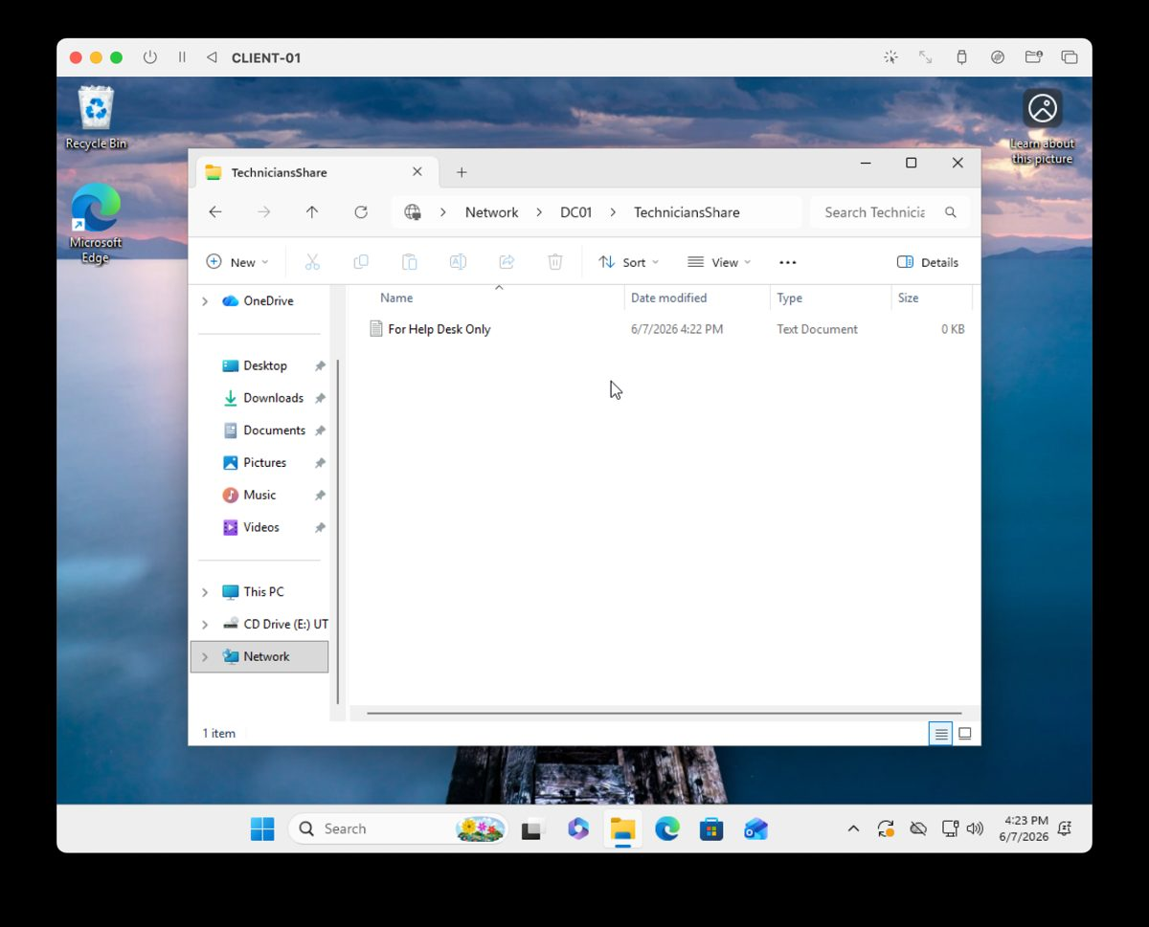
Figure 3. Help Desk group member accessing TechniciansShare.
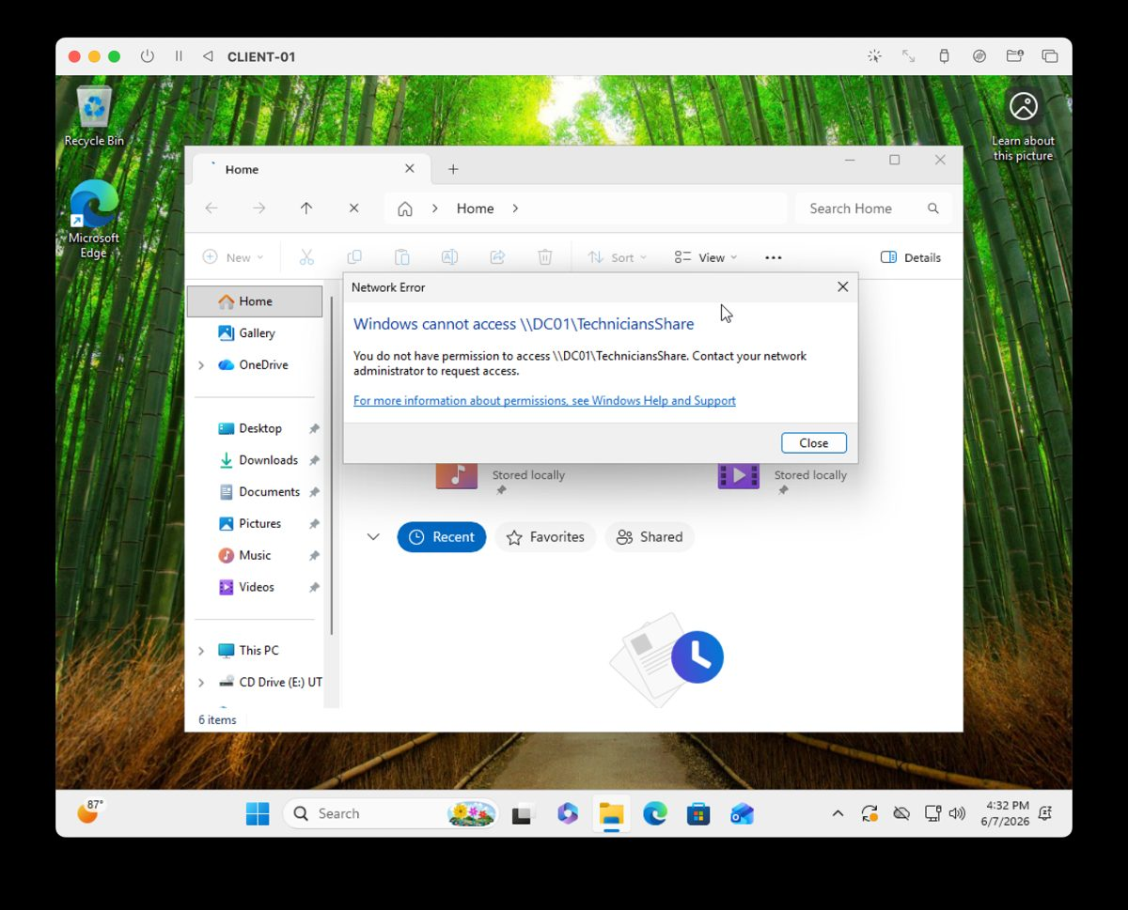
Figure 4. Unauthorized user denied access to TechniciansShare.

7. Group Policy Configuration
GPO | Purpose | Validation
SetFinanceBackground | Applied a Finance Department desktop wallpaper to users in the Finance OU. | Logged into CLIENT-01 as a Finance user and confirmed the wallpaper applied.
Corporate/Desktop Wallpaper Policy | Demonstrated centralized desktop configuration through Group Policy. | Ran gpupdate /force and validated policy behavior on the client.
1. Opened Group Policy Management on DC01.
2. Created a new GPO and linked it to the target OU.
3. Enabled the Desktop Wallpaper policy and configured the wallpaper path.
4. Ran gpupdate /force on CLIENT-01.
5. Logged in as a target user and verified the wallpaper applied.
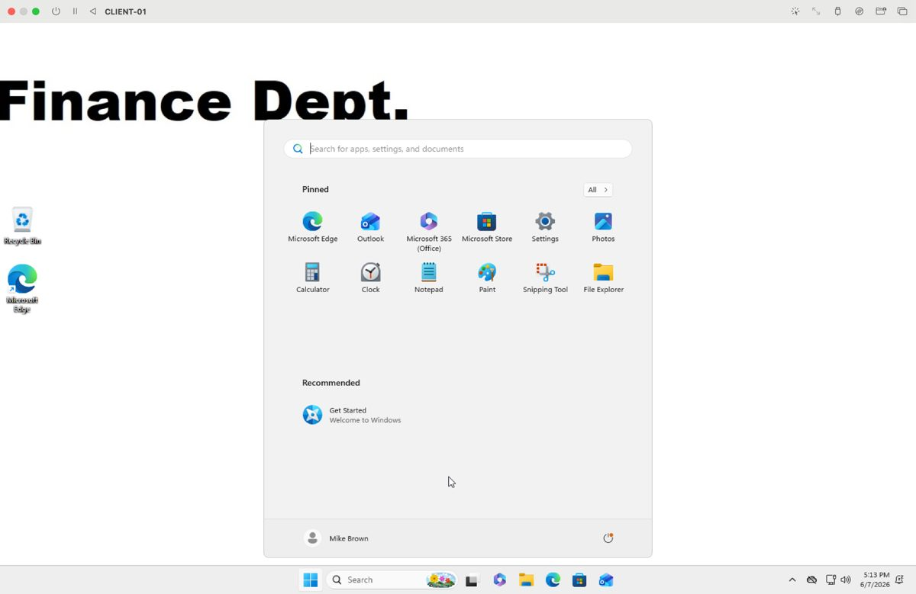
Figure 5. Finance Department wallpaper applied through Group Policy.

8. Help Desk Ticketing System Documentation
Created a ticketing log to document realistic Help Desk work in a structured format: issue, affected user, troubleshooting steps, resolution, status, and evidence screenshot names.
Ticket ID | Scenario | Resolution Summary
HD-001 | Password Reset | Password reset completed; user changed password at next logon and regained access.
HD-002 | Account Lockout | Account unlocked; user successfully authenticated afterward.
HD-003 | New User Onboarding | New AD account created, added to proper security group, and login verified.
HD-004 | Group Access Request | User added to Help Desk/Technicians group; gpupdate /force run; share access verified.
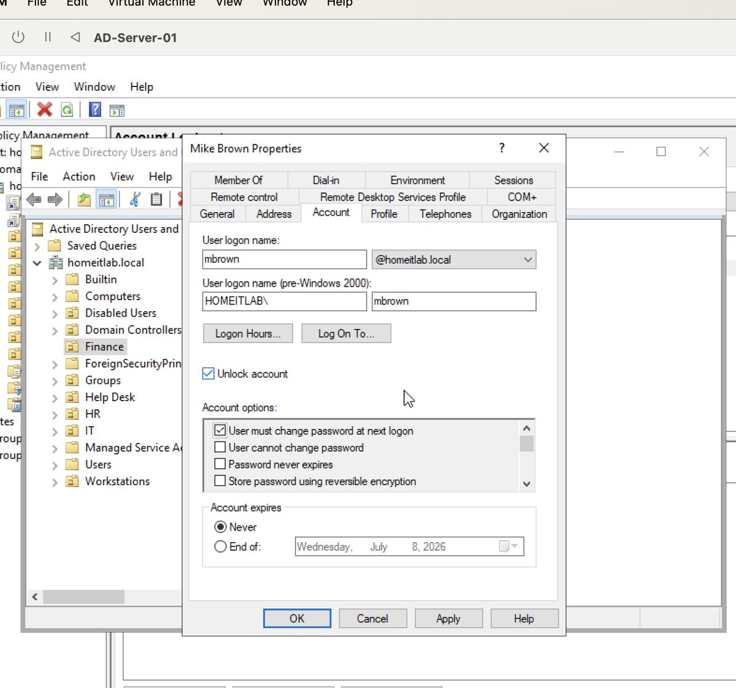
Figure 6. Password reset workflow in Active Directory Users and Computers.
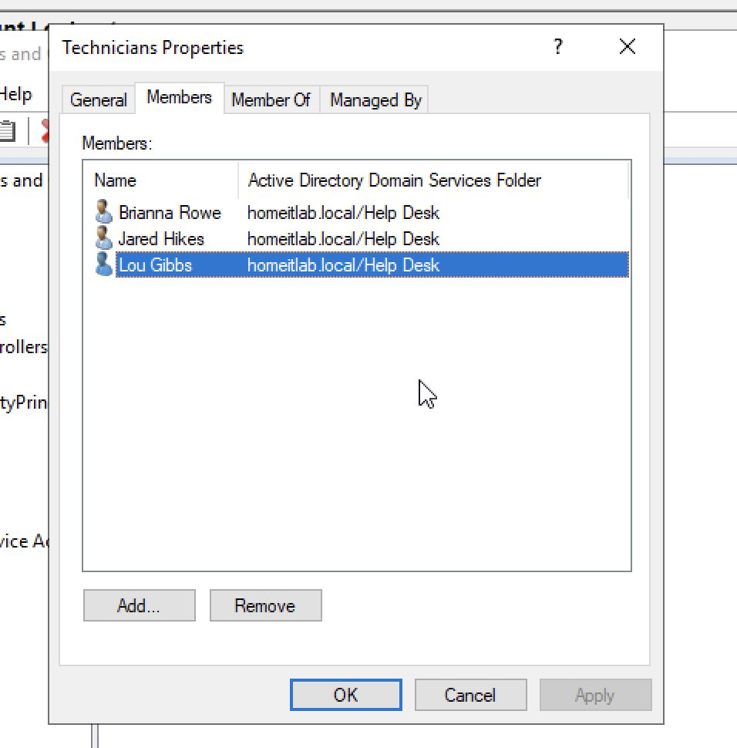
Figure 7. New user onboarding example in Active Directory.

9. DHCP Server Deployment and Scope Configuration
Installed and configured DHCP Server role, authorized DHCP in Active Directory, created and activated an IPv4 scope, configured scope options for DNS, gateway, and domain name, and validated client network connectivity.
DHCP Component | Configuration
DHCP Server | DC01.homeitlab.local
Authorization Account | HOMEITLAB\Administrator
Scope Name | HOMEITLAB-Scope
Address Pool | 192.168.64.50 - 192.168.64.100
Subnet Mask | 255.255.255.0
Router / Gateway | 192.168.64.1
DNS Server | 192.168.64.2
DNS Domain Name | homeitlab.local
1. Installed the DHCP Server role using Add Roles and Features.
2. Completed DHCP post-install configuration and authorized the server in AD DS.
3. Created the HOMEITLAB-Scope IPv4 scope.
4. Configured the address pool 192.168.64.50 through 192.168.64.100.
5. Configured scope options: 003 Router, 006 DNS Servers, and 015 DNS Domain Name.
6. Validated CLIENT-01 network connectivity and DNS configuration using ipconfig /all.
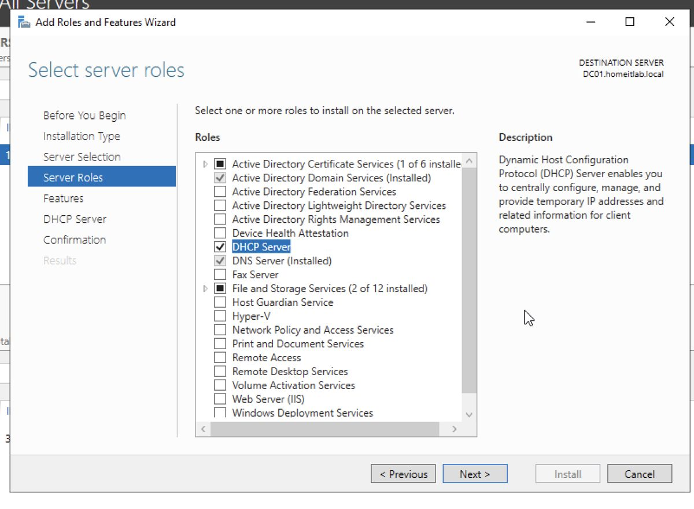
Figure 8. DHCP Server role selected in Add Roles and Features.
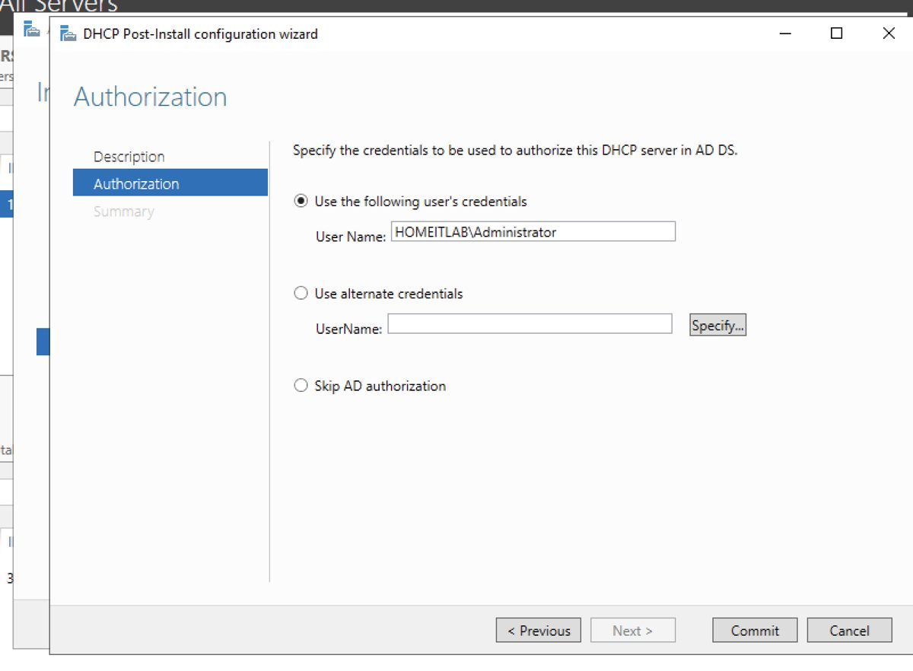
Figure 9. DHCP Post-Install Configuration Wizard authorizing DHCP in AD DS.
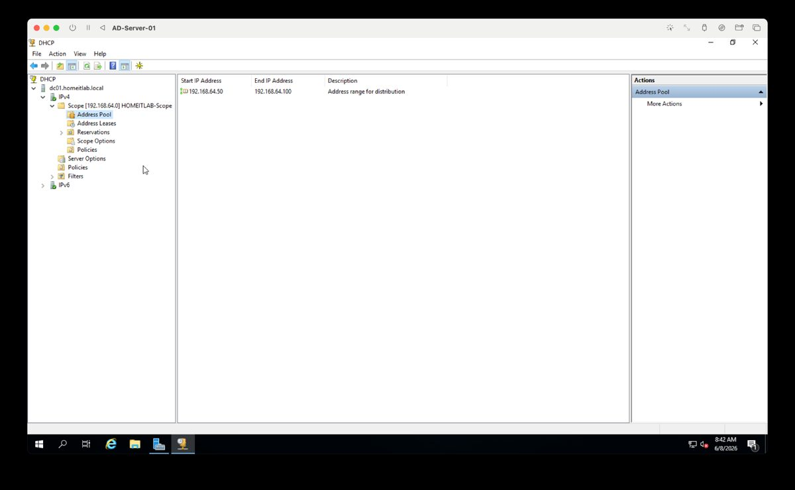
Figure 10. DHCP Address Pool configured for HOMEITLAB-Scope.
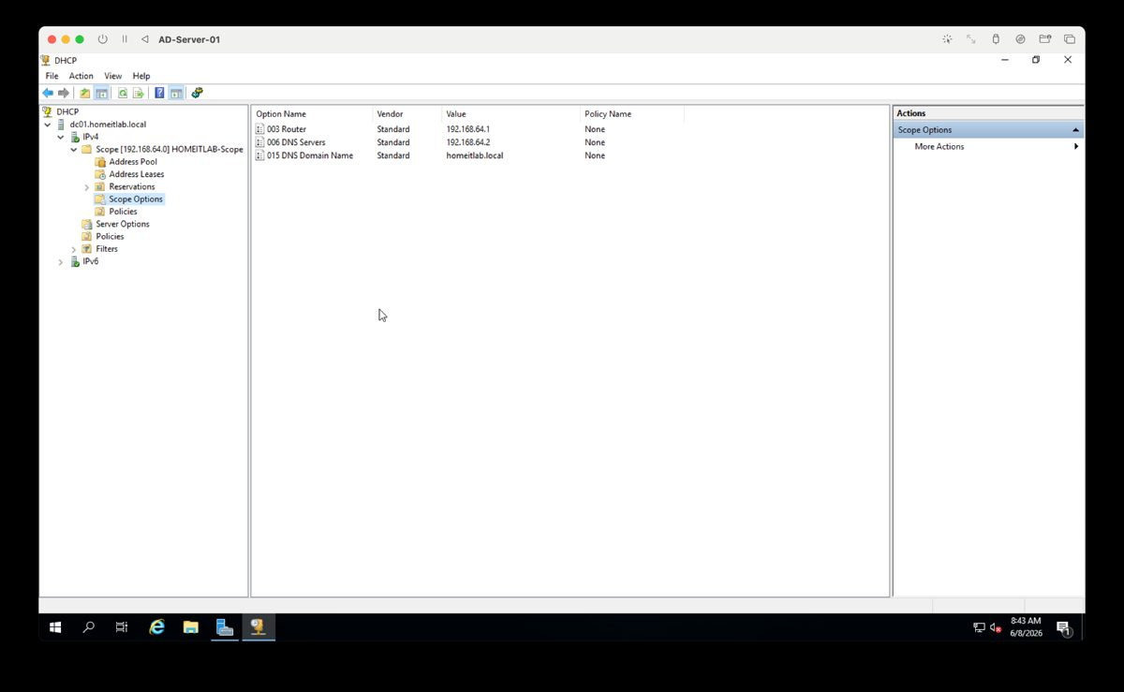
Figure 11. DHCP Scope Options configured for router, DNS server, and domain name.
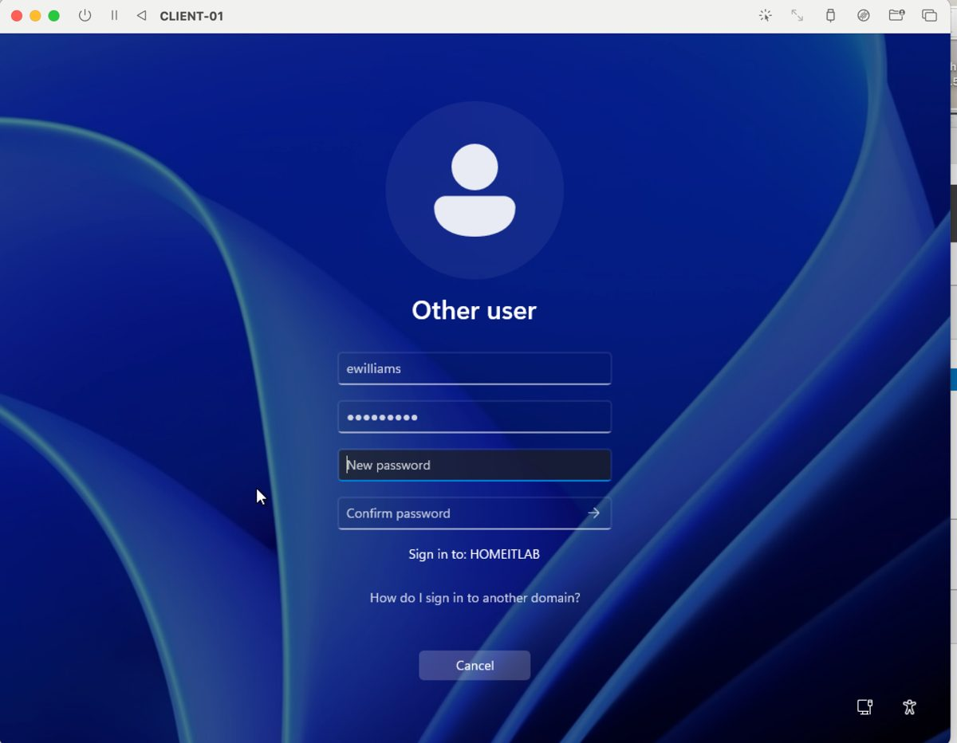
Figure 12. CLIENT-01 ipconfig /all used to validate client network connectivity.
DHCP lab note: Because the VMs are using UTM Shared Network mode, CLIENT-01 may still receive its lease from the UTM virtual gateway at 192.168.64.1. This was documented as a virtualization limitation. The Windows DHCP Server role, AD authorization, IPv4 scope, and DHCP options were still successfully configured and documented on DC01.

10. Troubleshooting Log
Issue | Symptoms | Resolution / Lesson Learned
UTM architecture and boot issues | Initial VM setup and boot process required several changes. | Used the proper VM architecture and machine type, corrected boot media, and verified the VM could boot to Windows Setup.
Windows Setup license terms error | Setup could not find Microsoft Software License Terms. | Removed the extra UTM Guest Tools ISO during Windows Server installation; installed Guest Tools only after Windows was installed.
Windows setup loop on CLIENT-01 | Client repeatedly returned to installer/upgrade screen. | Cleared the Windows ISO after installation so the VM booted from the installed virtual disk.
DNS resolution failure | nslookup homeitlab.local failed from CLIENT-01. | Configured CLIENT-01 to use DC01 as DNS at 192.168.64.2, flushed DNS, renewed IP settings, and retested.
Domain join failure | Domain join failed with username/password or domain lookup errors. | Validated DNS, verified DC01 reachability, and used correct domain administrator credentials.
File share permission denial | Unauthorized user could not access TechniciansShare. | Confirmed access control worked as designed; granted access only by adding users to the correct security group.
GPO refresh delay | Desktop wallpaper did not apply instantly. | Ran gpupdate /force and verified the target user was in the correct OU.
DHCP lease source limitation | CLIENT-01 showed UTM gateway as DHCP server. | Documented UTM Shared Network behavior while validating Windows DHCP role, scope, and options on DC01.

11. Skills Learned
- Windows Server 2019 installation and configuration in UTM/QEMU.
- Active Directory Domain Services deployment and domain controller promotion.
- DNS configuration and troubleshooting using ipconfig, nslookup, ping, and nltest.
- DHCP Server installation, AD authorization, IPv4 scope creation, and DHCP scope options.
- Windows 11 client deployment and domain join validation.
- Active Directory Users and Computers administration.
- OU design, user account creation, password reset, account unlock, and onboarding workflows.
- Security group-based file share permissions and access validation.
- Network drive mapping from a domain-joined workstation.
- Group Policy creation, linking, and client-side refresh with gpupdate /force.
- Help Desk ticket documentation and evidence tracking.
- Technical troubleshooting and professional documentation for portfolio use.

