**Index.html**

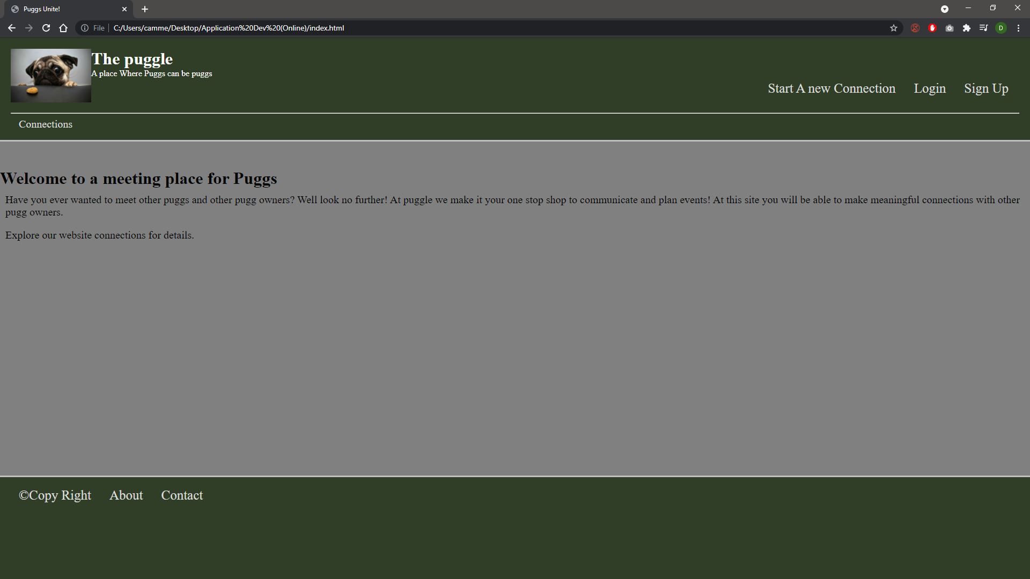

**Connections.html**

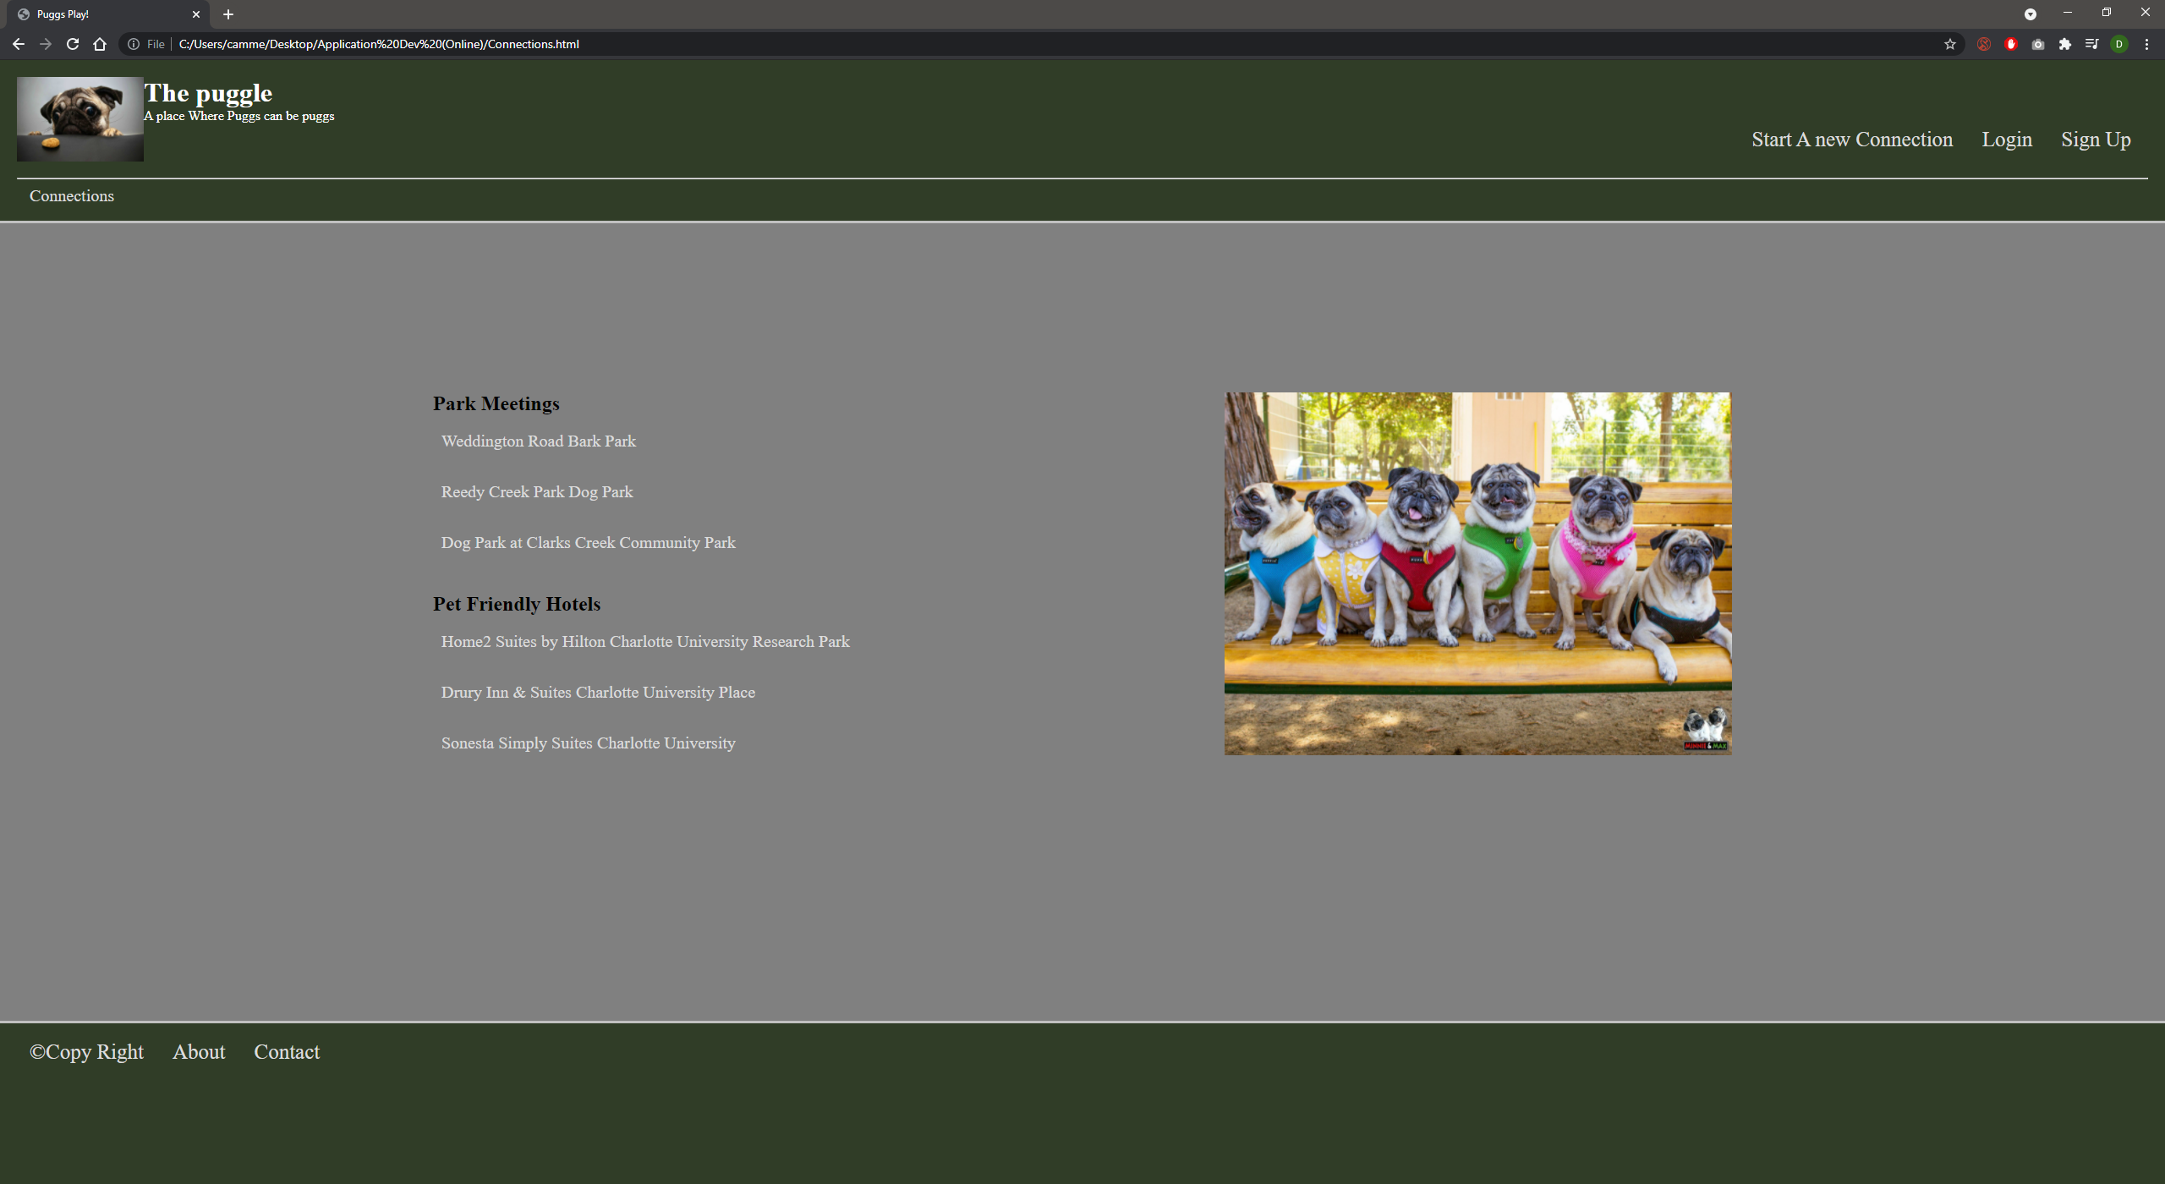

**Connections.html**

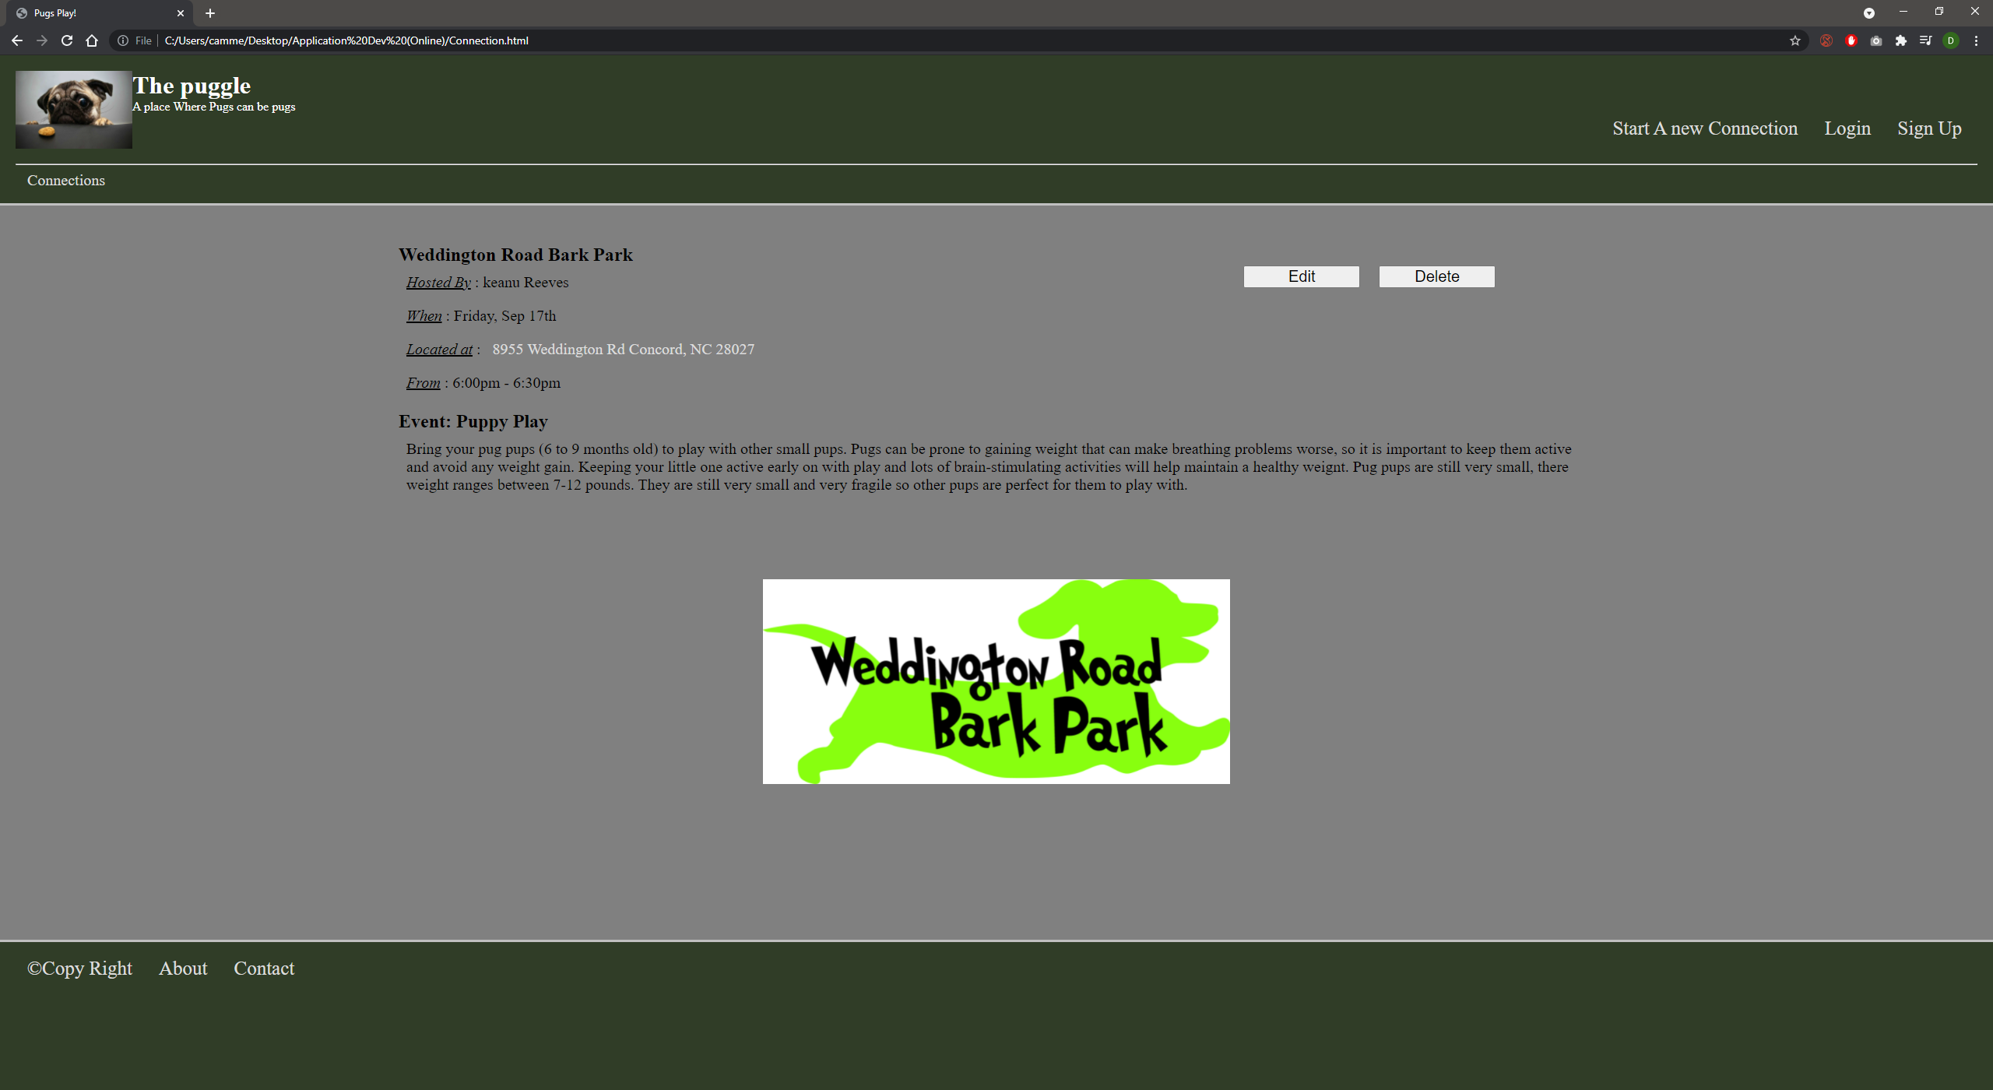

**NewConnection.html**

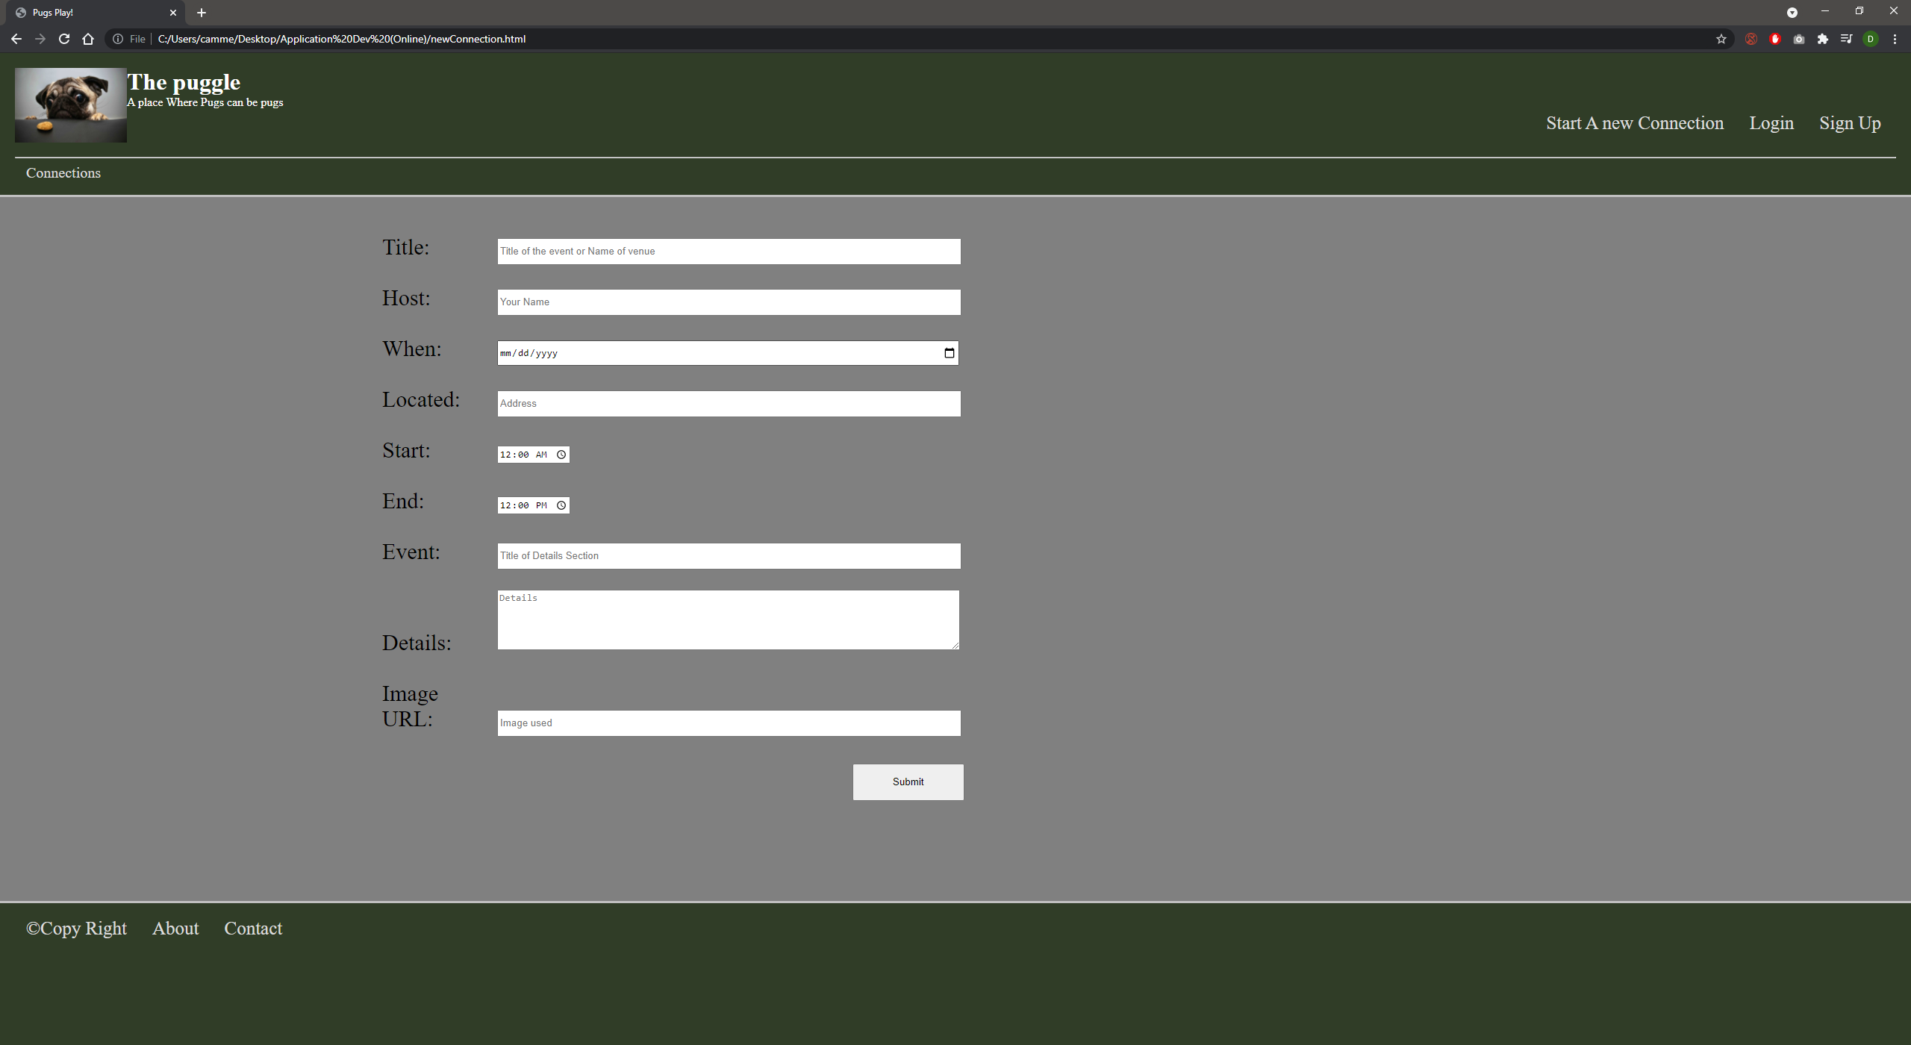

The home page has no additional features, it’s a little bland currently. Experienced difficulties discovering appropriate content for the home page, will update as the semester progresses. All links work as stated in the Project1 video Demo. I work primarily on a 27inch monitor so the webpages look as intended. However, when view on a smaller screen it begins to look weird. A challenge I faced was attempting to get the webpages to look the same on all screen sizes.