CADDE Workshop on Portable Metagenomics for Pathogen Surveillance

MRC Centre for Global Infectious Disease Analysis, Imperial College London

13-17 March 2023

Outbreak Analysis and Characterizing Pathogen Transmissibility: Estimating the Reproduction Number for SARS-CoV-2
Dr Charles Whittaker
with contributions from
Dr Ilaria Dorigatti and Prof Steven Riley, Dr Simon Cauchemez, Dr Anne Cori, Dr Patrick Walker & Prof Christophe Fraser

Background
Pandemics arise when a new virus capable of human-to-human transmission emerges that is sufficiently distinct from circulating viruses so that the level of population immunity is low or nil. New strains emerge by transfer from a zoonotic reservoir. Exactly how new viruses emerge is not clear and may differ for different pandemics. Possibilities include genetic re-assortment or recombination between human and avian viral strains, possibly via intermediary species (e.g. pigs, poultry or other animals), or by gradual accumulation of adaptive mutations.
The potential for pandemic viruses to cause significant mortality is illustrated by SARS-CoV-2, the causative agent of COVID-19, as well as the 1918-20 H1N1 ‘Spanish flu’ which is estimated to have killed at least 20,000,000 people worldwide. Note however that the much lower mortality caused by the 1957 H2N2 ‘Asian flu’, the 1966 H3N1 ‘Hong Kong flu’ or the 2009 H1N1 pandemics shows that devastation is not an inevitable result of a pandemic but depends on the biology of each new strain as well as the impact of interventions.
Preparedness is greatly helped by knowledge of the epidemiological determinants of virus spread such as the basic reproduction number R0. The aim of this practical is to estimate R0 (and related measures of transmissibility).
Objectives
From a methodological perspective, the practical will introduce you to the methods and issues surrounding parameter estimation in epidemic models. More specifically, we are going to use 2 different methods to estimate the reproduction number from epidemic data:
- In Part 1 of the practical, we will estimate the Basic Reproduction Number R0 via the exponential growth rate method.
- In Part 2 of the practical, we will use a tree reconstruction method called EpiEstim to estimate the Time-Varying Instantaneous Reproduction Number R(t).
We are going to consider the following dataset:
- The number of confirmed SARS-CoV-2 cases reported in the United Kingdom during the first 4 months of the COVID-19 pandemic [data from https://coronavirus.data.gov.uk/, accessed on 12th March 2023]
Practical Part 1

Estimating the reproduction number using the exponential growth rate method
We are going to learn how to estimate the basic reproduction number using Excel, and the time series of confirmed SARS-CoV-2 cases reported in the United Kingdom during February to June 2020.
The materials required for Practical Part 1 can be found in the excel spreadsheet called ‘CADDE_Workshop_Estimating_R_Part1Data.xls’.
Within this spreadsheet, the sheet ‘SARS-CoV-2 UK (Data)’ contains the weekly AND daily incidence of confirmed SARS-CoV-2 cases in the United Kingdom during February to June 2020 (the early phase of the COVID-19 pandemic).
Task 1a: Calculating the Exponential Growth Rate For Weekly Data
Use sheet ‘Task 1a-Weekly Exp Growth Rate’.
Using the weekly case incidence data:
- Plot Weekly COVID-19 Case Incidence (y-axis) against Observation Week (x-axis).
- Plot ln(Weekly COVID-19 Case Incidence) (i.e. the natural logarithm of the weekly COVID-19 case incidence) against Observation Week.
Linear increase in cases on a logarithmic scale indicates exponential increase in the number of infections. For how long does the epidemic grow exponentially?

Estimate the growth rate (r) of the epidemic during this exponential growth phase, and the doubling time, using the formula relating the number infected at two time points t₁ and t₂ of your choice
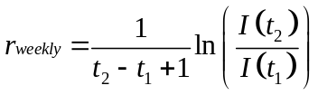 | (1)
NOTE: In Excel, use the function ln, NOT log
Here, the reported cases are weekly so you will need to divide your rates by 7 to obtain daily values. You can use Excel to calculate these quantities.

Task 1B: Integrating the Exponential Growth Rate with the Generation Time to Estimate the Basic Reproduction Number
In this task, we are going to explore the relationship between the epidemic growth rate r, the basic reproduction number R₀ and the generation time T_{g}.
The generation time T_{g} is the time it takes between infection of one individual and subsequent infection of others by that individual.
If the epidemic growth rate r AND the generation time T_{g} are known, it is possible to derive R₀ from the following equation:
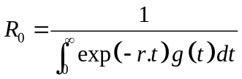 | (2)
where g(t) is the generation time distribution (i.e., the probability that the generation time T_{g} is equal to t).
Different models make different assumptions about the generation time. For the 3 following models, the equation for R₀ (i.e. equation (2) above) simplifies to the following:
Equations to Calculate R0 For 3 Simple Models
Discrete generation: 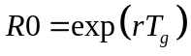
SIR: 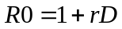
SEIR: 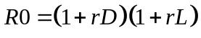
where T_{g} is the generation time, D is the mean duration of the infectiousness, and L is the mean duration of latency.
- The “Discrete Generation” model assumes that all individuals have the same generation time, T_{g}.
- The SIR model assumes that T_{g} is exponentially distributed with mean given by D.
- The SEIR model assumes that T_{g} is gamma distributed with mean given by the sum of D and L.
The generation time of SARS-CoV-2 and influenza – implications for control
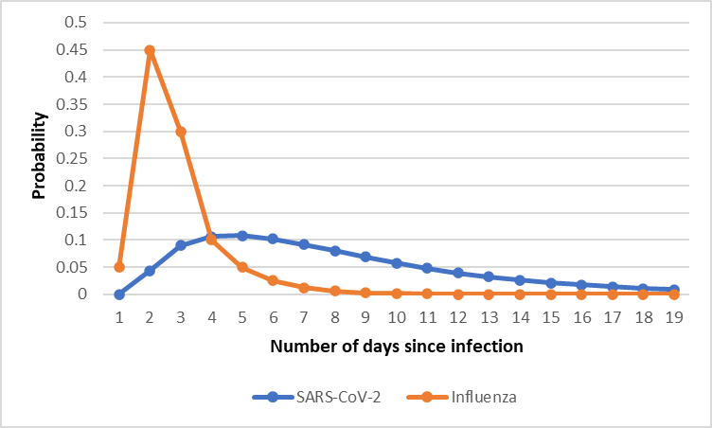
The graph below shows the distribution of the generation time for SARS-CoV-2 (from Cereda et al., arxiv, 2020) and for influenza (from Ferguson et al, Nature, 2005). The mean generation time is 6.6 days for SARS-CoV-2 and 2.6 days for influenza.
These differences in the generation time matter greatly to effective control of the pathogen and its spread.
For example, think about the logistical issues associated with the delivery of antiviral drugs during a pandemic.
What will be the likely impact on transmission if the drug is delivered 3 days after infection of the primary case of a household?

Now, you are going to use your estimate of the epidemic growth rate from Task 1a to estimate the basic reproduction number R0 for COVID-19 in the UK; for different models and for different parameters.
You are going consider a total of 6 models, 3 with a generation time of 2.6 days (like influenza) and 3 with a generation time of 6.6 days (like SARS-CoV-2). The parameters in each model are given in the following table:
 | Influenza Parameters | SARS-CoV-2 Parameters
Discrete generation | Tg = 2.6 days | Tg = 6.6 days
SIR | D = 2.6 days | D = 6.6 days
SEIR | L = 1 days  D = 1.6 days | L = 5 days  D = 1.6 days
where T_{g} is the generation time, D is the mean duration of the infectiousness, and L is the mean duration of latency.
For each model, use the box “Equations to Calculate R0 For 3 Simple Models” on page 5 to estimate R₀ for COVID-19 in the UK.
Use sheet ‘Task 1b - R0 Est. via r & Tg’ to do these calculations, then write your answers into the box below.
 | Using Influenza Parameters | Using SARS-CoV-2 Parameters
Discrete generation | R0 = | R0 =
SIR | R0 = | R0 =
SEIR | R0 = | R0 =
Are estimates of R affected by assumptions made on T_{g}? Are the differences epidemiologically relevant?

Practical Part 2
Using tree reconstruction methods to estimate the reproduction number
We are now going to use tree reconstruction methods described in the lecture to estimate the instantaneous reproduction number Rt. Specifically, we’re going to use the EpiEstim method, developed by Dr Anne Cori, Professor Christophe Fraser and others.
EpiEstim is a software tool used for estimating the reproduction number (Rt). It is particularly useful for infectious disease outbreaks, as it allows for real-time estimation of the progression and potential impact of the outbreak. It uses statistical methods based on the renewal equation to estimate Rt using a time-series of cases and the Generation Time distribution.
Note that we rarely have the Generation Time (because we rarely know when an individual was infected) and so often the Serial Interval is used instead. The Serial Interval is defined as the time between an infected individual developing symptoms and the development of symptoms in other individuals they infect. We will assume here for the purposes of this practical that the Generation Time and Serial Interval are equivalent and equal (this is common in epidemiological modelling).

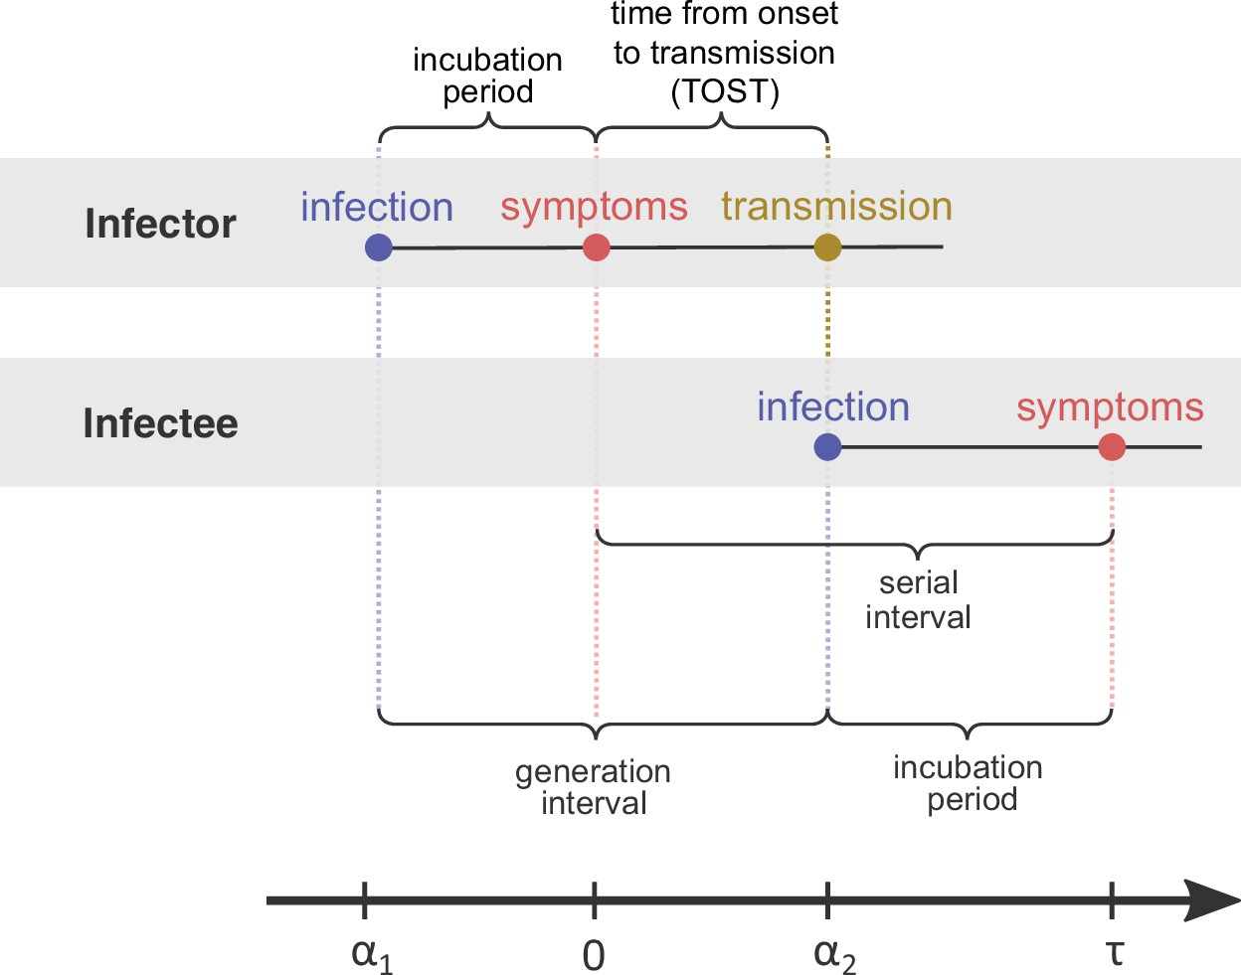
Figure: Schematic illustration of the Serial Interval and the Generation Time.

In this part of the practical, you are going to estimate Rt during the first few months of the COVID-19 pandemic in the United Kingdom; you are going to be using the following dataset:
- The number of confirmed SARS-CoV-2 cases reported in the United Kingdom during the first 4 months of the COVID-19 pandemic [data from https://coronavirus.data.gov.uk/, accessed on 12th March 2023]

A Reminder of EpiEstim:
EpiEstim combines prior case incidence (in blue) and the serial interval distribution (in green) to estimate the value of Rt required to produce the observed case incidence at time t (I_{t}).
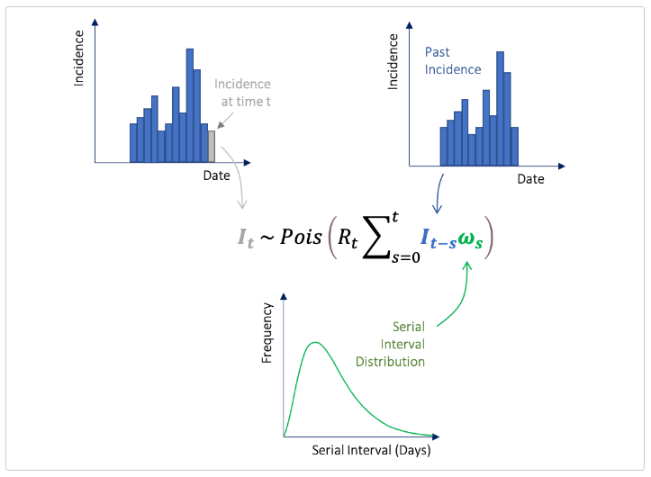
Figure: Overview of the process by which EpiEstim estimates the time-varying reproduction number Rt.

Task 2a: Estimating the reproduction number over time for COVID-19 cases in the UK during the first months of the pandemic.
EpiEstim estimates R_{t} using overlapping, sliding time windows (see Figure below). By default, these windows are set to be 1 week in duration i.e. successive overlapping 7 day time windows are used for Rt estimation, as shown below.
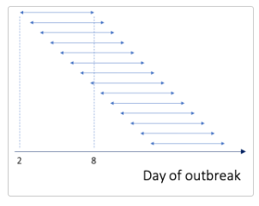
Figure: Illustration of the sliding, overlapping time windows which EpiEstim uses to estimate the time-varying reproduction number Rt.

Estimating Rt Using Weekly Windows
We are going to start this practical by estimating Rt for the UK COVID-19 case incidence data, using weekly windows for estimation of Rt.
Open RStudio and open the R script CADDE_Workshop_EpiEstim_SaoPaulo.R -
Run the following code (Lines 1 – 12) in your R script.
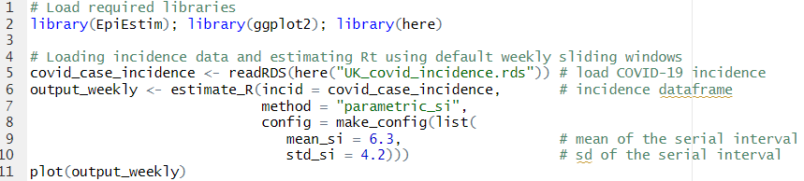
Lines 1-2: Load the required R packages to run these analyses.
Line 5: Loads the COVID-19 incidence data (a file caled “UK_covid_incidence.rds”)
Lines 6-10: Runs EpiEstim to estimate Rt using default weekly sliding windows and a serial interval with a mean of 6.3 days and a standard deviation of 4.2 days.
Line 11: Plots the output from running EpiEstim.

Examine the output you have just plotted. What happens to the reproduction number over time? Why do you think the reproduction number is changing in that way?

What is the date when your mean R estimate falls below the threshold of 1 for the first time?

Estimating Rt Using Daily Windows
If you wish to specify a different time window over which R_{t} is estimated, you use the t_start and t_end arguments within the config argument of the estimate_R() function.
t_start is the starting time for each window of Rt estimation and t_end is the end time of each window.
Run the following code (Lines 14 – 24) in your R script. This specifies t_start and t_end so that Rt is estimated using a time window of a single day (rather than a week as you did in the previous task), and then plots the output.
Lines 14-15: Specify the daily time-windows to feed into t_start and t_end.
Lines 16-22: Runs EpiEstim to estimate Rt using a daily window and a serial interval with a mean of 6.3 days and a standard deviation of 4.2 days.
Line 23: Plots the output from running EpiEstim.
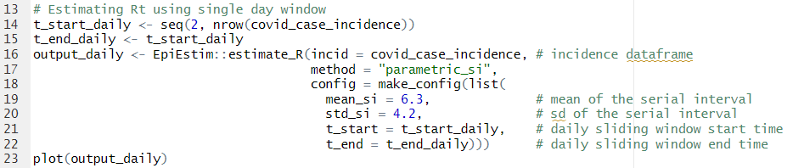
Examine the output you have just plotted and compare it to the output from when you used weekly sliding windows instead. You can Run Lines 25-34 in your R script to plot Rt estimated via weekly windows and daily windows on the same graph.
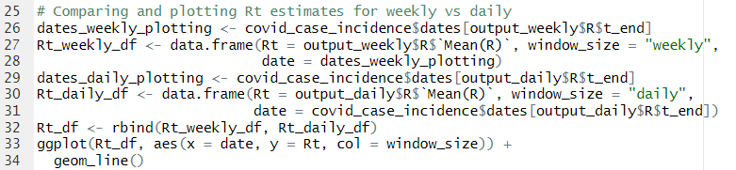
What are the main differences in the Rt estimates you get when using weekly windows vs daily windows?

Given what you know about how Rt is calculated, why do you think this is the case?

Task 2b: Exploring the impact of non-pharmaceutical interventions on the reproduction number over time.
Instead of calculating Rt across overlapping windows, you may want to compare estimates of Rt before and after control measures has been imposed.
In the UK, a nationwide lockdown was implemented on 25th March. In this Task, we’re going to calculate the average estimate for Rt before and after this date. Run the following code in your R script (Lines 37-48).
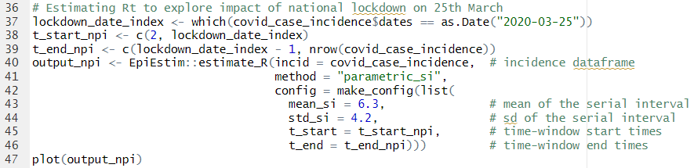
Examine the plotted graphs. What is the value of Rt before and after the national lockdown?
Lines 37: Extracts the date index for the 25th March 2020 (date of national lockdown).
Lines 38-39: Specify the time-windows to feed into t_start and t_end.
Lines 40-46: Runs EpiEstim, inferring only two values of Rt – the first value for the period up until 25th March 2020; and the second value for the period 26th March 2020 onwards.
Line 47: Plots the output from running EpiEstim.

