Headspace AI Operating Model: Proposal
For: Karan Singh, COO, Headspace
From: Eric Page and Chris Hogg (EPCH)
Date: June 17, 2026

The problem
Headspace has successfully used the OKR and WBR process for internal planning and tracking of performance; however, it takes significant time for each team to create each document (e.g. a workstream WBR), and the documents created are inconsistent and of varying quality. Your team has tried to build these documents using GenAI, with varying degrees of success, but has not yet been able to standardize and get reliable, high quality results across teams.

What EPCH will build
We will build the weekly portion of your AI Operating Model, which consists of 3 Skills and the foundation documents necessary to accurately and reliably run these Skills.
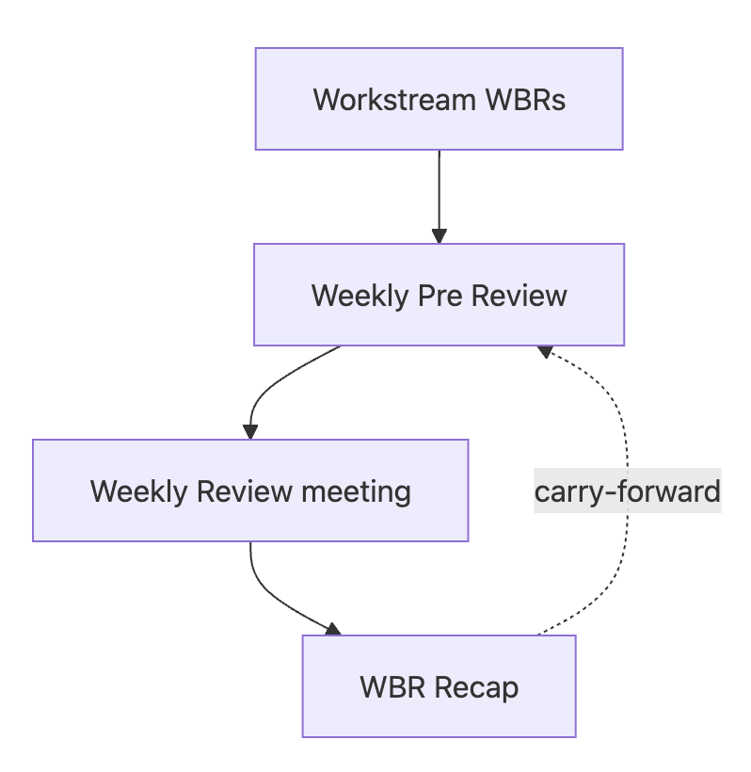
- Skill: wbr-create: Each of the 9 workstreams will be able to write its WBR against a fixed template using a WBR-creation skill.
- Skill: wbr-rollup: A separate skill rolls those up into the Weekly Pre Review while also runs its own read on the OKRs and metrics instead of just relaying what teams reported, and flags anything off-target.
- Skill: wbr-recap: A recap skill captures the decisions and open items from your Wednesday meeting

The weekly loop is the foundation of a larger operating stack (weekly rolls up to monthly, quarterly, and annual). This initial effort builds the weekly WBR loop only.

EPCH will work with Headspace to design and build the templates, the Skills and the foundation docs. We will run the first live cycles together over Weeks 1-4 and, at handoff, you will own these skills in a Headspace repository that your team can clone and operate without EPCH. We will format and load these Skills into your enterprise AI tool of choice e.g. Claude Chat. All WBR documents created by Skills will be stored, versioned and named clearly, and carry forward into next week's so nothing quietly drop.

Initial 5 week effort to get the 9 workstreams (WBRs) in place
We estimate 16 hours / week, between both Eric and Chris, for the first four weeks, then 8 hours in the final week to finalize and deploy across all 9 workstreams.

Week | Focus | Hours
1 | Discovery, alignment, scaffold | 16
2 | Build, onboard, first submissions | 16
3 | First live cycle of 2-3 workstreams | 16
4 | Second cycle, handoff, expansion kickoff | 16
5 | Trial the remaining 6-7 workstreams | 8
 | Total | 72

By the end of this project, the entire weekly WBR Loop will be in place.

What this initial month-long project is not
The following Skills stay out of this initial phase, so the WBR pilot stays focused on a clear goal:

- Monthly, quarterly, and annual. While these do build on the same foundation, we do not build these until the weekly loop holds.
- Integrations. Pulling from your systems of record (e.g. Drive, Asana, Jira) is a future phase. This month the context files are filled by hand and metrics come in as screenshots the DRIs paste into their submission. The loop runs end to end before anything is wired up.
- Official training: we will present the final workflows and demonstrate them for your Headspace team. Additional required training will increase the time needed under this proposal.
- Ad Hoc Building. this does not include ad-hoc building of skills or infrastructure, e.g., building a board or OpCo presentation.

What it costs
Our billable rate is $500 per hour per person, including time, knowledge and materials. We estimate that the Pilot proposal above will take about 72 hours over 5 weeks, which equates to a total project costs of $36,000. Note that we will bill based on actual hours and will seek prior approval for any projected overage in time and cost.

The IP and citing the work
We will build Headspace’s Skill Library on Headspace internal servers and infrastructure, and utilize Headspace’s Claude Enterprise instance. We will leverage EPCH's own internally developed operating-cadence framework, but Headspace will get an irrevocable, forever license to use it, adapt it, and run it for the needs of Headspace. EPCH will maintain rights to the framework itself so we can use it with ourselves and for others. Separately, we'd like to be able to disclose that Headspace is a client and describe this work at a high level, with nothing confidential and no member data.

Next steps
- Week of 6/15: Finalize NDA (done), Proposal and SOW.
- Week of 6/22: (Karan on PTO) EPCH receives packet of documents from Headspace to begin scoping work (brand docs, example WBR memos, company principles, etc)
- Week of 6/29: A short kickoff to confirm scope, pick the pilot workstreams and their DRIs, and start creating Skills

Appendix: The plan, week by week
Roughly 72 hours across five weeks: about 15 in discovery and alignment, 10 in build, and the rest running the loop and scaling it across the workstreams. Weeks one to four are the pilot on two to three workstreams; week five brings the rest up and running, at about half a week.

Week 1 · Discovery, alignment, and scaffold (16 hr)
- Kickoff with Karan: scope, pick the two to three pilot workstreams and DRIs, confirm the Weekly Review rhythm. 2 hr
- Exec team alignment: confirm the system serves the exec team's needs and the narrative they want from it. 1.5 hr
- Documentation-collection session, plus scheduling across exec calendars. 2 hr
- Review WBR history and collect good and bad examples. 4.5 hr
- Review Headspace's metrics method and build metric-definitions (owner, target, source, OKR trace per metric). 3 hr
- Load OKRs, principles, company core, and glossary into the context files. 2 hr
- Repo scaffold and conventions. 1 hr

Week 2 · Build, onboard, first submissions (16 hr)
- Build the three skills and the critic panel; author the templates, examples, and anti-examples from the WBR history. 9 hr
- Onboard the pilot DRIs: first /create-wbr walkthrough plus support through their first submission. 5 hr
- Collect the first real workstream WBRs. 1 hr
- Weekly review with Karan. 1 hr

Week 3 · First live cycle (16 hr)
- /wbr-rollup synthesizes the workstream WBRs into the Weekly Pre Review. First real run on real inputs, so budget time to debug the synthesis. 3.5 hr
- Prep and run the first Weekly Review meeting off the pre-read. 2 hr
- /wbr-recap produces the recap and the log records, first real run. 2.5 hr
- Tune the templates and critics from what the first cycle surfaces. 4 hr
- Support the DRIs on their second submission. 2 hr
- Weekly review with Karan. 2 hr

Week 4 · Second cycle, handoff, and expansion kickoff (16 hr)
- Second live cycle; last week's recap opens this week's pre-read, so the carry-forward proves out. Lighter now that the templates are tuned. 5 hr
- Tune from the second cycle. 1 hr
- Write the runbook, model-assisted. 2.5 hr
- Handoff session, including a dry-run of the pilot DRIs and Karan's team operating the loop themselves. 4 hr
- Kick off the expansion: introduce the loop to the other six or seven workstream DRIs and collect their first WBRs. Not tested this month. 2.5 hr
- Weekly review with Karan. 1 hr

Week 5 · The remaining workstreams (8 hr)
- Onboard the remaining six or seven workstream DRIs: walkthrough plus support on their first submission, faster now that the templates are proven. 4 hr
- First full nine-workstream cycle: /wbr-rollup synthesizes all nine into the Weekly Pre Review, the meeting runs, and /wbr-recap closes it. 2 hr
- Weekly review with Karan and engagement closeout. 2 hr

Note: All work is estimated and will be billed for hours incurred. Any projected overage to hours and costs will be agreed to in writing before work is done.

