GriNS 2.0 Editor

Ideas

This is a discussion document only, outlining some proposals for the new GriNS 2.0 editor. The editor is aimed to be released by the end of March 2001, allowing a 2 month (8 week) development schedule.

Main goal
The main goal is to design a highly-usable SMIL 2.0 and HTML+TIME editing environment for multimedia professionals.
- Who are our main customers? Who is going to purchase GriNS? Who are we writing software for?
  - Large companies wanting attractive web-sites that attract more customers.
  - Multimedia outfits creating the above.
  - Multimedia designers who already work with Macromedia flash, images, movies and so forth.
- What is the scope of the GriNS editor? Do we include any of the following features? Is it best just to retain our existing set of features?
  - Web-site management (uploading, manipulating).
  - Database connectivity.
  - Export to different platforms (SMIL switch statements).

Basic requirements.

- Any propositions must be doable in the current time frame.
- Propositions must use the existing GriNS functionality and toolset.

User requirements
- Ease of use.
- Must comply with a user’s workflow.

The typical designers workflow would probably be something similar to the following:
- Design the overall flow of the multimedia presentation / site.
- Design and build the assets for the presentation.
- Assemble them.
  - Drag-and-drop assets to the GriNS editor.
  - Arrange the assets in some sort of logical structure.
This is a point that should be discussed.
  - Once the document contains the basic structure, the user can fine-tune and edit the details. For example:
    - Editing the assets. Remember that even when the assets are only referenced by GriNS, the user still wants to edit them.
    - The timing of the nodes, in terms of begin delays, end-syncs and so forth. This could be non-trivial for a user with a poor understanding of structured multimedia. Perhaps the timeline view can be used for ‘tweaking’ timing information. This needs to be discussed more.
    - Layout information. Users would prefer to edit the positioning of nodes on an individual node basis (each node has it’s own region), while SmiL has been designed to reuse layout regions. This is a large and central issue.
    - Switch statements – language specific, bandwidth specific issues. Obviously some situations – e.g. language need to be done manually. Parts of the bandwidth could be done automatically, for example by compressing images and sound, and scaling down videos (how feasible is this?).
    - Document navigation. Which hyperlink goes where, which hyperlink accesses external documents and so forth. For an interactive multimedia presentation, this is of prime importance.
    - Meta information about the document, as well as “About..” pages etc.

- Exporting the document. Assuming the user has included the ‘originals’ as assets in the document, it could be GriNS task to scale down and convert the assets to streamable media types.
    - Should we include support for uploading to websites, ftp servers, or streaming media servers?
    - Should we include a pop-up box with an option to export to certain target audiences (for example, “28k, 56k, ISDN…”)?

Basic editor design.

GriNS could be focused on the user’s workflow. These are ideas only:

- Make the entire editor resemble a large version of a windows-like wizard. The workflow is set out in taskbar-like tabs on the bottom of the screen with “prev” and “next” buttons at either end. Each “task” would be a screen set-up with certain views open in conveniently arranged positions. For example:
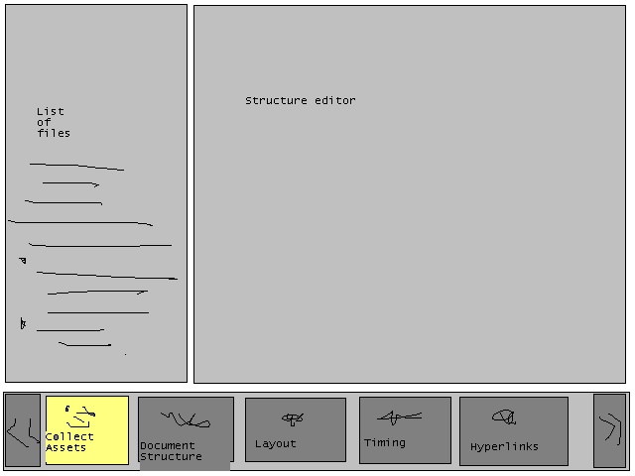
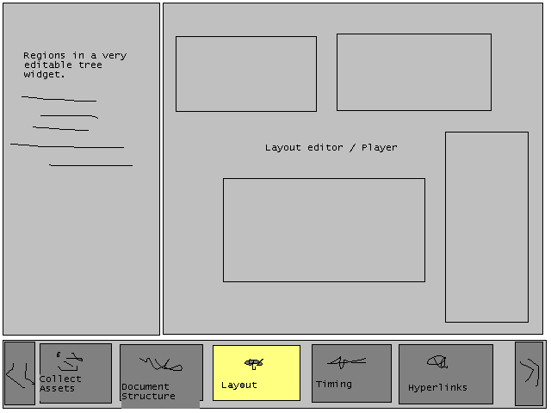
and so forth. Of course, these are extremely rough examples, you will have to use your imagination as well. Put menus, windows and so forth everywhere.

A good example for this is the windows installer maker, which, evidently was originally a mac program. It has a similar flow of commands along the top of the screen.

- Users are typically already familier with the following paradigms:
  - Timeline views. These are common and easily understandable as a left-to-right playing thing with many tracks. We should really have a play button and timeline under the structure view or timeline view.
  - Grouping objects. Users typically do this in Microsoft word; we could use this paradigm to add structure.
  - Dragging and dropping from asset boxes. Very simple from a user’s perspective.
  - Double-click to edit node, and properties boxes (e.g. in Adobe software) are typically floating mini-boxes that hang around the outside of your screen.
  - UNDO!!!! It’s disabled! Panic! Well, I do, anyway. Usually I’m usually glad that I saved my document regularly.
  - See image – double-click image – see toolbar and edit image. Most editors (e.g.) MS Word do this to some effect. We can pop up external editers. Ideally, GRINS could edit images, movies and sound, completely obliterating the multimedia editing market in the progress and becoming a household name. Ja. Maybe version 6.0 in 2010.
  - Typical windows things – cut, copy, paste, properties, drag, drop, right-click, etc.
  - “Welcome” boxes and tip-of-the-day.

Specific design issues.

These are far-fetched ideas, rather than implementable solutions before the “deadline”.

- We have the main editors – Structure view, Timeline view, Layout view. Should we keep the temporal view? Issues:
  - Is the temporal view actually useful?
    - It does show the whole document, structure, layout and all.
    - It is a jack of all trades. It doesn’t show timing particularly accurately, and editing structure in it makes a spaghetti that the structure view does much better.
    - Except for the structure, the timeline view already does everything, or could do it with a bit of work.
    - The temporal view is a long way from being a stable product; in the 8-week timeframe perhaps it is better to remove it and work on making the other views much better. One level of structure could be added to the currently selected node in the channel view, for example: 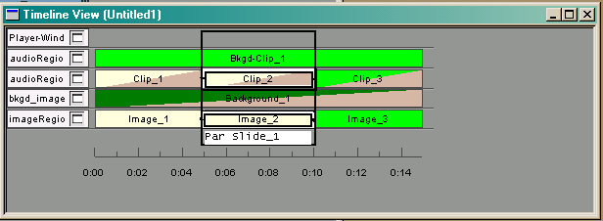
O.k, so that doesn’t work very well. The idea was to enable visual begin-delay, end-sync, and so forth editing in a timeline-based view.
- How is layout edited? Completely within the layout view or in conjunction with the timeline view (which shows the regions and should have the ability to edit, add, remove.)?
- Should the hierarchy view be “tweaked”? The code has been changed to make this easier. I propose the following changes:
  - Pars and seqs should be more horizontal and more vertical: 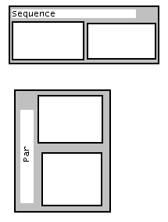
It looks like a silly idea, but I think a sillier idea is to have the main visual difference between a par and a seq be the colour of the nodes. Having a handle on the side of a par does make it a lot clearer which node is a seq and which is a par. Can we rotate text like this?
A more radical idea is to make the leaf nodes similar to the leaf nodes in the timeline view, and make them time-based in the structure view. This idea has already been thrown around quite a bit. This is a bit like the temporal view, but without regions and with boxes instead of bars.
  - Have some sort of visual indication of the region a node is played in. For example: 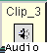. Yes, I’m too lazy to make it look good here, but unless the region is displayed on the node, the channel a node is played in (which is quite important) is hidden in the properties dialog.
- The layout view. The layout view is already similar in appearance and concept to most editors, with one main difference: most editors use a separate window for the layout. Conceptually, the layout view could show either all regions in the document (which it does now), or it could show the position of nodes at a certain point in time, including animations.
- The source editor – this should really be another view with the other more graphical views! Infact, if we want to get really fancy, we could turn the source editor into a SMIL 2.0 fancy editor with lots of bells and whistles – e.g. making the structure collapsible, making smil attributes bring drop-down boxes, etc. Anybody who is smart enough to understand our editor in it’s current state will probably want to drop to a basic editor and code SMIL by hand at some stage.

