TERRAFORM + AZURE
CI/CD Pipeline Project
A Real-World Case Study: From First Deployment to a Working GitHub Actions Pipeline
Prepared by
Pramod Sasi
ramisworld.lab — Azure Cloud & Terraform
June 2026
Repository: github.com/cwi1932/terraform-azure-cicd

Table of Contents
Table of Contents 2
1. Project Overview 3
1.1 What Was Built 3
1.2 Why This Project Matters 3
2. Architecture 3
2.1 Resources Deployed 3
2.2 Tooling 4
2.3 High-Level Flow 4
3. Phase 1 — First Local Deployment 4
3.1 Initial Configuration 4
4. Phase 2 — Remote State Backend 5
4.1 Setup Commands 5
4.2 Backend Configuration 6
5. Phase 3 — GitHub Actions CI/CD Pipeline 6
5.1 Final Workflow File 6
5.2 Service Principal & Secrets 7
6. Issues Encountered — Full Debugging Log 7
7. Final Result 12
7.1 Cleanup 12
8. Key Takeaways 12
8.2 Skills Demonstrated 13

1. Project Overview
This document is a complete, honest record of building a working Terraform + Azure infrastructure project, end to end — from a single virtual machine deployed by hand, through to a fully automated GitHub Actions CI/CD pipeline. It includes every real error encountered along the way, the root cause of each one, and the exact fix applied, with terminal commands and outputs preserved.
The goal of this document is not to present a clean, idealized walkthrough. It is to show the actual debugging process — the kind of work a freelance Azure/Terraform engineer genuinely does on real client infrastructure.

1.1 What Was Built
- A Linux virtual machine deployed in Azure using Terraform (resource group, virtual network, subnet, network interface, VM).
- SSH access secured via a dynamically generated key pair (no hardcoded local file paths).
- Remote Terraform state, stored securely in Azure Blob Storage instead of the local machine.
- A fully automated CI/CD pipeline using GitHub Actions — triggered on every push, running init, format check, plan, and apply automatically.
- Authentication handled via a dedicated Azure Service Principal, with credentials stored as encrypted GitHub Secrets.

1.2 Why This Project Matters
Most tutorials show Terraform working on the first try. Real client environments rarely behave that way. This project intentionally documents the friction — account mismatches, authentication quirks between Terraform's provider and backend, regional capacity limits, and CI/CD pipeline debugging — because that friction is what separates a beginner who can copy code from an engineer who can actually deliver working infrastructure under real constraints.

2. Architecture

2.1 Resources Deployed
Resource | Purpose
Resource Group | Logical container for all project resources
Virtual Network + Subnet | Private network space for the VM
Network Interface | Connects the VM to the subnet
Linux Virtual Machine | Ubuntu 22.04 LTS server, the actual compute resource
TLS Private Key (auto-generated) | SSH key pair generated at apply-time — no dependency on a local file
Storage Account + Container | Holds the remote Terraform state file (separate from the VM project)
Azure AD Service Principal | Robot identity used by GitHub Actions to authenticate to Azure

2.2 Tooling
- Terraform 1.14 (azurerm provider v4.78.0, tls provider v4.3.0, random provider)
- GitHub Actions for CI/CD automation
- Azure CLI for manual setup steps (resource groups, role assignments, service principals)
- Azure Storage (Blob) for remote Terraform state

2.3 High-Level Flow

terraform-azure-cicd/

├── provider.tf

├── main.tf (if exists)

3. Phase 1 — First Local Deployment
The project began as a single-file Terraform configuration, written, understood, and deployed manually from a local machine before any automation was introduced.

3.1 Initial Configuration
resource "azurerm_resource_group" "rg" {
name = "rg-terraform"
location = "East US"
}
resource "azurerm_virtual_network" "vnet" {
name = "vnet-terraform"
address_space = ["10.0.0.0/16"]
location = azurerm_resource_group.rg.location
resource_group_name = azurerm_resource_group.rg.name
}
resource "azurerm_subnet" "subnet" {
name = "subnet-terraform"
resource_group_name = azurerm_resource_group.rg.name
virtual_network_name = azurerm_virtual_network.vnet.name
address_prefixes = ["10.0.1.0/24"]
}
resource "azurerm_network_interface" "nic" {
name = "nic-terraform"
location = azurerm_resource_group.rg.location
resource_group_name = azurerm_resource_group.rg.name
ip_configuration {
name = "internal"
subnet_id = azurerm_subnet.subnet.id
private_ip_address_allocation = "Dynamic"
}
}
resource "azurerm_linux_virtual_machine" "vm" {
name = "vm-terraform"
resource_group_name = azurerm_resource_group.rg.name
location = azurerm_resource_group.rg.location
size = "Standard_B1s"
admin_username = "azureuser"
admin_ssh_key {
username = "azureuser"
public_key = file("~/.ssh/id_rsa.pub")
}
network_interface_ids = [azurerm_network_interface.nic.id]
os_disk {
caching = "ReadWrite"
storage_account_type = "Standard_LRS"
}
source_image_reference {
publisher = "Canonical"
offer = "0001-com-ubuntu-server-jammy"
sku = "22_04-lts"
version = "latest"
}
}
This configuration was run with the standard Terraform workflow:
terraform init
terraform plan
terraform apply
# verified in Azure Portal
terraform destroy
Result: Successfully deployed and destroyed. This confirmed the basic resource chain (Resource Group → VNet → Subnet → NIC → VM) and the dependency references between them.

4. Phase 2 — Remote State Backend
Before automation could work, Terraform's state file needed to move off the local laptop and into shared, durable storage — because GitHub Actions runs on temporary, disposable cloud machines with no access to local files.

4.1 Setup Commands
# Resource group dedicated to state storage
az group create --name rg-tfstate --location eastus
# Storage account to hold the state file
az storage account create \
--name tfstatepramod23062026 \
--resource-group rg-tfstate \
--location eastus \
--sku Standard_LRS
# Container (folder) inside the storage account
az storage container create \
--name tfstate \
--account-name tfstatepramod23062026 \
--account-key "<storage-account-key>"

4.2 Backend Configuration
Added to provider.tf, inside the terraform block:
backend "azurerm" {
resource_group_name = "rg-tfstate"
storage_account_name = "tfstatepramod23062026"
container_name = "tfstate"
key = "terraform.tfstate"
use_azuread_auth = true
}
Running terraform init at this point successfully migrated state from the local .tfstate file into Azure Blob Storage.
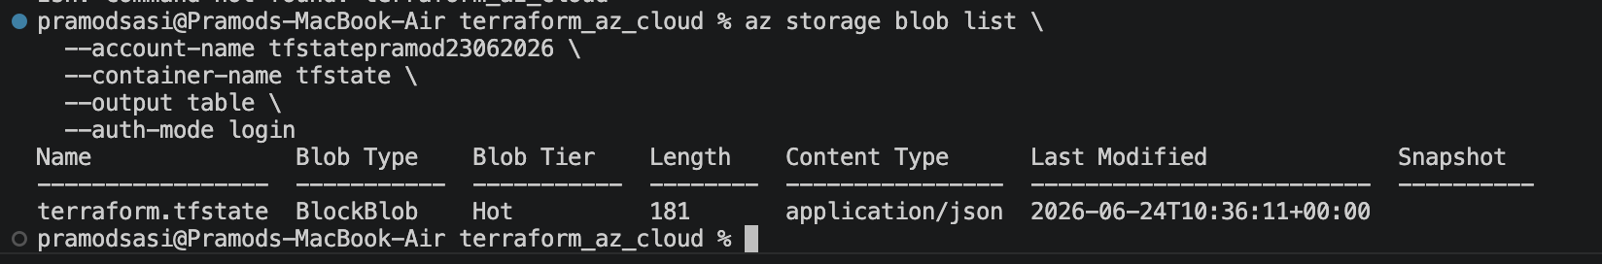

5. Phase 3 — GitHub Actions CI/CD Pipeline
With remote state in place, the next step was full automation: a pipeline that runs Terraform automatically whenever code is pushed to the repository.

5.1 Final Workflow File
.github/workflows/terraform.yml
name: Terraform CI/CD
on:
pull_request:
branches: [main]
push:
branches: [main]
env:
ARM_CLIENT_ID: ${{ secrets.AZURE_CLIENT_ID }}
ARM_CLIENT_SECRET: ${{ secrets.AZURE_CLIENT_SECRET }}
ARM_TENANT_ID: ${{ secrets.AZURE_TENANT_ID }}
ARM_SUBSCRIPTION_ID: ${{ secrets.AZURE_SUBSCRIPTION }}
ARM_USE_AZUREAD: "true"
jobs:
terraform:
runs-on: ubuntu-latest
steps:
- name: Checkout code
uses: actions/checkout@v4
- name: Setup Terraform
uses: hashicorp/setup-terraform@v3
- name: Terraform Init
run: terraform init
- name: Terraform Format Check
run: terraform fmt -check
- name: Terraform Plan
if: github.event_name == 'pull_request'
run: terraform plan -no-color
- name: Terraform Apply
if: github.ref == 'refs/heads/main' && github.event_name == 'push'
run: terraform apply -auto-approve

5.2 Service Principal & Secrets
GitHub Actions authenticates to Azure as a dedicated Service Principal (a non-human identity), rather than a personal login:
az ad sp create-for-rbac --name "github-terraform-sp" \
--role="Contributor" \
--scopes="/subscriptions/<subscription-id>"
The output (appId, password, tenant) was stored as encrypted secrets in the GitHub repository:
- AZURE_CLIENT_ID
- AZURE_CLIENT_SECRET
- AZURE_TENANT_ID
- AZURE_SUBSCRIPTION
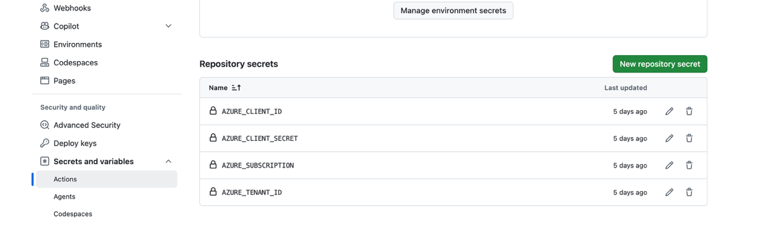 □

6. Issues Encountered — Full Debugging Log
The pipeline did not succeed on the first attempt. The following is the complete, chronological log of every real failure encountered, its root cause, and the exact fix applied. Each issue builds on the previous one — this is the genuine debugging trail, not a cleaned-up summary.
Issue 1: Wrong Azure Account / Tenant
Error encountered:
No explicit error — discovered via manual verification:
az account show
→ returned tenant "pramodsasiyahoo.onmicrosoft.com" instead of the intended "ramisworld.lab" tenant.
Root cause:
All initial setup (resource group, storage account) had been created under the wrong Azure account by default, since the CLI was authenticated to a different tenant than intended.
Fix applied:
az logout
az login # logged in specifically as ramisworld.lab
az account show # confirmed correct tenant
Lesson: always verify the active account/tenant with "az account show" before running any resource-creation command, especially when multiple Azure accounts exist.
Issue 2: Storage Provider Not Registered
Error encountered:
(SubscriptionNotFound) Subscription <id> was not found.
Code: SubscriptionNotFound
Root cause:
Brand-new Azure subscriptions do not have every resource provider "switched on" by default. Microsoft.Storage had not yet been activated for this subscription.
Fix applied:
az provider register --namespace Microsoft.Storage
az provider show -n Microsoft.Storage --query registrationState --output tsv
# waited until status returned "Registered"
Once registered, the original storage account creation command succeeded without any changes.
Issue 3: Service Principal Scoped to the Wrong Account
Error encountered:
az ad sp list --display-name "github-actions-terraform" --output table
→ returned empty when checked from the correct (ramisworld.lab) tenant.
Root cause:
The original Service Principal had been created while authenticated to the wrong tenant (Issue 1), so it had zero permissions in the subscription actually being used.
Fix applied:
az ad sp create-for-rbac --name "github-terraform-sp" \
--role="Contributor" \
--scopes="/subscriptions/<correct-subscription-id>"
A new Service Principal was created, correctly scoped, and all four GitHub Secrets were updated with its credentials.
Issue 4: Backend Authentication Defaulted to Azure CLI
Error encountered:
Error: unable to build authorizer for Resource Manager API: could not configure
AzureCli Authorizer: ... Please run 'az login' to setup account.
Root cause:
Terraform has two separate authentication paths: one for the provider (which manages resources) and one for the backend (which manages the remote state file). The provider correctly read the Service Principal credentials from environment variables. The backend, however, does not automatically inherit those same credentials — by default it attempts an Azure CLI session, which does not exist on a GitHub Actions runner.
Fix applied:
# Added to the backend block in provider.tf:
use_azuread_auth = true
# Added to the workflow's env block:
ARM_USE_AZUREAD: "true"
This explicitly tells the backend to authenticate using the same Azure AD identity (the Service Principal) instead of defaulting to a local CLI session.
Issue 5: Storage Permission Mismatch (403)
Error encountered:
Error: AuthorizationPermissionMismatch
"This request is not authorized to perform this operation using this permission."
Root cause:
Switching to Azure AD-based authentication (use_azuread_auth) introduced a new requirement: the identity (both the personal user account, and separately the Service Principal) needed an explicit role granting blob-level access. The previous Shared Key method bypassed this identity-based permission check entirely; AD-based auth does not.
Fix applied:
az role assignment create \
--assignee "<object-id-or-app-id>" \
--role "Storage Blob Data Contributor" \
--scope "/subscriptions/<sub-id>/resourceGroups/rg-tfstate/providers/Microsoft.Storage/storageAccounts/tfstatepramod23062026"
# Run once for the personal account (local testing)
# Run again for the Service Principal (CI/CD pipeline)
Both identities needed the role granted separately — one was not a substitute for the other.
Issue 6: Workflow YAML — env Block Scoped Incorrectly
Error encountered:
Error: subscription id not specified
Root cause:
The "env:" block containing ARM_* credentials had been nested under a single step (Terraform Init) instead of the job level, meaning every other step (Plan, Apply) had zero access to the Azure credentials.
Fix applied:
# Moved env: block to sit directly under the job,
# above "steps:", so it applies to every step in the job.
This is a common YAML structuring mistake — indentation determines scope, and a block indented one level too deep silently limits its effect to a single step rather than the whole job.
Issue 7: GitHub Secret Naming Mismatch
Error encountered:
Error: subscription id not specified (recurring, after the env-scope fix)
Root cause:
The workflow file referenced secrets.AZURE_SUBSCRIPTION_ID, but the actual secret stored in GitHub was named AZURE_SUBSCRIPTION (no _ID suffix). GitHub secret references must match the stored name exactly, character for character.
Fix applied:
# Updated the workflow file to reference the
# secret's actual name:
ARM_SUBSCRIPTION_ID: ${{ secrets.AZURE_SUBSCRIPTION }}
A reminder that secret names are arbitrary strings chosen at creation time — there is no enforced convention linking a GitHub secret's name to the Terraform variable it feeds.
Issue 8: Terraform Format Check Failure
Error encountered:
Run terraform fmt -check
main.tf
provider.tf
Error: Terraform exited with code 3.
Root cause:
Local edits had not been run through Terraform's canonical formatter before committing. "terraform fmt -check" never auto-fixes — it only reports files that are not already in standard format, and fails the step if any are found.
Fix applied:
terraform fmt
git add main.tf provider.tf
git commit -m "Fix formatting"
git push
This step exists specifically to enforce consistent style across a team; running "terraform fmt" locally before every commit avoids it entirely.
Issue 9: SSH Key Read From a Local File Path
Error encountered:
Error: Invalid function argument
Invalid value for "path" parameter: no file exists at
"/Users/pramodsasi/.ssh/id_rsa.pub"; this function works only with files
that are distributed as part of the configuration source code...
Root cause:
The original configuration read the SSH public key from a path on the local laptop. GitHub Actions runs on a separate, temporary cloud machine with no knowledge of that path or any files on it.
Fix applied:
resource "tls_private_key" "ssh" {
algorithm = "RSA"
rsa_bits = 4096
}
# Referenced in the VM resource instead of file():
public_key = tls_private_key.ssh.public_key_openssh
# Added the new provider to provider.tf:
tls = {
source = "hashicorp/tls"
version = "~> 4.0"
}
This generates a brand-new SSH key pair during every apply, entirely within Terraform — removing any dependency on local files. The trade-off: the key is regenerated on each fresh apply, so the previous key cannot be reused unless retrieved from Terraform output before destroying.
Issue 10: VM SKU Not Available in Region (Capacity Restriction)
Error encountered:
Error: SkuNotAvailable: The requested VM size for resource 'Standard_B1s' is
currently not available in location 'eastus'.
Root cause:
Azure regions periodically run out of available hardware capacity for specific, high-demand VM sizes — particularly the smaller, free-tier-friendly B-series sizes.
Fix applied:
# Attempted region change (eastus → eastus2) — same SKU still unavailable.
# Ran a direct capacity check:
az vm list-skus --location eastus2 --resource-type virtualMachines --output table --all | grep -v NotAvailable
The check revealed the entire B-series family was restricted for this subscription in this region. The available sizes were limited to the general-purpose D/E/F/M families.
Issue 11: VM Size / Image Hypervisor Generation Mismatch
Error encountered:
Error: BadRequest: The selected VM size 'Standard_D2s_v7' cannot boot
Hypervisor Generation '1'.
Root cause:
The chosen replacement VM size (Standard_D2s_v7) only supports Generation 2 virtual machines, while the configured Ubuntu image reference (22_04-lts) is a Generation 1 image.
Fix applied:
source_image_reference {
publisher = "Canonical"
offer = "0001-com-ubuntu-server-jammy"
sku = "22_04-lts-gen2"
version = "latest"
}
Switching to the "-gen2" SKU of the same Ubuntu image resolved the mismatch. This was the final fix — the next pipeline run completed successfully end to end.

7. Final Result
After all eleven issues were resolved in sequence, the pipeline completed successfully: code checked out, Terraform initialized against the remote backend, format check passed, and the apply step created all resources — resource group, virtual network, subnet, network interface, SSH key, and virtual machine — entirely automatically, triggered by a single git push.
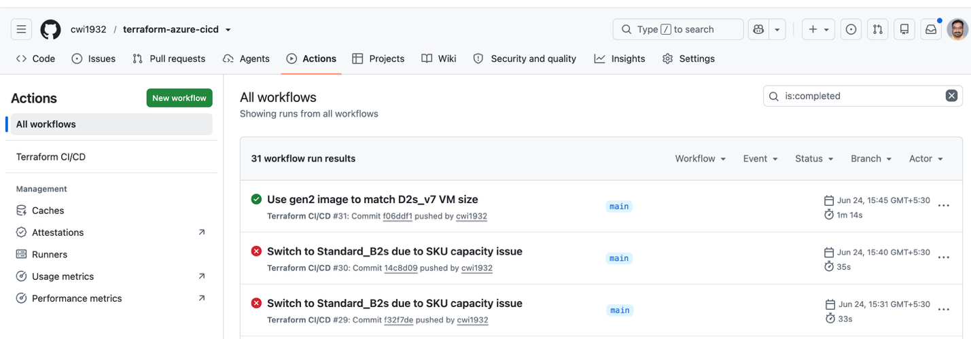

7.1 Cleanup
Following the same discipline used throughout this project, all resources were destroyed immediately after confirming success, to avoid unnecessary cost:
terraform destroy -auto-approve
# Destroy complete! Resources: 6 destroyed.
terraform state list
# (empty — confirmed clean)

8. Key Takeaways
- Terraforms provider authentication and backend authentication are separate systems — credentials available to one are not automatically available to the other.
- Remote state with locking (via Azure AD authentication) requires explicit role assignments distinct from general subscription-level permissions.
- CI/CD pipeline failures are rarely one single problem — each fix can reveal the next layer of an issue, and that is normal, expected behavior in real infrastructure work.
- Cloud capacity and SKU availability are real, subscription-specific constraints — not something visible from documentation alone, only from direct verification against the live subscription.
- Reading the exact error message, line by line, and tracing it to the most recent change is the core diagnostic skill that resolved every issue in this log.
- Designing infrastructure to avoid local-machine dependencies (such as dynamically generated SSH keys instead of local file paths) is essential for anything that needs to run in CI/CD.

8.2 Skills Demonstrated
- Terraform: resource dependencies, remote backends, state management, provider configuration
- Azure: RBAC role assignments, Service Principals, resource providers, VM SKU/capacity constraints
- GitHub Actions: workflow YAML structure, secrets management, job/step scoping
- Git: commit/push workflow, troubleshooting repository structure
- Systematic debugging: root-cause analysis across eleven distinct, real production-style issues
— End of Document —

