La Palma Earthquakes

Steve Purves

Rowan Cockett

2023-09-26

Abstract

In September 2021, a significant jump in seismic activity on the island of La Palma (Canary Islands, Spain) signaled the start of a volcanic crisis that still continues at the time of writing. Earthquake data is continually collected and published by the Instituto Geográphico Nacional (IGN). …

## 1 Introduction

Source: [Article Notebook](https://quarto-ext.github.io/manuscript-template-vscode/index.qmd.html)

Source: [Article Notebook](https://quarto-ext.github.io/manuscript-template-vscode/index.qmd.html)

|  |
| --- |
| Figure 1: Timeline of recent earthquakes on La Palma |

Source: [Article Notebook](https://quarto-ext.github.io/manuscript-template-vscode/index.qmd.html)

Source: [Article Notebook](https://quarto-ext.github.io/manuscript-template-vscode/index.qmd.html)

Based on data up to and including 1971, eruptions on La Palma happen every 79.8 years on average.

Studies of the magma systems feeding the volcano, such as Marrero et al. (2019), have proposed that there are two main magma reservoirs feeding the Cumbre Vieja volcano; one in the mantle (30-40km depth) which charges and in turn feeds a shallower crustal reservoir (10-20km depth).

Eight eruptions have been recorded since the late 1400s (Figure 1).

Data and methods are discussed in Section 2.

Let $x$ denote the number of eruptions in a year. Then, $x$ can be modeled by a Poisson distribution

$$p\left(x\right)=\frac{e^{−λ}λ^{x}}{x!} \left(1\right)$$

where $λ$ is the rate of eruptions per year. Using Equation 1, the probability of an eruption in the next $t$ years can be calculated.

| Name | Year |
| --- | --- |
| Current | 2021 |
| Teneguía | 1971 |
| Nambroque | 1949 |
| El Charco | 1712 |
| Volcán San Antonio | 1677 |
| Volcán San Martin | 1646 |
| Tajuya near El Paso | 1585 |
| Montaña Quemada | 1492 |

Recent historic eruptions on La Palma

Table 1 summarises the eruptions recorded since the colonization of the islands by Europeans in the late 1400s.

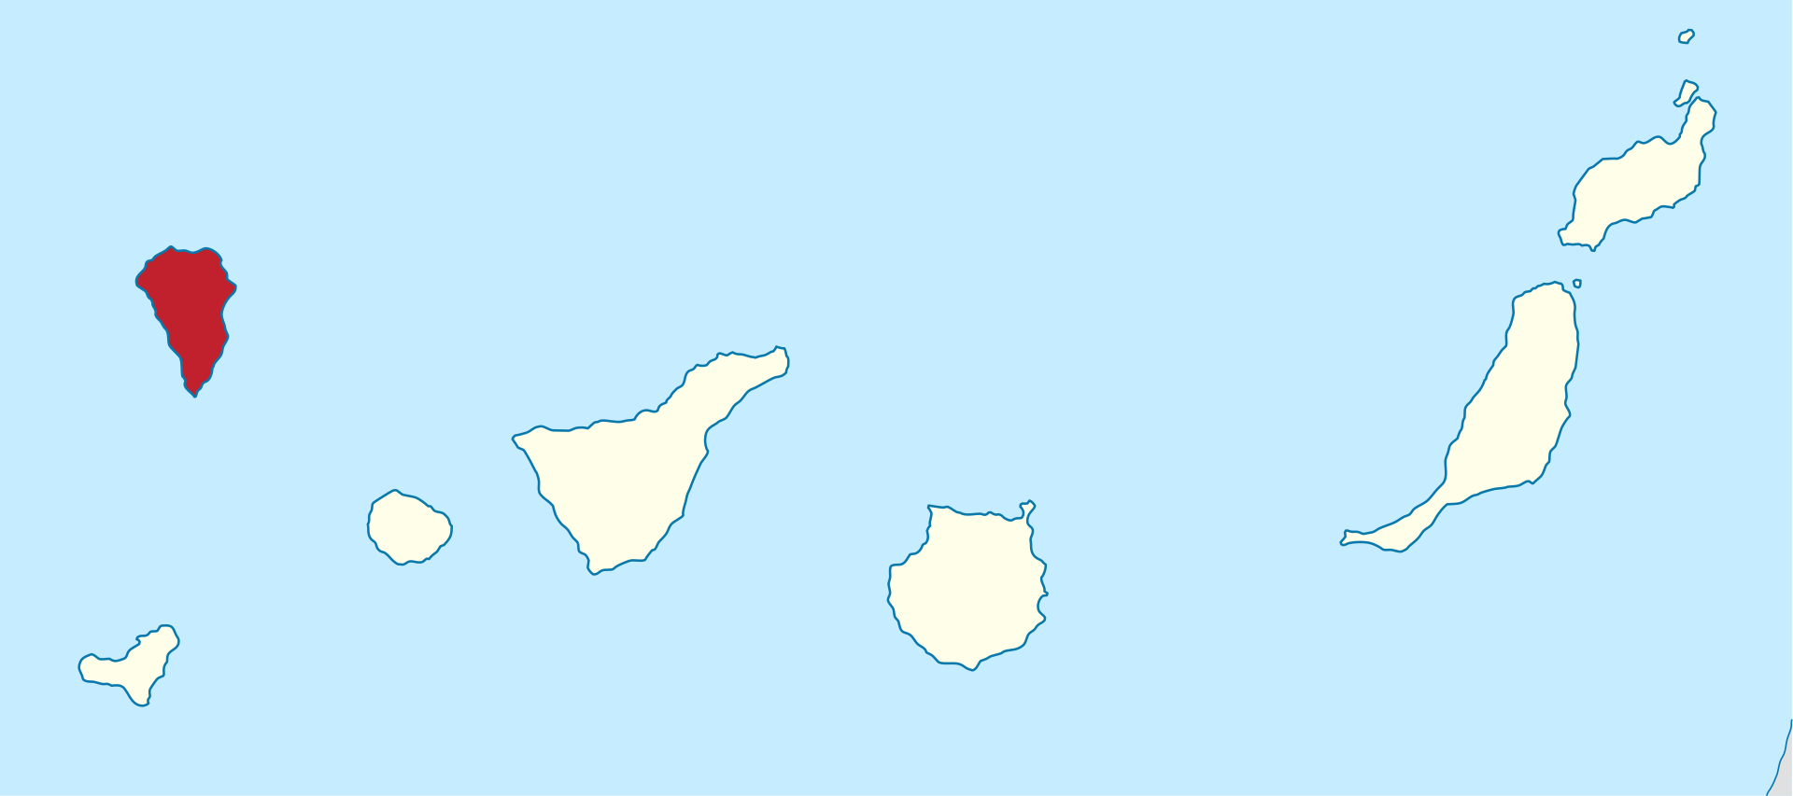

Map of La Palma

La Palma is one of the west most islands in the Volcanic Archipelago of the Canary Islands (Figure 2).

|  |
| --- |
| Figure 3: Locations of earthquakes on La Palma since 2017. |

Source: [Article Notebook](https://quarto-ext.github.io/manuscript-template-vscode/index.qmd.html)

Figure 3 shows the location of recent Earthquakes on La Palma.

## 2 Data & Methods

## 3 Conclusion

## References

Source: [Article Notebook](https://quarto-ext.github.io/manuscript-template-vscode/index.qmd.html)

Marrero, José, Alicia García, Manuel Berrocoso, Ángeles Llinares, Antonio Rodríguez-Losada, and R. Ortiz. 2019. “Strategies for the Development of Volcanic Hazard Maps in Monogenetic Volcanic Fields: The Example of La Palma (Canary Islands).” *Journal of Applied Volcanology* 8 (July). <https://doi.org/10.1186/s13617-019-0085-5>.