Christopher WIlliams

May 29, 2018

Assignment 4

Location And Maps Documentation

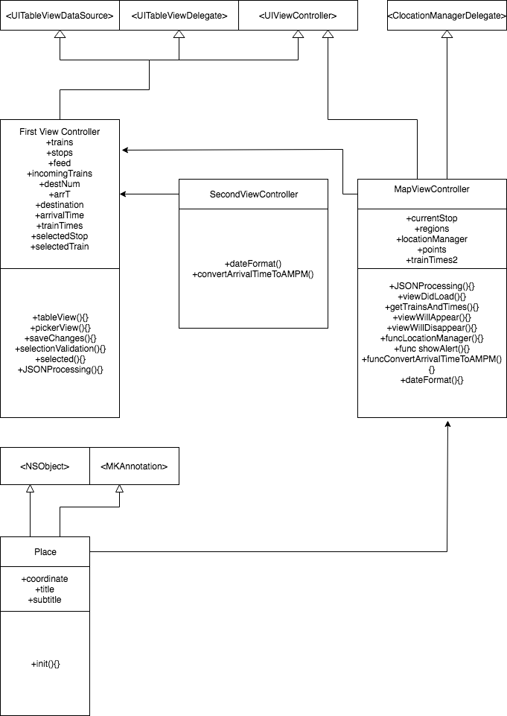

The class first view controller controls the first view. It loads the data for the pickers, saves the changes made when the user selects save changes. It validates correct selections, and it does JSON processing which checks for errors and makes sure the information being received is correct.

The second view controller loads a picker view with all the train times that are coming. It saves the changes that are made. Converts the times from JSON from 24 hour time to 12 hour time.

Both classes uses the global variables trains, stops, feed, incomingTrains, destNum, arrT, destination, arrivalTime, trainTimes, selectedStop, and selectedTrain.

The third View Controller, the one I just added is the Map View Controller. This processes JSON information, loadsData, getsTrainsAndTimes to dynamically update the information. This class converts the train times to 12 hour time. This class is used to display the MapView's longitude and latitude, as well as geofencing information on weather a person entered of exited an area.

What error conditions and anomalies during the communication and in the data

content that you have considered in the design and implementation of your app? What

measures did you take to allow your app to continue to function in the presence of

these conditions?

The additional area conditions I added are based on the data being processed from the JSON. I used the red line train information to get the trains going in the direction of 95th. So, Whenever a user enters the fencing zone, they will get the time information for the first redline train going to 95th in that zone. If the information is not yet present, the user is alerted with a message stating "Please Wait for the information to be calculated." If there is information, we present the user with the information that we have.

What measures did you take to avoid cyclic strong references in your code?

I avoided Cyclic Strong References by not having two strong references reference each other in a cycle. My strong references do not form any cycles. I also declared variables to be weak if I was unsure the instance of the references class had a strong reference to the class I was using.