Artificial Intelligence in Government:
Improving Public Sector Services Through Smart Technologies

Name: Erwin Cheng
Course: ITAI 2372 AI Applications
Instructor: Anna Rachapudi
Date: April 11, 2026

Introduction
Artificial Intelligence (AI) has quickly become one of the most influential technologies shaping modern society. In recent years, governments around the world have started adopting AI to improve how they operate and deliver services to citizens. Traditionally, public sector systems have relied on manual processes, fixed procedures, and reactive decision-making. While these approaches have worked in the past, they are no longer sufficient in a world where data is constantly growing and public expectations are increasing.
AI offers governments the ability to analyze massive amounts of data, recognize patterns, and make predictions that can improve efficiency and service quality. For example, AI can help optimize transportation systems, predict infrastructure failures, improve healthcare delivery, and enhance emergency response systems. These capabilities allow governments to shift from reactive to proactive approaches, which ultimately benefits citizens.
However, the use of AI in government is not without challenges. Issues such as data privacy, algorithmic bias, transparency, and high implementation costs must be carefully considered. Governments must balance innovation with responsibility to ensure that AI is used ethically and fairly.
This report explores a real-world case study of AI in infrastructure planning through Singapore’s Smart Nation initiative. It analyzes the problem addressed, technologies used, outcomes achieved, and challenges faced. In addition, the report proposes an innovative AI-based solution aimed at improving citizen engagement and policymaking in the public sector.

Case Study Analysis: AI in Infrastructure Planning (Smart Nation Initiative in Singapore)
Singapore’s Smart Nation initiative is widely recognized as one of the most advanced examples of AI integration in government. The initiative aims to transform the country into a fully connected, data-driven society where technology improves everyday life. A major focus of this initiative is infrastructure planning, which includes transportation systems, utilities, and urban development.
Singapore faces several challenges due to its limited land space and high population density. With millions of people living in a relatively small area, efficient infrastructure management is critical. Traditional approaches to infrastructure planning often rely on scheduled inspections and reactive maintenance. These methods can lead to delays, increased costs, and unexpected failures.
To address these issues, Singapore has implemented AI technologies such as machine learning, predictive analytics, and computer vision. IoT sensors are installed across the city to collect real-time data on traffic flow, road conditions, and environmental factors. This data is then analyzed using AI algorithms to detect patterns and predict potential problems before they occur.
For example, AI systems can predict when a road is likely to develop cracks or when traffic congestion is expected to increase. This allows authorities to take preventive action, such as scheduling maintenance or adjusting traffic signals. As a result, infrastructure systems become more reliable and efficient.
The benefits of this approach are significant. Predictive maintenance reduces long-term costs by addressing issues early. Traffic management systems improve commuting times and reduce congestion. Public safety is enhanced because potential risks are identified and addressed before they become serious problems. Additionally, data-driven decision-making allows urban planners to make more informed choices.
Despite these advantages, there are also challenges. The implementation of AI systems requires substantial investment in technology and infrastructure. Privacy concerns arise due to the use of sensors and surveillance systems. There is also a need for skilled professionals to manage and maintain these systems. Furthermore, reliance on data means that inaccurate or biased data can lead to flawed predictions.
Overall, Singapore’s Smart Nation initiative demonstrates how AI can significantly improve infrastructure planning while also highlighting the importance of addressing ethical and practical challenges.

Benefits | Challenges
Predictive maintenance | High implementation cost
Improved traffic flow | Privacy concerns
Enhanced public safety | Technical complexity
Data-driven decisions | Data bias risks
Efficient resource use | Scalability issues

Visual: Smart Infrastructure Monitoring System
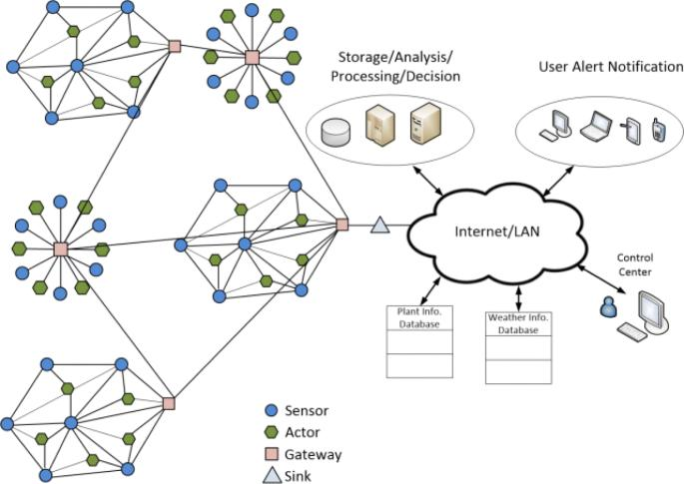
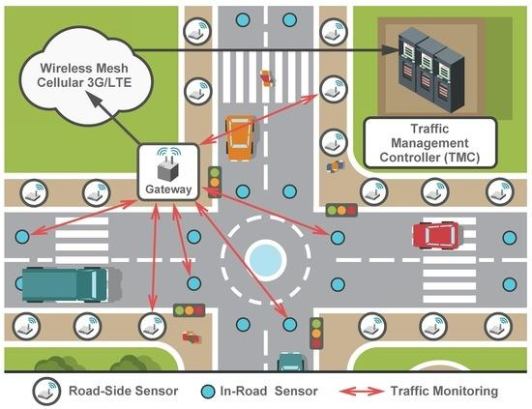


Innovative Proposal: AI-Based Citizen Feedback and Policy Recommendation System
In many countries, there is often a gap between citizens and policymakers. Traditional methods such as surveys and public meetings are limited in reach and often fail to capture real-time public opinion. This can result in policies that do not fully reflect the needs of the population.
The proposed solution is an AI-powered citizen feedback and policy recommendation system. This system would collect data from multiple sources, including mobile apps, government platforms, and social media. Using Natural Language Processing (NLP), the system would analyze citizen feedback to identify sentiment, key issues, and trends.
The system would then use machine learning algorithms to detect patterns and prioritize issues based on urgency and impact. A policy recommendation engine would suggest possible actions to policymakers, supported by data-driven insights. All of this information would be presented through a real-time dashboard.
The expected outcomes include faster decision-making, improved citizen engagement, and better alignment between policies and public needs. However, challenges such as data privacy, misinformation, and unequal access to technology must be addressed. Proper safeguards and human oversight are essential to ensure responsible use of AI.

How the System Works


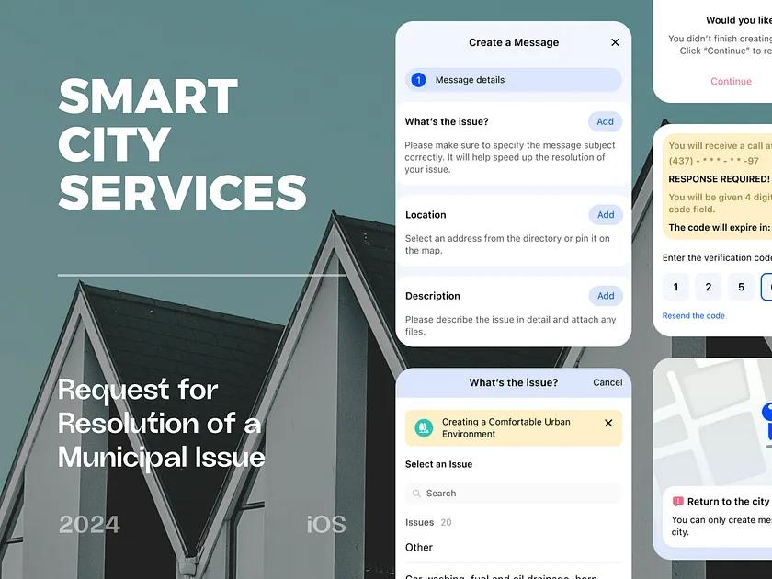


Conclusion
Artificial Intelligence is becoming an essential tool in modern governance. The case study of Singapore’s Smart Nation initiative shows how AI can significantly improve infrastructure planning by making systems more efficient, predictive, and responsive. However, it also highlights important concerns such as cost, privacy, and technical challenges.
The proposed AI-powered citizen feedback system offers a way to strengthen the relationship between governments and citizens. By using AI to analyze public opinion in real time, governments can make better decisions, respond more quickly to issues, and create policies that truly reflect public needs.
In the future, the successful integration of AI in government will depend not only on technology but also on ethical considerations, transparency, and inclusivity. When used responsibly, AI has the potential to make public services smarter, more efficient, and more accessible for everyone.

References
Smart Nation Singapore. (2024). https://www.smartnation.gov.sg
World Economic Forum. (2023). AI in Government. https://www.weforum.org
McKinsey & Company. (2023). The State of AI in the Public Sector. https://www.mckinsey.com
OECD AI Policy Observatory. https://oecd.ai
IBM. AI for Government Solutions. https://www.ibm.com

