Advantages of Using AI in the Manufacturing Industry

Name: Erwin Cheng
Course: ITAI 2372 AI Applications
Instructor: Anna Rachapudi
Date: April 18, 2026

1. Introduction
Artificial Intelligence (AI) isn’t just something you hear about in tech companies or futuristic movies anymore—it’s quietly transforming everyday industries, including manufacturing. From cars to packaged food, AI is helping companies produce goods faster, cheaper, and with better quality than ever before.
Now, when we think about manufacturing, steam buns probably aren’t the first thing that comes to mind. But that’s exactly what makes this case interesting. Steam bun production might seem simple—mix dough, add filling, steam it—but in reality, it’s a delicate and precise process. Small variations in temperature, timing, or ingredient ratios can completely change the final product.
In modern manufacturing environments, AI is being used to monitor machines, predict failures, detect defects, and even make decisions in real time. Instead of reacting to problems after they happen, companies can now prevent them before they even occur.
In this report, we’ll explore how AI can transform a steam bun manufacturing company. We’ll look at a detailed case study, break down the technologies used, and then propose a new AI-driven solution focused on reducing waste and improving sustainability.

2. Understanding Steam Bun Manufacturing
Before diving into AI, it’s important to understand how steam buns are actually made on a large scale.
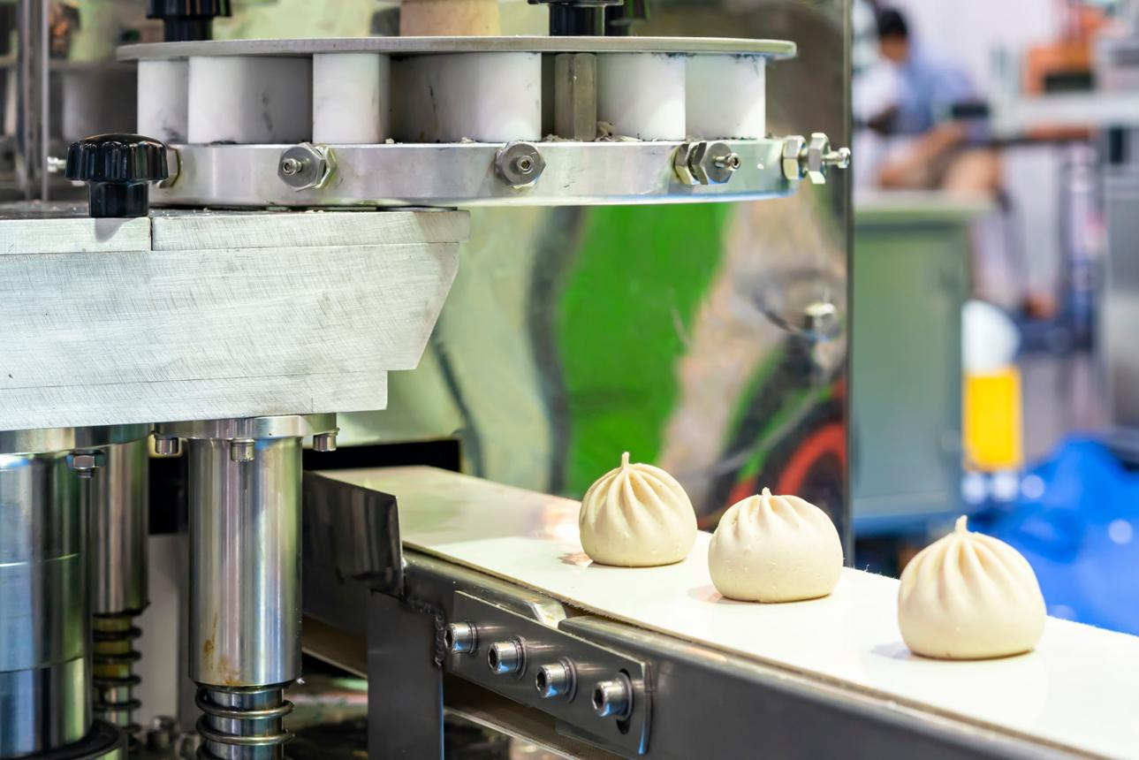
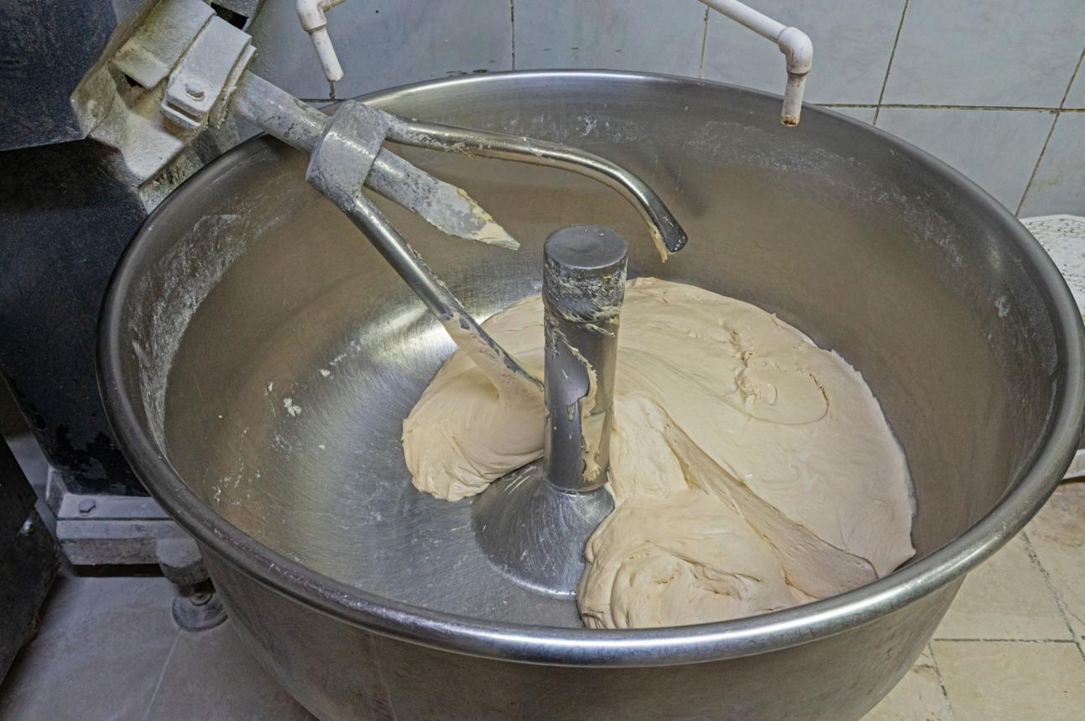
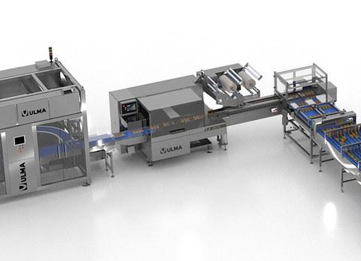
6
Figure 1: Industrial steam bun production process.
A typical production line includes:
- Dough mixing
- Fermentation (letting the dough rise)
- Filling and shaping
- Steaming
- Cooling
- Packaging
Each step depends heavily on timing, temperature, and consistency. If fermentation goes too long, the buns become too soft. If steaming temperature fluctuates, texture changes. Even filling placement matters for appearance and taste.
Traditionally, workers monitor these processes manually, but that leads to inconsistencies—especially at high production speeds.

3. Case Study: AI Implementation in a Steam Bun Factory
3.1 The Problem
Let’s imagine a mid-sized steam bun manufacturing company trying to scale up production. Business is growing, demand is increasing—but so are the problems.
Here’s what they were dealing with:
1. Equipment Breakdowns
Machines like steamers and mixers would fail unexpectedly, stopping production.
2. Inconsistent Quality
Some buns looked perfect, others didn’t—customers noticed.
3. High Waste Levels
Defective buns had to be thrown away, increasing costs.
4. Slow Manual Inspection
Human inspectors couldn’t keep up with the speed of production.
5. Energy Inefficiency
Steamers used more energy than necessary due to poor optimization.
At this point, the company had two choices: hire more workers or get smarter with technology. They chose the second option.
3.2 AI Technologies Introduced
To fix these issues, the company implemented several AI-based systems.
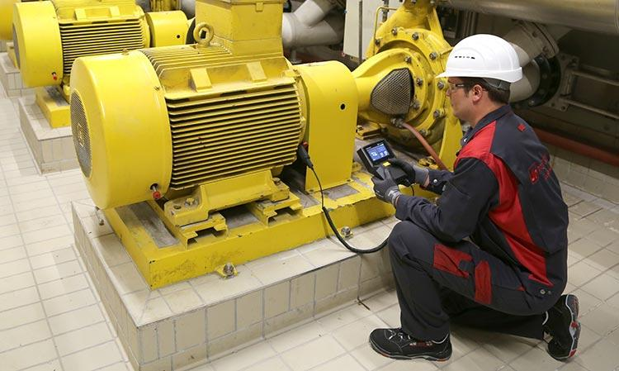
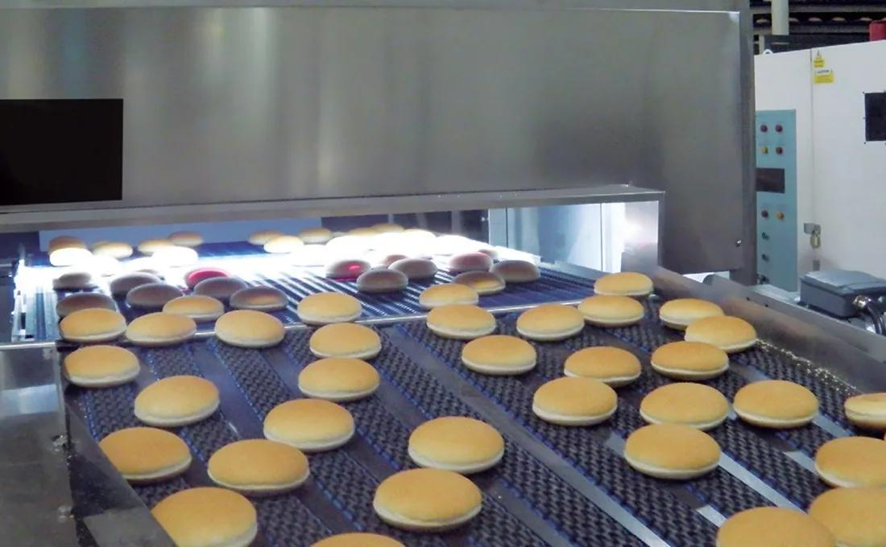
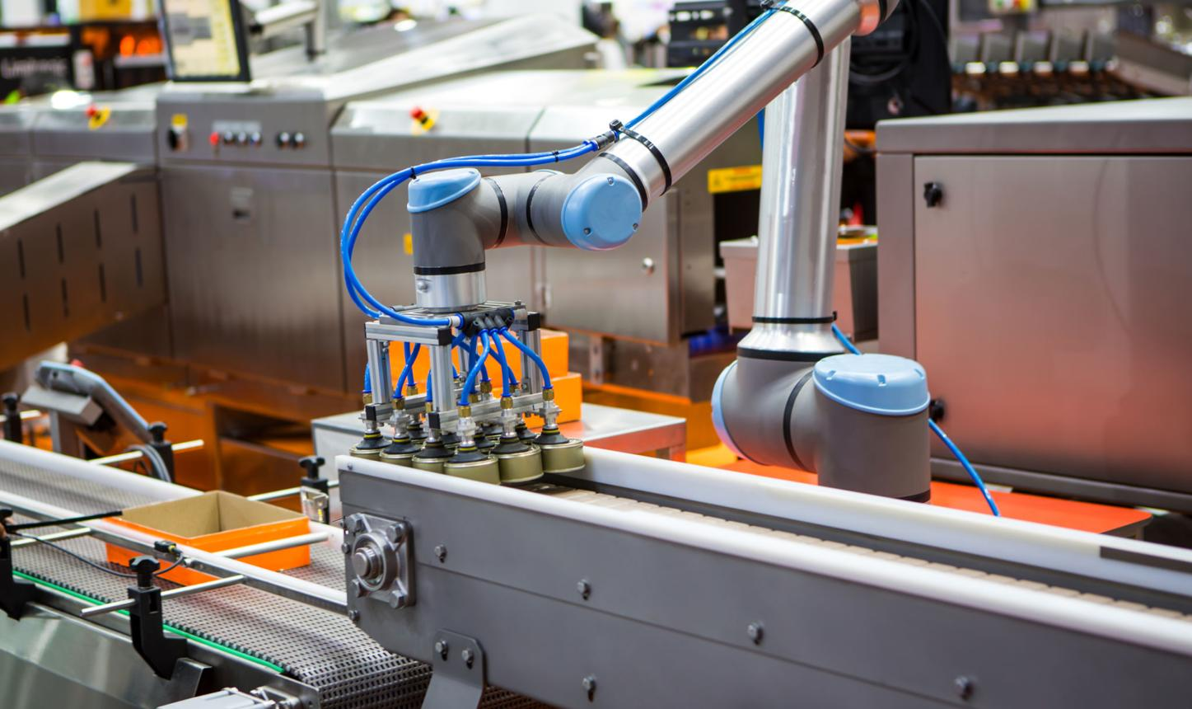

Figure 2: Key AI technologies used in smart manufacturing.

1. Predictive Maintenance (Machine Learning)
Instead of waiting for machines to break, sensors were installed to track:
Temperature
Vibration
Pressure
AI models analyzed this data and predicted when a machine was likely to fail.
Simple idea:
Fix the problem before it happens.

2. Computer Vision for Quality Control
Cameras were installed along the production line. AI analyzed each bun in real time to check:
- Shape
- Size
- Surface defects
- Filling placement
This replaced manual inspection and worked much faster.

3. Process Optimization Using AI
AI systems monitored:
- Dough fermentation time
- Steam temperature
- Humidity levels
If something drifted from optimal conditions, the system automatically adjusted it.

4. Robotics and Automation
Robotic systems handled repetitive tasks like:
- Filling buns
- Transferring trays
- Packaging
This improved consistency and reduced human error.

3.3 AI Workflow in the Factory
Here’s how everything connects:
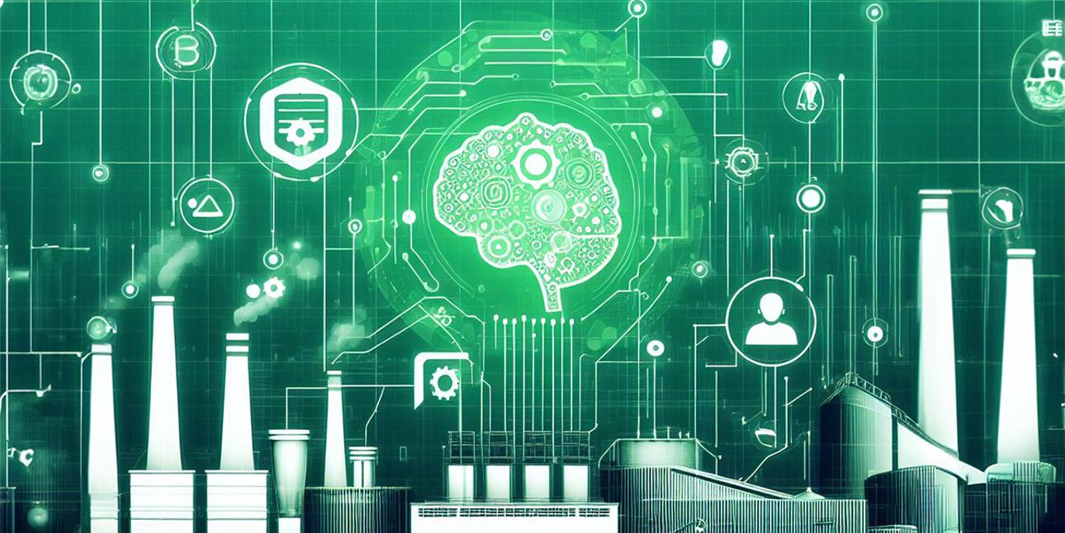
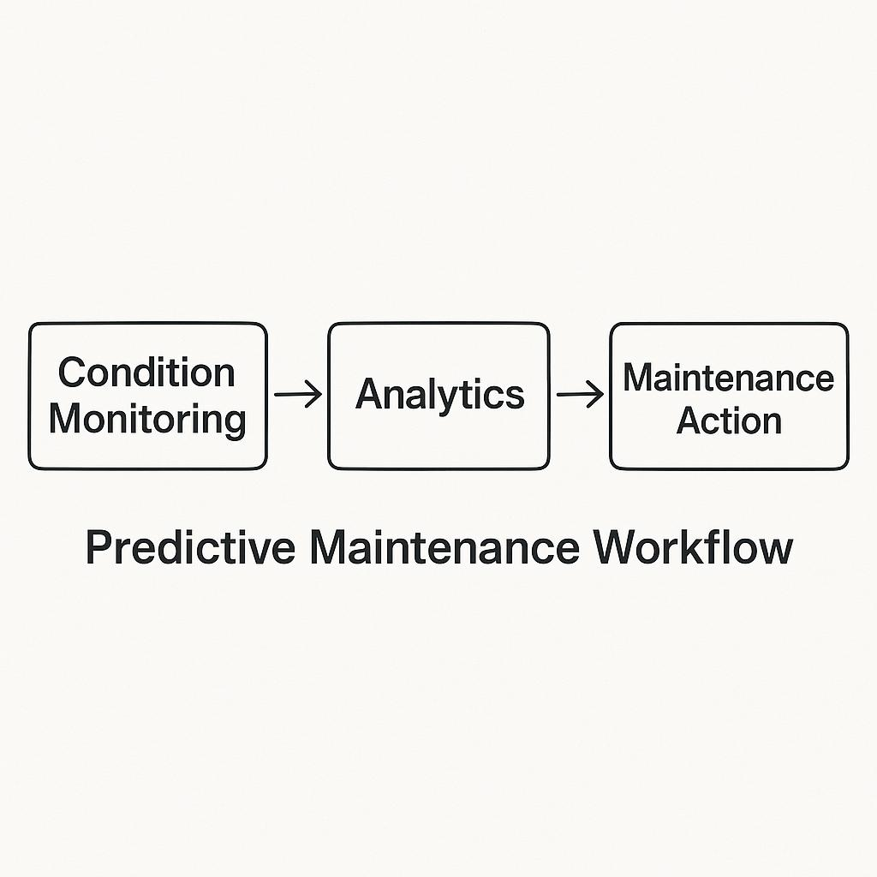
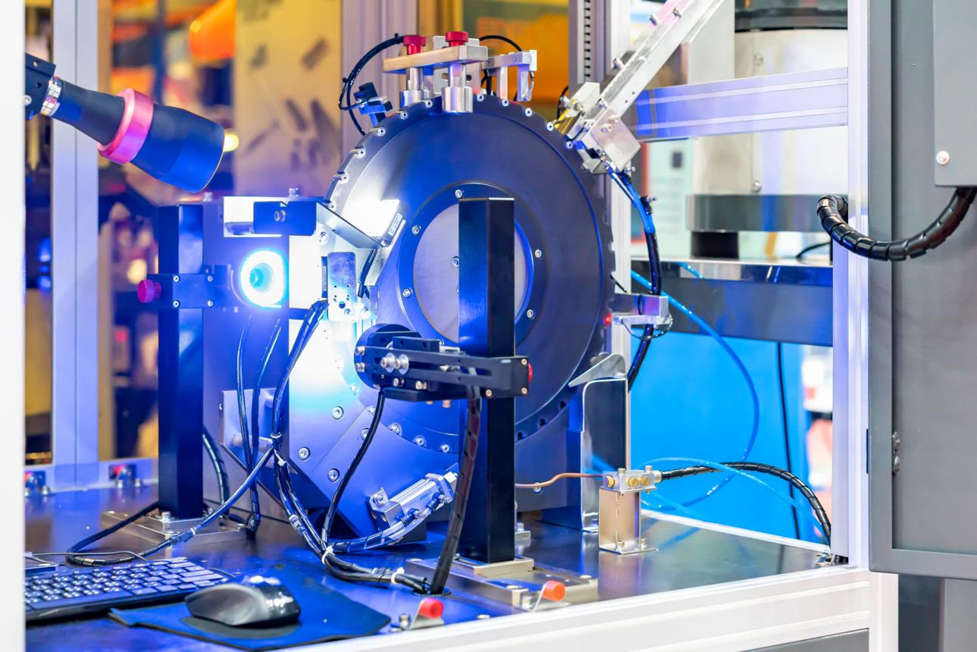

Figure 3: AI workflow in a smart manufacturing system.
Flow Explanation (Simplified):
- Sensors collect data
- Data goes to AI system
- AI analyzes patterns
- System predicts issues or detects defects
- Machines adjust automatically
- Managers monitor via dashboard

3.4 Results and Benefits
After implementing AI, the company saw major improvements.
1. Reduced Downtime
Machine failures dropped by about 35%.
2. Better Product Quality
Defect detection improved to over 95% accuracy.
3. Lower Costs
- Less waste
- Fewer repairs
- Reduced energy usage
4. Faster Production
Automation increased production speed without sacrificing quality.
5. Consistency
Every bun looked and tasted the same—huge win for customer satisfaction.

3.5 Challenges Faced
It wasn’t all smooth sailing.
1. High Setup Cost
AI systems aren’t cheap to install.
2. Training Workers
Employees had to learn new systems and tools.
3. Data Issues
AI needs clean, high-quality data—and getting that took time.
4. Integration Problems
Old machines didn’t easily connect with new AI systems.
5. Cybersecurity Concerns
More connected systems = more potential risks.

4. Proposal: AI-Based Waste Reduction System
Even with improvements, one major issue remained: waste.
Food manufacturing always deals with:
- Overproduction
- Defective products
- Inefficient ingredient use
So here’s a smarter solution.

4.1 The Idea: Smart AI Waste Management System
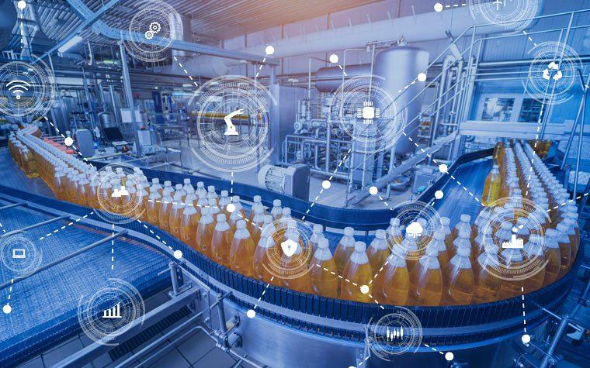
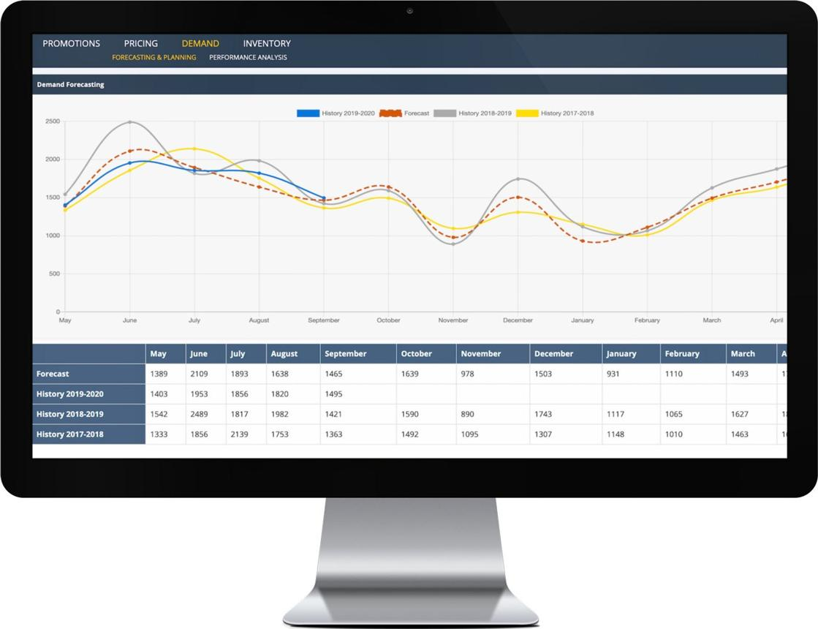
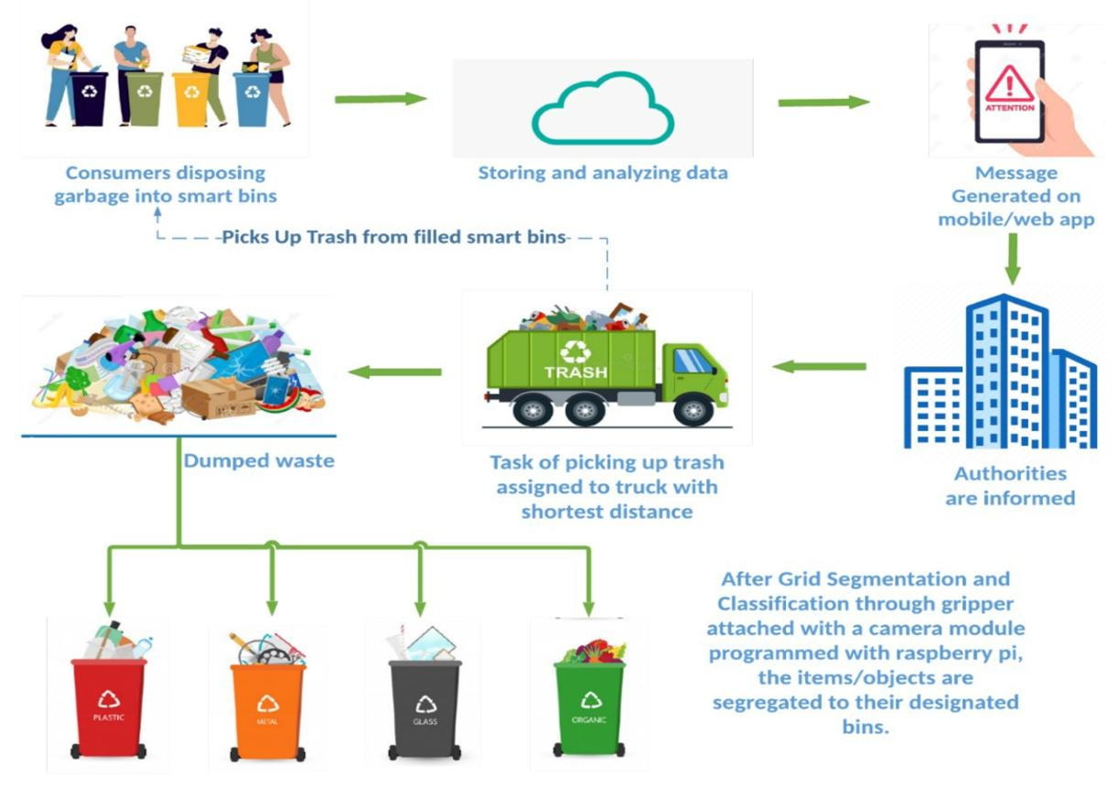

Figure 4: AI-driven waste reduction system.
4.2 How It Works (Step-by-Step)
- Step 1: Demand Forecasting
AI predicts how many buns are needed using:
- Past sales
- Seasonal trends
- Holidays

- Step 2: Smart Production Planning
Production adjusts automatically to avoid overproduction.

- Step 3: Real-Time Defect Tracking
Computer vision identifies patterns in defects and suggests fixes.

- Step 4: Ingredient Monitoring
Sensors track how much material is being used.

- Step 5: Waste Analytics Dashboard
Managers can see where waste is happening and why.

4.3 Benefits of This System
1. Less Food Waste
Estimated reduction: 25–35%
2. Cost Savings
Less wasted ingredients = more profit.
3. Sustainability
Better for the environment.
4. Smarter Decisions
Data helps managers improve processes.

4.4 Possible Challenges
- Requires accurate data
- Needs system integration
- Workers must adapt
- Initial cost

Discussion
The integration of AI into steam bun manufacturing demonstrates how even traditional food production industries can benefit from advanced technologies. AI not only enhances efficiency but also ensures product consistency, which is critical in the food sector.
One key insight from this case study is that AI works best when integrated across multiple stages of production rather than applied in isolation. For example, combining predictive maintenance with process optimization creates a more resilient and efficient production system.
Another key point is that AI doesn’t replace humans—it changes their role. Workers move from manual tasks to monitoring systems, analyzing data, and making higher-level decisions.

Conclusion
Artificial Intelligence is revolutionizing the manufacturing industry by enabling smarter, faster, and more efficient production processes. In the context of steam bun manufacturing, AI has proven to be highly effective in addressing key challenges such as equipment failure, product inconsistency, and operational inefficiencies.
The case study highlights how AI technologies—including machine learning, computer vision, and robotics—can significantly improve production outcomes. Additionally, the proposed AI-based waste management system demonstrates the potential for further innovation, particularly in sustainability and cost reduction.
While challenges such as high implementation costs and workforce adaptation remain, the long-term benefits of AI adoption far outweigh these obstacles. As technology continues to evolve, AI will play an increasingly important role in shaping the future of manufacturing.

References
- McKinsey & Company. (2021). The future of AI in manufacturing. Retrieved from https://www.mckinsey.com

- Deloitte. (2022). AI-driven manufacturing and smart factories. Retrieved from https://www2.deloitte.com

- IBM. (2023). What is predictive maintenance? Retrieved from https://www.ibm.com/topics/predictive-maintenance

- Food and Agriculture Organization. (2021). Food waste and sustainability in production systems. Retrieved from https://www.fao.org

- National Institute of Standards and Technology. (2020). Smart manufacturing and AI technologies. Retrieved from https://www.nist.gov

