Leveraging Artificial General Intelligence (AGI) in Steam Bun Manufacturing

Name: Erwin Cheng
Course: ITAI 2372 AI Applications
Instructor: Anna Rachapudi
Date: April 25, 2026

1. Introduction
Artificial intelligence has already begun transforming industries worldwide, but most of today’s systems are classified as narrow AI—designed to perform specific tasks such as image recognition, prediction, or automation. The next frontier, Artificial General Intelligence (AGI), promises a far more profound shift. AGI refers to machines capable of understanding, learning, and applying knowledge across a wide variety of tasks at a level comparable to human intelligence.
In the context of manufacturing, AGI could represent a paradigm shift from automated production to intelligent, self-optimizing ecosystems. The steam bun manufacturing industry—rooted in both tradition and industrial scalability—offers a compelling case study for exploring AGI’s transformative potential. Steam buns (bao) are widely consumed globally, and their production involves a delicate balance between precision, timing, and environmental control.
Despite advances in automation, current manufacturing systems still struggle with adaptability, quality consistency, and real-time decision-making. This case study examines how AGI could revolutionize steam bun manufacturing by addressing these challenges, enabling innovation, and reshaping the relationship between humans and machines in production environments.
Industry Analysis
Current State of Steam Bun Manufacturing
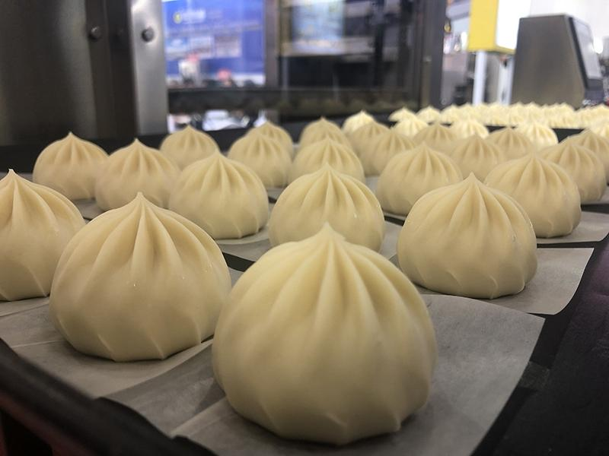

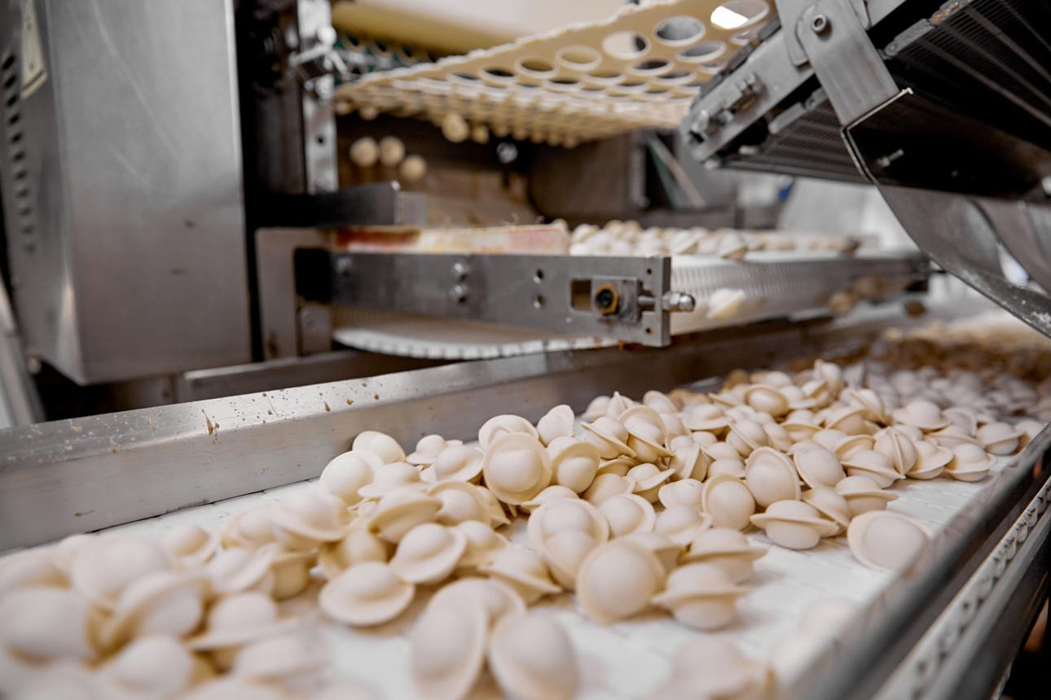
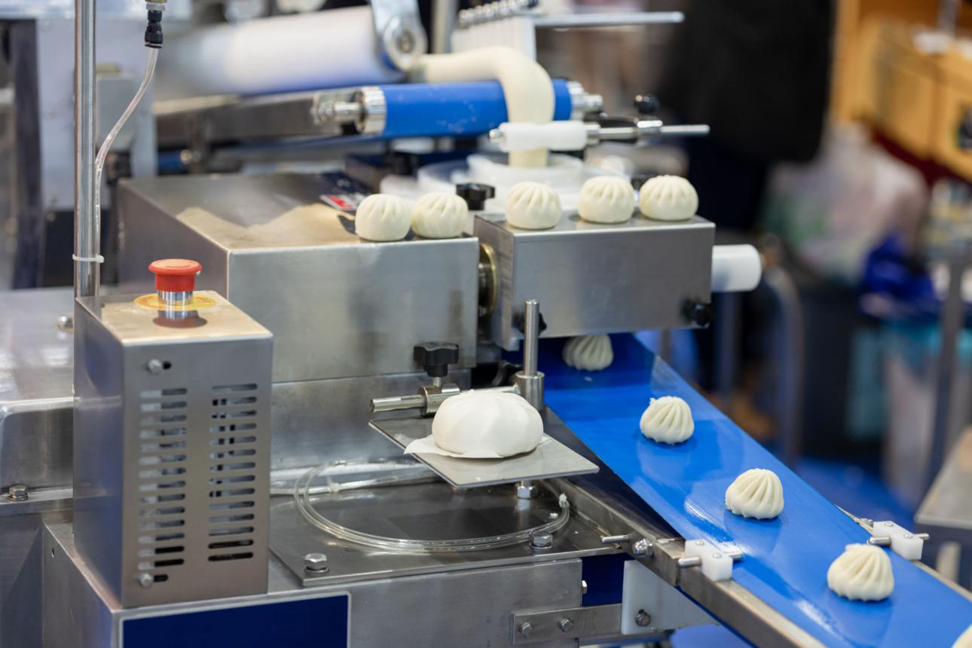
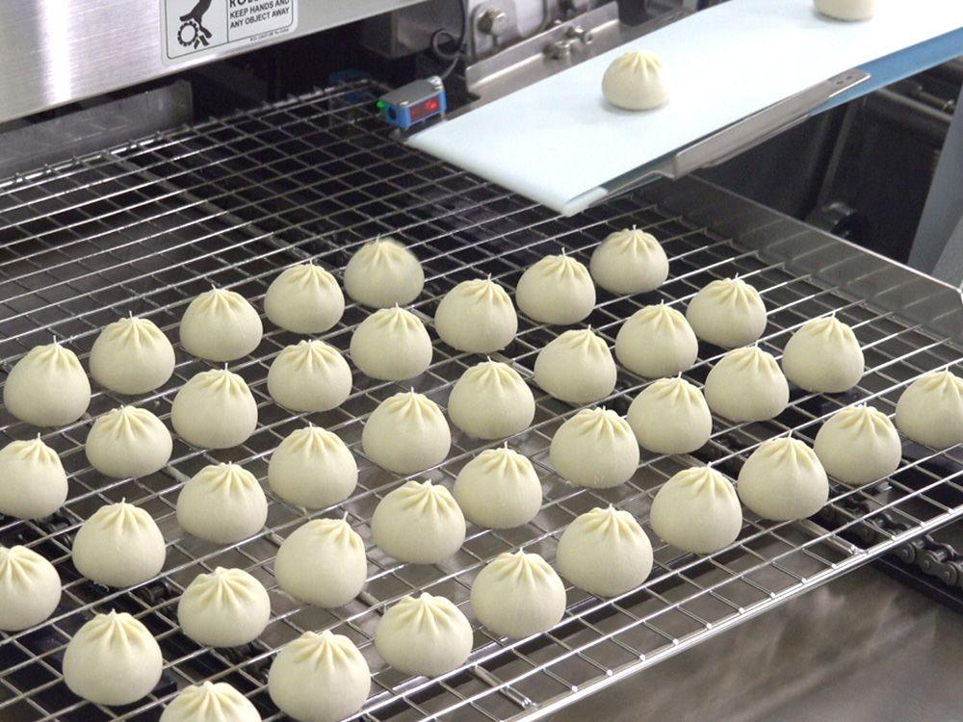
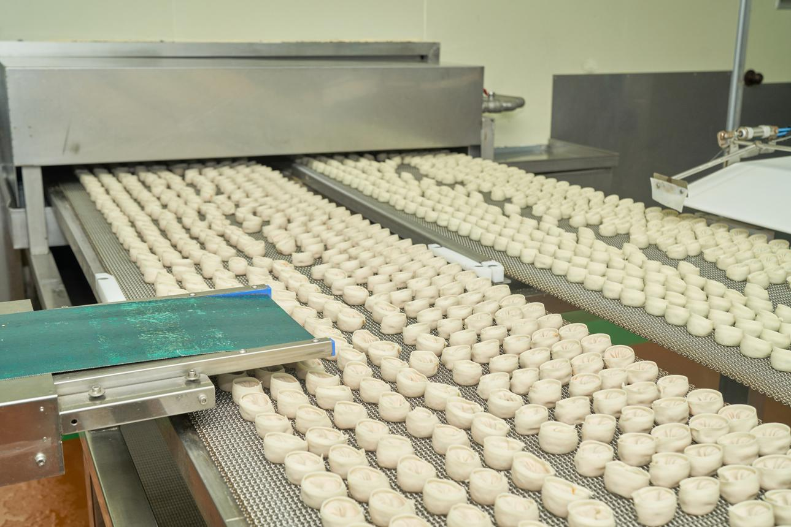
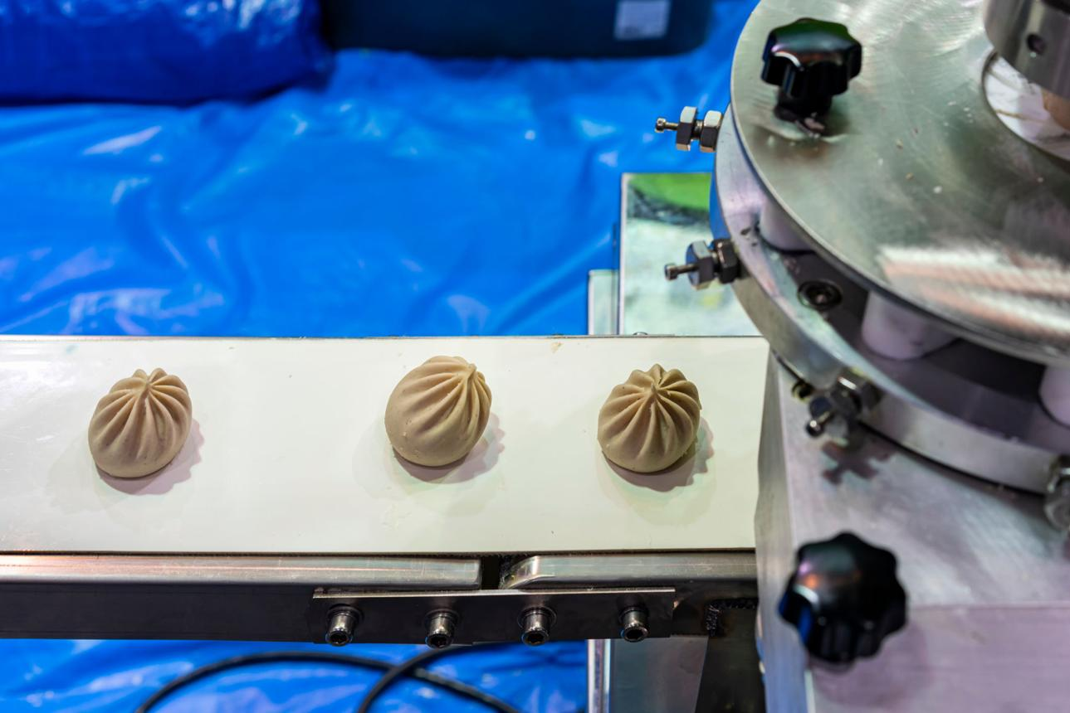
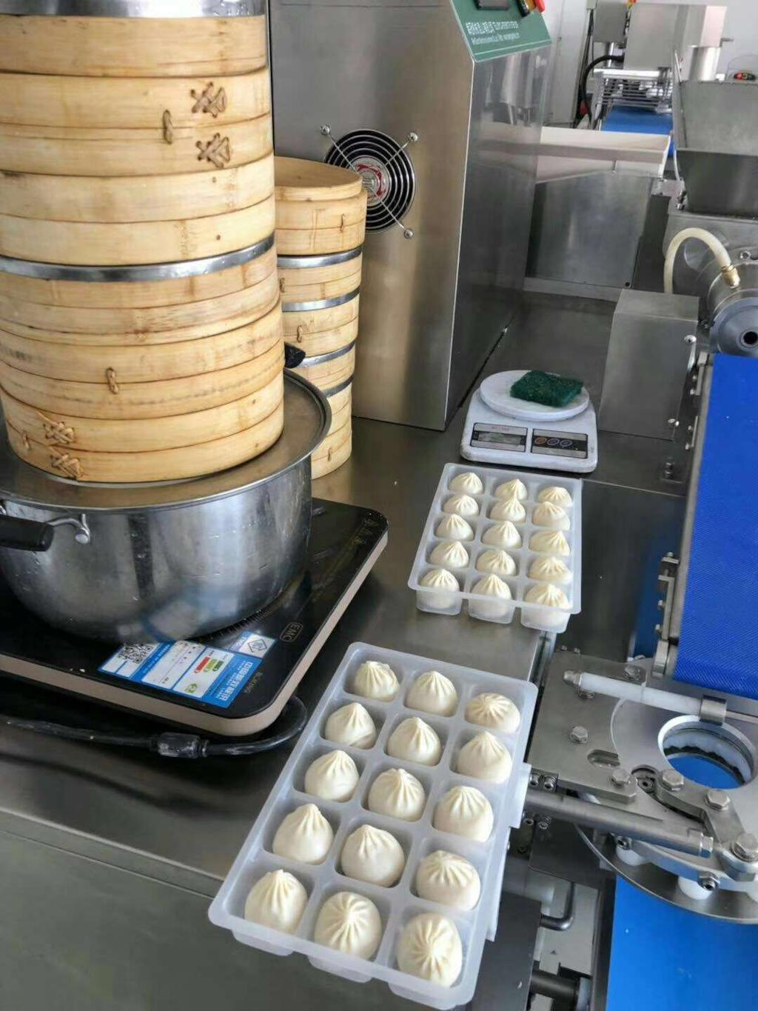
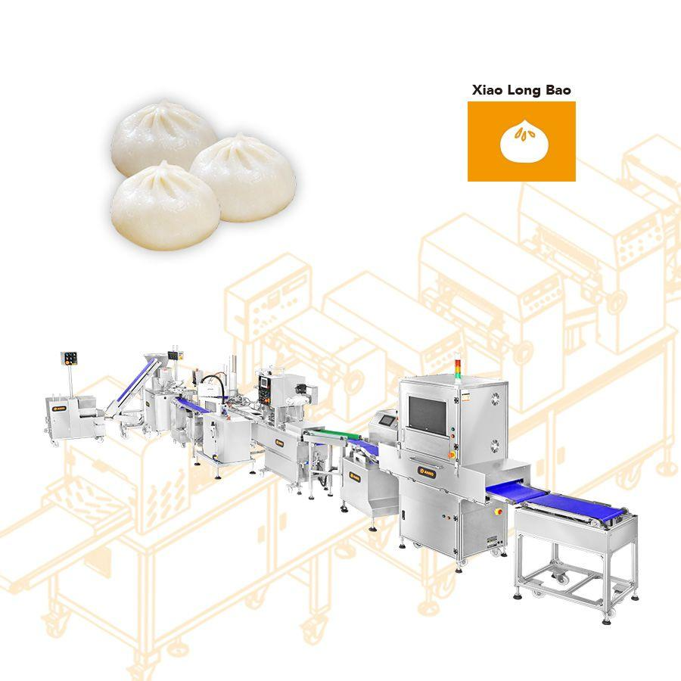
Steam bun manufacturing has evolved from small-scale artisanal kitchens to large industrial production facilities capable of producing thousands of units per hour. The modern production process typically includes:
- Ingredient preparation: Measuring flour, yeast, water, and other ingredients
- Dough mixing and fermentation: Achieving the right elasticity and texture
- Filling preparation: Meat, vegetable, or sweet fillings
- Shaping and forming: Machines or workers shape buns uniformly
- Steaming: Controlled heat and humidity cook the buns
- Cooling and packaging: Preparing products for storage and distribution
Automation has been integrated into many of these steps. Conveyor belts, robotic arms, and programmable logic controllers (PLCs) help standardize production and reduce manual labor. However, these systems are fundamentally rule-based and lack the flexibility required to adapt to variability.

Key Challenges in Steam Bun Manufacturing
1. Variability in Raw Materials
Flour quality can vary based on supplier, season, and storage conditions. Even small differences in protein content or moisture can significantly impact dough behavior. Traditional systems cannot dynamically adjust to these variations.
2. Environmental Sensitivity
Temperature and humidity play critical roles in fermentation and steaming. Minor fluctuations can lead to inconsistent texture or taste, requiring manual adjustments by experienced workers.
3. Labor Dependence
Although automation has reduced manual work, skilled operators are still needed to monitor processes, troubleshoot issues, and make judgment-based decisions.
4. Quality Control Limitations
Existing quality control systems rely on predefined thresholds. They may detect defects but cannot always understand why defects occur or how to prevent them.
5. Inefficient Demand Forecasting
Production planning often relies on historical data and simple predictive models, leading to overproduction (waste) or underproduction (lost revenue).
Existing Use of AI in the Industry
Current applications of AI in food manufacturing include:
- Computer vision systems for detecting defective products
- Predictive maintenance algorithms to anticipate machine failures
- Basic machine learning models for demand forecasting
While these technologies improve efficiency, they are limited in scope. They cannot generalize across tasks or make complex, multi-step decisions—highlighting the need for AGI.
Understanding Artificial General Intelligence (AGI)
AGI differs fundamentally from narrow AI in its scope and capabilities. While narrow AI excels at specific tasks, AGI aims to replicate general human intelligence, including reasoning, planning, learning, and adaptability.
- Core Characteristics of AGI
- Cross-domain learning: Ability to transfer knowledge between tasks
- Autonomous decision-making: Minimal human intervention required
- Context awareness: Understanding complex environments and variables
- Continuous learning: Improving performance over time without reprogramming
In a manufacturing setting, AGI would function not just as a tool, but as an intelligent system manager, capable of overseeing operations holistically.
AGI Application Proposal
1. Autonomous Production Optimization
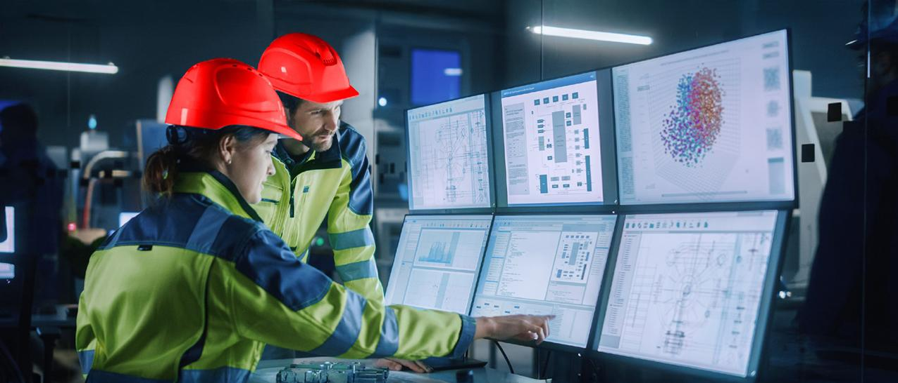
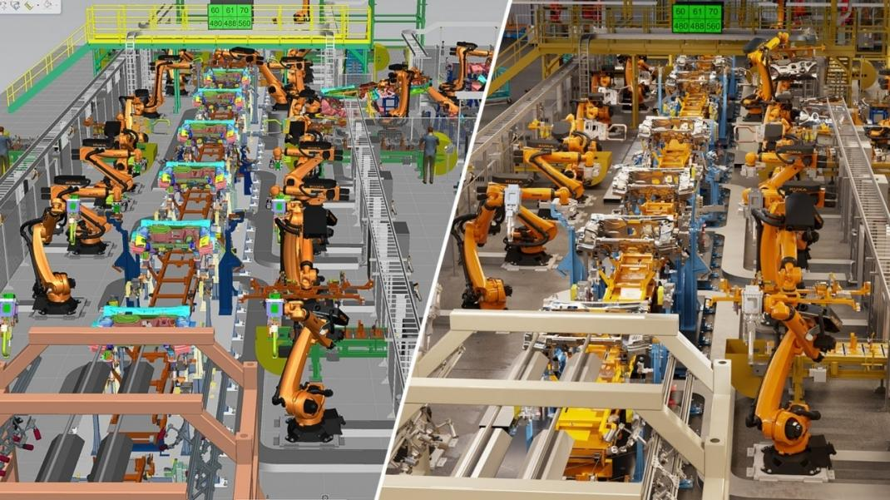
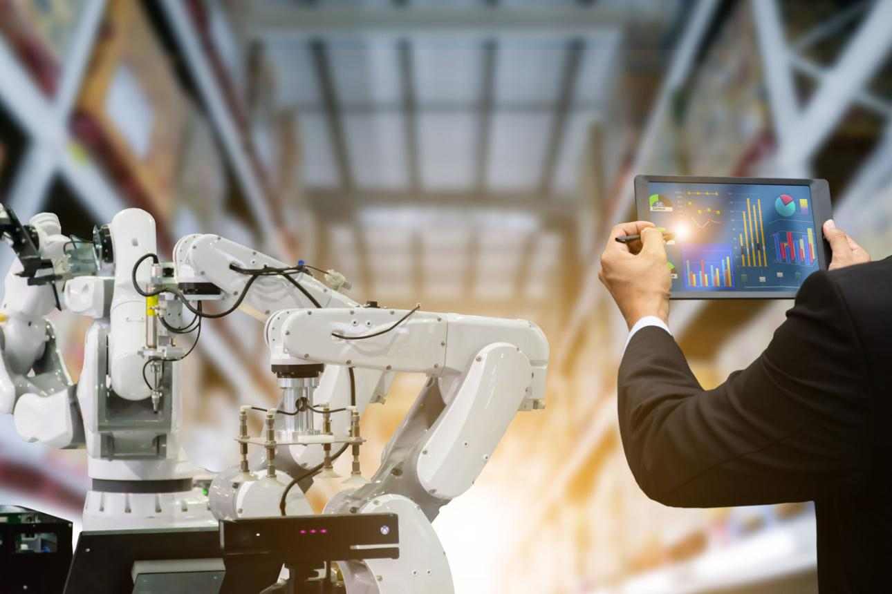

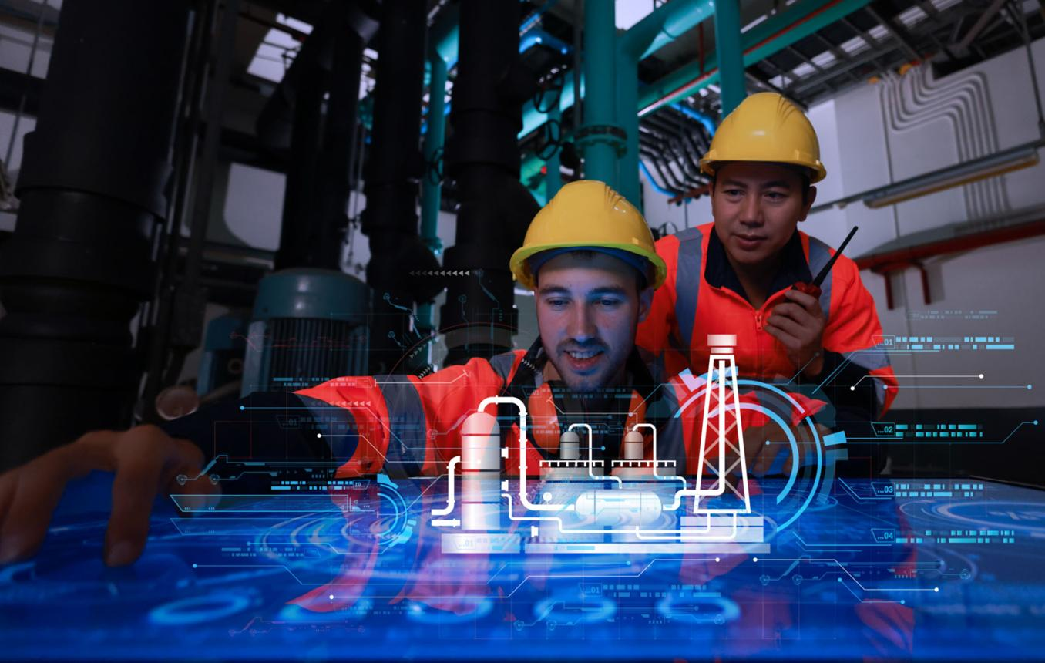
AGI could monitor and control the entire production line in real time. Unlike traditional systems, it would:
- Adjust ingredient ratios dynamically
- Modify fermentation times based on environmental data
- Optimize machine scheduling to reduce bottlenecks
For example, if humidity increases unexpectedly, AGI could instantly recalibrate steaming conditions to maintain product quality.
2. Advanced Quality Control and Prediction
AGI-powered systems would go beyond defect detection to defect prevention. By analyzing patterns across production data, AGI could:
- Identify root causes of inconsistencies
- Predict defects before they occur
- Automatically adjust upstream processes
This represents a shift from reactive to proactive quality management.
3. Intelligent Supply Chain Integration
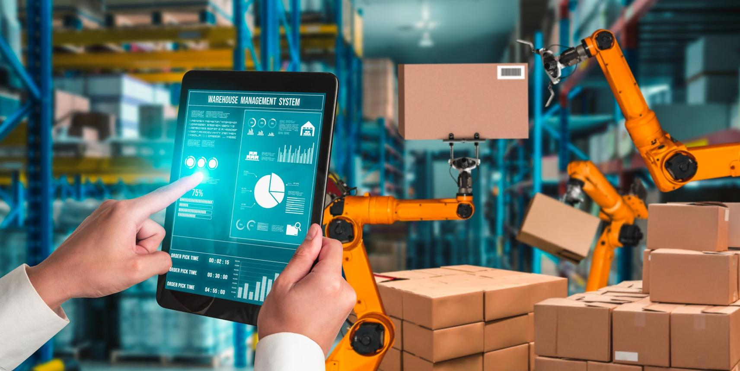
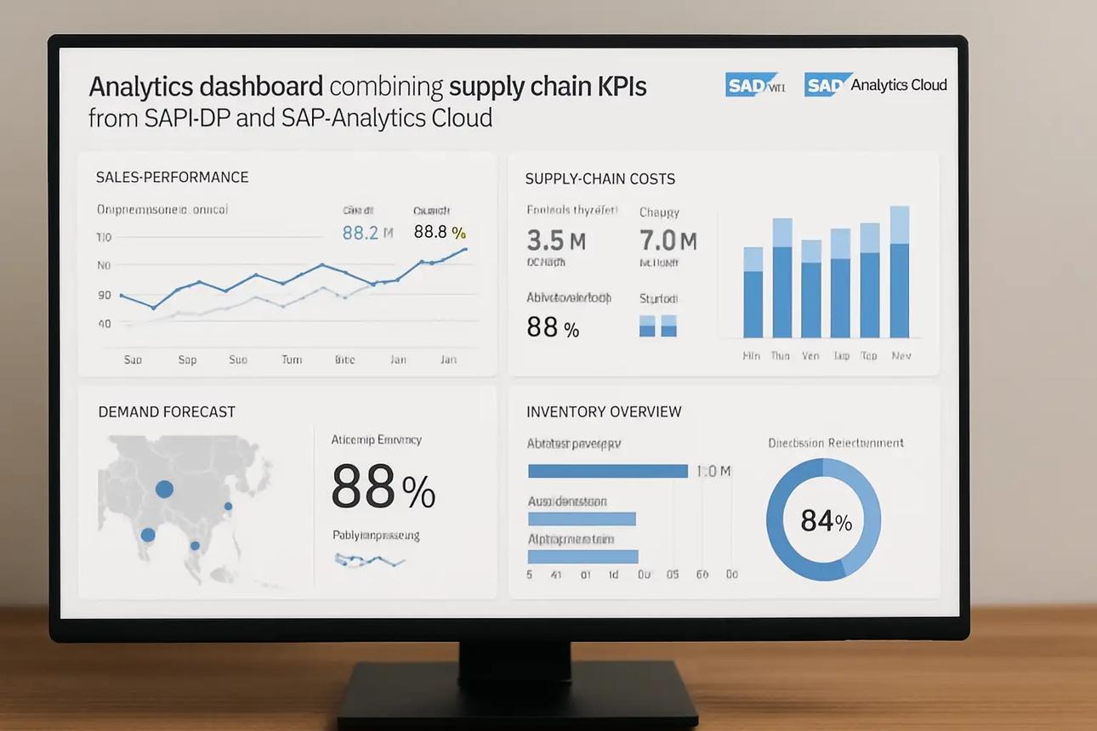
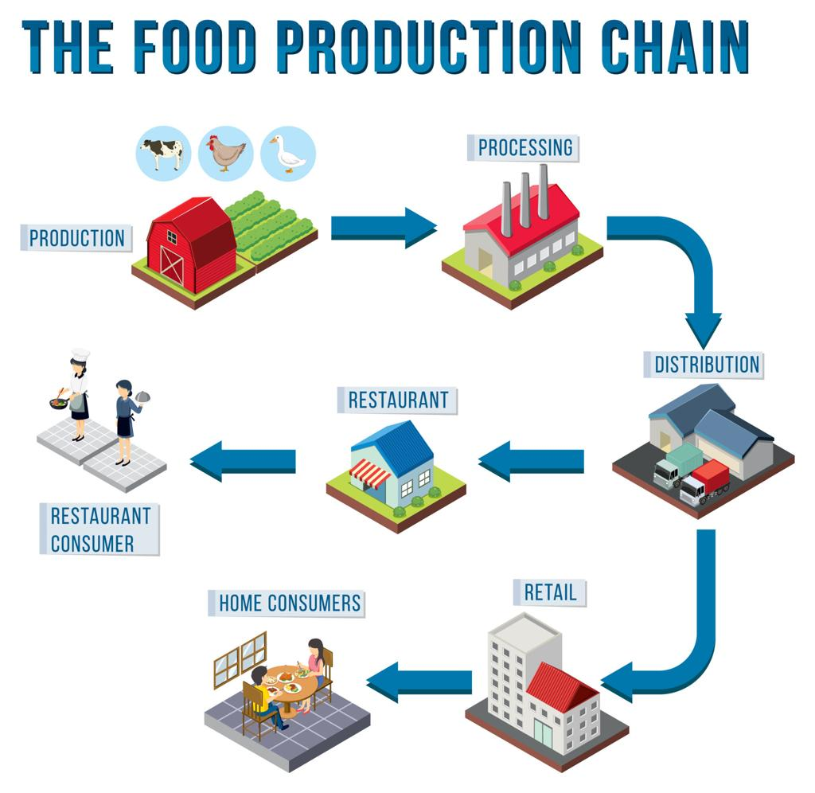
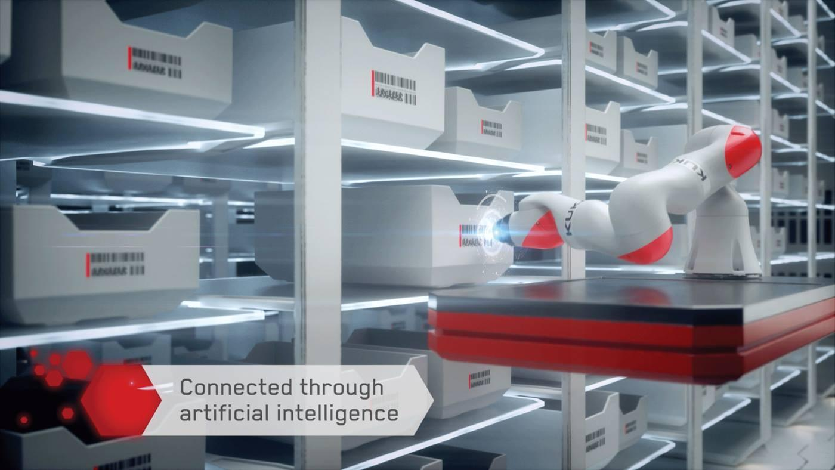


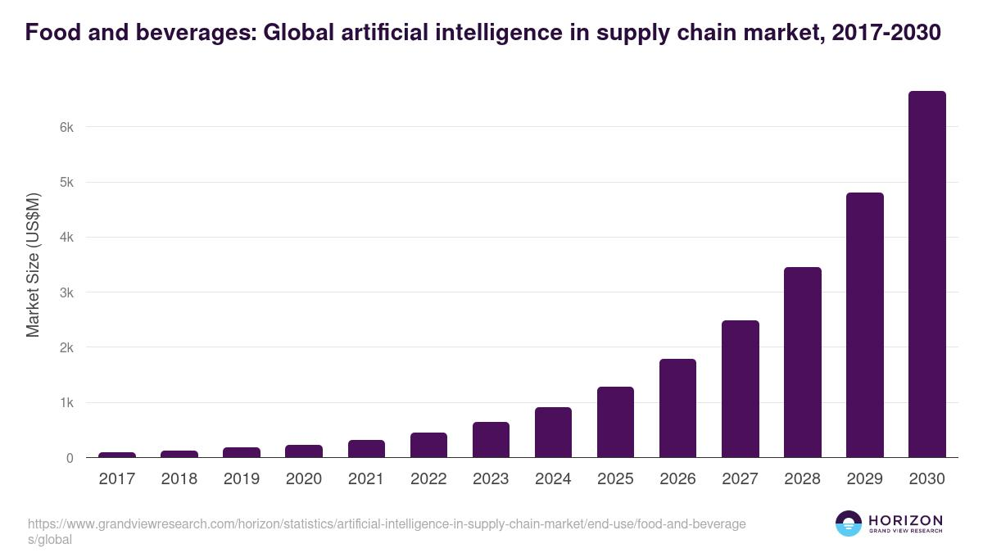
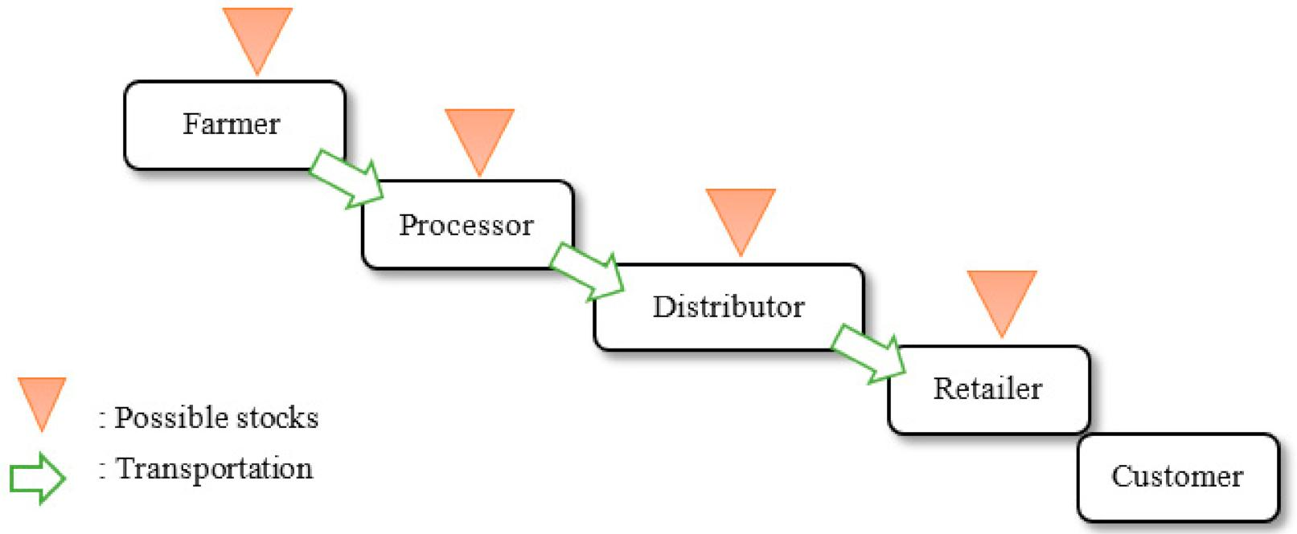
AGI could integrate data from suppliers, logistics networks, and market trends to optimize the entire supply chain. Capabilities include:
- Real-time inventory management
- Dynamic supplier selection based on quality and cost
- Predictive demand planning using external data (weather, events, trends)
This would significantly reduce waste and improve efficiency.

4. Product Innovation and Customization
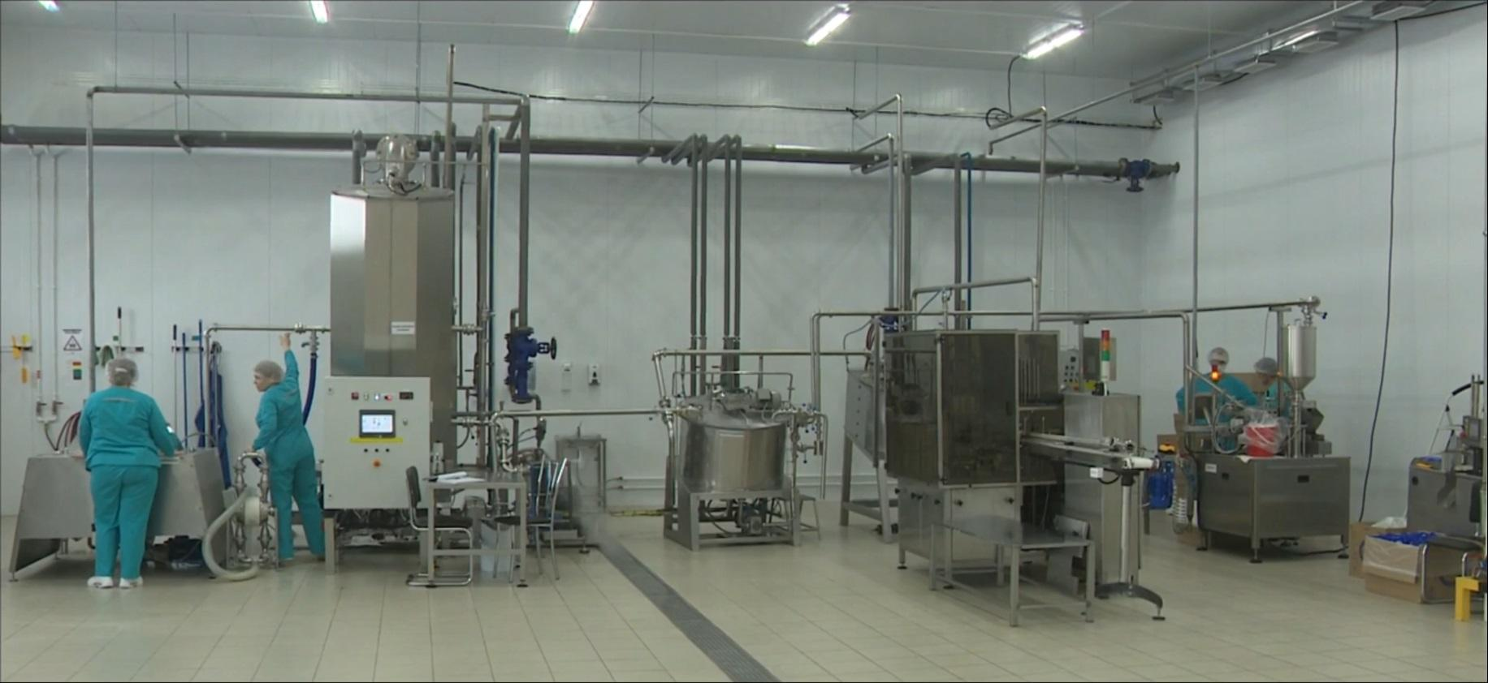







AGI could analyze consumer preferences, social media trends, and sales data to generate new product ideas. For example:
- Introducing region-specific flavors
- Developing healthier alternatives
- Customizing products for individual customers
AGI could even simulate market response before launching a product, reducing risk.
5. Human–AGI Collaboration
Rather than replacing workers entirely, AGI would augment human capabilities:
- Providing real-time recommendations
- Assisting in decision-making
- Automating repetitive tasks
Workers could focus on creative, strategic, and supervisory roles, leading to a more skilled workforce.
Benefits of AGI Implementation
1. Enhanced Efficiency
AGI enables real-time optimization, reducing downtime and increasing throughput.
2. Superior Product Quality
Continuous monitoring and adjustment ensure consistent output.
3. Cost Reduction
Lower labor costs, reduced waste, and optimized resource usage improve profitability.
4. Accelerated Innovation
Faster development cycles allow companies to stay competitive.
5. Sustainability Improvements
Efficient energy use and waste reduction contribute to environmentally friendly production.

Risks and Ethical Considerations
1. Workforce Displacement
Automation may reduce demand for certain jobs, requiring reskilling and workforce transition strategies.
2. Data Privacy and Security
AGI systems rely on large datasets, raising concerns about data protection.
3. Algorithmic Bias
Improper training data could lead to biased or suboptimal decisions.
4. System Dependence
Over-reliance on AGI could create vulnerabilities in case of system failures.
5. High Implementation Costs
Developing AGI infrastructure requires significant investment, limiting accessibility for smaller businesses.
Future Outlook
The integration of AGI into manufacturing is not an immediate reality but a long-term possibility. However, incremental advancements in AI, robotics, and data analytics are steadily paving the way.
In the next decade, we can expect:
- More adaptive AI systems
- Increased use of digital twins
- Greater integration of IoT devices
Eventually, these technologies could converge into AGI-like systems capable of transforming industries entirely.
Conclusion
Artificial General Intelligence represents a transformative opportunity for steam bun manufacturing and the broader food production industry. By enabling intelligent, adaptive, and autonomous systems, AGI could address long-standing challenges related to quality, efficiency, and innovation.
While the benefits are substantial, careful consideration must be given to ethical, economic, and social implications. Responsible implementation, combined with workforce adaptation and strong governance, will be essential.
Ultimately, AGI has the potential to redefine manufacturing—not just as a process of production, but as a dynamic, intelligent system capable of continuous improvement and innovation.
References:
McKinsey & Company. (2024). What is artificial general intelligence (AGI)?
https://www.mckinsey.com/featured-insights/mckinsey-explainers/what-is-artificial-general-intelligence-agi
Google Cloud. (2026). What is artificial general intelligence?
https://cloud.google.com/discover/what-is-artificial-general-intelligence
Fortune Business Insights. (2026). Artificial general intelligence market size & trends.
https://www.fortunebusinessinsights.com/artificial-general-intelligence-market-111187
Wikipedia. (2025). Artificial intelligence of things (AIoT).
https://en.wikipedia.org/wiki/Artificial_intelligence_of_things
IBM. (2025). Artificial general intelligence examples.
https://www.ibm.com/think/topics/artificial-general-intelligence-examples

