**Computer Store Inventory Database**

**Group 4: Cmd-R**

**CIS 353 - 02 Winter 2016**

Charles Dodge

Tyler Anson  
Ryan Korteway

Pierce Ortlieb

**Database Requirements**

This database is designed to help a small computer store keep track of their inventory and sales history. We are keeping track of the specifics of each computer and who each computer was purchased by. We are also keeping track of where the computer is manufactured for purposes of warranty claims etc.

**Database Specifications**

**Operating System**

This entity describes the relationship between the computer bought and the operating system that it will be running. The operating system itself must have a name (Windows,Mac OSX, etc.) as well as the number of bits the system utilizes. For the situation of this database, there should be no computers sold that have less than 32 bits. The version number of the operating system will be the primary key to keep track of what version of OS was sold with a specific computer.

**Hardware**

Every computer has multiple types of hardware. Each piece of hardware is classified by a serial # ( unique ), a type, and a name. Not all computers come with the same hardware but every computer must have some hardware.

**Customer**

Each customer has a name that is a weak key and the customer is going to be identified by the computer they purchase. In the identification, we will be tracking the payment method. We will also be keeping track of the customers address, the type of customer, the phone number, date of purchase, and the purchase history of the customer. All of our computers will be going to a customer, this is a required relationship. A customer can purchase more than one computer as well.

**Manufacturer**

Each computer is made by one or many manufacturers. We keep track of the distance traveled and the number of computers made by the manufacturer. We need the name of the manufacturer to be unique and because the manufacturers can have different locations this is a multi valued attribute.

**Computer**

Each computer is identified by a unique Serial Number. Every computer is going to have a model name. A sales price and a MSRP will also be associated with each computer. A inventory of each computer by its model name will be available on demand. Computers also have several mass storage drives (memory) of varying size and type which will be saved/shown as a multivalue attribute. Each computer will be having a purchaser at some point. Every computer will have a manufacturer but not all manufacturers will be in business. Every computer will have included hardware in its sales box and each computer will come preinstalled with a single Operating System.

**ER Diagram**

On next page

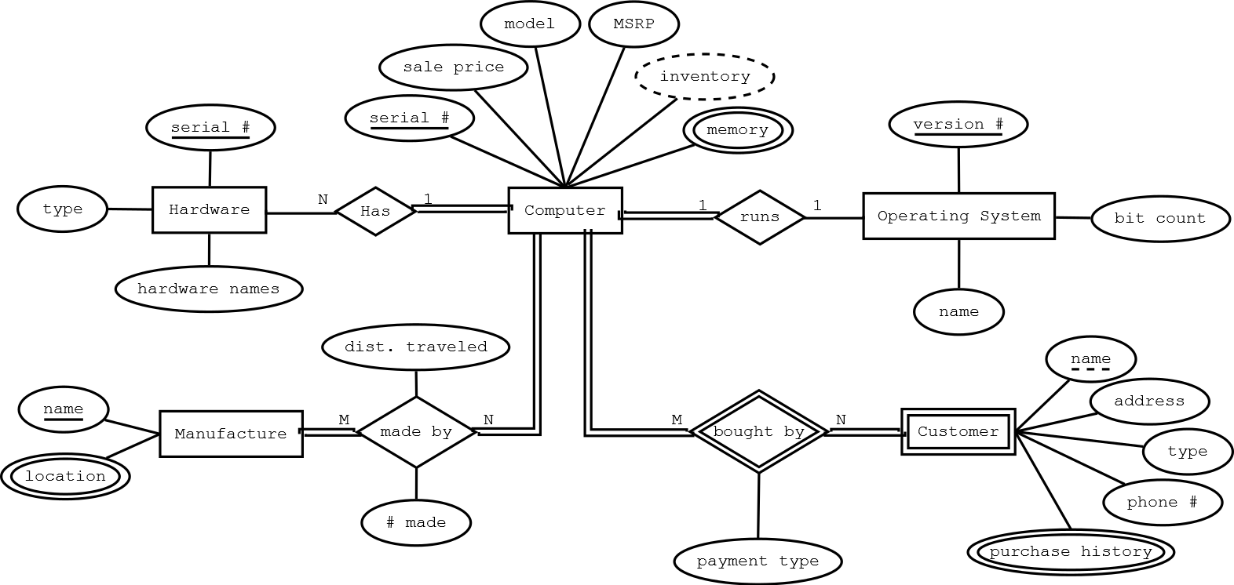

**Relational Schema**

Operating System(Version#, name, bit count)

Hardware(Serial#, type, hardwareNames)

Computer(Serial#, model, salePrice, MSRP, inventory, OS_version#, manufacturer name)

Manufacture(Name)

Customer(Serial Number, Name, address, type, phone#)

PurchaseHistory(Customer, Serial number, date)

BoughtBy( CustName,SerialNumber, paymentType)

Memory( Serial Number, Memory Size, Storage Type)

Location(manufacturer name, location)

MadeBy(Serial Number, Manufacturer name, distance from manufacturer, # of model made)

**Integrity Constraint Table**

|  |  |  |
| --- | --- | --- |
| IC Name, Table | IC Type | English Statement |
| compIC1, Computer | Key | Every computer has and is recognized by its Serial Number |
| compIC2 Version Number, OS | Key | Every operating system has to have a version number |
| hwIC1 Serial Number, Hardware | Key | Every piece of hardware is identified by its unique serial number |
| mIC1, Manufacturer | Key | Each manufacturer must have a unique name that it is identified by. |
| cIC1, BoughtBy | Key | Each computer in this list is bought by a customer name, and it is unique with the serial number. |
| memIC1, Memory | Key | Memory is identified by the unique Serial Number of the computer it is inside of and its memory size. |
| locIC1, Location | Key | each location is going to be identified by its manufacturer and its location. |
| memIC2I, Memory | 1 attribute | Every computer sold must have a hard drive/SSD >= 128 GB in size |
| compIC3, Computer | 2-attribute, 1-row | All computers must be sold at a higher price than its MSRP. sales price > MSRP |
| phIC1, PurchaseHistory | Foreign Key | All computers within the purchase history table must be computers in our database that we had to sell. |
| mbIC1, MadeBy | Key | Every entry in the made by table must have a composite key consisting of serial number and its manufacturer's name. |
| custIC1, Customer | Key | Every customer is identified by their name and the computer’s serial # that was purchased |