Dogwood Berry Mead

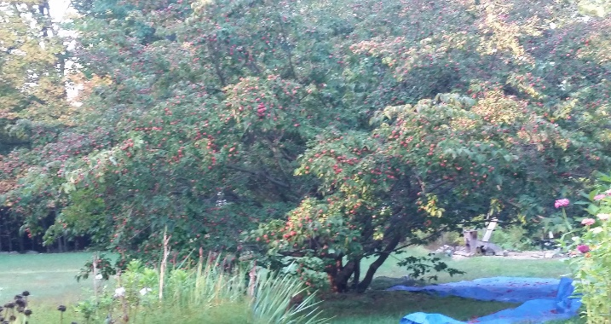*Ingredients (planned 2 gal, actual 4 gal)*

* Dogwood Berries (box 17x13x12 about half full (actually needed 1/4 this)
* 4lbs honey
* Safale US-05 yeast

*Steps:*

* De-stem and rinse
* Crush and collect the pulp using colander to remove solids. This resulted in 1 gal of mash
* Add honey and heat (175 10 minutes)
* *(Note - the plan was 2 gallons of final product. But the first stage turned out so thick I decided to water it down AFTER FIRST STAGE to (???) gal. The instructions are what I did, not what I recommend. Next time use 1/2 the berries for a 2gal recipe)*
* Chill and pour 1/2 gal into each of two 1-gallon carboys
* Top off the carboys with fresh water
* Pitch the yeast (note - I used bottom-swill from prior beer batch)
* Allow 4 days to work
* Prime, rack, and increase volume, bottle (all one step)
  + Rack off into larger carboy, Note there are LOTS of solids - I was able to get (amount)????????? from the primary stage.
  + Add priming sugar
  + Add water to bring it to 4 gal.
  + Mix
  + Bottle

