Chris Winsor

12-December-2021

Comp 6730 Advanced Database Systems Project - GNN Implementation

Questions:

Q1: Number of nodes in CORA = 2708 with 1433 features, 7 classes.

Q2: Number of graphs in ENZYMES = 600 of varying node and edge counts, 3 features, 6 classes.

Q3: Submission of models.py and train.py in .zip file (submitted separately)

Q4: Two Plots for CORA:

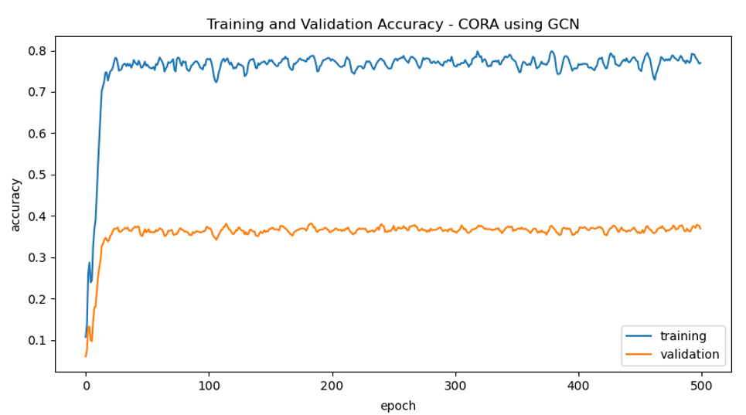

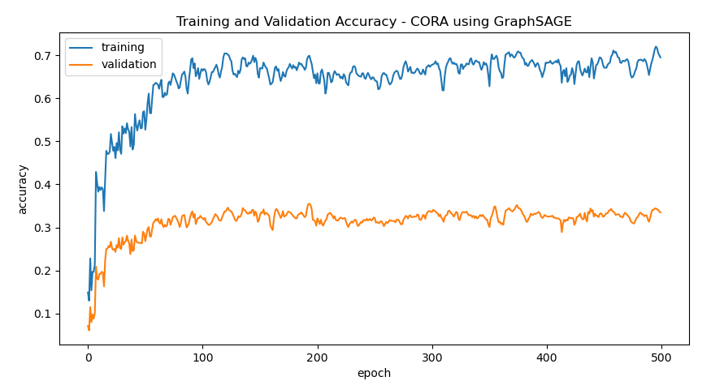

Q4: Two plots for ENZYMES:

<I was unable to get the GAT working for ENZYMES. Below is my review of the Graph Attention Networks paper, submitted for partial credit.

