WebGL
3D Rendering in the Browser

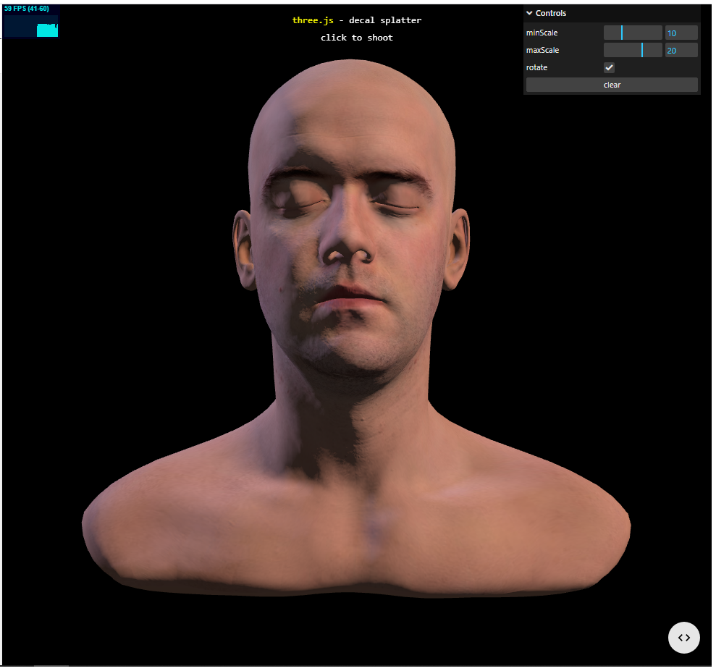
Chris Winsor
9/24/2023

This is a review of Web Graphics Library (WebGL). We give a brief overview then review frameworks.

WebGL is a javascript graphics library for rendering 3D/2D graphics in a browser. Applications include 3D web design, interactive games, data visualization.

Overview
- https://www.youtube.com/watch?v=f-9LEoYYvE4
- https://developer.mozilla.org/en-US/docs/Web/API/WebGL_API/Tutorial
- https://en.wikipedia.org/wiki/Volume_rendering

Frameworks
https://en.wikipedia.org/wiki/List_of_WebGL_frameworks

threejs
- https://threejs.org/
- https://threejs.org/examples/#webgl_decals
- Tutorial: https://fireship.io/lessons/threejs-tutorial-portfolio/

spline.design
takes as input:
- Video: MP4
- 3D Model
  - glTF file format for three-dimensional scenes and models (.gltf, or glb)
  - STL file format for 3D printing
  - FBX file format for 3D by Autodesk FBX software
  - OBJ geometry definition file format from CAD softwae
- Sound (MP3, WAV)
- Vector (SVG)
- Image (JPG, PNG)
- Spline (.spline scene)

regl
http://regl.party/
https://peterbeshai.com/blog/2017-05-26-beautifully-animate-points-with-webgl-and-regl/

babylon.js
https://www.babylonjs.com/

deck.gl 4.0 (Uber Engineering)

niivue
https://github.com/niivue/niivue
<examples all show unable to get webgl2 context. Perhaps this browser does not support webgl2>

glmatrix
https://glmatrix.net/

