2.5D Medical Segmentation using
Large Vision Models

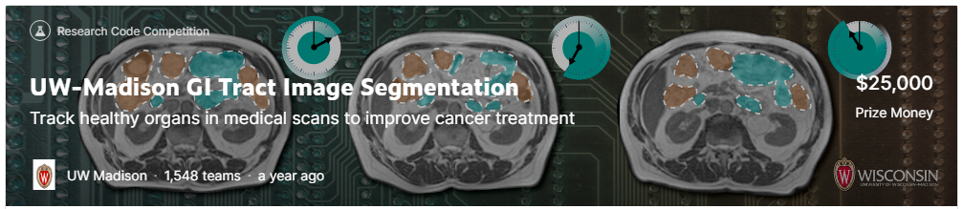
Chris Winsor
9/15/2023

This is a demonstration of 2.5D medical image segmentation based on UNET.
The dataset is from https://www.kaggle.com/c/uw-madison-gi-tract-image-segmentation.
The training code is from user AWSAF (https://www.kaggle.com/awsaf49) with discussion at
https://www.kaggle.com/competitions/uw-madison-gi-tract-image-segmentation/discussion/322549

Additional background on medical segmentation tools/approaches is available at https://github.com/cwinsor/medical_image_practice/blob/main/kaggle_UW_Madison_tech_review.pdf

Table of Contents
2.5D Training 1
Environment Setup (every time) 4
Environment Setup (first time) 4
.

2.5D Training
Download notebook and dataset:
- https://www.kaggle.com/code/awsaf49/uwmgi-2-5d-train-pytorch/notebook
- https://www.kaggle.com/datasets/awsaf49/uwmgi-25d-stride2-dataset
The dataset is 8GB. Extract the dataset revealing:
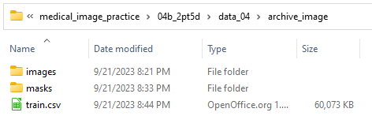
with .npy files under /images/images and /masks/masks.
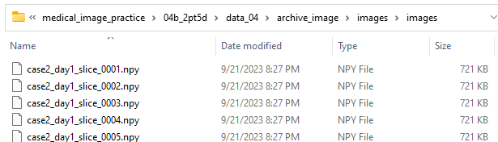
.
To run the training file it is necessary to remove 'class' from the df.drop() as that field is not in the train.csv.
# df = df.drop(columns=['segmentation', 'class', 'rle_len'])
df = df.drop(columns=['segmentation', 'rle_len'])

The runtime is about 30 minutes/epoch * 5 epochs = 2.5 hours.
The output of the "Training" section is model (best and last epochs)
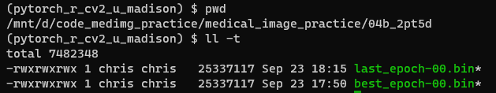
Training stats are logged locally and on W&B. In five epochs we achieve Dice of 90.8, Jaccard 88.1. This is achieved in epoch 4.
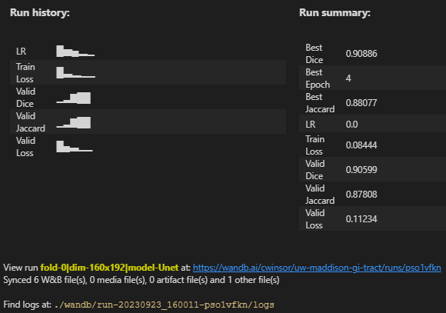
Running "Prediction" allows us to visualize the segmentation.
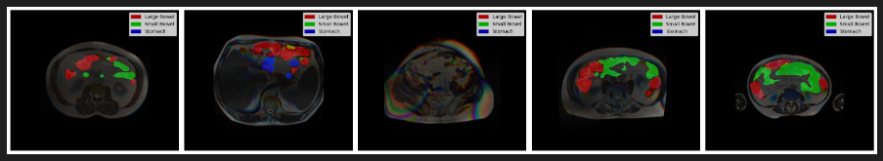

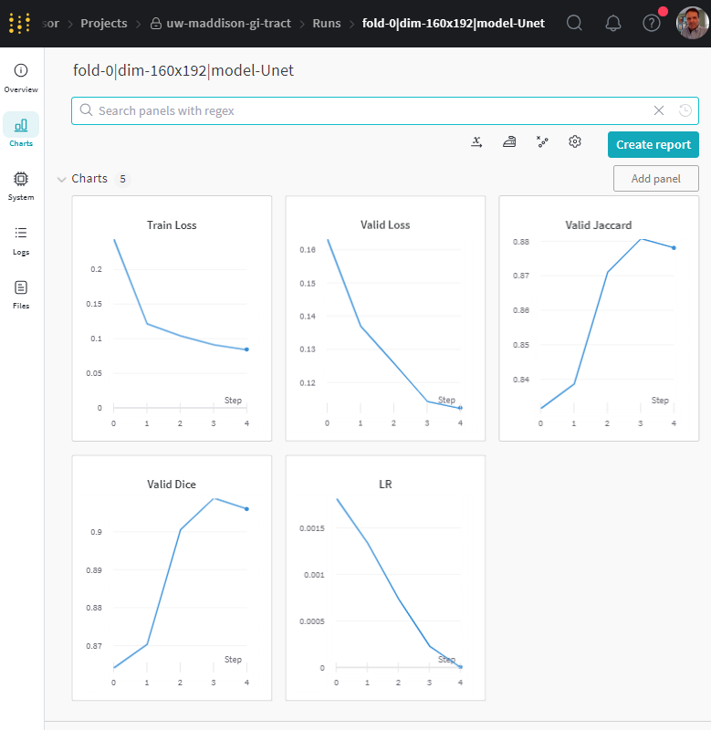
Environment Setup (every time)
In WSL ubuntu environment:
- git clone https://github.com/cwinsor/medical_image_practice.git
- conda activate pytorch_r_cv2_u_madison
- <for details on the conda environment refer to next section>
- cd /medical_image_practice/
- code -n .

Environment Setup (first time)
Steps are in README.txt under 014_2pt5d folder. Both conda and pip are used.
