The GC19HG Project

Preprocessing and Model Development
Chris Winsor 5/2023

GC19HG (GeoCovid19 Heterogeneous Graph) is a social media research project that seeks to understand how the micro-level behaviors of millions of users combine into macro-level topic trends. The work uses the CrisisNLP GeoCov19 dataset - a set of tweets relating to Covid19 from February to May of 2020. The dataset can be found at (https://crisisnlp.qcri.org/covid19).

Our approach combines heterogeneous graph machine learning, NLP pre-trained models and self-supervised learning using the PyTorch Geometric (PyG) library. The code here performs preprocessing of the raw data and establishes an initial modeling attempt.

The code can be run from a Google Colab notebook with launcher at https://github.com/cwinsor/uml_twitter/blob/main/colab_notebook_launcher.ipynb

Instructions to Run:
The best and easiest way is using Google Colab.

- From a browser open the following link: https://github.com/cwinsor/uml_twitter/blob/main/colab_notebook_launcher.ipynb
- Click the "Open in Colab" button.
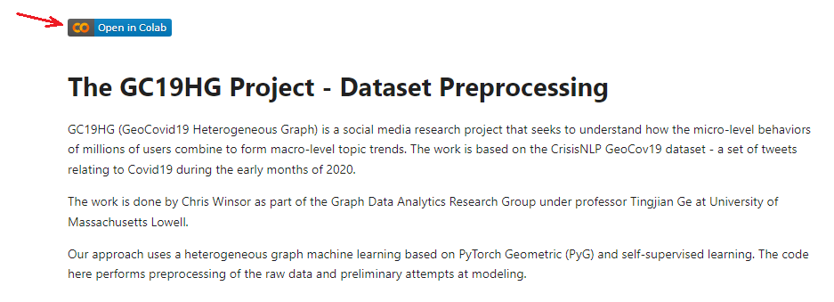
- Execute the blocks in sequence using the <ctrl>Enter keystroke combination.

For Developers
Versions and platform are in Appendix 1.

Two primary files are:
- g40_preprocess.py: parse and filter (a.k.a. "preprocessing")
- g41_train_test.py: model, dataset, training

Preprocessing

Parse
The parse step reads the raw .ijson Twitter files, identifies re-tweets, and extracts out the desired data. The desired data is retweet ID, retweet date, original tweet ID and original tweet text. A parser class performs most of the work detecting re-tweets (vs replies and other entries) and extracting out the desired fields.

Three output files are written: "originals.jsonl" (a dictionary of the original tweets), "re_tweets.jsonl" (a dictionary of retweets) and "list_o_r.jsonl" identifies which original tweet is associated with the retweet. The output files anticipate the what we will need to build the graphs - two types of nodes and a set of edges.

Output data format is string and date/time - i.e. no attempt is made yet to make embeddings or transform to torch vectors.
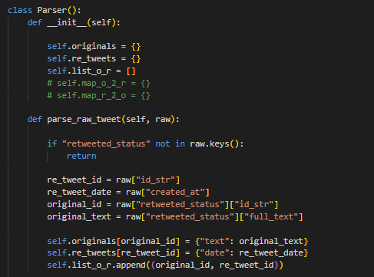
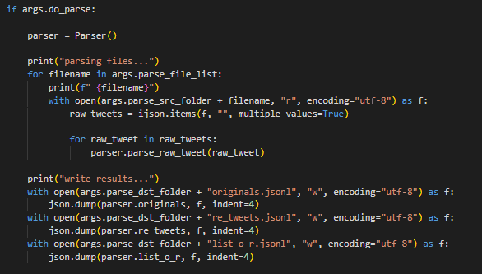

Filter
A filtering step establishes minimum and maximum threshold on number of retweets. This is to speed up development but also a large percent of tweets only get one or two retweets which is not very interesting. The code (as currently deployed) looks for tweets that receive between 6 and 8 retweets.

Train/Test
The primary tasks are:
- read node and edge data from the preprocessed files
- establish the node and edge lists
- transform any latent data of the nodes/edges into embeddings
Note that inherent node/edge data comes via the nodes themselves - this is different from the neighbor-search embeddings that come later.
Note - our edges do not have data so we do not require edge embeddings.

References:

Sample code:
https://github.com/pyg-team/pytorch_geometric/blob/master/examples/hetero/load_csv.py
https://github.com/pyg-team/pytorch_geometric/blob/master/examples/hetero/*

Tutorial:
https://pytorch-geometric.readthedocs.io/en/latest/tutorial/load_csv.html
https://pytorch-geometric.readthedocs.io/en/latest/tutorial/heterogeneous.html

Non-torch GNN
https://towardsdatascience.com/hands-on-graph-neural-networks-with-pytorch-pytorch-geometric-359487e221a8
https://towardsdatascience.com/a-gentle-introduction-to-graph-neural-network-basics-deepwalk-and-graphsage-db5d540d50b3

A very good top-level view of self-supervised training on graphs is at:
https://medium.com/stanford-cs224w/self-supervised-learning-for-graphs-963e03b9f809

Language Embeddings
A BERT language model used to transform the raw tweet text into an embeddings. Specifically we use the "bert-based-uncased" model from SentenceTransformer at https://www.sbert.net/. The details are as follows:
- The load_nodes_from_file() function takes as input a filename and a list of [column_name: encoder] mappings. The encoder is an instance of SequenceEncoder from https://www.sbert.net/. SequenceEncoder provides the __call__() interface that performs the encoding. SequenceEncoder is instanced within main() at the time of a call to "load_nodes_from_file()".
- load_nodes_from_file() reads the data from the file and proceeds to apply the encoders to the identified data_columns. In our our case, "original_tweet" data has only have one column ("text") and we specify the "bert-based-uncased" SequenceEncoder from https://www.sbert.net/ to be used.
The embeddings step transforms variable-length sentence strings into a fixed-length numeric representation (178 width). The final step of the transforms these into into a torch vector.
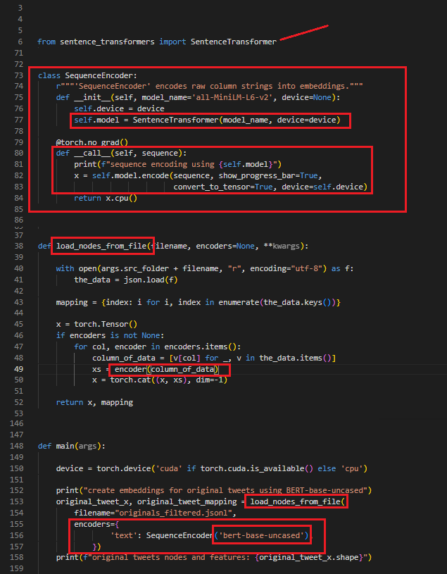

Date/Time Embeddings
Retweet data has date and time in date/time format data. Here we use a custom encoding that simply maps month and day to nominal values.
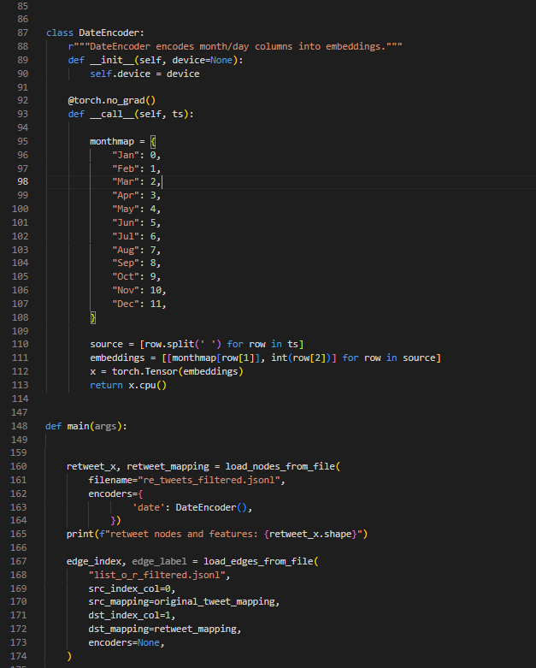

Edges
The final component for the graphs are the edges. Our edges do not carry any values/embeddings so it is sufficient to simply list them.
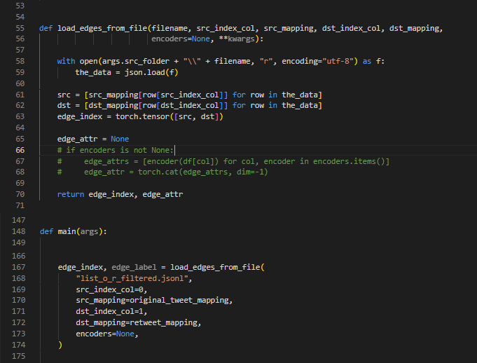

Heterogenous Data Object

From above we have two classes of nodes (original_tweet, retweet) and a list of edges. The HeteroData class encapsulate the data providing features such as test/train split, batch-oriented access, sortring and indexing. We create a HeteroData object.

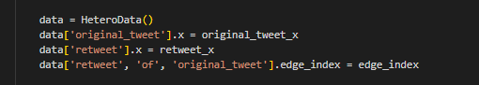

Heterogeneous GNN Model

The GNN model is where neighborhood search, aggregation and combining are performed. We use use 2 layers GCNConv and SAGEConv, 64 hidden channels and a linear layer for output. Our optimizer is Adam. We use a standard test/training loop with mse loss.
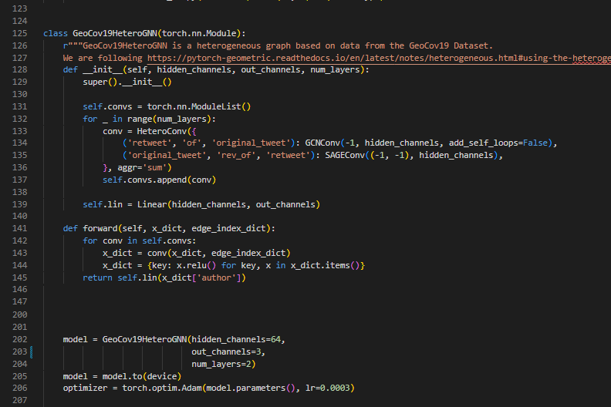

Appendix 1: Versions and Platform
The majority of the code is Python with command-line arguments. We used VS-Code as IDE and you will find a launch.json in the .vscode/ folder. To give users something easy to run we added a Colab notebook (referenced in section above).

We used WSL (Windows subsystem for Linux) using Ubuntu 20.04, because there was at least one library that was not supported under Windows. Our host had a NVIDEA GeForce RTX 3060 (12GB) although most of our work was in preprocessing so didn't use the GPU that much.

Conda versions were mostly PyTorch 11.7, Python 3.9.12.

# Name Version Build Channel
aiohttp 3.8.4 py39ha55989b_0 conda-forge
aiosignal 1.3.1 pyhd8ed1ab_0 conda-forge
anyio 3.5.0 py39haa95532_0
appdirs 1.4.4 pyh9f0ad1d_0 conda-forge
argon2-cffi 20.1.0 py39h2bbff1b_1 anaconda
arrow-cpp 8.0.0 py39hbd6f097_1
asttokens 2.0.5 pyhd3eb1b0_0 anaconda
async-timeout 4.0.2 pyhd8ed1ab_0 conda-forge
attrs 21.4.0 pyhd3eb1b0_0 anaconda
aws-c-common 0.4.57 ha925a31_1
aws-c-event-stream 0.1.6 hd77b12b_5
aws-checksums 0.1.9 ha925a31_0
aws-sdk-cpp 1.8.185 hd77b12b_0
babel 2.11.0 py39haa95532_0
backcall 0.2.0 pyhd3eb1b0_0 anaconda
beautifulsoup4 4.11.1 py39haa95532_0 anaconda
blas 1.0 mkl
bleach 4.1.0 pyhd3eb1b0_0 anaconda
blosc 1.21.0 h19a0ad4_1 anaconda
boost-cpp 1.78.0 h5b4e17d_0 conda-forge
bottleneck 1.3.5 py39h080aedc_0
brotli 1.0.9 h2bbff1b_7
brotli-bin 1.0.9 h2bbff1b_7
brotlipy 0.7.0 py39h2bbff1b_1003
bzip2 1.0.8 he774522_0 anaconda
c-ares 1.18.1 h8ffe710_0 conda-forge
ca-certificates 2023.5.7 h56e8100_0 conda-forge
certifi 2023.5.7 pyhd8ed1ab_0 conda-forge
cffi 1.15.1 py39h2bbff1b_3
cfitsio 3.470 h2bbff1b_7 anaconda
charls 2.2.0 h6c2663c_0 anaconda
charset-normalizer 2.0.4 pyhd3eb1b0_0
click 8.1.3 win_pyhd8ed1ab_2 conda-forge
cloudpickle 2.0.0 pyhd3eb1b0_0 anaconda
colorama 0.4.4 pyhd3eb1b0_0 anaconda
cryptography 38.0.1 py39h21b164f_0
cuda 11.7.1 0 nvidia
cuda-cccl 11.7.91 0 nvidia
cuda-command-line-tools 11.7.1 0 nvidia
cuda-compiler 11.7.1 0 nvidia
cuda-cudart 11.7.99 0 nvidia
cuda-cudart-dev 11.7.99 0 nvidia
cuda-cuobjdump 11.7.91 0 nvidia
cuda-cupti 11.7.101 0 nvidia
cuda-cuxxfilt 11.7.91 0 nvidia
cuda-demo-suite 11.8.86 0 nvidia
cuda-documentation 11.8.86 0 nvidia
cuda-libraries 11.7.1 0 nvidia
cuda-libraries-dev 11.7.1 0 nvidia
cuda-memcheck 11.8.86 0 nvidia
cuda-nsight-compute 11.8.0 0 nvidia
cuda-nvcc 11.7.99 0 nvidia
cuda-nvdisasm 11.8.86 0 nvidia
cuda-nvml-dev 11.7.91 0 nvidia
cuda-nvprof 11.8.87 0 nvidia
cuda-nvprune 11.7.91 0 nvidia
cuda-nvrtc 11.7.99 0 nvidia
cuda-nvrtc-dev 11.7.99 0 nvidia
cuda-nvtx 11.7.91 0 nvidia
cuda-nvvp 11.8.87 0 nvidia
cuda-runtime 11.7.1 0 nvidia
cuda-sanitizer-api 11.8.86 0 nvidia
cuda-toolkit 11.7.1 0 nvidia
cuda-tools 11.7.1 0 nvidia
cuda-visual-tools 11.7.1 0 nvidia
cycler 0.11.0 pyhd3eb1b0_0
cython 0.29.32 py39h99910a6_1 conda-forge
cytoolz 0.11.0 py39h2bbff1b_0 anaconda
dask-core 2022.5.0 py39haa95532_0 anaconda
dataclasses 0.8 pyhc8e2a94_3 conda-forge
datasets 2.10.1 pyhd8ed1ab_0 conda-forge
debugpy 1.5.1 py39hd77b12b_0 anaconda
decorator 5.1.1 pyhd3eb1b0_0 anaconda
defusedxml 0.7.1 pyhd3eb1b0_0 anaconda
dill 0.3.6 pyhd8ed1ab_1 conda-forge
docker-pycreds 0.4.0 py_0 conda-forge
entrypoints 0.4 py39haa95532_0 anaconda
executing 0.8.3 pyhd3eb1b0_0 anaconda
faiss 1.7.2 py39hfccd52d_2_cpu conda-forge
faiss-cpu 1.7.2 hf9c7e24_2 conda-forge
fftw 3.3.9 h2bbff1b_1
filelock 3.10.0 pyhd8ed1ab_0 conda-forge
flake8 6.0.0 py39haa95532_0
flit-core 3.6.0 pyhd3eb1b0_0
fonttools 4.25.0 pyhd3eb1b0_0
freetype 2.12.1 ha860e81_0
frozenlist 1.3.3 py39ha55989b_0 conda-forge
fsspec 2022.3.0 py39haa95532_0 anaconda
gflags 2.2.2 ha925a31_1004 conda-forge
giflib 5.2.1 h62dcd97_0 anaconda
gitdb 4.0.10 pyhd8ed1ab_0 conda-forge
gitpython 3.1.31 pyhd8ed1ab_0 conda-forge
glib 2.69.1 h5dc1a3c_2
glog 0.6.0 h4797de2_0 conda-forge
gst-plugins-base 1.18.5 h9e645db_0
gstreamer 1.18.5 hd78058f_0
huggingface_hub 0.13.3 pyhd8ed1ab_0 conda-forge
icc_rt 2022.1.0 h6049295_2
icu 58.2 ha925a31_3
idna 3.4 py39haa95532_0
ijson 3.2.0.post0 pyhd8ed1ab_0 conda-forge
imagecodecs 2021.8.26 py39hc0a7faf_1
imageio 2.9.0 pyhd3eb1b0_0 anaconda
importlib-metadata 4.11.3 py39haa95532_0
importlib_metadata 4.11.3 hd3eb1b0_0
intel-openmp 2021.4.0 haa95532_3556
ipykernel 6.9.1 py39haa95532_0 anaconda
ipython 8.3.0 py39haa95532_0 anaconda
ipython_genutils 0.2.0 pyhd3eb1b0_1 anaconda
ipywidgets 7.6.5 pyhd3eb1b0_1 anaconda
jedi 0.18.1 py39haa95532_1 anaconda
jinja2 3.0.3 pyhd3eb1b0_0 anaconda
joblib 1.1.1 py39haa95532_0
jpeg 9e h2bbff1b_0
json5 0.9.6 pyhd3eb1b0_0
jsonschema 4.4.0 py39haa95532_0 anaconda
jupyter 1.0.0 py39haa95532_8
jupyter_client 7.2.2 py39haa95532_0 anaconda
jupyter_console 6.4.3 pyhd3eb1b0_0 anaconda
jupyter_core 4.10.0 py39haa95532_0 anaconda
jupyter_server 1.23.4 py39haa95532_0
jupyterlab 3.5.3 py39haa95532_0
jupyterlab_pygments 0.1.2 py_0 anaconda
jupyterlab_server 2.16.5 py39haa95532_0
jupyterlab_widgets 1.0.0 pyhd3eb1b0_1 anaconda
kiwisolver 1.4.2 py39hd77b12b_0
lcms2 2.12 h83e58a3_0 anaconda
lerc 3.0 hd77b12b_0
libaec 1.0.4 h33f27b4_1 anaconda
libblas 3.9.0 1_h8933c1f_netlib conda-forge
libbrotlicommon 1.0.9 h2bbff1b_7
libbrotlidec 1.0.9 h2bbff1b_7
libbrotlienc 1.0.9 h2bbff1b_7
libclang 12.0.0 default_h627e005_2
libcublas 11.11.3.6 0 nvidia
libcublas-dev 11.11.3.6 0 nvidia
libcufft 10.9.0.58 0 nvidia
libcufft-dev 10.9.0.58 0 nvidia
libcurand 10.3.0.86 0 nvidia
libcurand-dev 10.3.0.86 0 nvidia
libcurl 7.88.1 h86230a5_0
libcusolver 11.4.1.48 0 nvidia
libcusolver-dev 11.4.1.48 0 nvidia
libcusparse 11.7.5.86 0 nvidia
libcusparse-dev 11.7.5.86 0 nvidia
libdeflate 1.8 h2bbff1b_5
libfaiss 1.7.2 hba6d9cf_2_cpu conda-forge
libfaiss-avx2 1.7.2 h1234567_2_cpu conda-forge
libffi 3.4.2 hd77b12b_6
libiconv 1.16 h2bbff1b_2
liblapack 3.9.0 5_hd5c7e75_netlib conda-forge
libnpp 11.8.0.86 0 nvidia
libnpp-dev 11.8.0.86 0 nvidia
libnvjpeg 11.9.0.86 0 nvidia
libnvjpeg-dev 11.9.0.86 0 nvidia
libogg 1.3.5 h2bbff1b_1
libpng 1.6.37 h2a8f88b_0
libprotobuf 3.20.3 h23ce68f_0
libssh2 1.10.0 h680486a_2 conda-forge
libthrift 0.15.0 h636ae23_0 conda-forge
libtiff 4.4.0 h8a3f274_2
libuv 1.40.0 he774522_0
libvorbis 1.3.7 he774522_0
libwebp 1.2.4 h2bbff1b_0
libwebp-base 1.2.4 h2bbff1b_0
libxml2 2.9.14 h0ad7f3c_0
libxslt 1.1.35 h2bbff1b_0
libzopfli 1.0.3 ha925a31_0 anaconda
locket 1.0.0 py39haa95532_0 anaconda
lxml 4.9.1 py39h1985fb9_0
lz4-c 1.9.4 h2bbff1b_0
m2w64-gcc-libgfortran 5.3.0 6 conda-forge
m2w64-gcc-libs 5.3.0 7 conda-forge
m2w64-gcc-libs-core 5.3.0 7 conda-forge
m2w64-gmp 6.1.0 2 conda-forge
m2w64-libwinpthread-git 5.0.0.4634.697f757 2 conda-forge
markupsafe 2.1.1 py39h2bbff1b_0 anaconda
matplotlib 3.5.3 py39haa95532_0
matplotlib-base 3.5.3 py39hd77b12b_0
matplotlib-inline 0.1.2 pyhd3eb1b0_2 anaconda
mccabe 0.7.0 pyhd3eb1b0_0
mistune 0.8.4 py39h2bbff1b_1000 anaconda
mkl 2021.4.0 haa95532_640
mkl-service 2.4.0 py39h2bbff1b_0
mkl_fft 1.3.1 py39h277e83a_0
mkl_random 1.2.2 py39hf11a4ad_0
msys2-conda-epoch 20160418 1 conda-forge
multidict 6.0.4 py39ha55989b_0 conda-forge
multiprocess 0.70.14 py39ha55989b_3 conda-forge
munkres 1.1.4 py_0
nbclassic 0.5.2 py39haa95532_0
nbclient 0.5.13 py39haa95532_0 anaconda
nbconvert 6.4.4 py39haa95532_0 anaconda
nbformat 5.3.0 py39haa95532_0 anaconda
nest-asyncio 1.5.5 py39haa95532_0 anaconda
networkx 2.7.1 pyhd3eb1b0_0 anaconda
nltk 3.8.1 pyhd8ed1ab_0 conda-forge
notebook 6.4.11 py39haa95532_0 anaconda
notebook-shim 0.2.2 py39haa95532_0
nsight-compute 2022.3.0.22 0 nvidia
numexpr 2.8.4 py39h5b0cc5e_0
numpy 1.23.4 py39h3b20f71_0
numpy-base 1.23.4 py39h4da318b_0
openjpeg 2.4.0 h4fc8c34_0 anaconda
openssl 1.1.1t hcfcfb64_0 conda-forge
opt_einsum 3.3.0 pyhd8ed1ab_1 conda-forge
packaging 21.3 pyhd3eb1b0_0
pandas 1.5.1 py39hf11a4ad_0
pandocfilters 1.5.0 pyhd3eb1b0_0 anaconda
parso 0.8.3 pyhd3eb1b0_0 anaconda
partd 1.2.0 pyhd3eb1b0_1 anaconda
pathtools 0.1.2 py_1 conda-forge
pcre 8.45 hd77b12b_0
pickleshare 0.7.5 pyhd3eb1b0_1003 anaconda
pillow 9.2.0 py39hdc2b20a_1
pip 22.3.1 py39haa95532_0
ply 3.11 py39haa95532_0
portalocker 2.7.0 py39hcbf5309_0 conda-forge
prometheus_client 0.13.1 pyhd3eb1b0_0 anaconda
prompt-toolkit 3.0.20 pyhd3eb1b0_0 anaconda
prompt_toolkit 3.0.20 hd3eb1b0_0 anaconda
protobuf 3.20.3 py39hd77b12b_0
psutil 5.9.4 py39ha55989b_0 conda-forge
pure_eval 0.2.2 pyhd3eb1b0_0 anaconda
pyarrow 8.0.0 py39h953b917_0
pycocotools 2.0 pypi_0 pypi
pycodestyle 2.10.0 py39haa95532_0
pycparser 2.21 pyhd3eb1b0_0
pyflakes 3.0.1 py39haa95532_0
pyg 2.3.0 py39_torch_1.13.0_cu117 pyg
pygments 2.11.2 pyhd3eb1b0_0 anaconda
pynvml 11.4.1 pyhd8ed1ab_0 conda-forge
pyopenssl 22.0.0 pyhd3eb1b0_0
pyparsing 3.0.9 py39haa95532_0
pyqt 5.15.7 py39hd77b12b_0
pyqt5-sip 12.11.0 py39hd77b12b_0
pyro-api 0.1.2 pyhd8ed1ab_0 conda-forge
pyro-ppl 1.8.4 pyhd8ed1ab_0 conda-forge
pyrsistent 0.18.0 py39h196d8e1_0 anaconda
pysocks 1.7.1 py39haa95532_0
python 3.9.15 h6244533_2
python-dateutil 2.8.2 pyhd3eb1b0_0
python-fastjsonschema 2.15.1 pyhd3eb1b0_0 anaconda
python-xxhash 3.2.0 py39ha55989b_0 conda-forge
python_abi 3.9 2_cp39 conda-forge
pytorch 1.13.0 py3.9_cuda11.7_cudnn8_0 pytorch
pytorch-cuda 11.7 h67b0de4_0 pytorch
pytorch-mutex 1.0 cuda pytorch
pytz 2022.1 py39haa95532_0
pywavelets 1.3.0 py39h2bbff1b_0 anaconda
pywin32 302 py39h2bbff1b_2 anaconda
pywinpty 2.0.2 py39h5da7b33_0 anaconda
pyyaml 6.0 py39h2bbff1b_1 anaconda
pyzmq 22.3.0 py39hd77b12b_2 anaconda
qt-main 5.15.2 he8e5bd7_7
qt-webengine 5.15.9 hb9a9bb5_4
qtconsole 5.3.0 pyhd3eb1b0_0 anaconda
qtpy 2.0.1 pyhd3eb1b0_0 anaconda
qtwebkit 5.212 h3ad3cdb_4
re2 2022.04.01 h0e60522_0 conda-forge
regex 2022.10.31 py39ha55989b_0 conda-forge
requests 2.28.1 py39haa95532_0
responses 0.18.0 pyhd8ed1ab_0 conda-forge
sacrebleu 2.3.1 pyhd8ed1ab_0 conda-forge
sacremoses 0.0.53 pyhd8ed1ab_0 conda-forge
scikit-image 0.19.2 py39hf11a4ad_0 anaconda
scikit-learn 1.1.3 py39hd77b12b_0
scipy 1.9.3 py39he11b74f_0
send2trash 1.8.0 pyhd3eb1b0_1 anaconda
sentence-transformers 2.2.2 pyhd8ed1ab_0 conda-forge
sentencepiece 0.1.95 py39h59b6b97_0
sentry-sdk 1.16.0 pyhd8ed1ab_0 conda-forge
setproctitle 1.3.2 py39ha55989b_1 conda-forge
setuptools 65.5.0 py39haa95532_0
sip 6.6.2 py39hd77b12b_0
six 1.16.0 pyhd3eb1b0_1
smmap 3.0.5 pyh44b312d_0 conda-forge
snappy 1.1.9 h6c2663c_0 anaconda
sniffio 1.2.0 py39haa95532_1
soupsieve 2.3.1 pyhd3eb1b0_0 anaconda
sqlite 3.40.0 h2bbff1b_0
stack_data 0.2.0 pyhd3eb1b0_0 anaconda
tabulate 0.9.0 pyhd8ed1ab_1 conda-forge
terminado 0.13.1 py39haa95532_0 anaconda
testpath 0.6.0 py39haa95532_0 anaconda
threadpoolctl 2.2.0 pyh0d69192_0
tifffile 2021.7.2 pyhd3eb1b0_2 anaconda
tk 8.6.12 h2bbff1b_0
tokenizers 0.13.2 py39hca44cb7_0 conda-forge
toml 0.10.2 pyhd3eb1b0_0
tomli 2.0.1 py39haa95532_0
toolz 0.11.2 pyhd3eb1b0_0 anaconda
torchaudio 0.13.0 pypi_0 pypi
torchinfo 1.7.1 pyhd8ed1ab_0 conda-forge
torchvision 0.14.0 pypi_0 pypi
tornado 6.2 py39h2bbff1b_0
tqdm 4.65.0 pyhd8ed1ab_1 conda-forge
traitlets 5.1.1 pyhd3eb1b0_0 anaconda
transformers 4.27.1 pyhd8ed1ab_0 conda-forge
typing 3.10.0.0 pyhd8ed1ab_0 conda-forge
typing-extensions 4.4.0 py39haa95532_0
typing_extensions 4.4.0 py39haa95532_0
tzdata 2022g h04d1e81_0
ucrt 10.0.20348.0 haa95532_0
urllib3 1.26.13 py39haa95532_0
utf8proc 2.6.1 h2bbff1b_0
vc 14.2 h21ff451_1
vs2015_runtime 14.32.31332 h1d6e394_9 conda-forge
wandb 0.14.0 pyhd8ed1ab_0 conda-forge
wcwidth 0.2.5 pyhd3eb1b0_0 anaconda
webencodings 0.5.1 py39haa95532_1 anaconda
websocket-client 0.58.0 py39haa95532_4
wget 3.2 pypi_0 pypi
wheel 0.37.1 pyhd3eb1b0_0
widgetsnbextension 3.5.2 py39haa95532_0 anaconda
win_inet_pton 1.1.0 py39haa95532_0
wincertstore 0.2 py39haa95532_2
winpty 0.4.3 4 anaconda
wordcloud 1.8.2.2 py39ha55989b_1 conda-forge
xxhash 0.8.1 hcfcfb64_0 conda-forge
xz 5.2.8 h8cc25b3_0
yaml 0.2.5 he774522_0 anaconda
yarl 1.8.2 py39ha55989b_0 conda-forge
zfp 0.5.5 hd77b12b_6 anaconda
zipp 3.11.0 py39haa95532_0
zlib 1.2.13 h8cc25b3_0
zstd 1.5.2 h19a0ad4_0

