GeoCov19 Heterogenous Graph (GC19-HG)
Chris Winsor 5/2023

GC19-HG is a project to study macro-level characteristics of social media based on preferences and behaviors of individuals. The work uses tweets from a twitter dataset, specifically CrisisNLP GeoCov19 and is done as part of the Graph Data Analytics Research Group under professor Tingjian Ge at University of Massachusetts Lowell.

The code described here performs preprocessing and preliminary modeling of tweets identified in the CrisisNLP GeoCov19 dataset (https://crisisnlp.qcri.org/covid19). The code can be run from Google Colab following the instructions below. It consists of the Colab notebook and a small number of python files.

Context
The CrisisNLP GeoCov19 dataset is a collection of tweets from early 2020 relating to COVID-19 pandemic.

A Google Colab notebook is available to run the model. Steps are provided below and a sample dataset is included.

For development and data preprocessing the code is available from a git repo. This involves an IDE like VS-Code and a Linux box.

Requirements:
To run the code you will need:
A Google Colab account
Access to Weights & Biases (https://wandb.ai/site)

Instructions to Run:
The best and easiest way is using Google Colab.

- From a browser open the following link: https://github.com/cwinsor/uml_twitter/blob/main/colab_notebook.ipynb
- Click the "Open in Colab" button.
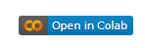
- You should see the notebook.
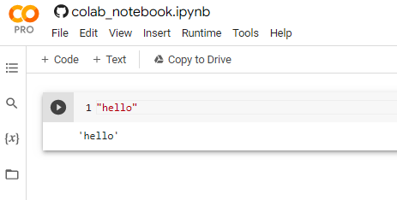
- Execute the blocks in sequence using the <ctrl>Enter keystroke combination.

At the End of the Day
At the end of the day we're going to need an InMemoryDataset. The process() method will give up a graph, and it is up to us to decide what the contents and structure of this graph - i.e. what nodes and edges.

Working backward from there - we are given a raw "dataset" and need to process that into something usable for the InMemoryDataset.process() method. Our approach is to establish a set of files, each containing data similar to that of a single SQL table. Specifically each file will have a key, attributes and optionally foreign keys referring to another file-table.

Complicating things is the fact that GeoCov19 is given as a daily drop. We will need to merge these together at some point.

Of course like any raw data, GeoCov19 requires preprocessing:
original tweet ID and text are duplicate for each retweet - need to rationalize
tweet text needs to be converted into vectorized (embedding) - use HuggingFace BERT for this
date/time needs to be converted into an embedding - parse this into month/day/hour, then use Scikit-learn LabelEncoder.fit_transform()

These steps are done after the merge since we need access to all the values.

Daily Parse Into 2 Tables (Relational SQL-like)
This reads the raw .ijson file and picks out the information we need for our tables. It writes out the SQL-like tables. NO data conversion is done here. We use a dictionary representation where the dictionary key is the (original tweet ID) or the (retweet ID) i.e. we leverage the existing keys in the dataset.
The "values" of the dictionary are the attributes of the table. For the first table that will be "tweet_text" and for the second table will have attributes "fk_original_tweet_id" and "date".

We parse each day independently, writing out two files for each day.

Merge
Here we take all the days of files and merge them together.
The original_tweets file is done first - this involves first combining then de-duplicating.
The retweets files are done second - this is simply combining (there are no duplicates here)

ToVec
Once we have the merged files we need to convert all values into integer or float.
- tweet text: we apply HuggingFace BERT - this replaces text with a set of embeddings
- date/time: in retweets we convert date/time into yy, mm, dd, hh orginals

We write both original_tweets and retweets to file and this is our "dataet"

InMemoryDataset
The work is done by the process() method. For InMemoryDataset a single call to process() is made and it is the responsibility of this call composes all graphs. At the end of process() a call is made to self.collate() which tells InMemoryDataset base class to establish and index and internal representation of "the dataset". The base class writes a file to the "processed" folder with this representation.

We are responsible for defining process(), specifically what each graph will look like and include. We take an approach similar to https://github.com/khuangaf/PyTorch-Geometric-YooChoose.git. The approach is approximately:
- select something to be the central node
- build a graph around it
In the YooChoose example they have a clickstream of a web shopping site. For their "central node" they use the "session" - i.e. the session ID from the clickstream. Associated with the session are a set of clicks and these become the other nodes in the graph. Thus the nodes of the graph in that example are the session node and related click nodes (each with product IDs and related information. The edges are the links from click to session.

The predicted quantity in this graph is binary (purchase or not).

In our case the "central node" is the original_tweet, and our graph will consist of the retweets. The edges are the link from retweet to original tweet. Our predicted quantity is binary (number of retweets > 5).

We also need to

For Developers
Environment was Windows10 with VS-code as IDE.
Versions are in Appendix 1. We use conda library management.

Windows Support:
Almost everything works on Windows except that pyg_lib or its alternate torch-sparse are not available for Windows as of this writing. See https://pytorch-geometric.readthedocs.io/en/latest/install/installation.html#additional-libraries

Git
The git repository is https://github.com/cwinsor/uml_twitter.git

The files include:
.vscode/launch.json | Launch.json to run different preprocessing steps
g19_hetero_data.py | a subclass of torch_geometric HeteroData  to hande a single data element
g19_hetero_dataset.py | a subclass of torch_geometric InMemoryDataset  allowing loading data in batches
10_preprocess.py | a set of functions which perform individual preprocessing steps  runtime switches select which preprocessing step is to be performed
geocov19_model.py | a torch.nn.Module
colab_notebook.ipynb | The Google Colab notebook. It allows users can easily run the project.

Conda environment versions:
pytorch 1.13.0
pytorch-cuda 11.7
torchinfo 1.7.1
huggingface_hub 0.13.3
wandb 0.14.0

Message Passing Convolution Layer
HGTConv
HGTConv is at (https://arxiv.org/pdf/2003.01332.pdf and https://github.com/pyg-team/pytorch_geometric/blob/master/examples/hetero/hgt_dblp.py)

HeteroConv
HeteroConv (torch.geometric.nn.HeteroConv) was introduced in PyG 2.0 to allow the development of models based on heterogeneous graphs (graphs with multiple node and/or edge classes). Most importantly HeteroConv includes support for message passing layers (torch_geometric.nn.conv.MessagePassing) such as GraphSAGE or GCNConv. Message passing starts from a node and performs k-hop neighbor traversal, aggregating the results as embeddings for the node. In a heterogeneous graph each class of edge connects different types of nodes, so during traversal HeteroConv applies a convolution operator based on the class of edge. A dictionary is established as part of __init__() for this purpose which maps from edge class to convolution function.

GeoCoV19Model implements HeteroConv layer. We use GCNConv for our edge class (we only have one class of edge).
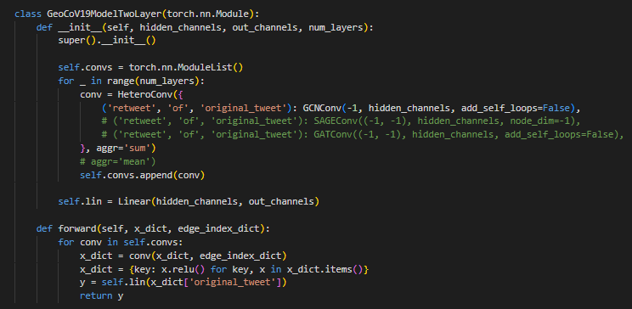
References:
https://pytorch-geometric.readthedocs.io/en/latest/notes/heterogeneous.html#using-the-heterogeneous-convolution-wrapper
https://towardsdatascience.com/hands-on-graph-neural-networks-with-pytorch-pytorch-geometric-359487e221a8
https://github.com/pyg-team/pytorch_geometric/blob/master/examples/hetero/hgt_dblp.py

G19HeteroData and G19HeteroDataset
G19HeteroData and G19HeteroDataset are classes that extend the Torch-provided base classes for heterogeneous graph data (HeteroData and InMemoryDataset).

Resources/references
https://pytorch-geometric.readthedocs.io/en/latest/notes/heterogeneous.html
https://pytorch-geometric.readthedocs.io/en/latest/tutorial/heterogeneous.html
https://pytorch-geometric.readthedocs.io/en/latest/tutorial/load_csv.html
https://pytorch-geometric.readthedocs.io/en/latest/tutorial/create_dataset.html

Self-tests
G19HeteroData and G19HeteroDataset each have a self-test which can be run by setting a runtime switch - see the code for details.

G19HeteroData
The G19HeteroData class (in file g19_hetero_data.py) represents the heterogeneous graph including classes and instances of nodes and edges. It follows https://pytorch-geometric.readthedocs.io/en/latest/generated/torch_geometric.data.HeteroData.html.

There are two classes of nodes "original_tweet" and "retweet". Establishing a self["original_tweet"].x attribute has two effects, first it defines a class of node ("original_tweet"), and secondly it establishes an instance of that node class in the graph. "retweet" is the second class of node in the heterogeneous graph and instances are established similarly.
Edges classes are defined in a similar fashion using self[*].edge_index. In this case a pair of node indices is provided along with the edge class identifier. In our case the adjacent nodes are of class "retweet" and "original_tweet". Thus the edge is defined as ["retweet, "of", "original_tweet"].

The intent is to a NLP model such as bert-base-uncased (https://huggingface.co/bert-base-uncased) for tweet text embeddings, but placeholders are used for now.

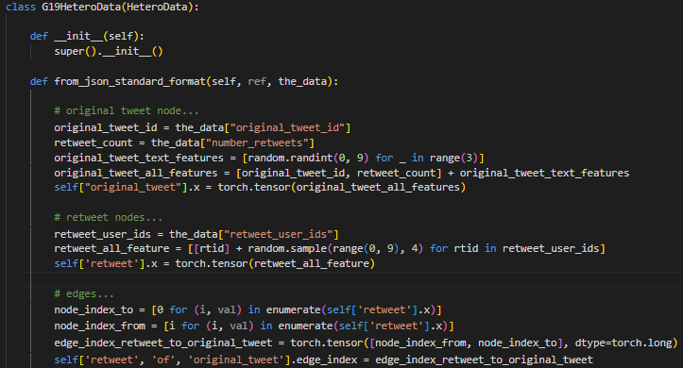

G19HeteroDataset
G19HeteroDataset (in file g19_hetero_dataset) extends torch_geometric.data.InMemoryDataset. This class is used to load the data from file and return batches of data during training. Each "sample" of data is a graph (an instance of G19HeteroData described above) consisting of an original tweet (node), set of retweets (nodes) with edge from retweet node to original tweet node.

Data Preprocessing
The steps are: download GeoCov19 dataset, rehydration, preprocessing.

Dataset
GeoCov19 dataset is available at the CrisisNLP page. It does not include tweet information (text) only the tweet IDs. To download the dataset refer to the CrisisNLP page.

Rehydration
Rehydration takes the tweet IDs identified in GeoCov19 and pulls the information (such as the text of the tweet) from Twitter using the Twitter API. Rehydration is performed using tools available at the CrisisNLP page - refer to CrisisNLP for further information.

Preprocessing
Preprocessing organizes the data into a format suitable for our purposes - namely a graph dataset using PyTorch Geometric. Because the rehydrated dataset is large the preprocessing takes a two step batch-oriented approach processing each day separately then merging into a whole dataset.

The code is in 10_preprocess.py. The primary feature are the IncomingTweet and TweetEncoder.
IncomingTweet receives json in the GeoCov19 raw data file format, picks the desired data into our preferred internal dictionary format. TweetEncoder which encodes our internal dictionary to json for writing to file.
Two steps (parse, merge) are used during processing. In addition a summary analysis can be performed. The runtime switches are "perform_parse", "perform_merge" and "perform_analyze".
Three folders are used for the data during preprocessing:
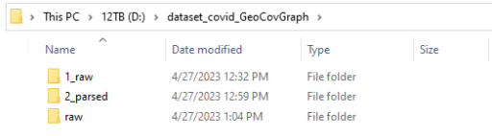
The first folder is "1_raw" contains raw .ijson files after rehydration. These are the largest files and organized by day.
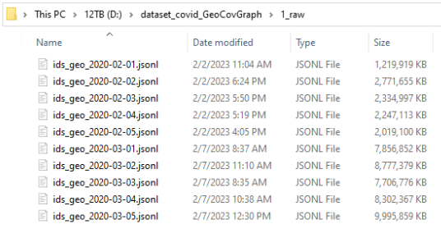
The second folder is "2_parsed". This folder contains the results of the first step in preprocessing (parse). During parse the pertinent data is extracted from the raw data. The pertinent data includes original tweet ID, original tweet text, retweet ID and retweet date. The output files are organized by day and within each file the data has been sorted by original tweet ID (to streamline downstream tasks).
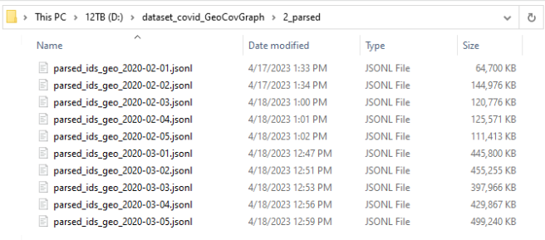
The final folder is "raw" which contains the output of the merge step. A single file "merged_all.jsonl" is the output. Incremental backups are made each time a merge is performed thus there are numerous timestamped backup files in this folder.
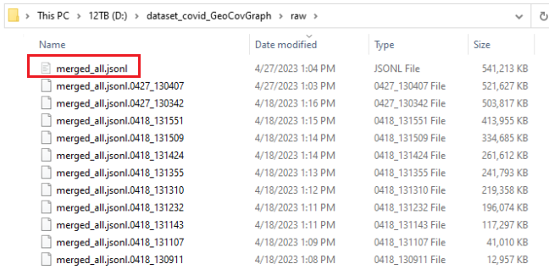

Preprocessing Example
VS-code is the recommended tool for development.
- From the VS-Code interface click on the "Run and Debug" icon (fourth on left)
- Click the dropdown
- Select the desired preprocessing step (parse, merge, analyze)
- Click the green arrow to run.

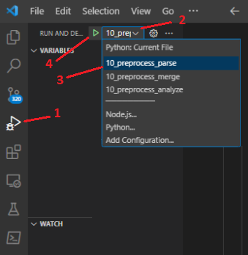
The launch.json file specifies the runtime arguments and can be edited or extended as needed.

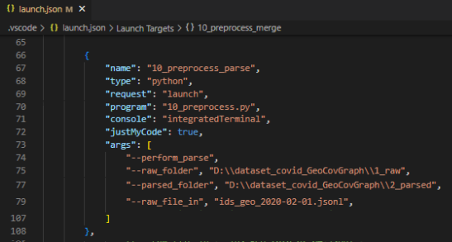
Manually running is not recommended but is also possible.

Parse:
python 10_preprocess.py --perform_parse --raw_folder D:\dataset_covid_GeoCovGraph\1_raw --parsed_folder D:\dataset_covid_GeoCovGraph\2_parsed --raw_file_in' ids_geo_2020-02-01.jsonl

Merge:
python 10_preprocess.py --perform_merge --parsed_folder D:\dataset_covid_GeoCovGraph\2_parsed --merged_folder D:\dataset_covid_GeoCovGraph\raw --merged_file_in_out merged_all.jsonl --parsed_file_in parsed_ids_geo_2020-02-01.jsonl

Analysis
A basic summary analysis can be performed on the merged_all data through the "perform_analyze" switch. The example below shows a total of 700K tweets in the dataset received at least one retweet. The vast majority of tweets receive less than 5 retweets. Only 19 tweets landed in the top 7 retweet buckets (over 1000 retweets). One tweet received 30K retweets!

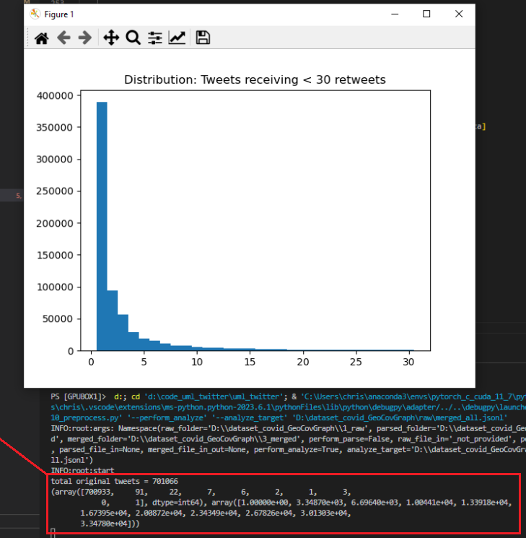

It is interesting to investigate the content of the most popular tweets. This can be done by editing the 10_preprocess.py file in the "analyze" function.

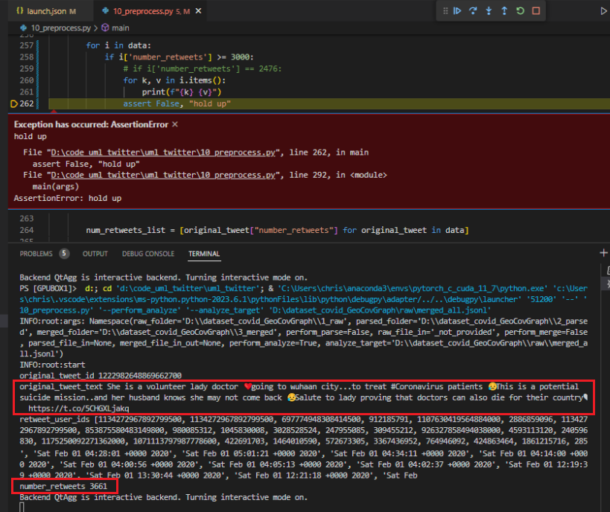

Additional References:
https://medium.com/stanford-cs224w/self-supervised-learning-for-graphs-963e03b9f809
https://github.com/paridhimaheshwari2708/GraphSSL
https://pytorch-geometric.readthedocs.io/en/latest/tutorial/create_dataset.html
https://pytorch-geometric.readthedocs.io/en/latest/tutorial/heterogeneous.html
https://paperswithcode.com/paper/semi-supervised-classification-with-graph
https://github.com/dmlc/dgl/blob/master/examples/mxnet/gcn/README.md
https://github.com/tkipf/gcn
https://ogb.stanford.edu/ and specifically https://ogb.stanford.edu/docs/graphprop/
https://towardsdatascience.com/a-beginners-guide-to-graph-neural-networks-using-pytorch-geometric-part-1-d98dc93e7742

Versions

