Gumball Machine

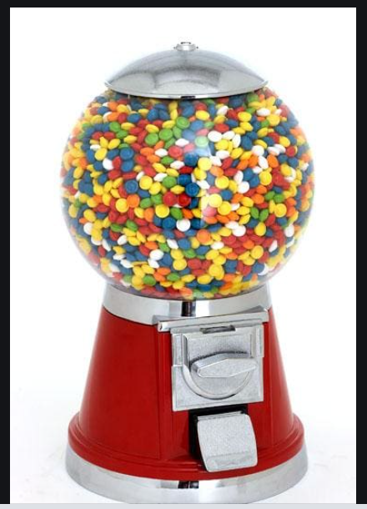

**What does a Gumball Machine do?**

Holds gumballs

Accepts coin(s)

Put in coin and returns a gumball

Validate coin value

Makes noises

Turn knob

Store coins

Won’t dispense when empty

Won’t dispense when coin is incorrect

**What information does a gumball machine need to function?**

Coin(s) is correct

Knob is fully turned then coin is stored

Gumball is present

|  |  |  |
| --- | --- | --- |
| **Requirement** | **Use Case** | **Story** |
| **1**  **Happy Path** | **Customer inserts coin**  **Turns knob**  **Receives gumball** | **As a customer I would like to insert a coin and receive a gumball.** |
| **2**  **No Candy Present** | **Customer inserts coin**  **Knob does not turn**  **No candy is returned**  **Coin remains in slot** | **As a customer if the gumballs are sold out the knob should not turn.** |
| **3**  **Incorrect coin** | **Customer inserts coin**  **Knob does not turn**  **No candy is returned**  **Coin remains in slot** | **As customer if submit an incorrect coin the knob won’t turn** |
| **4**  **Change Box is full** | **Customer inserts coin**  **Knob does not turn**  **No candy is returned**  **Coin remains in slot** | **If the change box is full, the machine is inoperable.** |
| **5**  **Owner cashes out** | **Owner opens the change box**  **Owner refills the gumballs**  **Report: reset gumball counter** | **As the owner I would like to retrieve the coins and refill the gumballs** |
|  |  |  |

**Nouns**

gumballs

coins

knob

gumball cost

gumball machine

coin box

gumball counter

// customer

// owner

coin slot

========================================

gumball machine

state: isEmpty()

isChangeBoxFull

coin mechanism

gumball container

property: gumballCounter

**Verbs**

Insert coin

Turn knob

Dispense gumball

Validate coin(amount)

Store coin

Refill gumballs

Empty change box