hey all - this morning I did a one day sprint. I had an idea - "How might we match doners with public radio stations in need". I had this idea at 7AM while making my coffee and listening to a local publicly funded station.
I wrote down a mission statement and a few features that I could think about.
After I got to my computer I opened Claude to ask it to help me make a spec. We went back and forth about what I was looking for and finalized on something.I started having it build the site, but quickly ran in to token problems. I took the spec to Bolt (I have been trying a bunch of different products), I have been frustrated in all of the dev stuff I needed to do with VSCode and wanted to try more vibe making. I got about the same place as I did in clusde before I ran out of tokens. I went back to the insiders version of VSCode and brought my spec. I kept running into issues of various types so finally jumped into the Figma beta. I’ve been using the Figma beta Figma design and Figma make and thought I’d try to see what I could do there. I had it create a visual and then took that and my spec into Figma make and created the following site in 10 minutes.

https://sweat-rinse-25569166.figma.site/

#PublicRadio #NPR #TechForGood #RapidPrototyping #CommunitySupport #Innovation #OneDay Build

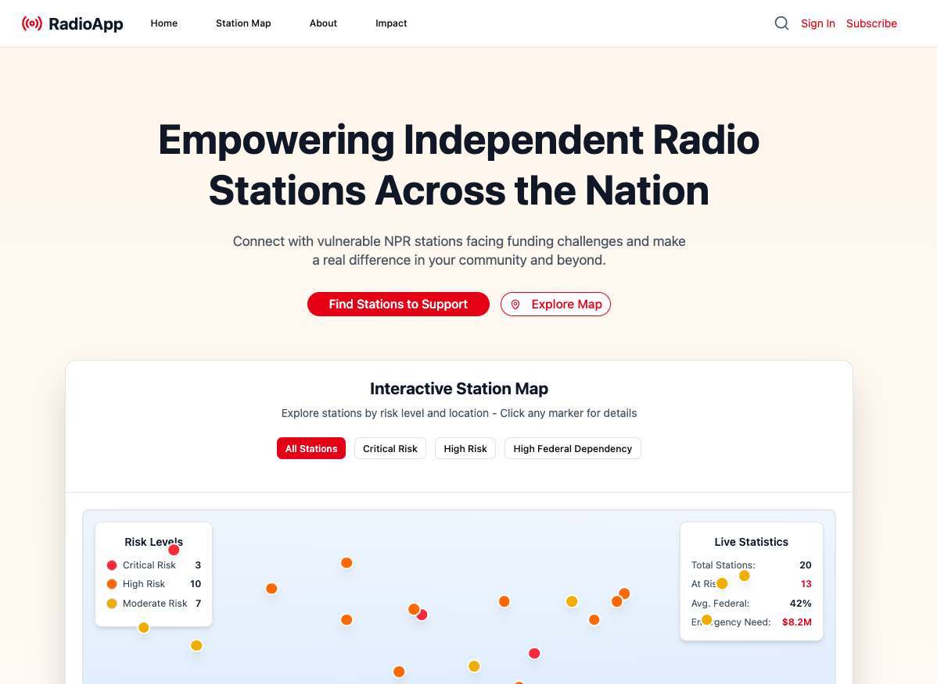

It’s not perfect, but it’s close enough to get people thinking about the project.

Learning
- Tokens and token use is a real thing. I was using the free versions of different products and could never actually make something. So I cheated and made a spec and would take that from product to product.
- It is very quick to make an idea a reality. But it is a façade, it’s not a working thing just a mock. But that is good enough to prove out ideas most of the time.
- Being inspired to create and enabled to make is a blessing. In the past I would have so many ideas like this but not the skill or time to make them.
- Bouncing around gave me a very good idea of what sorts of functionality I liked and what products had problems that I didn’t like.
This morning, I did a one-day sprint. I had an idea: "How might we match donors with public radio stations in need?" The thought struck me at 7 a.m. while I was making coffee and listening to a local publicly funded station.
I quickly jotted down a mission statement and a few features that came to mind.
Once at my computer, I turned to Claude for help developing a spec. We went back and forth finalizing what I wanted, and then I had it begin building the site—but soon ran into token limits. I took my spec to Bolt (I’ve been trying a variety of products lately), hoping for a smoother experience than with VSCode, which can be cumbersome for quick experiments. With Bolt, I got about as far as I did with Claude before hitting those same token roadblocks. So, I returned to the insiders version of VSCode and brought my spec along. Again, I encountered various issues, so I finally decided to try the Figma beta. Using Figma’s new Design and Make features, I created a visual and then, using my spec, built the following site in just ten minutes.
https://sweat-rinse-25569166.figma.site/
It’s not perfect, but it’s close enough to get people thinking about the project.

Learning
- Token limits are a real barrier. Using free versions of different products, I couldn’t actually finish anything, so I “cheated” by making a spec and moving it between tools.
- Turning an idea into a reality can be remarkably fast, even if it’s just a façade—a mockup, not a for real working app. But that’s often good enough to validate ideas.
- Feeling inspired and empowered to create is a true gift. In the past, I had many ideas like this but lacked the skill or time to bring them to life.
- Jumping between products gave me a clear sense of which features I liked and which pain points I want to avoid in the future. It gave me insight into what people may like or not as they also use these kinds of products.

From Coffee to Code: Building RadioApp in One Day to Save Public Radio
How a 7 AM idea became a working prototype to connect donors with at-risk NPR stations

The 7 AM Spark
This morning, while making my coffee and listening to KEXP (my local publicly funded radio station), a thought hit me: "How might we match donors with public radio stations in need?"
With recent NPR layoffs making headlines and stations across the country facing funding crises, I couldn't shake the feeling that passionate public radio supporters simply don't know which stations need help most urgently. We have crowdfunding for individual projects, but no coordinated way to identify and support at-risk stations before they're forced to cut programming or close entirely.
So I did what any reasonable person would do: I spent the entire day building a solution.

The One-Day Sprint
7:00 AM - Idea strikes while listening to local public radio
7:15 AM - Wrote down mission statement and core features
8:00 AM - Opened Claude to create a detailed spec
10:00 AM - Started building in Claude, hit token limits
11:00 AM - Switched to Bolt for more "vibe-based" development
1:00 PM - Hit limits again, moved to VS Code
3:00 PM – Uploaded to GitHub and continued on some refinements
4:10 PM - Had a working prototype: RadioApp

What RadioApp Does
The concept is elegantly simple: transparency meets action.
RadioApp creates a national map showing public radio stations categorized by funding risk level:
- 🔴 Critical Risk: Stations facing immediate closure or severe cuts
- 🟠 High Risk: Stations with dangerous funding gaps
- 🟡 Moderate Risk: Stations with concerning trends
Key Features:
- Interactive map with real-time station data
- Risk assessment based on federal dependency and local funding
- Direct connection between supporters and stations in need
- Emergency funding alerts and coordination
- Transparent statistics about the crisis scope

Why This Matters Right Now
The numbers tell a stark story:
- Many stations depend heavily on federal funding (often 40%+ of budgets)
- Local fundraising varies dramatically by market size
- Station closures disproportionately impact rural and underserved communities
- There's no centralized way to identify which stations need emergency support
When KEXP runs a fundraiser, their passionate Seattle fanbase responds. But what about the small-market station in rural Montana that's about to go dark? Their potential supporters might live anywhere in the country but have no way to discover the crisis.

The Bigger Picture
RadioApp isn't just about technology—it's about community resilience. Public radio stations are often the last independent voices in their markets, providing local news, emergency information, and cultural programming that commercial stations don't prioritize.
Every station that closes is a community that loses a vital resource. But every station that stays open because of coordinated support is a victory for independent journalism and local voices.
But there's something equally important happening here: We're living in an unprecedented moment where individual people can go from "I wish someone would fix this" to "I built something to fix this" in a single day. The democratization of development tools means the barrier between idea and impact has virtually disappeared.
For too long, people have felt powerless watching problems they care about—thinking solutions require huge teams, massive budgets, or years of development. That feeling of "I can't make a difference" is being shattered by accessible AI tools, visual development platforms, and collaborative coding environments.
If you have an idea that could help your community, there's never been a better time to just... build it. The tools exist. The time investment is minimal. The only question is: what problem keeps you up at night that you could solve by tomorrow night?

What's Next?
This prototype proves the concept works technically—though it's important to note this is currently using mock data and the visual design is incomplete. The real work lies ahead: partnering with organizations who have access to actual station funding data and building a polished, production-ready platform.
I've made the code open-source on GitHub so others can fork, contribute, and iterate on the concept.
I'm looking for:
- Feedback from public radio professionals and supporters
- Data partnerships with NPR, CPB, and station associations
- Conversations with people who understand the funding landscape
- Collaborators who share the vision of saving public radio

The Ask
If you work in public radio, support public media, or just think this is a problem worth solving, I'd love your thoughts.
What am I missing? What would make this most useful? Who should I be talking to?
Sometimes the best solutions come from the simplest questions asked at the right moment. This morning's coffee-fueled idea might just help ensure that local public radio stations—and the communities they serve—have a fighting chance.

Try the prototype: RadioApp Demo (Note: Currently using mock data)
Fork on GitHub: [Project Repository - Link TBD]
What problems have you solved over coffee? Share your quick-build stories in the comments.

#PublicRadio #NPR #TechForGood #RapidPrototyping #CommunitySupport #Innovation #OneDay Build

