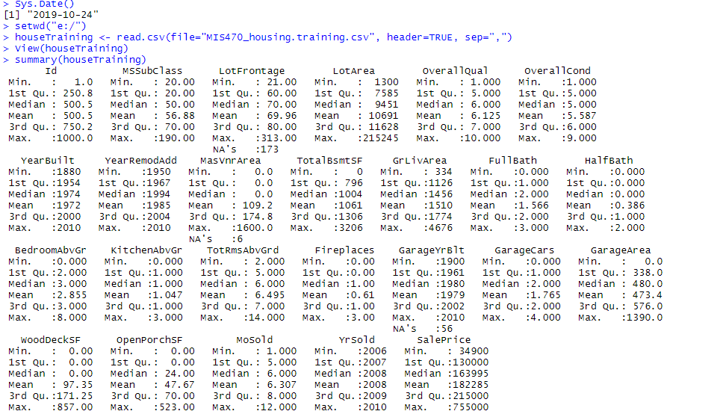  
  
The summary statistics are straight-forward and there is not much to say about them currently. Interesting to see where features are not present, we have 0s, and that will affect the results so I suspect there might need to be some work done to normalize the data. Additionally, month sold isn’t really a “quantitative” value but might be treated as such, and I am sure there is some correlation between it and sale price.

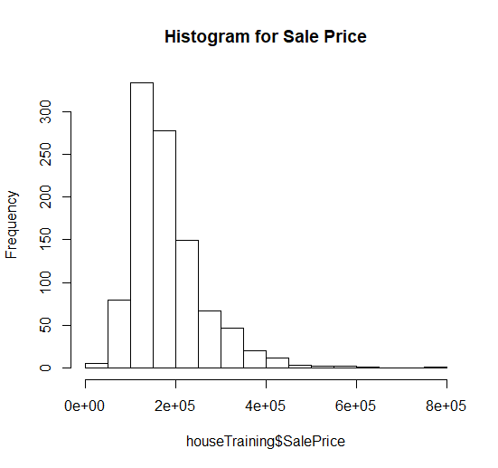

Histogram using ggplot2:

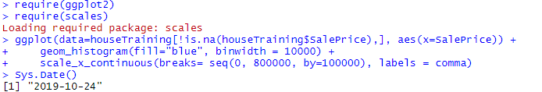

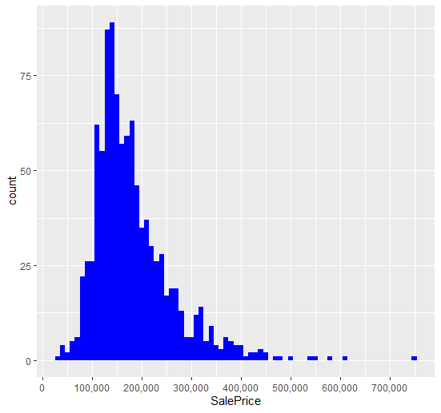

Describe the summary and shape of the distribution of sale price:  
  
It is obvious that Sale Price doesn’t follow normal distribution, so before performing regression it will likely need to be transformed. The distribution also is right skewed, which we would expect because few people can afford expensive houses, as well as the fact that the upper bounds are significantly higher than the lower bounds.