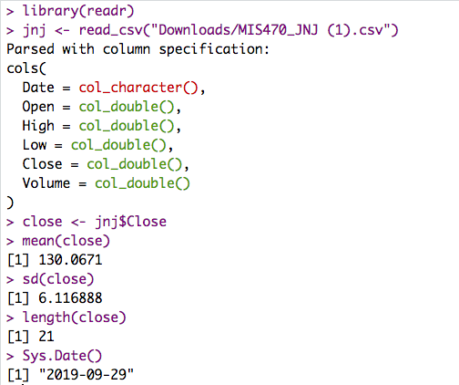

df = n -1 = 20

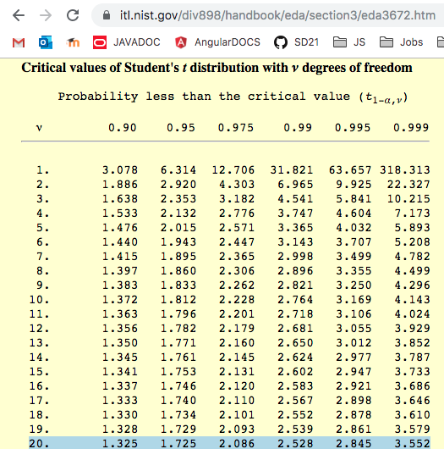

So to find the confidence intervals we have to calculate the error m. Since the population standard deviation is unknown (typical) we will multiply the critical value by the sample standard deviation divided by the sqrt of n. I used to R to find m for each level. (T-distribution, particularly since this quite a small sample size). Stored in an appropriately named variable to add/subtract from the sample mean to find the CI(s).

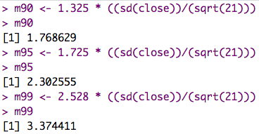

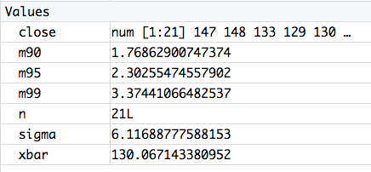



Then subtracting and adding to the mean as necessary we find the upper and lower limits of the confidence intervals.

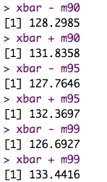

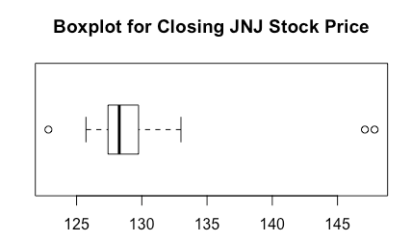

90% CI: [128.29, 131.84]

95% CI: [127.77, 132.37]

99% CI: [126.69, 133.44]

The pattern I observe here is that as we increase the confidence interval our margin of error increases and precision decreases, that is the width of our confidence internal is increasing. As CI increases, we can say with greater certainty that the population parameter is included in the interval. For example, for every 100 intervals we construct at 95% CI, 95 of them will include the population parameter. This is more frequently better than a point estimate or hypothesis testing as we get a range of numbers, the margin of error, as well as a probability factor.