Lesson 1 Basic Building Blocks

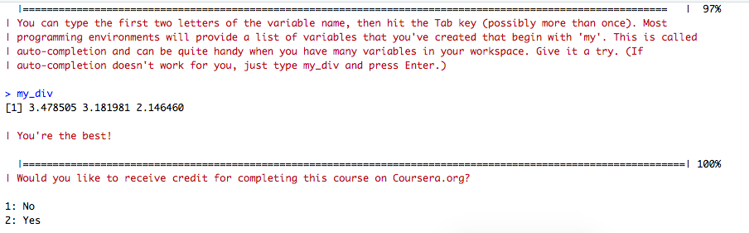

Lesson 2 Workspace and Files

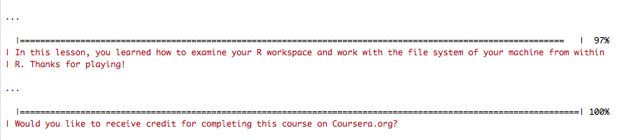

Lesson 3 Sequences of Numbers

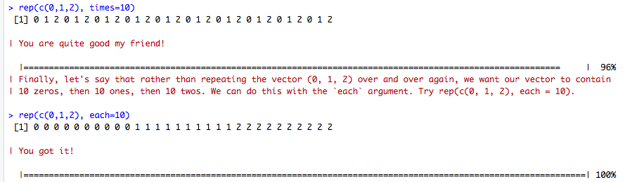

Lesson 4 Vectors

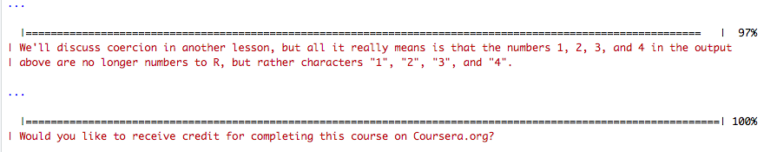

Lesson 5 Missing Values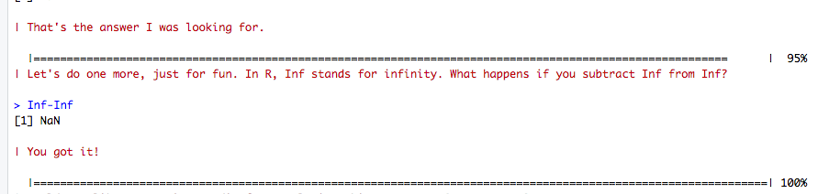

Lesson 6 Subsetting Vectors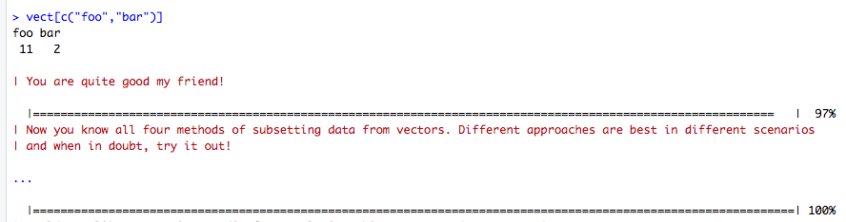

Lesson 7 R Programming Matrices and Data Frames

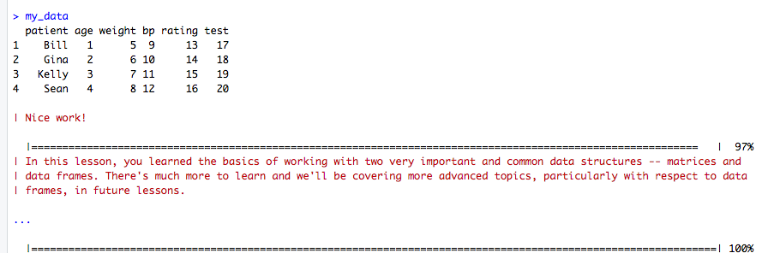

Lesson 8 Logic

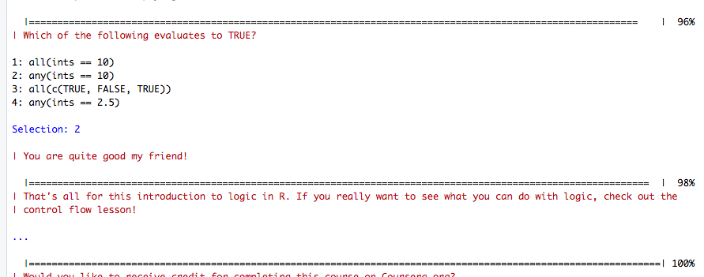

Lesson 9 Functions

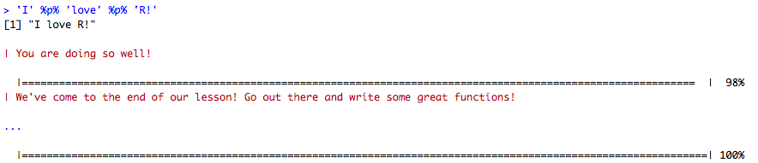

Lesson 10 lapply and sapply

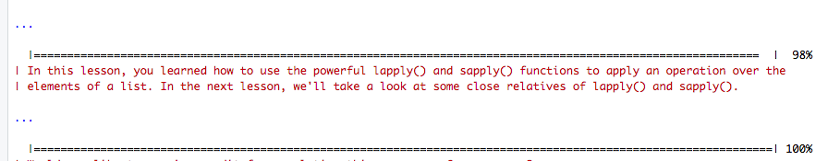

Lesson 12 Looking at Data

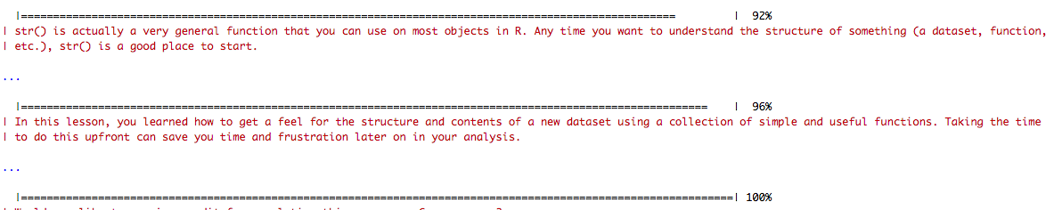

Lesson 14 Dates and Times



Lesson 15 Base Graphics

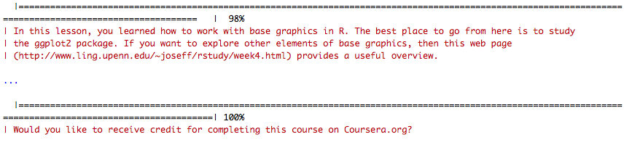

Screenshot of Current Date in R

