Regression Model:
How does GDP affect Currency Exchange?
Cecil Kitch
Colorado State University – Global Campus
Regression Model
In order to answer the question “How does GDP affect US/EUR currency exchange,” a simple linear regression is performed with a brief interpretation. Using powerful software packages and R programming, one can quickly generate summary statistics, a scatter plot, and a linear regression model. These tools allow us to analyze and visualize and assess the relationship between a predictor variable and a response variable. The results of the analysis show determined that the model was in fact a good fit. The R value was determined to be significant, thus we can use the linear regression equation to predict the US/EUR exchange rate.
Analysis
Importing the data set into R studio from excel using the clipboard pipe, a data frame was created. Each column of the data set was then a variable, in order to plot, and provides a way to regress the currency exchange rate against the gross domestic product. The following lines of R code were used:
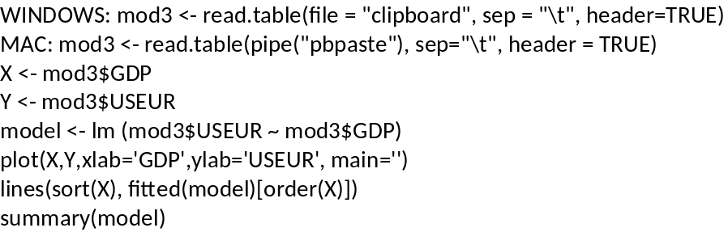
Figure 1 – R code used to perform the regression and generate summary statistics.
This code imports the data from our clipboard into a data-frame, and outputs a scatter plot with a linear regression model fitted, as well as summary statistics.
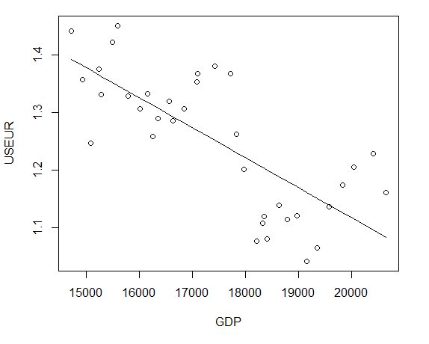
Figure 2 – Scatter plot of GDP vs US/EUR fitted with a linear regression. The negative slope of our regression line displays a moderate negative correlation.
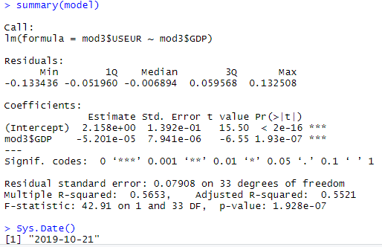
Figure 3 – Summary stastics for the GDP vs USEUR Model
The summary provides us with the R-squared value, which measures the strength of the realtionship between the model and dependent variable on a convenient 0 to 100% scale. Here the value of R-squared is greater than 50%, coming it between 55-56%. That is, 56% of the variation in the y-variable (dependent variable, response) is explained by the x-variable (independent variable, predictor). In other words, we might say that R-squared tells us how well the data fits the regression model, in this case 56% of the data fits the regression model. The summary statistics additionally provide us with the coefficients, intercepts, and margin of error needed to generate the populate the values of our regression line equation. Extracting this information into the linear equation format, we obtain:
USEUR = 2.158 - (5.201e-05*GDP) + 0.07908.
In order to determine if this regression equation can be used to predict, we must detemine if the value of R is significant. To determine if R is significant we test if the absolute value of R is greater than the critical value of the correlation coefficient. To obtain the value of R, we take the square root of R-squared. Using R-programming, this can be obtained with the function sqrt(). In this case, sqrt(0.5663) = 0.7518643. With 35 observations in our data set, we will use the critical value associated with 40 degrees of freedom, that is 0.304. In this case, R = 0.7518643, which is greater than 0.304. Therefore, we can say that R is significant, thus our model is a good candidate for using the regression equation obtained to predict USEUR. If the value of R had not been significant we would have to directly take the predictor as the average of Y. Additionally, based on guidelines outlined in the course material, we also say that there is a moderate negative correlation between our variables.
Using the equation, USEUR = 2.158 - (5.201e-05*GDP) + 0.07908, we can predict USEUR given a value of GDP. In other words, USEUR is predicted to decrease -5.201e-05 when GDP increases by one, and when GDP is zero it is predicted to be 2.23708. At this point, a few iterations of substituting in GDP values from the data set were executed, to see how the known values compared to a predicted value.

GDP |  | USEUR - Known | USEUR - Predicted
14721.350 |  | 1.4419 | 1.471423
14926.098 |  | 1.3569 | 1.460774
15079.917 |  | 1.2464 | 1.452774
15240.843 |  | 1.3754 | 1.444404

Based on the above four iterations, only the first prediction was relatively close. As mentioned above, R-squared tells us that model only fit 56% of our observations. There is a relative degree of disparity between our predicted values and our known values, however, we know that currency exchange has many variables in addition to GDP that influence the value. If there were a perfectly linear relationship between GDP and USEUR, then all 35 of our observations would fit on a straight line. This is not and is never the case, thus using GDP as a sole predictor of the exchange will never be highly accurate, but a strong correlation is definitely apparant.
References
Berrier, J., Nestler, S., Pardoe, I., Sturdivant, R., & Watts, K. (2018). ZyBook: Mis 470: Data Science Foundations.
DSS - Interpreting Regression Output. (2007). Retrieved October 23, 2019, from https://dss.princeton.edu/online_help/analysis/interpreting_regression.htm.
Appendix
