**Option #2:  Star Schema – Northwind database**

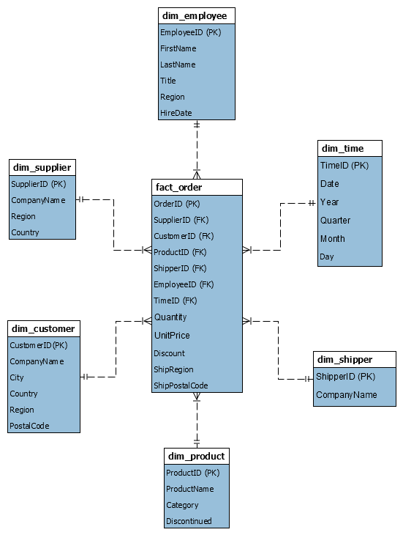

Designing a star schema was a bit foreign to me, but after completing this assignment I have a better understanding of the purpose of the schema, and how this will integrate with a data warehouse. The difficult part was identifying facts and dimensions, and then de-normalizing the tables. Obviously, I am used to thinking in reverse. Initially I struggled to complete this CT using the Jigsaw Database, using the ERD provided for Northwind made understanding what was required much easier. I could have potentially included more attributes or order details, but I chose to limit the scope here to what I thought might be useful in routine analytics. In real life I expect business requirements are going to dictate what attributes are required to be housed in the data mart.