**Option #1:  Relational Data Model – Order Entry**







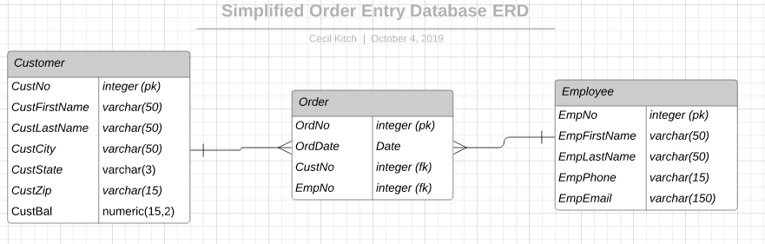

Challenges associated with this module included orienting myself to psql and pgAdmin tools, as well as translating my experience with other SQL implementations. I was unsure how to handle the creation of a complex primary keys with letter/number combinations, therefore I chose to use the PostGRESQL datatype serial for creating my primary keys and referenced them in constraints as foreign keys of type integer. I also choose to set to set null on delete.