**Option #1:  Washington State Patrol Case Questions**

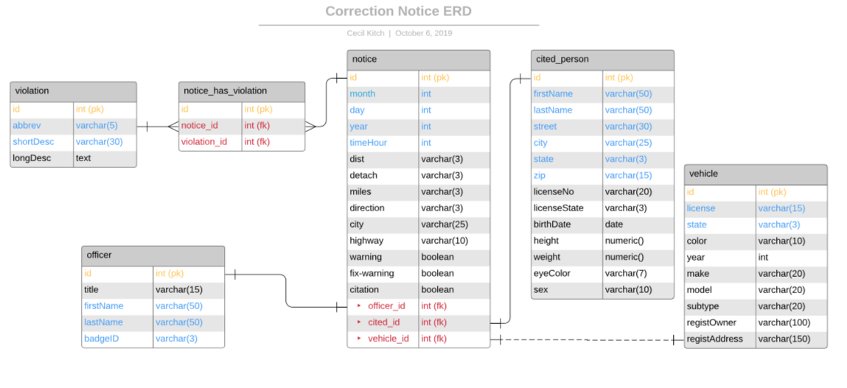

The five entities: Violation, Officer, Notice, CitedPerson, and Vehicle. Ended up with an association table between notice and violation due to the many-to-many. Color coding was used to represent primary keys in gold are unique, nonnull, and autoincrementing. Foreign keys represented in red, and other non-nulls were labeled in blue. Solid relationship lines indicate a defining relationship, thus foreign keys are required to be non-null. The optional relationship between vehicle and notice is indicated using a dashed line.

|  |  |  |  |
| --- | --- | --- | --- |
| Violation | Notice | 1:M | notice must have at least one, but may have many violations |
| Officer | Notice | 1:M | notice must have one officer |
| CitedPerson | Notice | 1:M | notice must have one cited person |
| Vehicle | Notice | 1:M | a notice may optionally specify one vehicle |