Option #1:   Order Entry

1. Screenshot of Database Creation

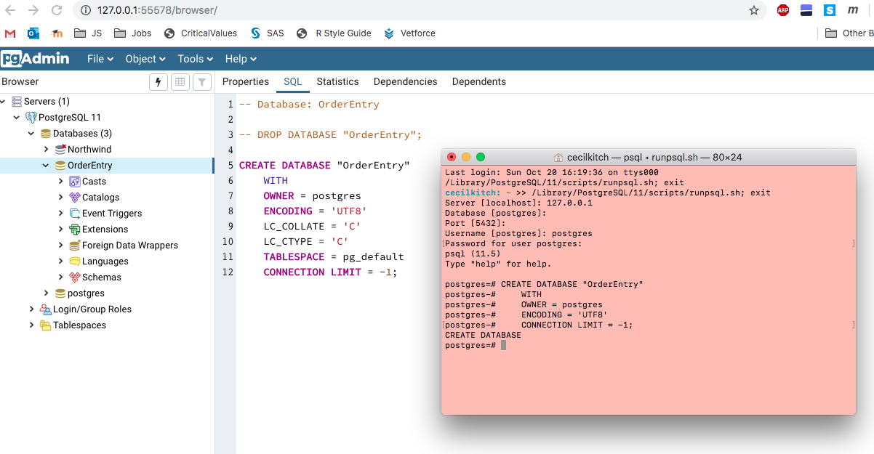

1. Screenshot of Table Creation.

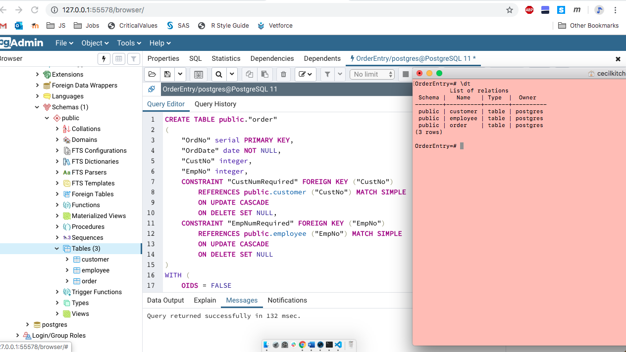

1. Screenshot of Queries showing populated tables, and insert statements

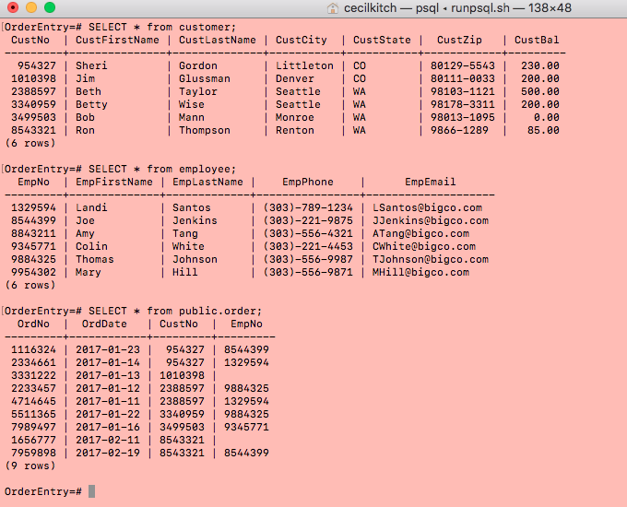



Key learnings from this assignment were the case-sensitive nature of the insert and create statements and the requirements for using the double quotes to access those tables and fields. In retrospect I would have given the column names more descriptive lowercase names, perhaps using underscores rather than capital camel case. I was being too literal in using column names directly from the table in course material.  
  
Question:  
 1.) How do I get the primary keys to have a letter appended to the front such as C, E, O? Is that a database function or is that formatting should be done on the front end in a GUI?  
  
Lesson Learned:  
2.) Trying to execute “INSERT INTO order” failed with a syntax error because it is a reserved word. Required referencing it using public.”order”.

---- Will avoid this word for table/attribute names in the future.