**EE307 Digital Electronics and Integrated Circuits**

HW4 - Assigned: 1/29/17 Due: 2/3/17

**Solutions /**

This week's homework is about real world delays, building a multiplier and a bit more on using LTSpice.

1. LTSpice: Reading for homework
   1. Comment 1: When you use symbols you only need to include the model file on the toplevel schematic. If you put the model file path in each symbol then for some reason you need to change the path, you’ll need to change it in every single symbol. So please remove the path from each individual schematic that has a symbol. Nothing to do for this “question”.
   2. Comment 2: If you have two wires that aren't connected but have the same name, LTSpice will interpret that as them being the same wire and treat them as if they are connected. That means that you don't have to draw long wires between everything that's connected - you just have to name two segments of wires the same. Nothing to do for this “question”.
   3. You may want to change the supply voltage at some time during the quarter so having a VDD pin on your symbols. I think you can put a source with its value set to a variable (See below “.PARAM”) but I haven’t used it enough to be sure it won’t cause problems in the future.
   4. LTSpice technique 1 for this week: Here’s a new technique that will allow you to do two very handy things.
      1. It’ll let you sweep any value, not just voltages and currents. By “any value” I mean resistances, capacitances, temperature, etc.
      2. This technique and can also save you a ton of work when you change values used in many places. It allows you to change the value in one place but have the change take effect in every place that it’s used.

First let’s look at how you can sweep other values than voltage or current by using variables (.PARAM). When doing a graphical (drag and drop) circuit entry, there are two things you need to do to use .PARAM. Instead of giving a resistor value like 1K, put in a name surrounded by curly brackets like {RC}. Names have to follow the same rules you use for other names in your schematics. The second thing you need to do is click on the .op icon and enter: .param RC=1k:

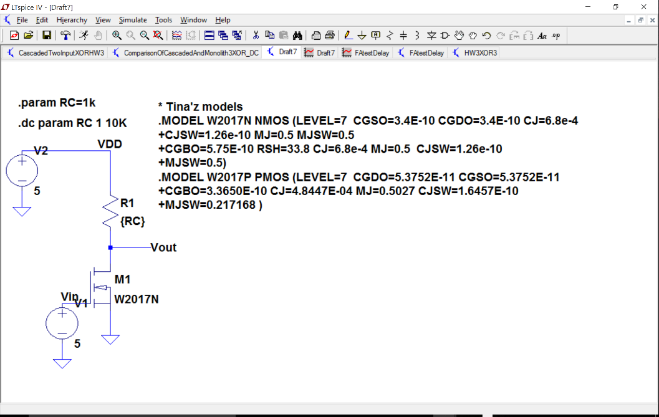

The curly brackets tells LTSpice that you are setting that value to a variable. The .param sets a value to that variable. To sweep the value you need to set the DC sweep as shown at the top of the next page.

The value you set in the .PARAM directive doesn’t matter if you are sweeping the variable value in your DC sweep but you have to give it some initial value or the compiler will complain. Let’s say you want to find a resistor that will give you an output centered around 3.5V when VGS=5V. First set VGS=5V as shown in the above schematic and then set the simulator values on the DC sweep as follows:

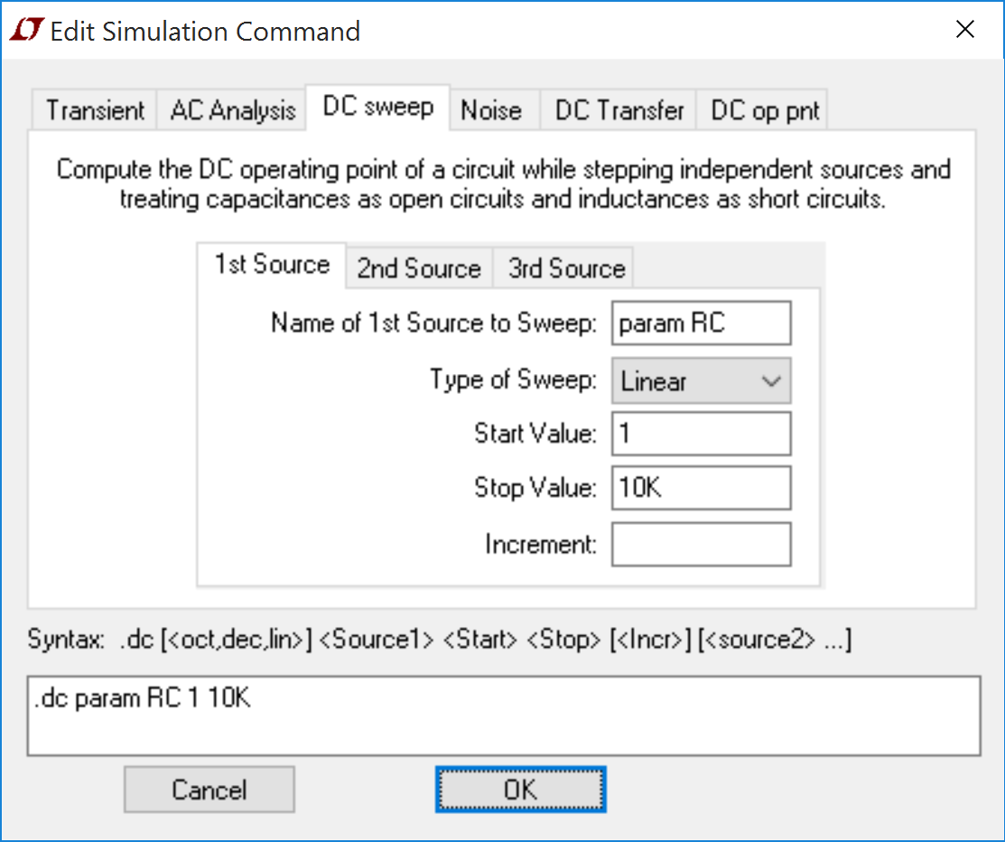

Don’t forget the ‘param’ before RC. That tells LTSpice to look for something defined in a .PARAM statement.

When you run this simulation the output voltage will change as RC changes. Whatever you sweep shows up on the X-axis. Whether you swept a voltage, a resistance, a capacitance, a temperature, a current or whatever:

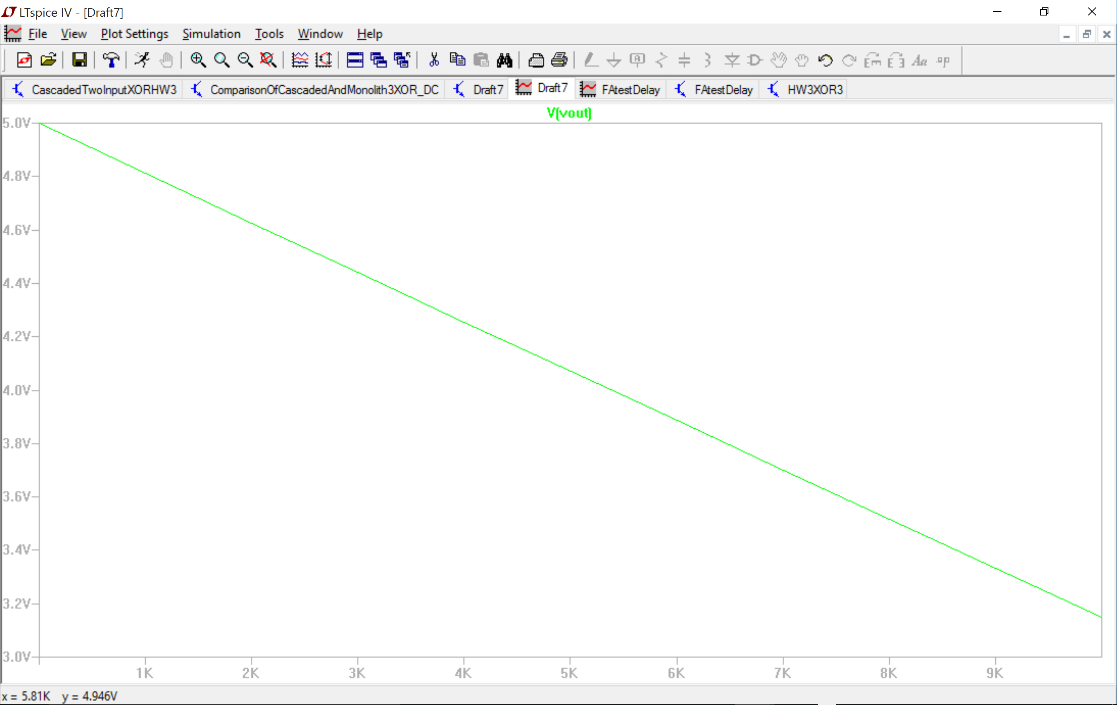

To find where the output equals 5V use a cursor (right click here and select “Attached cursor – 1st” . That should allow you to drag the cursor along the graph line. (A single left click on the signal name also gives you 1st and a double click on the signal name gives you 1st & 2nd). The position of the cursor is displayed in a separate little window). **NOTE:** that the value that you sweep is shown on the X-axis.

The first use described above is about sweeping a value. The second use, which I’ll explain next, just sets a value of a component or a whole bunch of components depending on where you use the variable. When I say “A component value” I mean 1k on a resistor or 1nF on a capacitor or something like that. This use of .PARAM is useful if you want to use the same value in, say, twenty places but you want to be able to change all of them to a new value easily all at the same time. If you set all those places to the variable (not the value) then you just need to change the value in the .PARAM directive to change all twenty places at once. The picture on the next page doesn’t show multiple RTL inverters but if it did, on each one I could set the R value to {RC} and then when I changed the 8.1K in the .PARAM statement all the resistors with {RC} as their value would change to the new value.

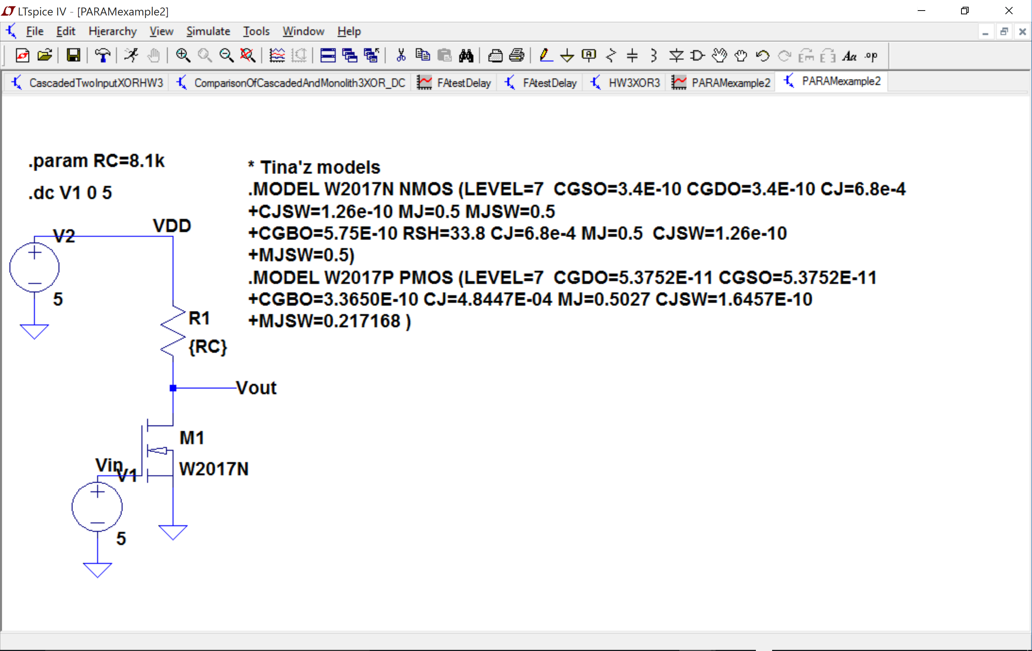

You can use “RC” as a value in as many places as you’d like and then when you change its value in the .PARAM directive, all fields that have been designated as having a value of “RC”. You can use as many .PARAM directives as you need. Nothing to do for this “question”.

A note on .PARAM: You can use a parameter inside a symbol. If you do that you can specify the value inside the schematic of the symbol or at the toplevel or any level between as long as it is higher in the pyramid than the schematic that uses the PARAM value. Here’s an example:

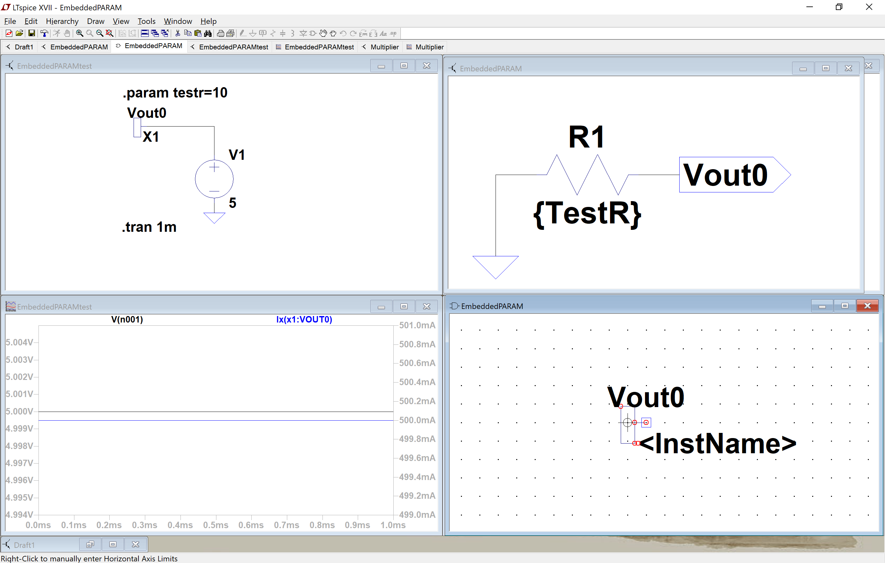

* 1. Many of you are already using buses but here’s more information. LTSpice technique 2 for this week: This comes from <http://ltwiki.org/index.php5?title=Undocumented_LTspice#Bussing_of_Connections_and_Components_.28BUS_shorthand_notation.29>

As your circuits start having to deal with more and more inputs, buses will be useful.

The subcircuit: (I used the 3-bit XOR from last week)

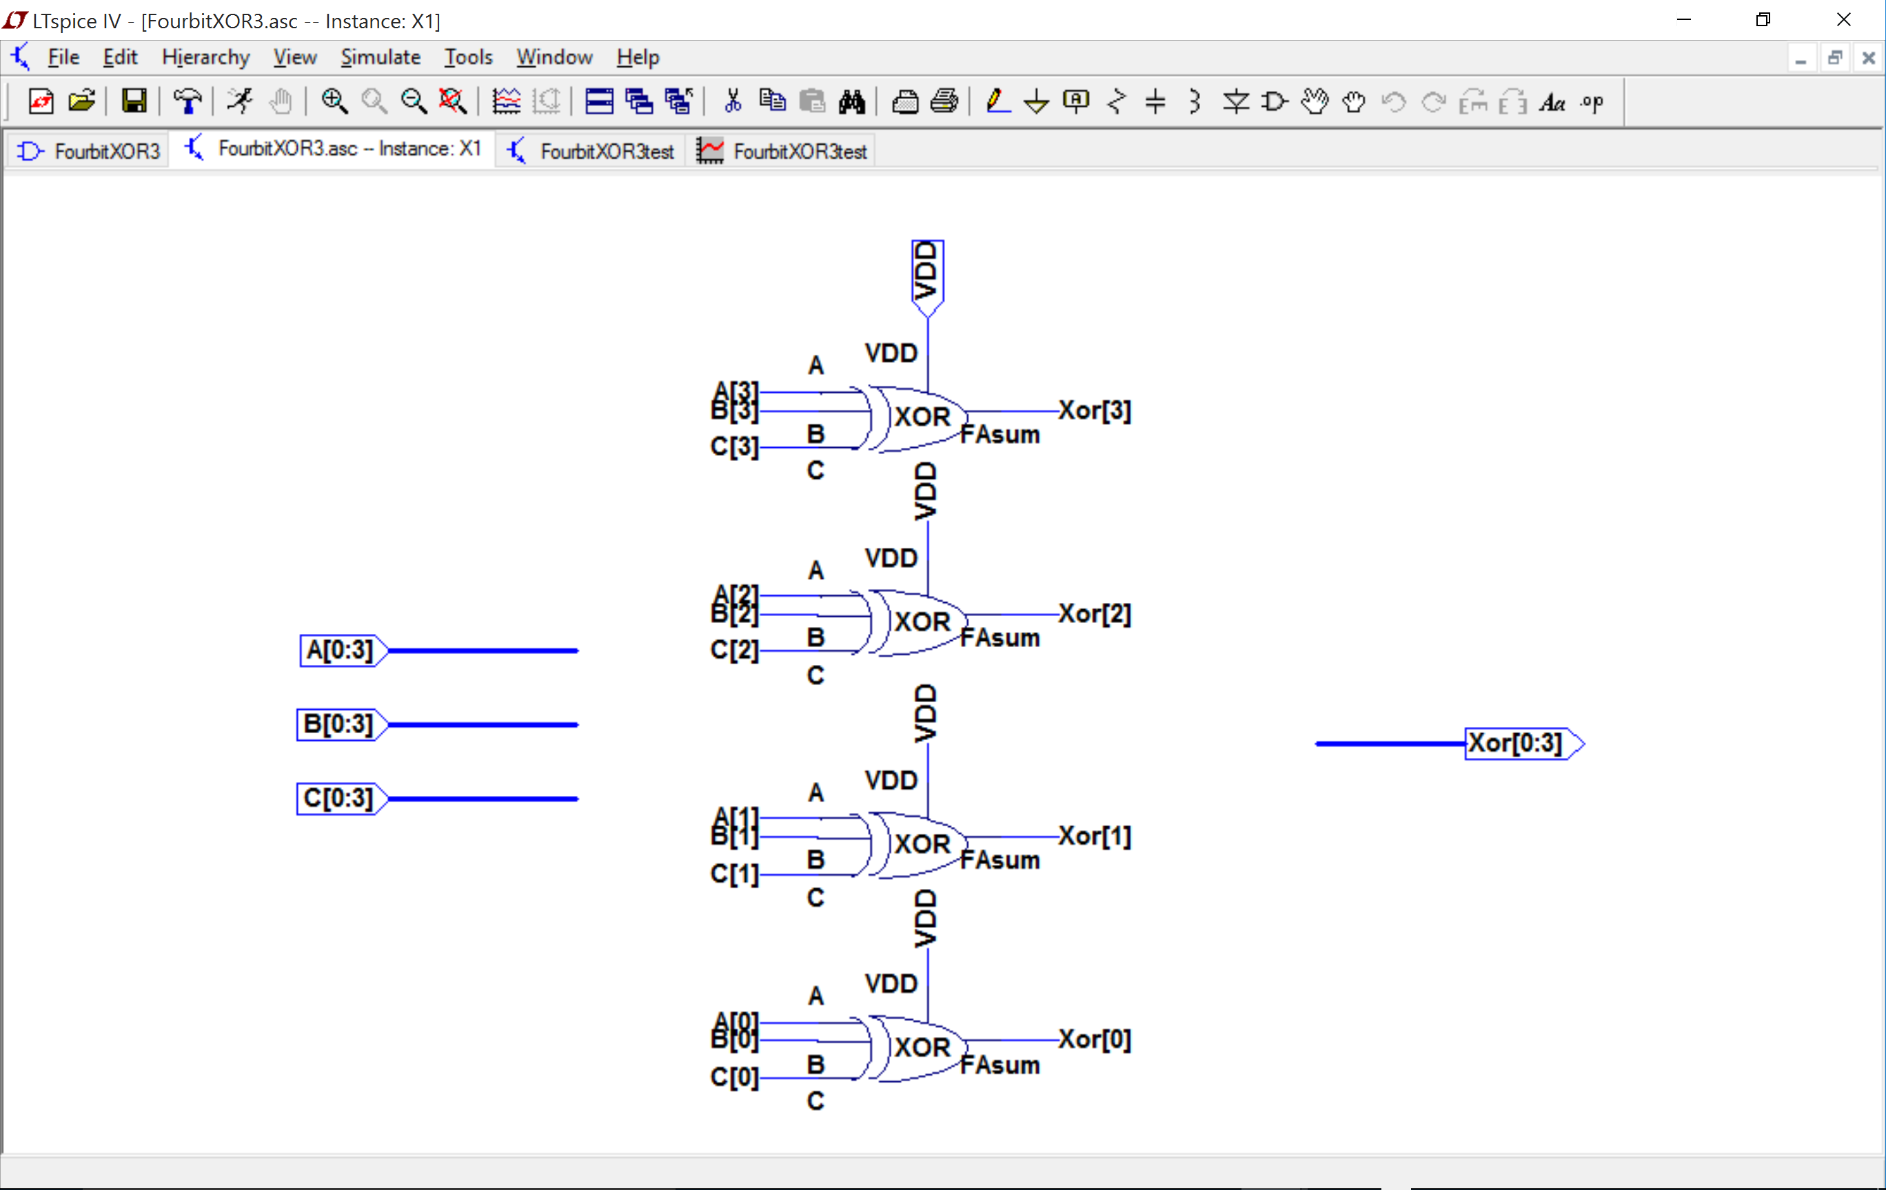

The symbol:

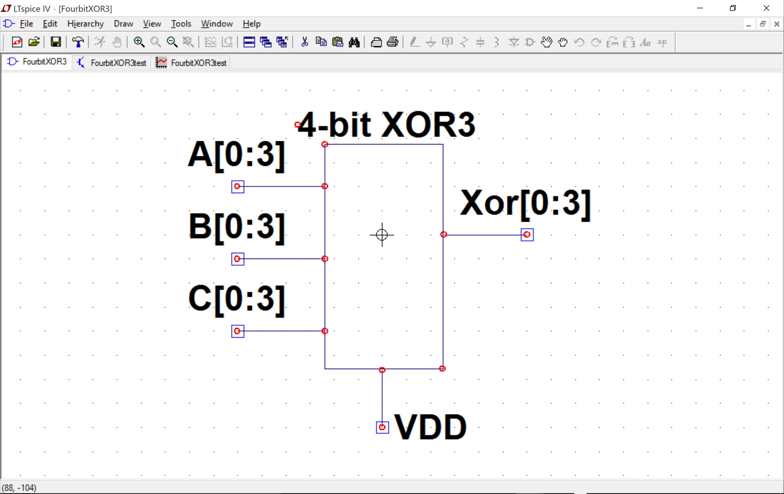

The test circuit:

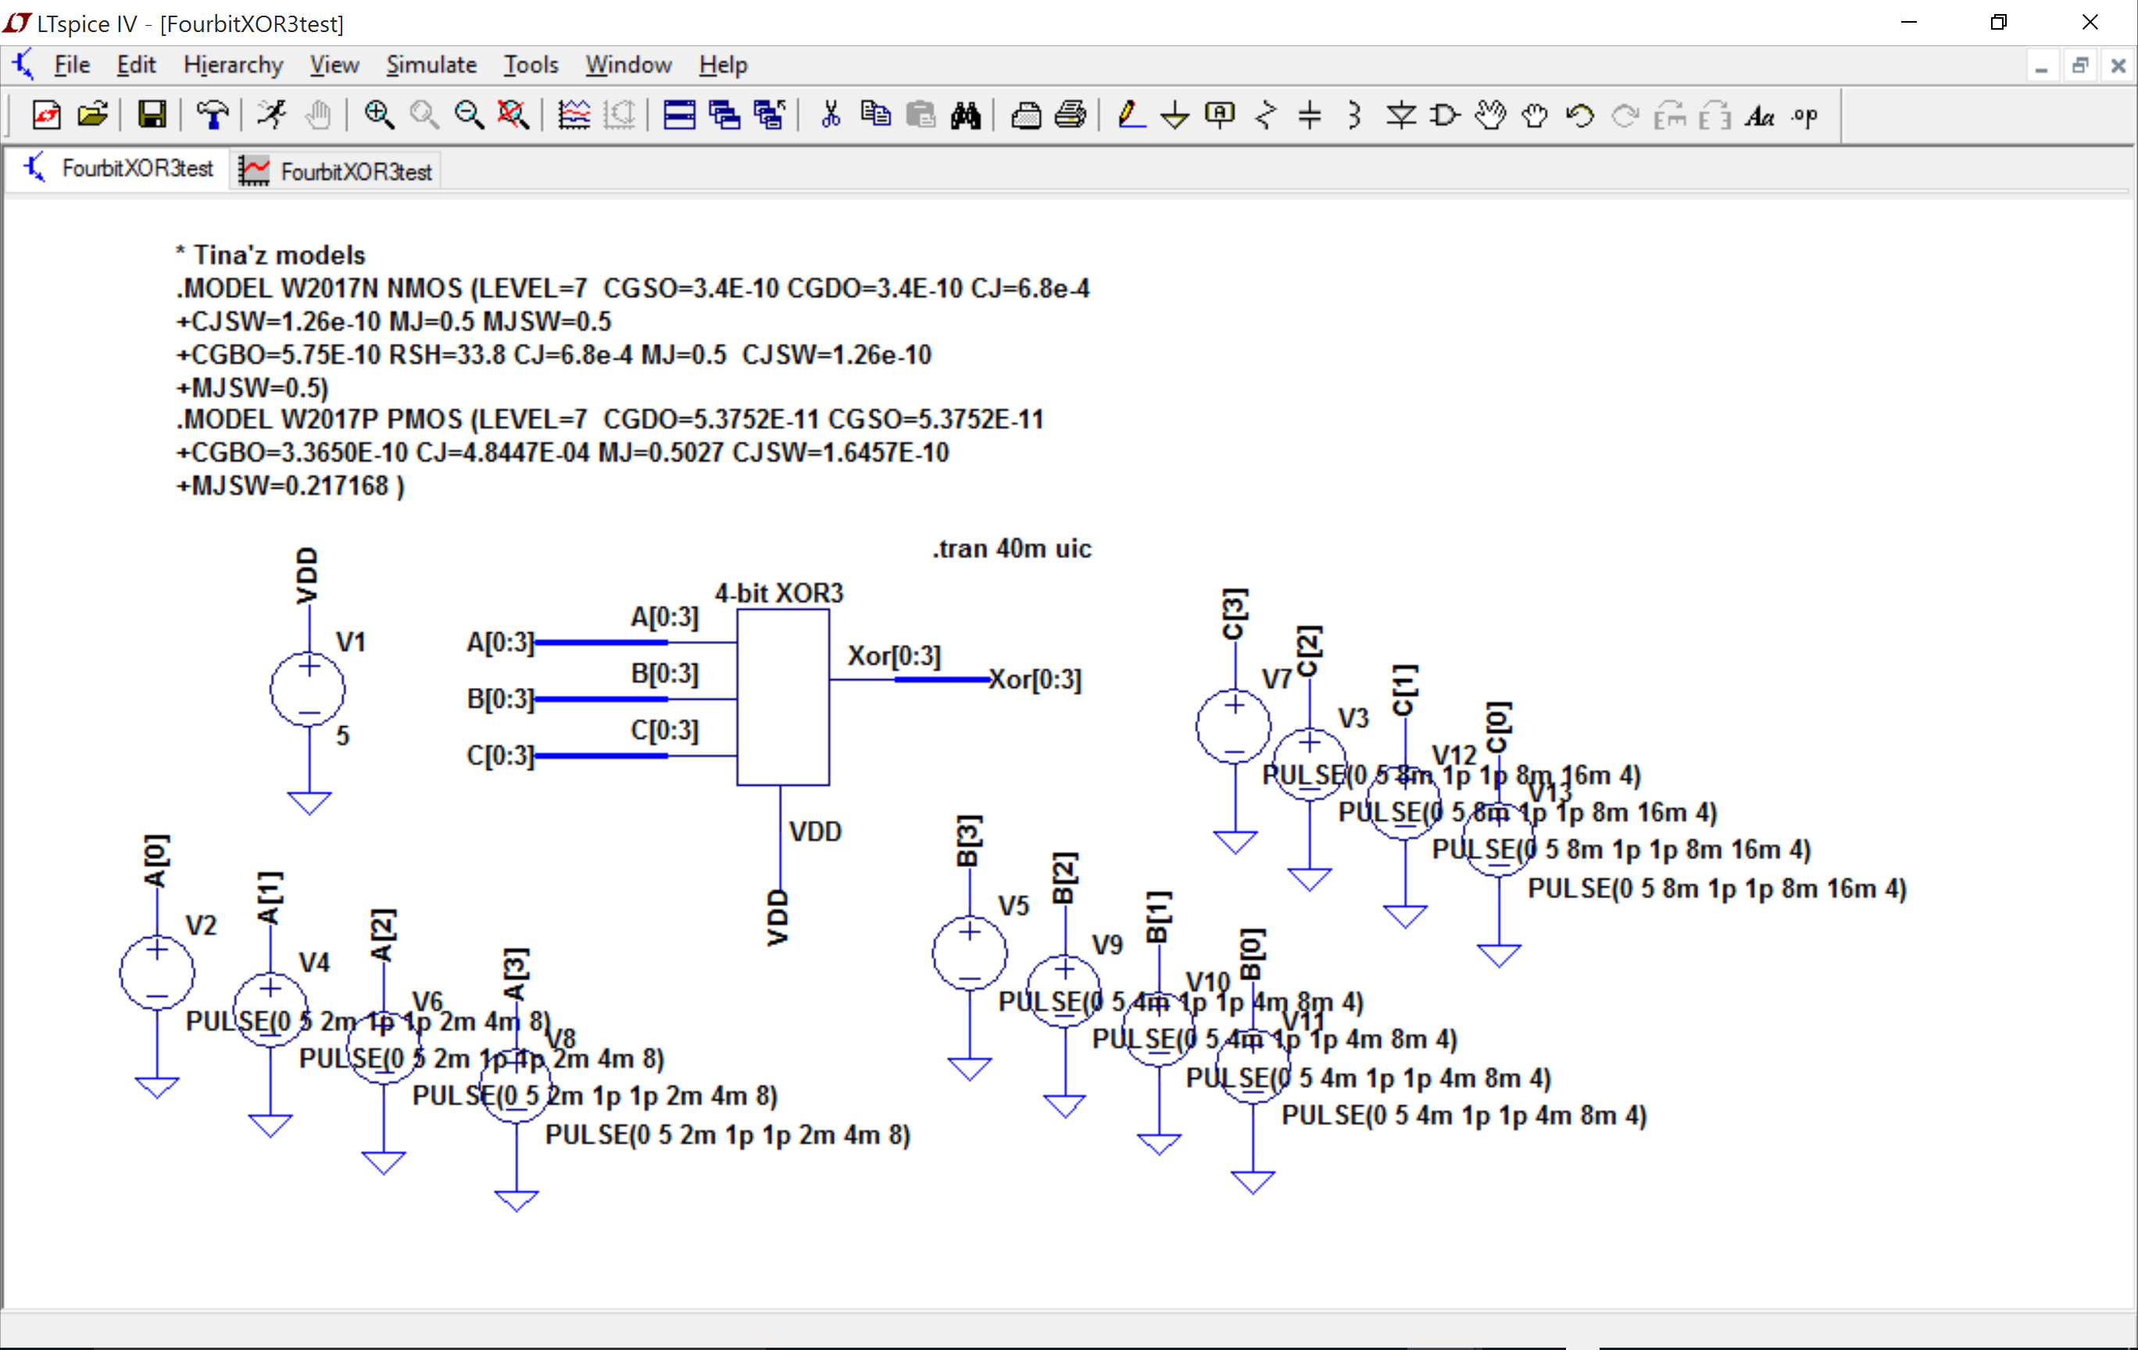

The results: (Adding signals by right clicking on graph area and adding wire from bus that we are interested in)

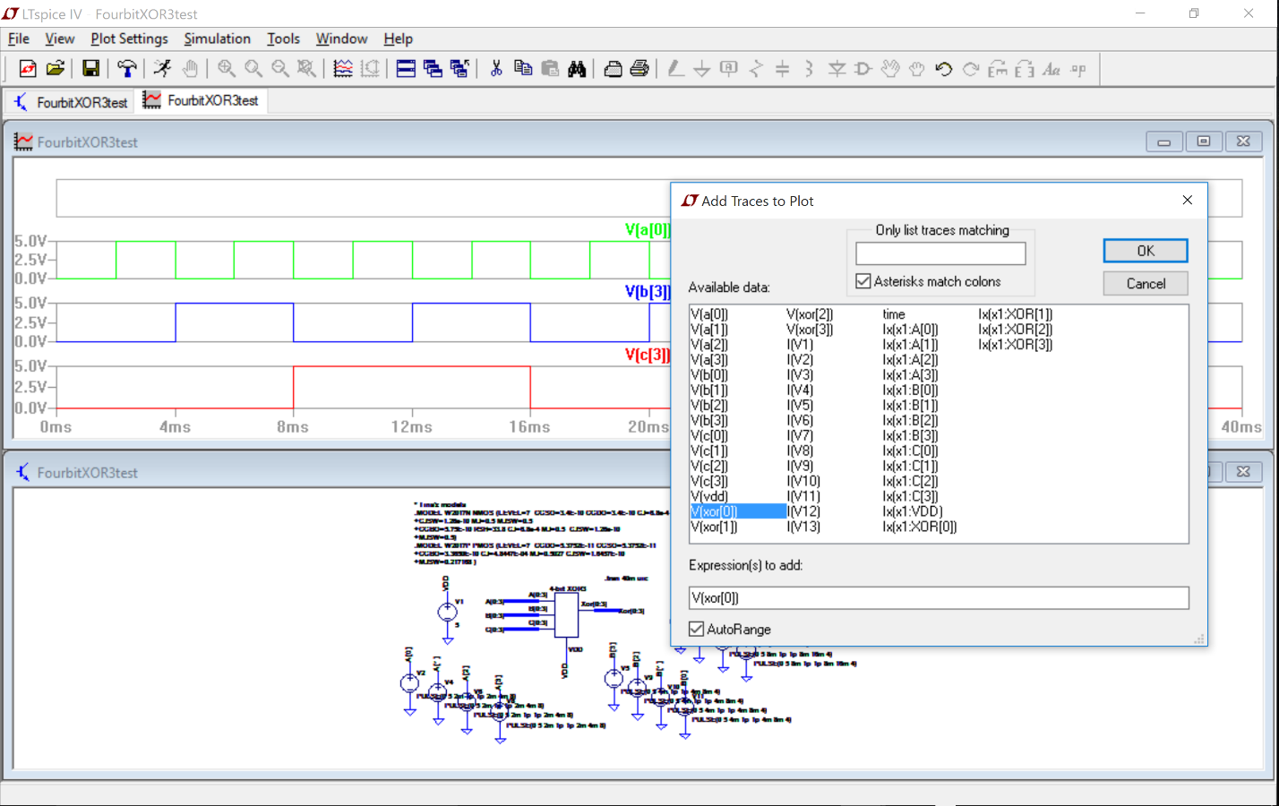

Graph:

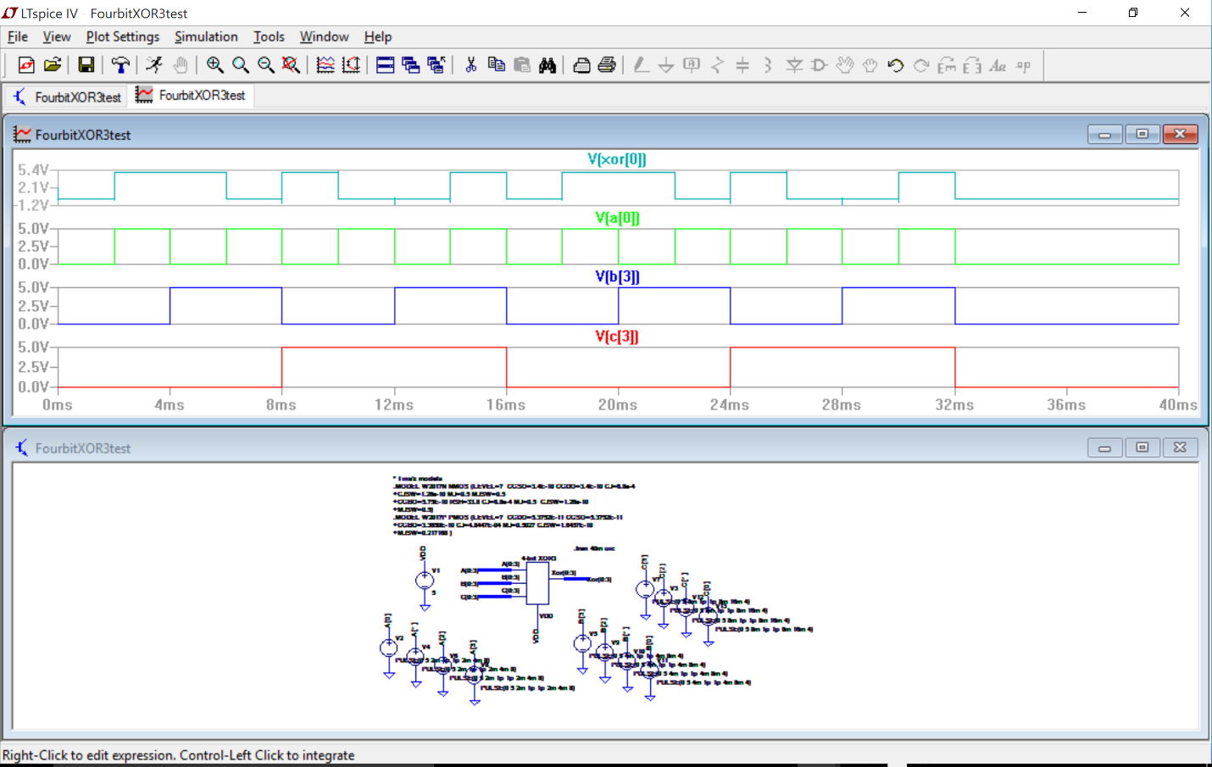

Nothing to do for this “question”.

Sometimes you want to set a single wire of a bus to GND, VDD or connect it to another wire. There’s an “e” component in SPICE that is convenient but it will give infinite current so it won’t give you a realistic behavior. I prefer putting a very small resistor (0.01Ω or so) is series:

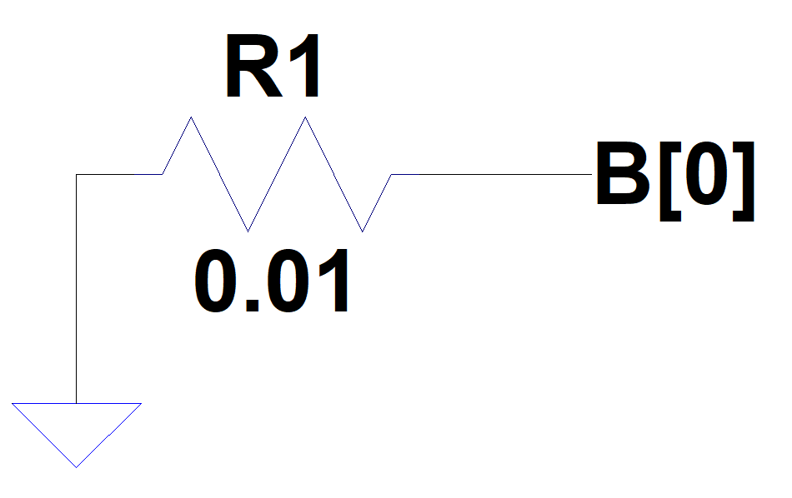

1. Delay and time constants. Review math to derive rise, fall and propagation delay equations:
   1. Say you knew the R and C at a node, find an equation for rise time. The slide with the propagation delay may be of use.

**ANSWER:** **(4pts)** There are two events here: 1. Where the signal gets to 10% and 2. Where the signal gets to 90%.

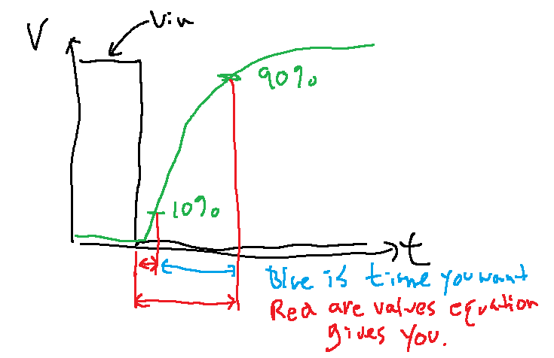

The rise time is the difference between the two. I’ll calculate each separately and then subtract:





Subtracting the two:



* 1. Say you knew the R and C at a node, find an equation for fall time. The slide with the propagation delay may be of use.

**ANSWER:** **(4pts)** There are two events here: 1. Where the signal gets to 90% and 2. Where the signal gets to 10%. The fall time is the difference between the two. I’ll calculate each separately and then subtract:







The equations for rise and fall times are the same.

* 1. Find an equation for the propagation delay assuming it is completely described by the RC characteristics of the node and the input has an instantaneous input transition.

**ANSWER:** **(4pts)** This is in the slides. This is also a time and therefore has to have a start time and stop time but in the case of propagation delay you assume time=0 to be where the inputs change instantaneously. Since the input changes instantaneously, the 50% of the input also happens at time=0. So in the final math you’d subtract the second time but, in this case, the second time is zero so is usually not shown in calculations:





So whether you use the high-to-low calculation or the low-to-high calculation, you get the same equation for the propagation delay.

1. You did the math to find the delays when you know R and C. The next two problems help you find R and C. This problem is about finding R.

|  |  |  |  |  |  |  |  |  |  |  |  |  |  |  |  |  |  |  |  |  |  |  |  |  |  |
| --- | --- | --- | --- | --- | --- | --- | --- | --- | --- | --- | --- | --- | --- | --- | --- | --- | --- | --- | --- | --- | --- | --- | --- | --- | --- |
| IDS(mA) |  |  |  |  |  |  |  |  |  |  |  |  |  |  |  |  |  |  |  |  |  |  |  |  |  |
| 15 |  |  |  |  |  |  |  |  |  |  |  |  |  |  |  |  |  |  |  |  |  |  |  |  |  |
|  |  |  |  |  |  |  |  |  |  |  |  |  |  |  |  |  |  |  |  |  |  |  |  |  |  |
|  |  |  |  |  |  |  |  |  |  |  |  |  |  |  |  |  |  |  |  |  |  |  |  |  |  |
|  |  |  |  |  |  |  |  |  |  |  |  |  |  |  |  |  |  |  |  |  |  |  |  |  |  |
| 10 |  |  |  |  |  |  |  |  |  |  |  |  |  |  |  |  |  |  |  |  |  |  |  |  |  |
|  |  |  |  |  |  |  |  |  |  |  |  |  |  |  |  |  |  |  |  |  |  |  |  |  |  |
|  |  |  |  |  |  |  |  |  |  |  |  |  |  |  |  |  |  |  |  |  |  |  |  |  |  |
|  |  |  |  |  |  |  |  |  |  |  |  |  |  |  |  |  |  |  |  |  |  |  |  |  |  |
| 5 |  |  |  |  |  |  |  |  |  |  |  |  |  |  |  |  |  |  |  |  |  |  |  |  |  |
|  |  |  |  |  |  |  |  |  |  |  |  |  |  |  |  |  |  |  |  |  |  |  |  |  |  |
|  |  |  |  |  |  |  |  |  |  |  |  |  |  |  |  |  |  |  |  |  |  |  |  |  |  |
|  |  |  |  |  |  |  |  |  |  |  |  |  |  |  |  |  |  |  |  |  |  |  |  |  |  |
| 0 |  |  |  |  |  |  |  |  |  |  |  |  |  |  |  |  |  |  |  |  |  |  |  |  |  |
|  | 0 |  |  |  | 0.5 |  |  |  | 1 |  |  |  | 1.5 |  |  |  | 2 |  |  |  | 2.5 |  |  |  | VDS |

* 1. For the graph above, what is Ron? VDD=3V. Use a two point average approximation.

**ANSWER:** **(4pts)** The two point approximation takes the starting point (perceived) resistance and the ending point (perceived) resistance and averages them. The perceived resistance on a transistor is the voltage across it (VDS) over the current through it (IDS). Since the transistor will ALWAYS start at a large VDS, the transistor starts all the way to the right on the IDS vs VDS graph.

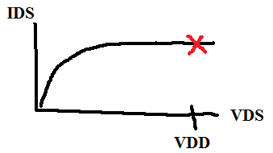

The (perceived) resistance there is:



The propagation delay is found at the 50% mark of the swing and since CMOS circuits have a full swing from VDD to GND, the 50% mark is at VDD/2. That will be the second point where a perceived resistance is found:

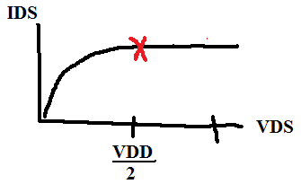



The two-point approximation would then equal the average of the two:



* 1. For the graph above, what is Ron? VDD=3V. Use the center point approximation.

**ANSWER:** **(4pts)** In this case you’d take the point in the center between VDD and VDD/2 and use it to approximate the resistance:

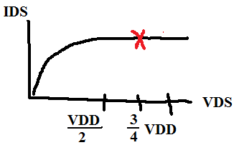



* 1. Why do you use the active region of the graph when calculating Ron?

**ANSWER: (4pts)** Using an inverter as the example: To find propagation delay you use an infinitely fast change on the input and watch how long it takes for the output to get to VDD/2. There are two cases that you might see: 1. Input goes from 0V to VDD instantaneously or 2. Input goes from VDD to 0V instantaneously. Simple stated, Vin always equals 0V or VDD. For an inverter that means that the |VGS| of the PMOS and NMOS are either VDD & 0 or 0 & VDD. So that’s the story of what is on Vin and the VGSs of the two transistors.

To find the region of operation, you also need to look at VDS. In this case, VDS of the NMOS and PMOS are Vout and VDD-Vout respectively.

Another thing to note is that when the input changes instantaneously, the output doesn’t change instantly. So whatever it was before the input changes, the output stays there until it has time to discharge or charge through the transistors.

In the case where the input goes from 0 to VDD, the input starts at 0V so the output starts at VDD. Right after the change in input the output will still be what it was before the change in the input, VDD. At that point, for the NMOS, you have VGS=VDD and VDS=VDD. That puts you at this point on the IDS vs VDS graph:



Note that when the input goes to VDD, the PMOS instantly goes into cutoff. Since it doesn’t conduct, it can be ignored for analysis.

As the output discharges through the NMOS, VDS (Vout) drops and you move to the left on the IDS vs VDS graph:



So you start in the active region because you’ll always have VIN=VOUT=VDD(=VGS=VDS) and you’ll move left until you hit the VDD/2 point which is where it’s generally considered to have transitioned.

For a PMOS the exact same argument can be made except the graphs look like:

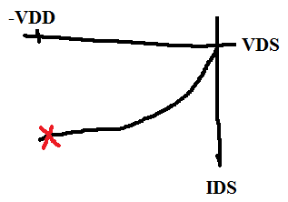

And:

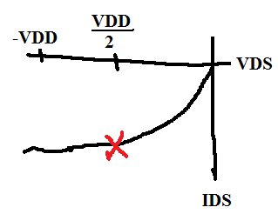

* 1. For and VTN=0.6V and VDD=5V, what is Ron using the center point approximation? (Using the equation instead of the graph).

**ANSWER:** **(4pts)** To find an R you need a voltage and a current:



Since you know the VDD of the circuit, the one point approximation puts you at:



To find current, assume that you’ve just switched your input (instantaneously) and the transistor that is **ON** has |VGS|=VDD. This will be true whether the input is going from 0V to VDD or VDD to 0V. Also assume λ=0 (which I forgot to put in the question). Then the current will be:



So the perceived resistance will be:



* 1. What is the resistance of a resistor made of a rectangular N+ doped region of silicon that is 40μm long and 2μm wide? (See table at top of next page)

**ANSWER: (4pts)**



* 1. What is the length of a resistor made in P+PLY that is 2μm wide and has a resistance of 10KΩ? (See table at top of next page)

**ANSWER:** **(4pts)**



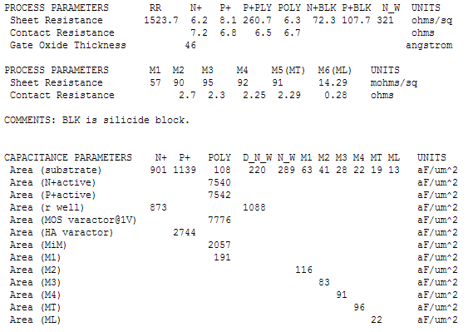

1. Vm, VIL, VIH, VOL and VIH. Assuming that:

>> the magnitude of VTN is the same as VTP and is 0.5V

>> Vomax=6V and Vomin=0V

>> VDD=6V

>> K’=200μA/V**2** for both. Remember K’=k’(W/L)

>> λ for both is 0.07 A**-1**

* 1. Find Vm

**ANSWER:**



* 1. Find gain

**ANSWER:**





* 1. Find VIL

**ANSWER:**

You need the current so first let’s calculate that:

625μA

Setting up the equation to find VIL: 



* 1. Find VIH

**ANSWER:** 



* 1. Find NML

**ANSWER:**

VIL-Vomin=2.74V-0V=2.74V

* 1. Find NMH

**ANSWER:**

Vomax-VIH=6V-3.26V-0V=2.74V

1. This week’s work on the computer is to build the MUX for the datapath.
   1. Draw the truth table for a MUX that selects between two inputs. The tricky part here is to determine the inputs and the outputs on the MUX.

**ANSWER:**

|  |  |  |  |
| --- | --- | --- | --- |
| INPUTS | | | OUTPUT |
| SEL | A | B | Out |
| 0 | 0 | 0 | 0 |
| 0 | 0 | 1 | 1 |
| 0 | 1 | 0 | 0 |
| 0 | 1 | 1 | 1 |
| 1 | 0 | 0 | 0 |
| 1 | 0 | 1 | 0 |
| 1 | 1 | 0 | 1 |
| 1 | 1 | 1 | 1 |

* 1. Find the logic for the MUX.

**ANSWER:**



* 1. Build the MUX with gates. Nothing to show for this question.
  2. Make a single symbol that takes two 9-bit inputs (just one select signal) and selects between them.
  3. Use your MUX to select between the adder or multiplier outputs. Package the entire adder, multiplier and MUX into a single symbol. You may have to zero some wires since the output of the adder isn’t as wide (doesn’t have as many bits) as the multiplier. Nothing to show for this question.
  4. Test the datapath. Set A=1110 and B=0011. Switch the select signal and show the output switch between the two outputs. Please turn in a screen capture showing the output changing with a change in the select value.

**ANSWER:**

The output should go between 000010001 and 000101010