Objective: To create a basic computer, building from the transistor level up, that can

* Load SRAM data to a register file
* Store data from a register to SRAM data memory
* Add two pieces of data from the register using a basic ALU (adder and multiplier) then storing value back into the register file
* Multiply^

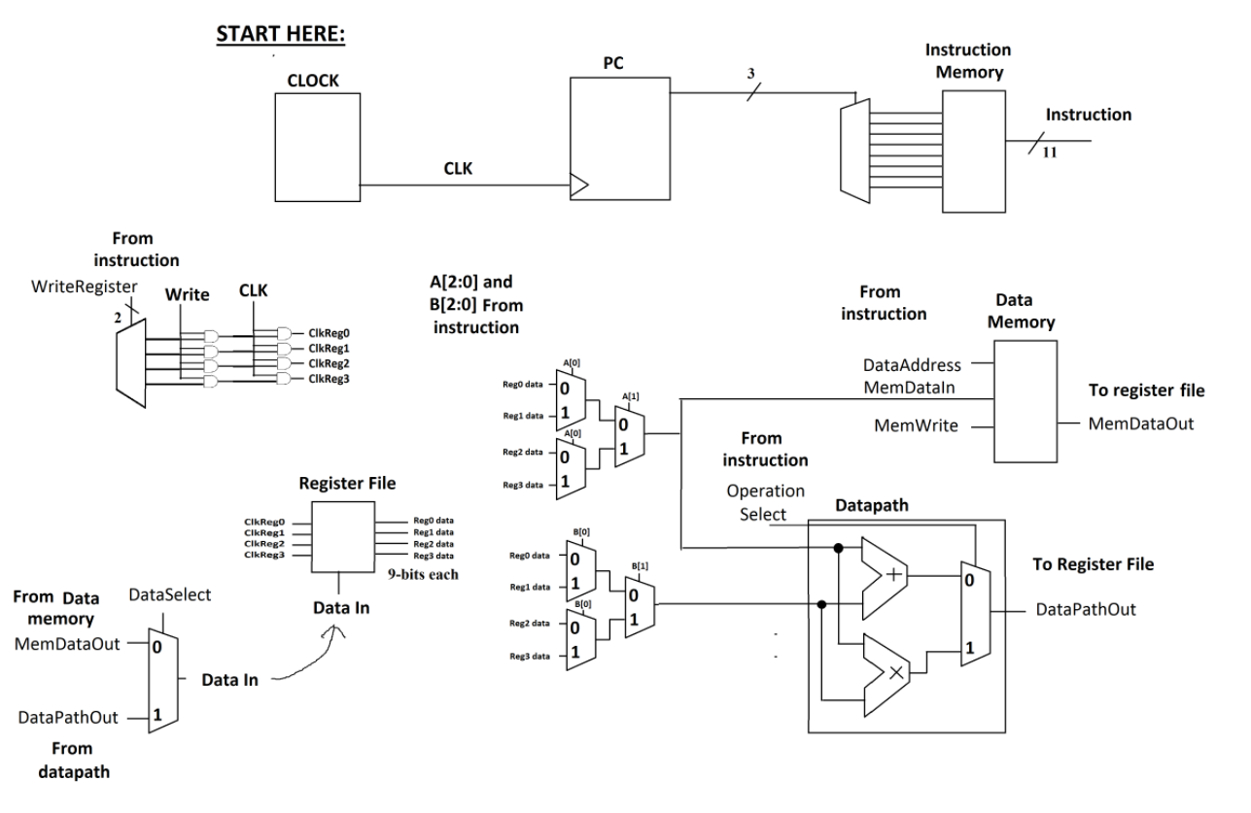

My progress:

I would first of like to begin by saying thank you Tina for teaching us how to use LTspice, I really appreciate your enthusiasm for teaching us the magic of simulation.

I did get a working reg file along with a decoder and a simple ALU however my SRAM cells were not working as they should. I was not able to wire everything as shown above however I do have most of the working components.

Attached below are my attempts. Thank you for your consideration.

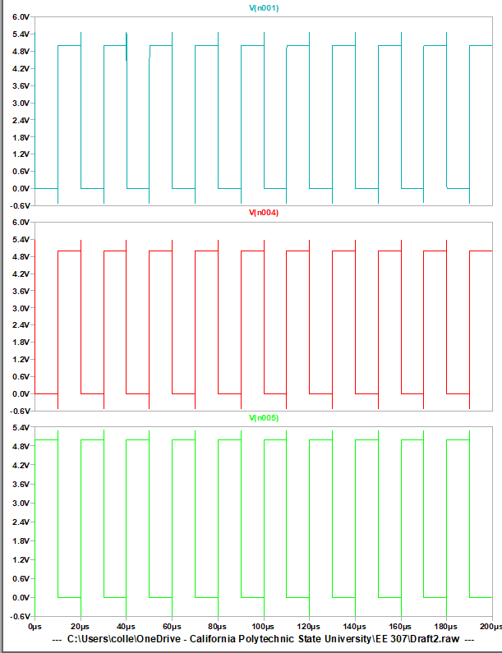

Register to SRAM attempts