Carl Morgenstern HW2

Problem 1:

1. Artificial intelligence describes when a computer can do something in a “smart” or human way. Such as playing a chess game. Machine learning is a subset of AI, but the program can determine the constraints of the problem by using data rather than having them determined by a human. Deep learning is a subset of Machine learning that uses Neural Networks, that is particularly useful for image or speech recognition. The deep, refers to deeper layers of inputs that the neural network creates, for facial image recognition, layer 1: pixels; layer 2: edges of color; layer 3: facial features (eyes, nose, mouth, hair); layer (4) determine if the object has a face.
2. My background comes from Power. I have worked at a utility for the past year and a half, where my priority has been building distribution circuit models and organizing data. I have used distribution circuit models to analyze effects of PV, run fault studies, protection coordination studies, and voltage level studies.
3. Utilities know surprisingly little about their distribution system. Even if utilities have access to AMI meters, they don’t have a way to analyze the data the meters are collecting. One of the uses could be to identify behind-the-meter devices such as home-based batteries, or EVs. Using AMI data, a machine learning program could be trained with customers that are known to have these devices.
4. A successful application of machine learning in the power domain has been uses google maps satellite images to identify solar panels. By training a dataset with a wide range of solar panel satellite images, a utility can search their service territory to identify locations of installed PV. Based on the size of the solar panel array, the size can be estimated.

Problem 2:

1. Bernoulli distribution can only have two outcomes, 0 or 1 with different weights assigned to the possibility of each outcome. Binomial distribution is the sum of independent and identical Bernoulli actions. Example: Bernoulli is a coin flip with odds of getting head. Binomial is a 4 coin flips, with odds of getting 0,1,2,3,4 heads.
2. Binomial has a limited number of trails, and therefore a limited number of possible outcomes. Poisson has an unlimited number of possible outcomes, and is a probability distribution. Binomial distribution example: there are a 100, words on a page, each word has a 1% chance of having a typo, plot the outcomes are 0 to 100 words having a typo. Poisson distribution example: on average there is 4 typos per page in a book, what is the probability there are 20 on a page? The poission distribution does not need to specify the number of words, (maybe each page is infinite words), but the further you get from the mean, the probability of that action occurring decreases. The poisson distribution can describe the binomial distribution as the number of trails reach infinity.

Source: https://keydifferences.com/difference-between-binomial-and-poisson-distribution.html

1. The exponential distribution is the probability distribution that describes the time or distance between Poisson events. So there are on average 4 typos per day, a poisson distribution, the distance on a page between typos can be described by an exponential distribution with an theta = ¼.

Source: <https://www.youtube.com/watch?v=FvsuFa0PkG4>

1. Law of large numbers is a theorem says that if you preform the same experiment many times, the average result should be close to the expected value, and the average will be more accurate to the expected value as the trails of the same experiment is increases.

Source: <https://en.wikipedia.org/wiki/Law_of_large_numbers>

1. No matter what the natural distribution of a system is, as your sample size approaches infinity, the distribution of frequency of the means of the system will begin to be perfectly represented by a normal distribution.

Source : https://www.khanacademy.org/math/ap-statistics/sampling-distribution-ap/sampling-distribution-mean/v/central-limit-theorem

1. The sum of independent squared normal distributions, is a chi-squared distribution. What a chi-squared statistic informs us is how much difference exists between the two distributions. A low value for chi-square means there is a high correlation between the two sets of data. This can be used to calculate correlation between two sets of normal distributions or test to see how well the expected distribution matches with the input data. As the independent normal variables increase (or the degrees of freedom), the chi-squared distribution approaches a normal distribution.

Source: <http://www.statisticshowto.com/probability-and-statistics/chi-square/>

1. We must be able to understand how humans have traditionally described data sets, and the tools they have used to analyze them. This allows us to describe what the machine learning programs we are designing are going to do in terms of traditional techniques. Anyone without any understanding of data can throw it into a machine learning program and generate results but they will have no way of explaining how they got from the inputs to the outputs. By understanding the distributions, we can extract approximate parameters from the data and mathematically prove what our machine learning program is doing, and that it follows natural trends.

Problem 3:

2. The dataset contains cases from a study that was conducted between 1958 and 1970 at the University of Chicago's Billings Hospital on the survival of patients who had undergone surgery for breast cancer.

4. There are 4 input variables

5.

Variance Age: 116.71458266366656

Mean Age: 52.45751633986928

Variance Op_year: 10.558630665380907

Mean Op_year: 62.85294117647059

Variance ax_nodes: 51.69111753991214

Mean ax_nodes: 4.026143790849673

Variance survival: 0.19527483124397302

Mean survival: 1.2647058823529411

6. Math, handwritten on a sheet. Correlation coefficient p = 0.08952944559093895

7. marginalized op year. variance: 0.00014058307022551543 mean: 0.09090909090909091

Once marginalized, they are not the same as the original variance and mean.

8. The data for the first variable (age of patients) fits ok, but there is still a lot of error. The second variable (experiment per year) fit poorly

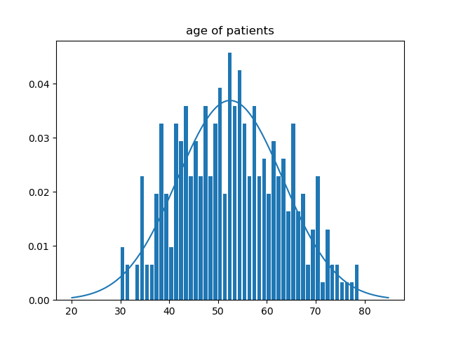

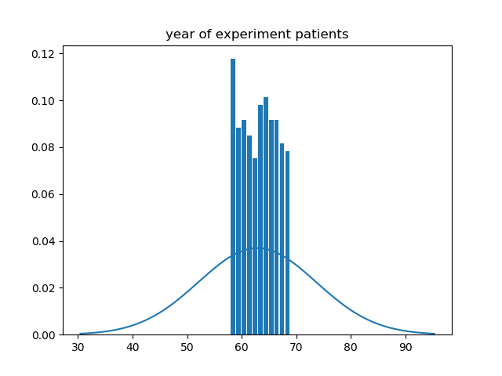

9. There seems to be almost no correlation between the two variables, this was confirmed by a very low correlation coefficient.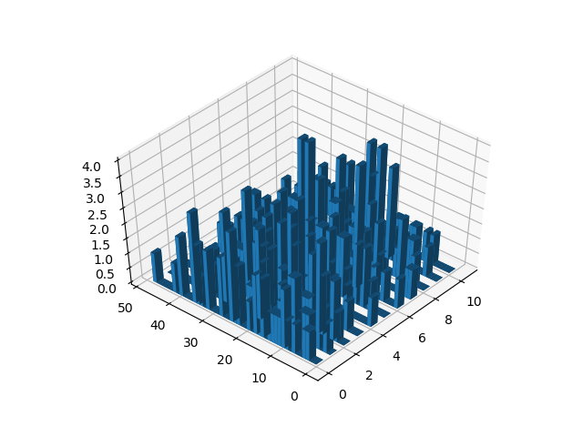

Problem 4:

1. Gaussian mixture distribution is a combination when multiple gaussian distribution are combined to describe one variable. When data has more than 1 peak.
2. The integral over the whole space must be 1.
3. The dataset is mpg of cars. The variable I will be plotting over is MPG of different cars.

4.

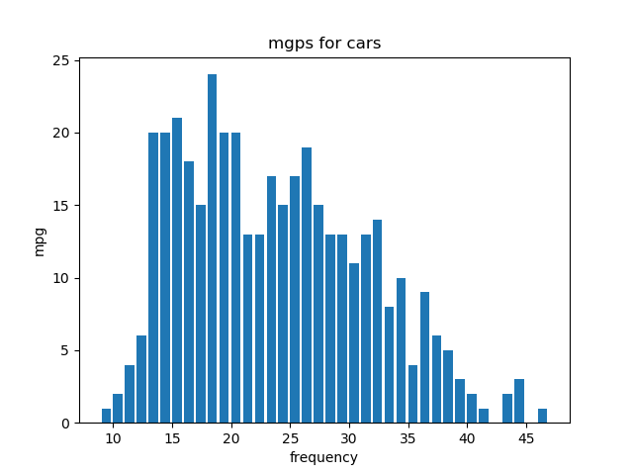

5. I will plan on using two bases. Im going to fit the data to a guassian mixture function using python. I’m estimating that the mean of the bases will be around (18, 28). To estimate the variance of the two peaks, I’d draw normal distribution curves around both peaks. I would try to guess the standard deviation by estimating how far from the mean encapsulates ~1/3 of the data. Then I would square estimated standard deviation to find the variance. The weights would be calculated by roughly totaling up the data under both guassians. In the above dataset I’m guessing that the weights will be about 50% for both curves.

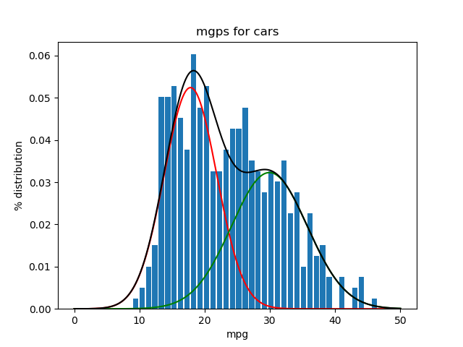

The means ended up being: [17.88, 29.995]

The variance: [16.517, 33.518]

The weights: [0.535, 0.465]

Problem 5a:

1.

Dataset: <https://data.nrel.gov/submissions/69>

Residential load profiles, and generated electric vehicle load profiles.

This dataset is separated into 3 files. Generated customer profiles for 200 homes for a year. Level 1 charging (1920W) EV generated profiles for 348 different EVs. Level 2 charging (6600W) EV generated profiles for 348 different EVs. The profiles are for a whole year at 10-minute intervals. The household data was extracted from a larger dataset: <https://www.eia.gov/consumption/residential/data/2009/index.php?view=microdata>

2.

Inputs: household, car, charging level, time, day. Ouput: Electricity consumption

3.

Assessing impact of charging on a customer, or on a grid. Forecasting the charging.

4.

You can infer roughly the next time the vehicle is going to charge based on previous charging patterns.

When the vehicle is going to stop charging.

5.

I would like to do a project on identifying if customers have EVs or batteries at their home. So, I would create a set of training data, by adding the profiles that correlate together to each other. I would see how this training data correlates to each other. Do an FFT on the EV profiles to determine if there times have strong correlations. Determine slopes between, datapoints to see if there is a correlation between charging and the change of total consumption. Basically, try to identify prominent features and correlations to determine new features that aren’t the starting variables.

Problem 5b:

1.

Dataset: <https://openei.org/datasets/files/961/pub/>

Load data from cities. The data has hourly kW usage for a whole year (I think 2004). The data has categories for electric and gas heating, cooling, fans, interior Lights, water heater, and interior equipment. There is a massive repository with each dataset describing different building types in different cities.

Another Dataset: <https://data.nrel.gov/submissions/69>

Residential load profiles, and generated electric vehicle load profiles.

2.

There are 10 categories per file:

Time (Day and Hour), Electricity, Fans:Electric, Cooling:Electric, Heating:Electric, InteriorLights:Electric, InteriorEquipment:Electric, Gas, Heating:Gas, InteriorEquipment:Gas, WaterHeater:Gas

But the files are also separated if they are Residential or Commerical, City, Building Name.

So, if you include that time has two variables, then there are 14 starting variables in the data set.

3.

Identifying if PV is installed at one of the customers. Or forecasting load.

4.

Yes. You can likely infer gas heating and electric from each other. You can infer what the next hour of data is going to look like from the last hour, you can infer what the next day of data is going to look like from the previous day, or previous same day of the week. There is likely a lot of correlation from between, heating, cooling, and fans.

5.

I would like to do a project on identifying if customers have EVs or batteries at their home. But since this data doesn’t specify this, I would not be able to train the data. So, I could either use this data and run it through a model to simulate normal usage of a customer with an EV or Battery, or I could change the project. If I wanted to do a forecasting project, I would start looking at what variables, are correlated and use an FFT to determine periodicity. I would also look to see if there are correlations between different cities or load types, to see if there are other features that normally aren’t used, and if during different times of day different variables have different weights.

Problem 6:

1.

Filter method looks at each variable independently and determines weights of those variables correlating to the data. The highest rated variables are then used. The wrapper method looks at sets of variables to see which set can describe the data best, so the variables are not looked at independently.

2.

I would use the filter method first to determine some sort of correlation from my inputs to output, but then I would probably use the wrapper method. This tends to be more accurate and since there aren’t a ton of variables, a wrapper function would remain be computationally efficient.

3.

Currently the archive is offline.

4.

I will plan on using SVD extraction in python. This is a filter method because it weighting features individually.

5.

Problem 7:

1.

Same as problem 5.

<https://data.nrel.gov/submissions/69>

2.

To simplify the problem the of this little homework assignment I will only be doing this to tell if the EV that is known to reside at a house begins charging or stops charging.

Features: total electricity consumption, time, change of load from last 10-minute interval (slope from last charge), change of slope from last 20-minute charge, change (slope) of electric consumption from last hour, electric consumption difference from previous day at same time, electric consumption difference from previous week at same day and time.

For this assignment to simplify the data extraction required I will look at the following features to see their correlation: total electricity consumption, time, change of load from last 10-minute interval (slope from last energy consumption)

3.